Kanoknat Cheepchiewcharnchai

Crosby Merch website

Table of Contents

Analysis 6

Identifying problem 6

Project description 6

Stakeholders and interviews 7

Justifications of how the solution can be solved by computational methods 11

Research 13

Current solution 13

Similar solutions 14

Method of payments 21

Solution Proposal 23

Features of solution 23

Limitations of solution 27

Hardware and Software requirements 28

Hardware Requirements 28

Software Requirements 28

Success Criteria 29

Shared Criteria 29

Customer Criteria 29

Admin Criteria 31

Design 33

Top Down Design 33

Justification 34

Entity Relationship Diagram 35

Tables of database 36

TblUsers: 36

TblItems: 36

TblBaskets: 37

TblBasketItems: 37

TblOrders: 37

Page Design 38

Login page 38

Generic Browse page 40

Generic Item Details page 42

Generic Basket page 44

Purchases page 47

Admin homepage 49

Items page 51

Add Item page 53

Remove item page 55

Orders page 57

Generic Orders page 59

Accounts page 61

Accounts List page 63

Account Details page 65

Account Info page 67

Add Account page 69

Remove Account page 71

Testing data 73

Iterative Development Test Data 73

Post Development Test Data 76

Usability Testing Plan 82

General Questionnaire 82

Customer Questionnaire 83

Admin Questionnaire 83

Development 84

Setup 84

Connection.php 84

Creating Tables 85

Install.php 85

Login 91

Logout 99

Preventing bypass 102

Customer 105

Navbar.php 105

Homepage.php 111

Itemdisplay.php 121

Addtobasket.php 125

Basket.php 128

Confirmpurchase.php 135

Purchases.php 139

Purchasebasket.php 144

Admin 147

Adminnavbar.php 147

Adminhomepage.php 148

Items.php 149

Adminbrowse.php 150

Adminitemdisplay.php 153

Additems.php 156

Addingitem.php 159

Removing items 163

Orders.php 164

Unprocessed.php 165

Processorder.php 166

Processingorder.php 170

Processed.php 171

Completeorder.php 172

Completingorder.php 174

Completed.php 175

Completedetail.php 176

Accounts.php 178

Accountslist.php 179

Accountdisplay.php 181

Accountinfo.php 182

Accountorders.php 184

Processaccountorder.php 187

Processingaccountorder.php 188

Completeaccountorder.php 189

Completingaccountorder.php 190

Addaccounts.php 191

Addingaccount.php 194

Removeaccounts.php 197

Removeaccountdisplay.php 198

Removingaccount.php 200

Evaluation 204

Functional and Robustness testing 204

Shared 204

Customers 205

Admins 207

Usability Testing 211

Customer 211

Admin 214

Final Testing 217

Shared 217

Customers 223

Admins 231

Success of Solution 242

Shared Criterions 242

Customer Criterions 243

Admin Criterions 244

Improvements to Unmet Criteria 247

Customer Criterions 247

Admin Criterions 247

Maintenance and Limitations 248

Potential Improvements 249

Appendix 250

Mystyle.php 250

# Analysis

## Identifying problem

Recently, Crosby house has come up with ideas of some merchandise which we would like to sell to the pupils within the house. However, we do not actually have a proper system set up for buying and selling them yet. It will be confusing and hard for the person in charge to create and send out a form before finally being able to go through the results one by one only after making sure that everyone has filled in the form. We are also hoping that we will be able to add more items to the collection of merchandises in the future. This will result in a more complicated and longwinded process to deal with over time, due to the need for someone to physically process the data.

## Project description

I intend to create a shopping website for pupils to buy the house merchandise. They will be able to choose the item, quantity and size (when available) that they wish, these items will be added to their ‘shopping cart’ before confirming purchase at the checkout. I want the ‘admin’ of this website to be able to add new items or remove existing items to the merch list at any point. They should easily be able to see what items each person had bought from this website, including any details (quantity & size).

## Stakeholders and interviews

In this section I will be interviewing my stakeholders using a set of questions that I have made to help me to design a website that will fit their needs. The questions are as follows:

Questions for Admin

What makes a good merch selling website?  
 - Does the aesthetics of a website affect your experience?  
 - What types of devices should the website be compatible with?  
 - Which pages of the website need the most attention?  
 - What key information/features should be on the homepage

What are the current problems with the current solution?  
 - Does the current solution function as it should?  
 - Have you had any negative experiences with the current solution?  
 - What do you think is currently missing from the current solution?

What functionalities are needed for those using the website?  
 - What will customers need to be able to do?  
 - What functionalities will the admins need?  
 - How will the system of the website work?

Questions for customers

What makes a good website for a restaurant?  
 - Does the aesthetics of a website affect your experience?  
 - What types of devices should the website be compatible with?  
 - Which pages of the website need the most attention?  
 - What key information/features should be on the website?

What are the current problems with the current solution?  
 - Does the current solution function as it should?  
 - Have you had any negative experiences with the current solution?  
 - What do you think is currently missing from the current solution?

**Current Head of house, Admin – Julian Lee**

As the head of house is it Julian’s responsibility to gather everyone’s order and process them. This is why he will be a good stakeholder for this project, acting as the admin of the website. He will be able to use this website to hopefully make his job at gathering orders from everyone easier.

Does the aesthetics of a website affect your experience?  
 “Definitely, I think that the aesthetic of a good website should attract the customer to be more likely to buy our merch. I want the website pages to be able to complement and enhance the aesthetic of the merch itself. However when talking about aesthetic of the website on admin’s side, I don’t think that it matters that much, as long as the website is laid out so that it is easy to use.

What types of devices should the website be compatible with?  
 “I want the website to be compatible with my laptop since that is when it is easiest for me to do my work. My phone tends not to be used for work so I don’t really need it to work on the phone, I don’t mind if it works on the phone as well or not because I will most likely not be using it on my phone anyways.”

Which pages of the website need the most attention?  
 “I think that the page which will display all of the merch will be the most important, as that would be where the customers are first introduced to each merch items. If they are attracted to the merch from this page in the first place then it will be likely for them to buy the merch.”

What key information/features should be on the homepage?  
 “I do not really think that a home page is important for this merch website, as long as the merch display page is attractive, then that page can act in itself as a homepage to welcome the users.”

Does the current solution function as it should?  
 “The current solution works fine, however it does not provide the aesthetic and description of each items like I would prefer it to.”

Have you had any negative experiences with the current solution?  
 “When I have to collect and process the data of the orders, it was really hard for me to keep track of who wants which item. I also had the problem of people sending in their order at different times which made me forget which ones I have already processed and which ones I haven’t done yet, it was very time consuming to have to try and figure out what has been added to the list of orders and by whom. Another problem is that the form that is sent out only allows one reply from each person, this means that once someone has sent their form, they cannot change their mind to get more/less items. That means that people will have to talk to me in person and it is quite hard to keep track of all of those requests.”

What do you think is currently missing from the current solution?  
 “The current solution is a Microsoft forms, therefore when I look at responses from each person it will show up with their email address, which I may not be familiar with each person’s email address. This meant that I had to spend extra time to work out who the order actually needed to made for, slowing down he process even more.”

What will customers need to be able to do?  
 “Customers should be able to view all the merch that is available to them and choose which ones they would like to order. They should be able to place multiple orders and at any time that they would like.”

What functionalities will the admins need?  
 “I would like the admins to be able to create and accounts, so that it is easier for me to remember names instead of emails. I would also like to be able to view each orders that has been made and who is was made by, and show if the order has been processed or not. Apart from adding and deleting accounts admin must also be able to edit the available merch and put a front and back picture of the merch on the website.”

How will the ordering system of the website work?  
 “Once the pupil places an order, I’ll be able to see the details of their orders and that will allow me to make a list of all the merch that is needed. I should be able to check that a transaction has been made and I will then get the orders ready. After everything is done I should be able to mark the orders of as finished.”

**Pupil of Crosby House, Customer – Genta Yamanouchi**

As one of the pupils in Crosby house, Genta will be a good stakeholder for this project because he will be the user of this website. In particular he has already ordered two merch items which means that he has used the ordering form beforehand and will be able to judge the difference between the existent solution and the new solution.

Does the aesthetics of a website affect your experience?  
 “Yes it does. I find that a website that look appealing to me makes me want to buy from it more. Probably because if the quality of the website is high, then most likely the quality of the merch will also be high.”

What types of devices should the website be compatible with?  
 “I have tried to do online shopping on my phone before but I found that it was too inconvenient, the picture were too small and I was only able to see one item at a time as I was scrolling down, which is why I always do my online shopping on my laptop. I also find that the only time where I actually have time to properly browse for items is when I am on my laptop.”

Which pages of the website need the most attention?  
 “I think that when I look at a shopping website, the most important page is the item browsing and individual item displaying page. This is because those pages are where I will actually make my decisions of which items I will actually want to buy. The browsing page lures me into a specific item, and on it’s specific page, the details on the items will truly let me decide if I want to buy it or not.”

What key information/features should be on the website?  
 “When it comes to a shopping website I think that the ability to be able to browse items and see the items in the basket before I checkout is very important. It is also important for me to be able to see the order that I have made, and the item that I am waiting for. Since they are all important aspects of a shopping website, I really want to be able to move from one page to another very easily.”

Does the current solution function as it should?  
 “The current solution works, but not very well. It currently isn’t very attractive and the Microsoft form feels so far away from being a proper selling mechanic for the house merch.”

Have you had any negative experiences with the current solution?  
 “It doesn’t allow me to buy more than one of the same item, which I had wanted to do. It was also kind of hard to browse and choose the items because of the way Microsoft forms lays it out.”

What do you think is currently missing from the current solution?  
 “I think that the biggest issue that the current solution has right now is the browsing mechanic, as it is very inefficient. It would be helpful to also have some kind of total so that I know how much I am spending without having to calculate it myself. And something that isn’t really a problem but would really contribute to my experience of buying the merch is to have the buying process by aesthetically pleasing.”

**Conclusions made from interview:**

From the interviews with my stakeholders, I now have an idea of what I should be including into my website, both for the functionality of the admin and the customers.

On the management side of the website:

* No need for aesthetics, because efficiency in functionality is more valued
* Need to be able to work on laptops/PC
* Need to be able to add and remove users
* Need to be able to add and remove merch items, being able to insert the front and back pictures for each item
* Need to be able to see contents and details of each orders made by each user
* Need to be able to see and change the processing status of each item in and order

On the customer side of the website:

* The website must be aesthetically pleasing
* Need to be able to work on laptop/PC
* Need to be able to easily browse through all merch items
* Need to be able to place multiple orders
* Need to be able to choose size and quantity of each merch item before adding to basket
* Need to be able to see the total cost of the basket
* Need to be able to traverse between basket and merch display page
* Need to be able to see all orders made and see its processing status

## Justifications of how the solution can be solved by computational methods

This problem will be well suited for a computer since the data can easily be entered and processed. Because there will be a lot of data that needs to be processed (e.g. total cost for each person, total number of each merch in each sizes that needs to be ordered and for who), the computer will be able to accomplish these tasks much faster than humans. From the side of the customers, it allows convenience for them to be able to do the online shopping from anywhere and at any time, which gives them more freedom in browsing and selecting product. It will also allow many people to be able to browse and order the merch at the same time.

**Thinking ahead**

The inputs I will need for my solution to work, include customer data such as their login details of their school system, which will be collected manually by us to be used as the login for this website. Additionally, data of merch items will be needed to create the list of clothing on the website. Input will also be required from admin to sign orders off when they have been completed, so that the process of checking orders off orders can be ran smoothly.

The outputs my system will give include the total cost of a the merch purchased. Customers may also have an online receipt as an output (showing the total amount of money that they spent). The system will also display the status of each item (e.g. ordered, received, completed).

My website may potentially have reusable components. For example, the CSS of my website could be used across multiple pages of my website (homepage, shopping page, checkout etc.) as it is logical and aesthetically pleasing that each page of my website follows the same colour scheme and design features.

**Thinking procedurally**

I am breaking up the problems into smaller steps so that it will be easier for me to come up with many little solutions that will join together to solve the entire solution. The problems are as follows:

Placing an order:

* The customer should be able to login
* The customer needs to see a list of all the merch
* The customers should be able to add merch items into their basket
* Customers need to make payments for their orders

Preparing an order:

* Admin needs to be able to see the orders placed by all end users combined into one
* The admin need to be able to sign off orders once they are complete
* Orders that are signed off should be removed from the display after a certain amount of time.

Delivering an order:

* Admin need to know which belong to which individual end user

**Thinking logically**

Branching and looping will be needed for some aspects of my solution. For example, once a customer has added an item to their shopping cart, they can either choose to loop back to browse for more items, or they can choose to proceed to checkout and pay to confirm purchase.

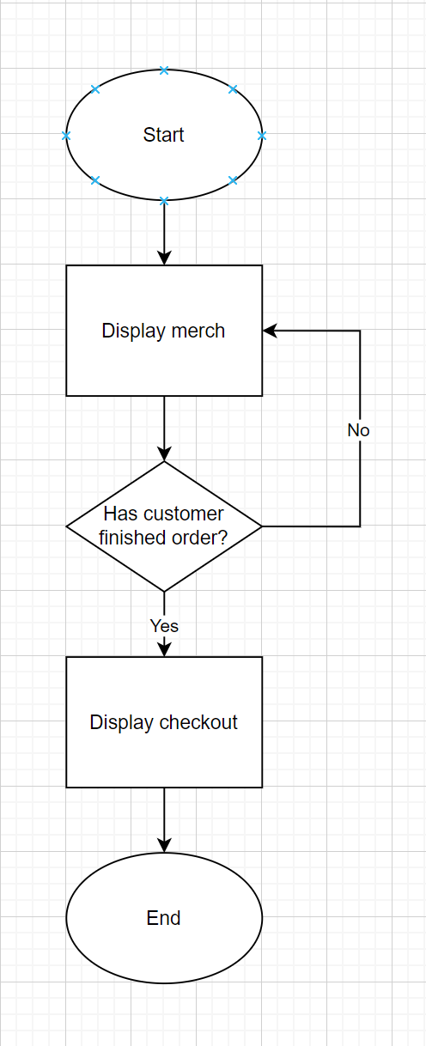



Start

## Research

### Current solution

Currently, the house merch system is ran using a Microsoft forms which lists each item and size individually. It is quite time consuming for Julian to have to look at what each person has ordered and then to write them down one by one. It is also an inconvenience for the pupil since they have to go through the entire list of items just to look for one that they actually wanted to buy. Although it is still quite straightforward since there are still only 8 items, but as we go on and there are more and more merch then it will grow to become a big problem for both Julian and all of the students.

**limitation of current solution**

Although this is a working solution, it is not very efficient for both the admin or the customer. I have listed some limitations of using a Microsoft forms below:

Basic customisation options  
Whiles Microsoft forms allows for a certain degree of customisation in terms of design and layout, its options are relatively basic compared to a proper e-commerce platform that offer extensive customisation to match the brand identity and improve user experience. Since the form only allows the pupil to choose a size of the item that they want, it means that they are only able to get no more than one of each item from the website.

Form can only be used once  
Once the form has been summited, the pupil cannot go back to change what they have submitted. Or even to look at their response. Not being able to have access to the form once it has been summitted means that pupils will only be able to buy merch once, if they change their mind and decide that they want to buy another item they that will not be possible for them. This also means that Julian will have to create and post a new form every time a new item has been added to the list of existing merch.

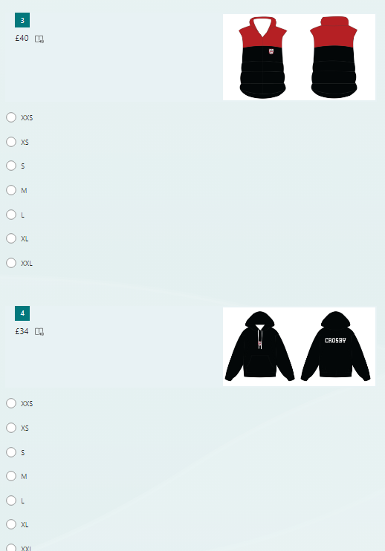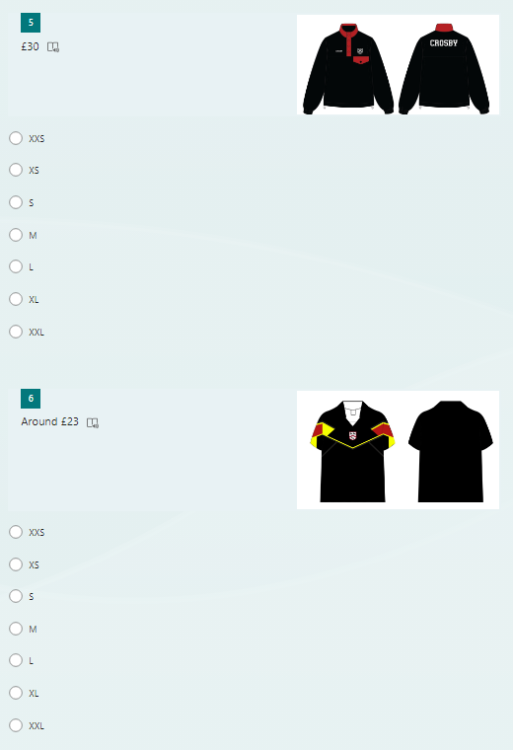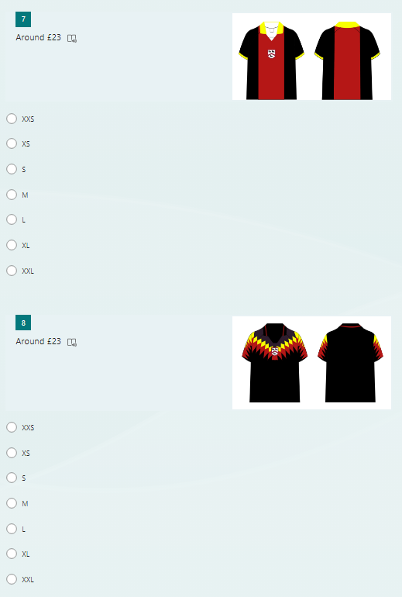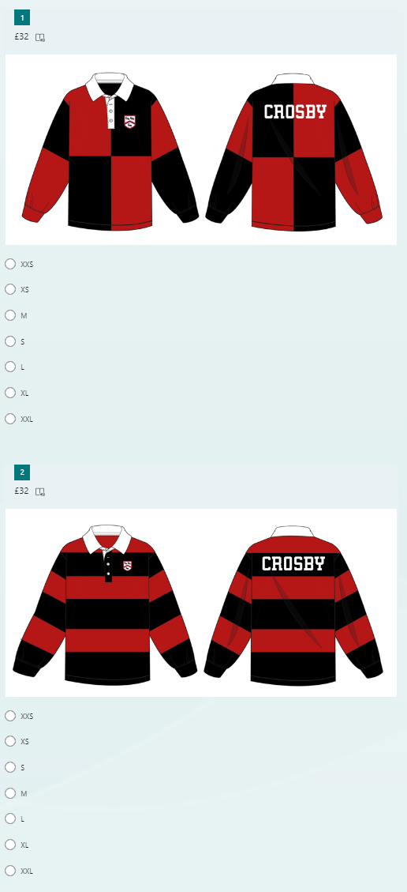No shopping cart functionality  
The lack of a shopping cart ability may make it hard for the pupils to keep track of which item they had chosen to buy. This will become a big problem and waste of time when the list of merch has grown significantly.

### Similar solutions

Similar solution 1 : H&M website (men’s section)

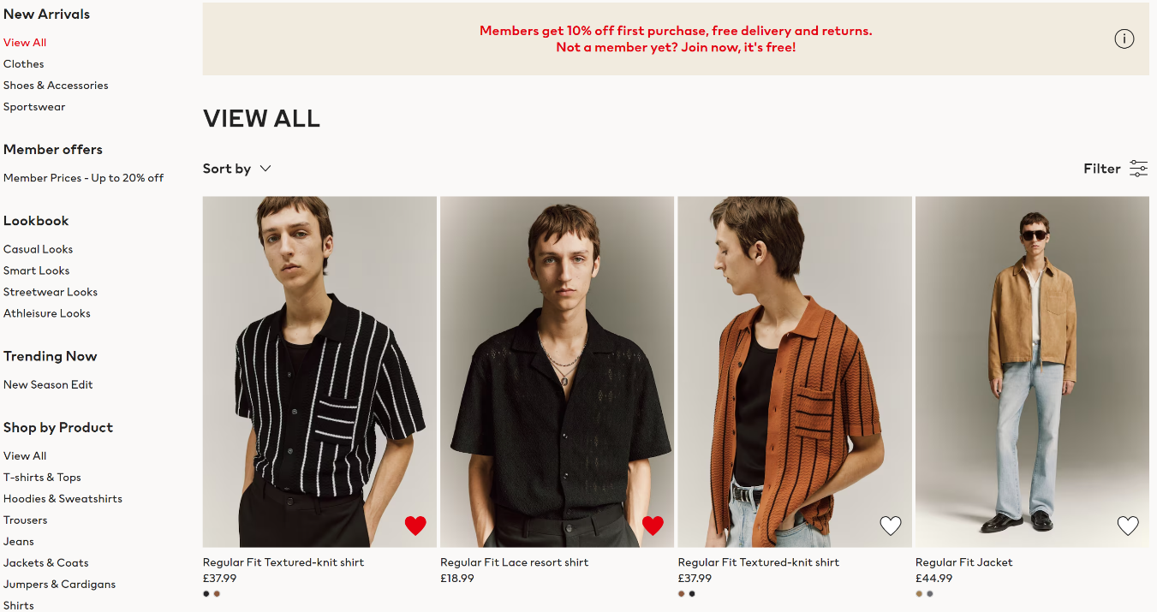

This is the display page of items that are sold by H&M for men

Features identified:

* Allows you to search for items quickly and easily by clicking on the navbar located on the left side of the screen, bringing you to a different page with only the items mentioned
* Allows you to like each add item to ‘favourite’ by clicking on the heart on each photo of the item, which can checked by the navbar at the top of the page
* Each item shows you the name and the price of the item as well as the colour that they are provided in
* Has arrows on the photos to allow you to look at other photos of same item without having to click onto the page of the item
* 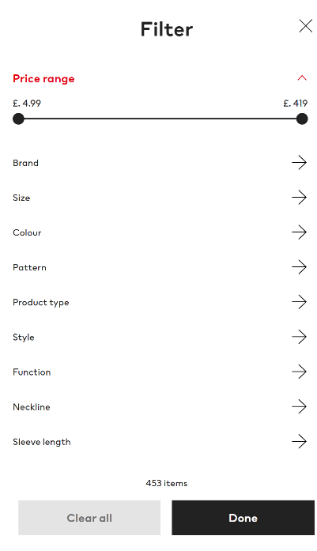Allows you to view items in different sort orders: recommended, Newest, Lowest price, Highest price
* Has a filter that allows you to only search for items which fits a description that the want:

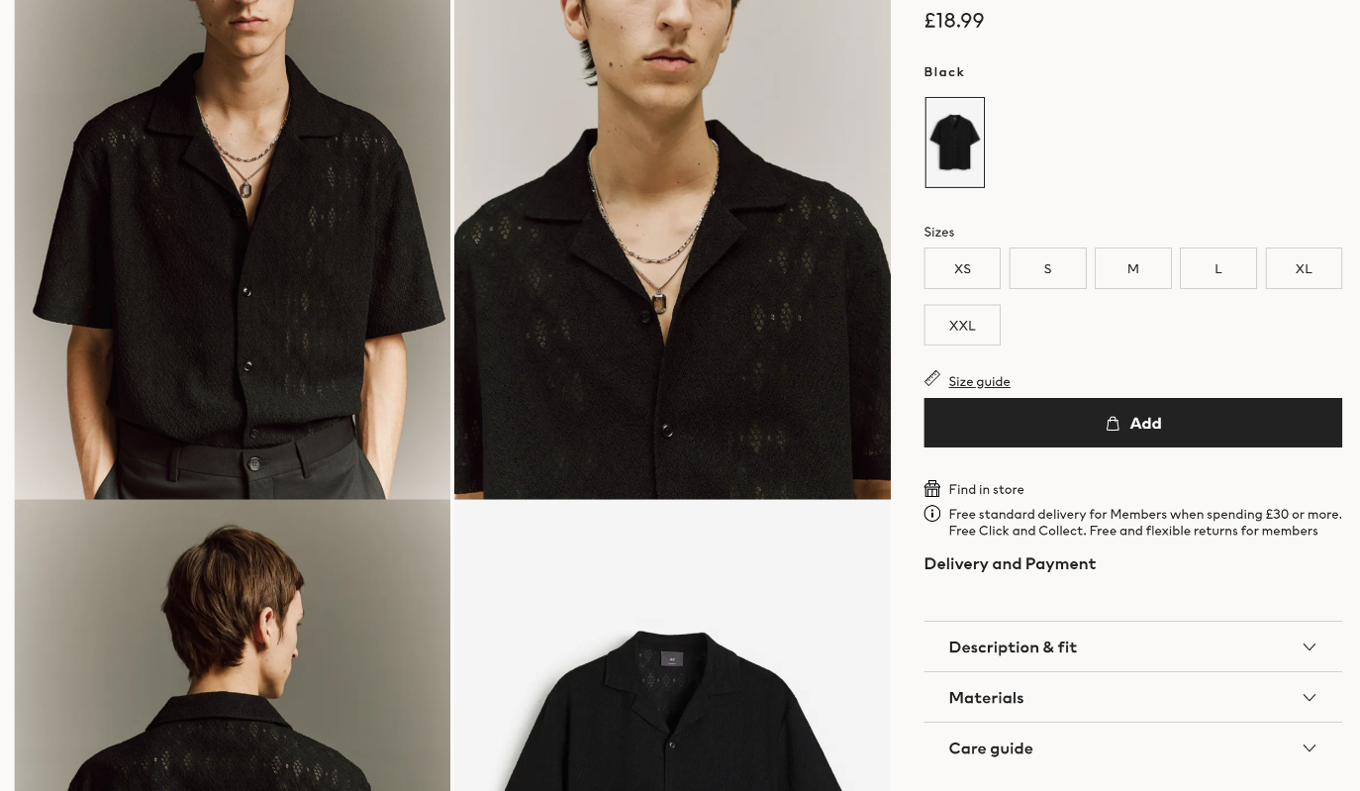

This is the display page of the item once you click onto them

Features identified:

* Scrolling up and down the page will allow you to see the different photos of the item on the left side of the screen whilst the ‘add to cart’ is fixed onto the right side of the screen
* You can choose which size you would like from the selection that they offer
* There is an accessible size guide to the right of the size selections
* You can check the details of the item under the ‘add’ on the bottom right of the screen: Description & fit, Material, Care guide
* 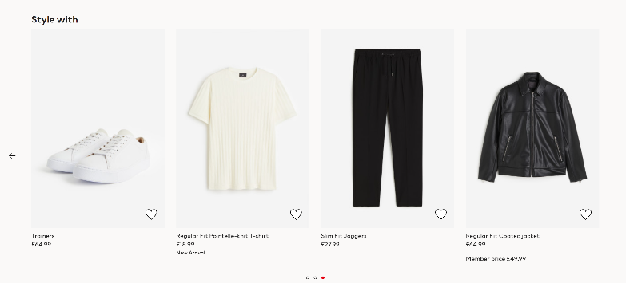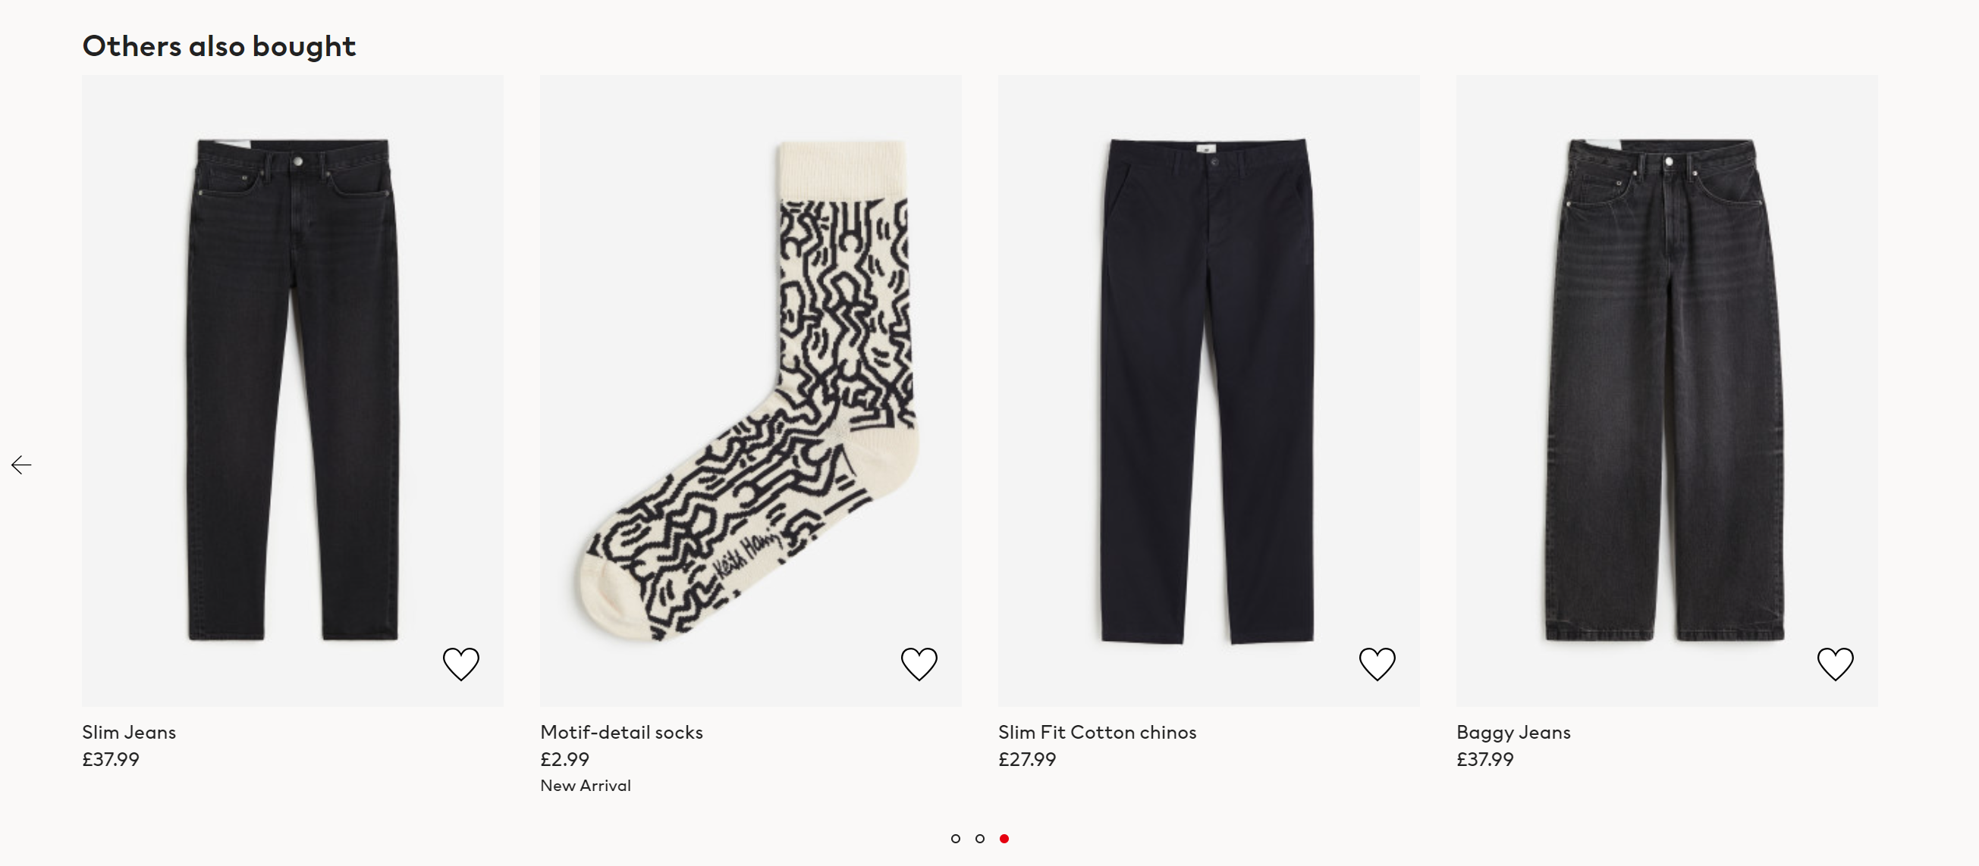Once you scroll to the bottom of the page you will be able to locate a ‘style with’ section, suggesting you some other items that may go well with the one you are currently browsing, you can traverse left and right on this section to see more options
* Beneath the ‘style with’ section there is a ‘Others also bought’ that shows you which items were other people tend to buy together with the one you are currently browsing

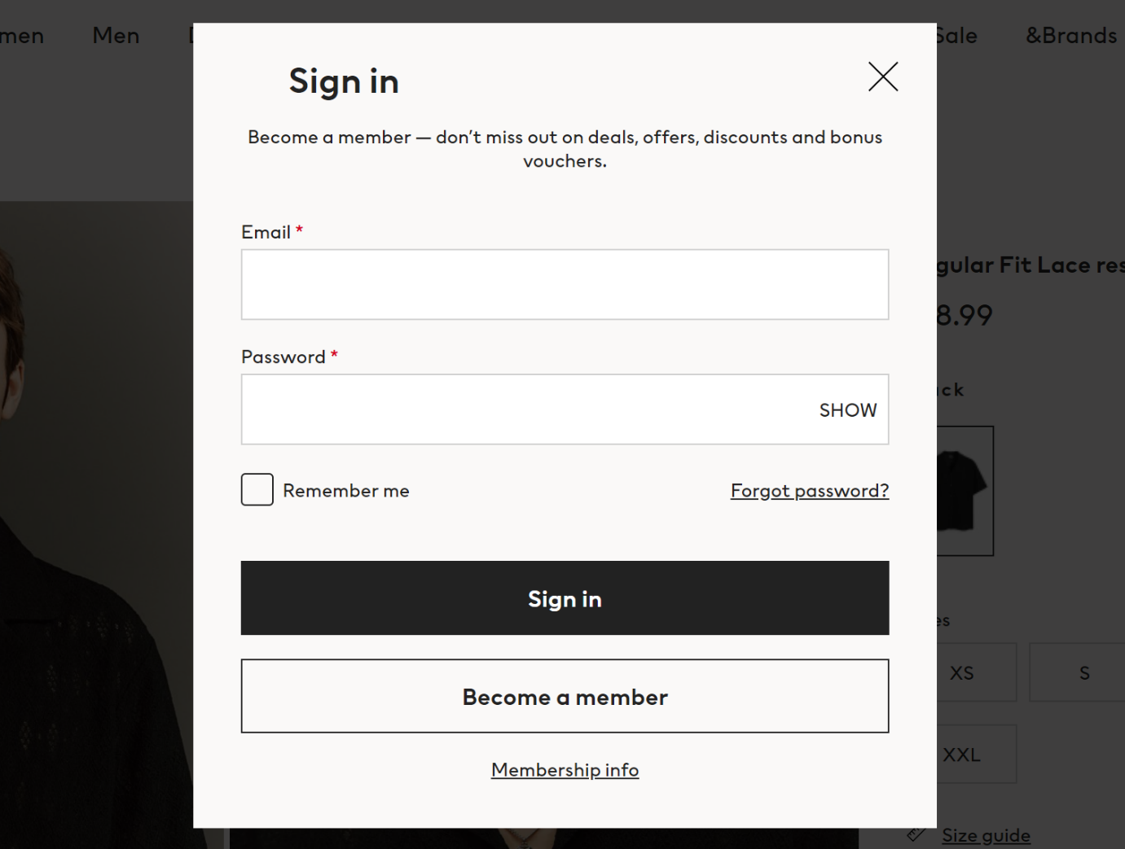

This is the sign in page for the H&M website

Features identified:

* Accessible on the navbar at the top if every page
* A simple popup page that does not require you to be redirected to a different link
* Can choose to show password but otherwise would be hidden by replacing each letter with indistinguishable dots.
* Has a ‘Remember me’ checkbox which allows you to be automatically signed into the website once reopened through the same device
* Has a ‘Forgot password?’ to allow you to change/ recover your password when forgotten
* When incorrect login details has been entered, an error message is displayed in red

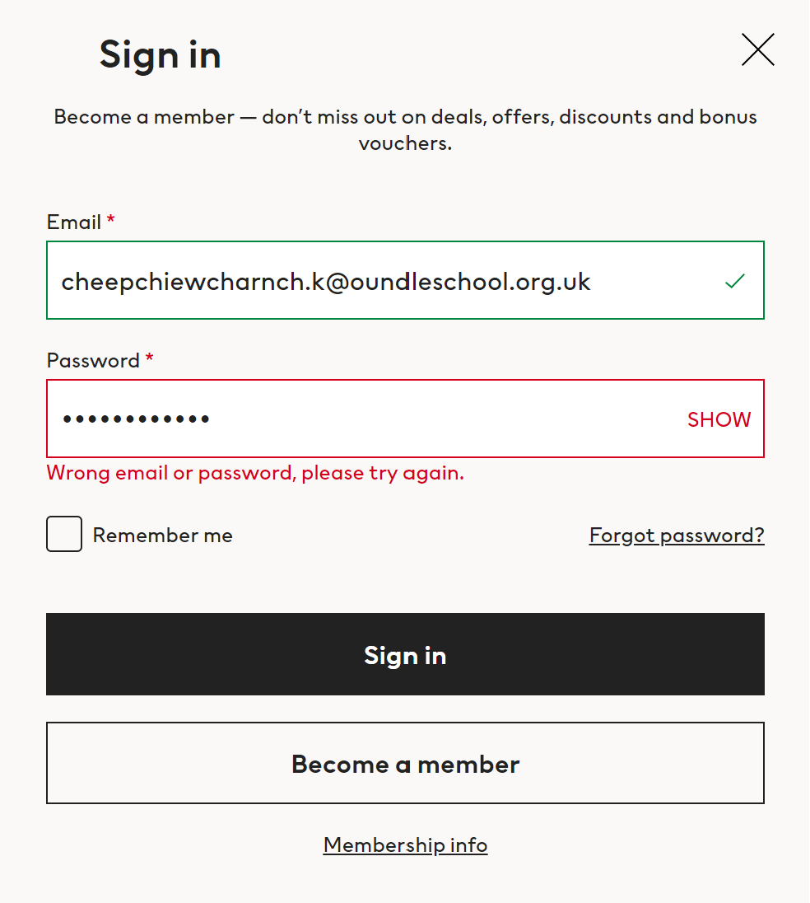

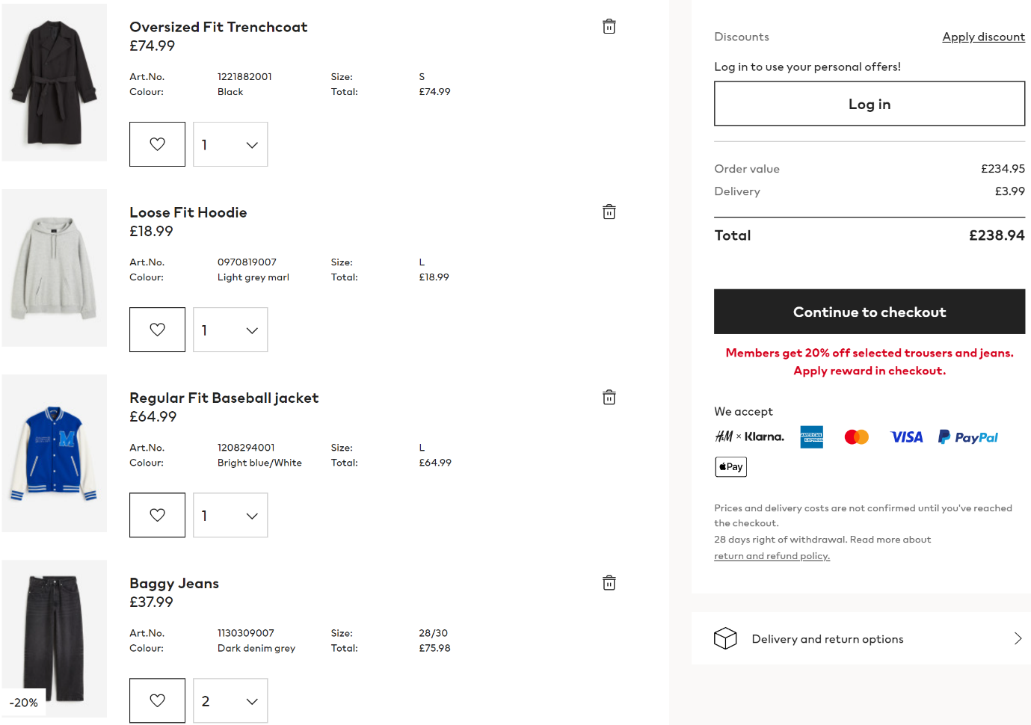

This is the ‘Shopping bag’ page which lists your item before you checkout and pay

Features identified:

* Shows pictures and details of each items (e.g. name, individual cost, size, quantity, total cost)
* Allows the user to get rid of an item in the basket just by clicking the bin icon located on each of the items
* Shows the applicable discount on each item, on the picture of the item
* Shows the total cost of the order on the right, directly above the checkout button
* Shows the methods of payments available to be made by the customer

Similar solution 2 : Etsy (setting up a shop)

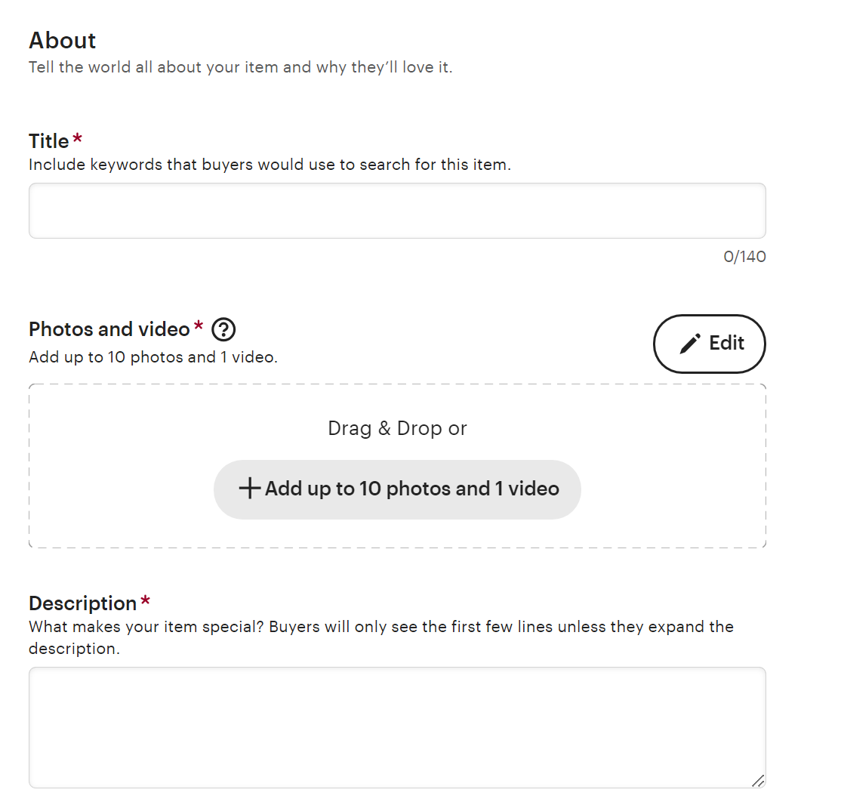In this section, I will be looking at the process of adding an item onto an online shop in Etsy, so that I can know what inputs are asked for in the process of adding an item and whether they are optional or not.

* Name of item (required)
* Add photos and video (at least one required, maximum ten photos and one video)
* 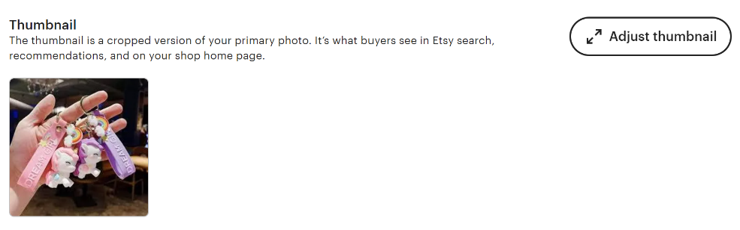Write a description of the product (required)
* When the photos are added, a thumbnail must be chosen from one of the entered photos
* 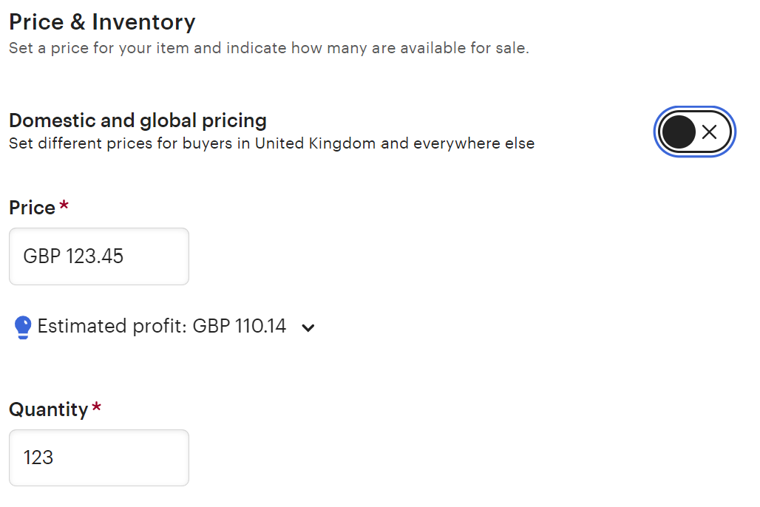Price per item (required)
* 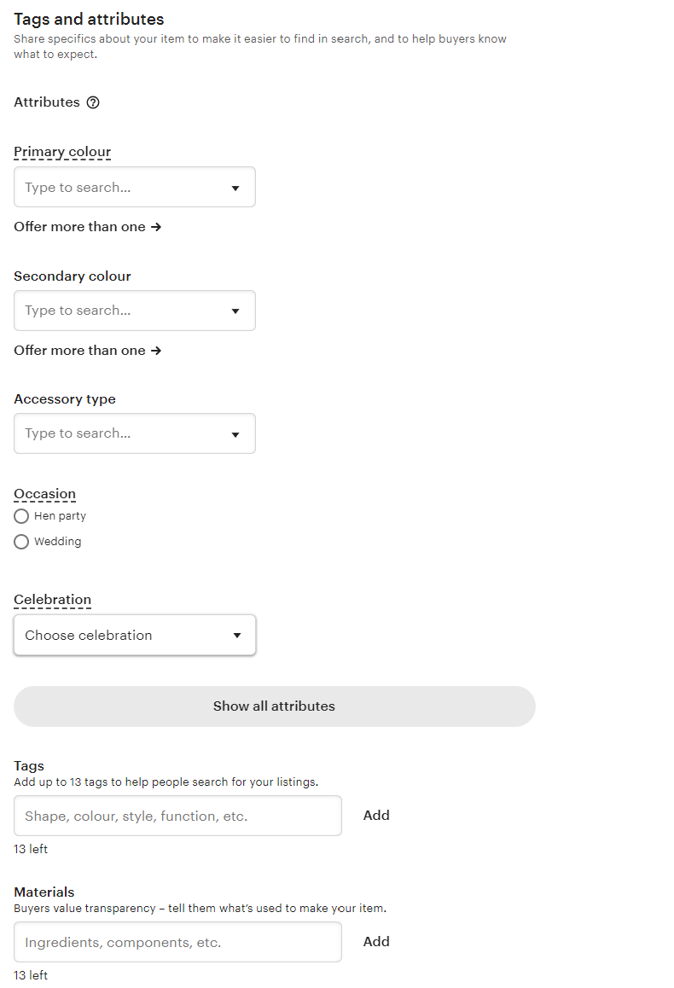Quantity of stock (required)
* Colour of the item – primary and secondary (not required)
* Item tags, keywords, to help searching for item easier (not required)
* Material of item used for information provided to customer (not required)
* 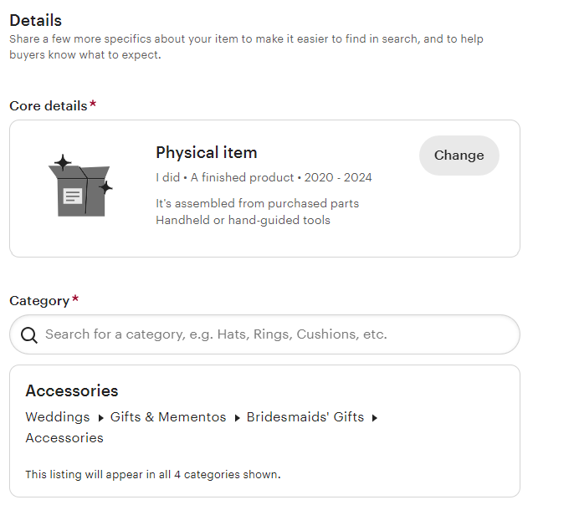Whether or not the item is physical or digital (required)
* 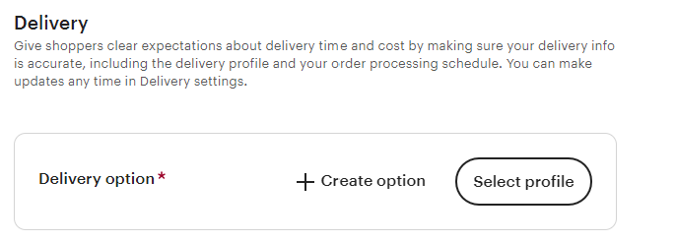The item category (required)
* Information on how item will be delivered (required)

### Method of payments

In this section I will research the potential methods of payment that I can use for my project.

**Credit/debit:**

Pros:

* Convenience for customer – Very easy for pupils to make transactions since they just have to enter some card details
* Convenience for admin – The admin will have to do no work in checking that transactions are successful since that can be done by the computer itself
* Speed of transactions – The transaction requires little to no time to be sent through, meaning the purchase can be confirmed really quickly
* Recurring payment capability – If card details are saved onto their device then it will be easy for a pupil to purchase from the website easily every time

Cons:

* Safety of card details – I am not familiar with creating a system online that will take the card detail from someone and making a transaction, this may lead to safety issues for the students cards details
* Purchase confirmation (OTP) – To ensure that the purchase is being made by the owner of the card, an OTP must be used to confirm. I am not familiar with how it will work and how to incorporate messages through phone numbers. Apart from this pupils in the 3rd-4th form does not have access to their phones which means that they will not be able to access their OTP number.
* Availability of card – Although most pupils will have access to a debit card, some may not, and it is unfair if someone without a card would like to purchase the merch.
* Technological illiteracy – Some pupils are still not used to making purchases online since they are still young. They may be scared away from making purchases even though they might want to get the merch.

**Bank transfer:**

Pros:

* Convenience for customer – Very easy for pupils to make transactions as long as they have a bank account. The process of transferring money trough bank accounts are relatively simple.
* Pay by parents – if a student does not have a bank account, the transfer can also easily be done by their parents in their stead.
* Low safety risk – I will not have to be scared of security problems like for a card detail which may be leaked onto the internet.
* No need for a system to be set up – Since I am not in charge of the bank applications, it means that I will not need to set up any kind of system in terms of transferring money from one to another.

Cons:

* Delay of transactions – Transactions may not be instant, sometimes taking up to days before they are cleared, which may delay the confirming process of the purchase.
* Transfer fees – Money transfers from one bank to another may have transfer fees. The transfer fees will differ for each bank which is unfair towards the pupils, especially for overseas students.
* Human error – being in a boys boarding house, sometimes pupils are not very cautious and may transfer money to a wrong account number. In that case there is nothing that I will be able to do for the money that has be incorrectly transferred.
* Human management – the admin is required to check the bank balance every time someone makes a transaction, they also need to check which transactions are made by who by looking at account numbers, and if the amount of money that is received is correct. Only then will the admin be able to confirm the purchase made by the pupil.

**House bank:**

Pros:

* Convenience for customers – pupils will easily be able to put the amount of money spent onto a bill that will be retracted off their house bank after the purchase has been confirmed.
* Money flexibility – House bank allows students to go into debt which can be paid of by cash/money transfer at a later time. This allows for pupils to be able to make purchases when they don’t have money on them, but can pay back easily at a later time either by them or by their parents.

Cons:

* Consent of purchase – Student may use house bank to buy merch without their parents’ permission, this may cause issues from the parents perspective, since their child is spending their money without permission
* Debt collection – When many pupils go into a lot of debt, it starts becoming an issue to get everyone to pay it off. It will be an inconvenience for the admin of the house bank.

**Cash:**

Pros:

* Convenience for customers – cash is easily accessible by everyone, and is a form of payment that is accepted by people. It does not create extra steps for pupils to go through to have to confirm their payment.
* Speed of transaction – Although it may take a while to check the amount of money, however once that has been done, the purchase will be confirmed immediately.

Cons:

* Change of cash – By taking in cash as the payment method, a change of cash is required. However, there is not always the correct amount of change providable by the Admin.
* Different currencies – Being in a boarding house, some over seas pupils may not have much GBP cash that is available to them.
* Human requirement – Paying with cash will require a human to receive and give change to the pupil. They have to manually check the amount of cash received against the amount of cash required, which will be time consuming. Sometimes if there is no one to receive the cash then it will mean that purchases are not able to be made.

## Solution Proposal

### Features of solution

#### Shared Features:

* **Login Page**

**Feature**: Both admins and users will access the same login page, where they log in with secure credentials.

**Explanation**: Having a unified login page simplifies the user interface, as the same page is used for both admins and users. The system will differentiate the user roles after login, directing admins to the appropriate admin dashboard and users to their browsing page, where the aesthetic requirement will be met as needed.

* **Logout Function**

**Feature**: A logout option in the navbar that takes user and admins back to the login page.

**Explanation**: This provides users and admins with a secure and convenient way to exit the site, ensuring that their session ends properly and their information is protected. It aligns with the security requirements for customer accounts.

#### Customer Features:

* **Browsing Page with Product Display**

**Feature**: A browsing page that displays all available merchandise, with product images, names, and costs.

**Explanation**: This satisfies the customer requirement to easily browse through all merchandise. The inclusion of pictures, names, and prices makes it visually appealing, aligning with the need for an aesthetically pleasing website. It allows customers to quickly identify items they are interested in.

* **Search Bar and Filter Options**

**Feature**: A search bar and filters to refine the product list by category, size, price range, etc.

**Explanation**: This feature enhances the user experience by allowing customers to efficiently find specific items or narrow down their options based on preferences. It ensures the website meets the customer need to easily browse and sort merchandise.

* **Sorting Options for Products**

**Feature**: Ability to sort products by price, popularity, or newest items.

**Explanation**: Sorting helps customers navigate through the items in an order that makes sense to them, whether they are looking for the cheapest, newest, or most popular products. This option ensures a better browsing experience and satisfies the need for easy product navigation.

* **Detailed Product Pages**

**Feature**: Clicking on a product takes the user to a detailed page with high-quality images, descriptions, and specifications.

**Explanation**: This allows customers to explore the product in detail, ensuring they can make informed decisions before purchasing. It also satisfies the need to view item details like size options and costs clearly, which is essential for a smooth shopping experience.

* **Size and Quantity Selection**

**Feature**: The option for users to select the size and quantity of the item before adding it to their basket.

**Explanation**: This addresses the customer need to choose size and quantity before adding to the basket, ensuring they can tailor their order to their exact requirements. It supports the goal of placing multiple orders and customizing purchases.

* **Add to Basket Functionality**

**Feature**: The ability to add selected items (with chosen size and quantity) to the shopping basket.

**Explanation**: This feature allows customers to build their order by adding products they want to buy to the basket. It’s essential for fulfilling the need to place multiple orders and makes the purchase process easier.

* **Basket Page with Item Details and Total Cost**

**Feature**: A basket page that displays all items, their quantities, prices, and the total cost of the basket.

**Explanation**: This feature ensures transparency, allowing customers to see the total cost before finalizing their order. It also aligns with the need to display all orders and the total cost of the basket, making it easier for customers to track their spending.

* **Item Removal from Basket**

**Feature**: The option for users to remove items from the basket before completing their purchase.

**Explanation**: This adds flexibility, allowing customers to adjust their order if necessary, which supports the customer need for ease of use and customization during the shopping process.

* **Purchase Button to Complete the Order**

**Feature**: A purchase button that, once clicked, clears the basket and marks the items as purchased.

**Explanation**: Since no online transactions are required, this feature allows customers to finalize their orders without handling sensitive payment data. It meets the need for a simple, safe purchase process while removing the complexity of online transactions.

* **Purchases Page with Order Status**

**Feature**: A dedicated purchases page where customers can see all their past orders and their processing status (unprocessed, processed, finished).

**Explanation**: This feature allows users to track their orders and understand where each one stands in the fulfilment process. It satisfies the customer need to see all orders made and check the processing status, providing clarity and transparency in the order lifecycle.

* **View Details of Past Orders**

**Feature**: Clicking on any past order will display its detailed contents, including the items purchased and their status.

**Explanation**: This feature enhances customer experience by providing detailed insights into previous orders. It aligns with the need to view order histories and understand exactly what was purchased, offering better customer support and tracking.

* **Cancel Unprocessed Orders**

**Feature**: Only unprocessed orders can be cancelled by the user.

**Explanation**: This feature adds flexibility and control for the customer over their orders, allowing them to cancel an order if it hasn’t yet been processed. It meets the customer need to manage orders in real time and helps avoid frustration if changes need to be made.

* **Navbar for Easy Navigation**

**Feature**: A consistent navbar at the top of every page with links to "Browse," "Basket," "Purchases," and "Logout."

**Explanation**: The navbar ensures seamless navigation between different sections of the website. This feature satisfies the need to easily traverse between the basket, merchandise display, and purchase history without confusion or additional steps.

#### Admin Features:

* **Admin Homepage**

**Feature**: The admin homepage acts as the central hub for navigating to various management sections: **Items Management**, **Orders Management**, and **Accounts Management**.

**Explanation**: This page is designed for efficient workflow by organizing key management functions into distinct sections, allowing admins to quickly choose what they need to work on.

* **Items Management Page**

**Feature**: Admins can view, add, and remove items from the inventory. The list displays item details such as item name, price, description, and type.

**Explanation**: The page mirrors the browsing display on the customer side, allowing admins to efficiently manage the product catalogue. Admins can add new items with necessary details (name, price, description, type) and remove outdated or irrelevant items from the inventory to keep the product offering current.

* **Add New Item Functionality**

**Feature**: Admins can add new items to the inventory by entering details such as item name, price, description, and type.

**Explanation**: This feature allows the admin to expand the product catalogue by adding new items. The type field allows categorization for easy filtering on the customer-facing browsing page.

* **Remove Item Functionality**

**Feature**: Admins can remove items from the inventory, preventing them from appearing in the customer catalogue.

**Explanation**: The ability to remove items ensures that outdated or out-of-stock products are no longer displayed to customers, which helps maintain a streamlined and accurate catalogue.

* **Orders Management Page**

**Feature**: The Orders Management page allows admins to view and manage customer orders, categorized by Unprocessed, Processed, and Finished.

**Explanation**: This page helps admins track and manage the progress of orders, from receipt to fulfilment. The orders are categorized to ensure that unprocessed orders are handled first, followed by processing and completion.

* **Order Details and Status Management**

**Feature**: Admins can view the details of each order, including items, quantities, and total cost. They can update the status of orders (unprocessed, processed, finished).

**Explanation**: The ability to manage order status allows admins to keep track of the fulfilment process and ensure timely processing. Admins can move orders through various stages (unprocessed → processed → finished) based on their current status.

* **Account Management Page**

**Feature**: Admins can view, add, and remove customer accounts. Each account includes details such as username, name, email, and order history.

**Explanation**: This feature enables admins to manage the user base, ensuring they can control customer information and facilitate account creation or removal when necessary. Admins can also access detailed order history for each customer.

* **View and Manage Customer Baskets**

**Feature**: Admins can view customer baskets associated with individual accounts and manage the order status (processed, finished).

**Explanation**: This function allows admins to directly interact with customer orders, making it easier to process orders manually by users.

* **Add New Account Functionality**

**Feature**: Admins can create new user accounts by entering details such as name, username, and password.

**Explanation**: Admins have to manually add new customer accounts, since this e-commerce website is only limited to the members of Crosby House.

* **Remove Account Functionality**

**Feature**: Admins can remove customer accounts from the system.

**Explanation**: This feature gives admins the ability to delete inactive accounts (when students leave school), ensuring that user data is kept up to date and accurate.

* **Navbar for Navigation**

**Feature**: The navbar at the top of every page includes links to Items Management, Orders Management, Accounts Management, and a Logout option.

**Explanation**: The navbar provides consistent and intuitive navigation throughout the admin interface, ensuring that admins can easily switch between management sections and securely log out when finished.

* **Consistent Layout and Interface**

**Feature**: All admin pages (Items Management, Orders Management, Accounts Management) share a consistent design, including the layout, structure, and navigation options.

**Explanation**: A consistent design improves the user experience by reducing confusion and ensuring that admins can focus on their tasks without needing to relearn the layout on each page.

### Limitations of solution

One of the main limitations of this solution is the absence of an integrated payment system. This decision stems from the concern of handling online financial transactions. As I am not confident in managing sensitive financial data, there is a legitimate fear that, in the event of an error, transactions could be mishandled, potentially leading to financial losses or fraud. Therefore I have chosen to use the house bank system as a means to pay instead, this means that the admin will need to use a separate system to handle users’ expenses.

Another key limitation of the proposed solution is the lack of consideration for hosting the website on an external server. While the website can be developed locally using as XAMPP (for a local webserver), there are no current plans for setting up a live, publicly accessible hosting solution. This means that the website will not be available for public access or use unless hosted on a server, which is essential for real-world deployment. This limitation is justified in the context of the project’s scope, as hosting and deployment require specific technical expertise, and these decisions are being deferred in favour of focusing on the website’s core functionality and local testing instead.

## Hardware and Software requirements

### Hardware Requirements

This solution won't require me to purchase any hardware. Instead, I’ll use the school computers to run a local web server via XAMPP (described in software requirements). If I decide to explore hosting options later, it will likely be through an external company that offers a free hosting plan.

### Software Requirements

For website development, I’ll be using Visual Studio Code, which offers full support for HTML, CSS, Bootstrap, JS, and PHP. The design of the webpages will rely heavily on CSS and Bootstrap, as both stakeholder groups highlighted their importance for visual appeal. Furthermore, VS Code seamlessly integrates with GitHub, allowing me to automatically save and back up my progress externally.

For local hosting, I will use XAMPP, which provides an Apache web server and a MySQL database. I’ll manage the database using phpMyAdmin, making the process of working with the database more user-friendly.

## Success Criteria

### Shared Criteria

1) **Login Page Security and Access**

**Success Criteria**: Users and admins must be able to log in with valid credentials, and the system must prevent unauthorized access. Upon entering the correct credentials, users and admins must be sent to their respective pages.

**Justification**: Ensuring that only authorized users can access the admin panel is critical for the security and integrity of the system.

**Measurable Test**: **All** attempts to login with invalid credentials will not allow you to proceed any further. When entering correct credentials users and admins must **always** be sent to their respective pages.

2) **Website Responsiveness**

**Success Criteria**: The website should be fully functional across different devices (laptops, PCs, tablets, smartphones).

**Justification**: A responsive design ensures that customers and admins can access the site on any device, improving accessibility and customer satisfaction.

**Measurable Test**: There should be **no** **broken features or design issues** on mobile, tablet, and desktop devices. This can be checked by performing cross-device testing to verify that all features (navigation, product browsing, adding to basket, etc.) work seamlessly on various screen sizes.

3) **Navbar Consistency and Navigation**

**Success Criteria**: The navbar should be consistent across all pages, allowing easy navigation between the various pages.

**Justification**: A consistent navigation structure ensures that users and admins can easily move between sections without confusion, improving efficiency.

**Measurable Test**: All pages (excluding the login page) must contain a navbar that will take you to **correct** pages. Navbar of users and admins should be different for the respective side and should always **look the same throughout all pages**.

### Customer Criteria

1) **Ease of Navigation**

**Success Criteria**: Customers can easily navigate between pages (Browse, Basket, Purchases, Logout) without confusion or excessive clicks.

**Justification**: Smooth navigation ensures a user-friendly experience, which is critical for customer satisfaction.

**Measurable Test**: Users should be able to move between pages in no more than **2 clicks**.

2) **Product Browsing Efficiency**

**Success Criteria**: Customers should be able to find products efficiently using search, filters, and sorting options.

**Justification**: Fast and efficient product browsing enhances the shopping experience, directly impacting sales and customer satisfaction.

**Measurable Test**: Customers should find the product within **1 minute** of using filters or search options.

3) **Add to Basket Functionality**

**Success Criteria**: Customers can successfully select size, quantity, and add an item to the basket without errors.

**Justification**: The ease of adding items to the basket ensures a smooth purchasing process, which contributes to higher conversion rates.

**Measurable Test**: Item is added to users’ basket **without encountering errors**.

4) **Basket Page Interaction**

**Success Criteria**: Customers can view and manage the contents of their basket, including removing items and seeing the total cost.

**Justification**: A functional and intuitive basket page is essential for preventing abandoned carts and improving the user experience.

**Measurable Test**: Users should be able to remove items and see an updated total cost **correctly**.

5) **Order Placement and Purchase Completion**

**Success Criteria**: Customers can place an order successfully by clicking the "Purchase" button and clearing the basket afterward.

**Justification**: A smooth purchase process is essential to close the sale and fulfil the customer’s intent to buy.

**Measurable Test**: Success in order placement and the **basket clearing**, once order is placed it should be **visible in the purchases page**.

6) **Order Status Visibility**

**Success Criteria**: Customers should be able to view the status of their orders (unprocessed, processed, finished) and check the contents of past orders.

**Justification**: Clear visibility into order status provides transparency and reduces customer uncertainty, increasing trust.

**Measurable Test**: Users should be able to view a **correctly shown order status** of each basket.

7) **Unprocessed Basket Cancellation**

**Success Criteria**: Users can cancel unprocessed orders from their purchases page.

**Justification**: Giving customers control over unprocessed orders helps reduce dissatisfaction and provides flexibility.

**Measurable Test**: Users should have the ability to cancel unprocessed orders successfully, which will be **removed from their purchases page**.

### Admin Criteria

1) **Efficient Access to Management Sections**

**Success Criteria**: Admins must be able to navigate between Items Management, Orders Management, and Accounts Management pages without delays.

**Justification**: The efficiency of navigating between sections directly impacts the overall productivity of admins, as they need to switch between these sections frequently.

**Measurable Test**: Admins should be able to access any pages from the homepage with no more than **5 clicks**.

2) **Items Management – Add/Remove Item Functionality**

**Success Criteria**: Admins must be able to add new items and remove existing ones easily and seamlessly.

**Justification**: Item management is crucial for maintaining an up-to-date and accurate product catalogue, which is essential for customer satisfaction.

**Measurable Test**:

* + The time taken to add an item should take no longer than **1 minute** (assuming item details has been decided on)
  + The time taken to remove an item should take no longer than **1 minute**

3) **Orders Management – View and Manage Order Status**

**Success Criteria**: Admins must be able to view order details and change the status of orders (Unprocessed, Processed, Finished).

**Justification**: Proper management of order statuses ensures smooth processing of items to customers.

**Measurable Test**:

* Admins must be able to update the order status in **less than 1 minute**.
* The order status should update in the system **immediately**, and the status change should be reflected across all relevant pages.

4) **Account Management – Add/Remove User Accounts**

**Success Criteria**: Admins must be able to add new user accounts and view and remove existing ones when necessary.

**Justification**: Account management ensures that the system only contains approved users.

**Measurable Test**:

* + Admins must be able to add a new user account in **less than 3 minutes**.
  + Admins must be able to remove user accounts in **less than 1 minutes**.

5) **View and Process Customer Baskets**

**Success Criteria**: Admins must be able to view customer baskets and change the order status from Unprocessed to Processed or Finished through their account page.

**Justification**: Processing customer orders efficiently is vital to ensure that customers receive their items in a timely manner and that orders are tracked properly.

**Measurable Test**: Admins should be able to change the status of any order from Unprocessed to Processed or Finished in **less than 1 minute** through the account page.

# Design

## Top Down Design

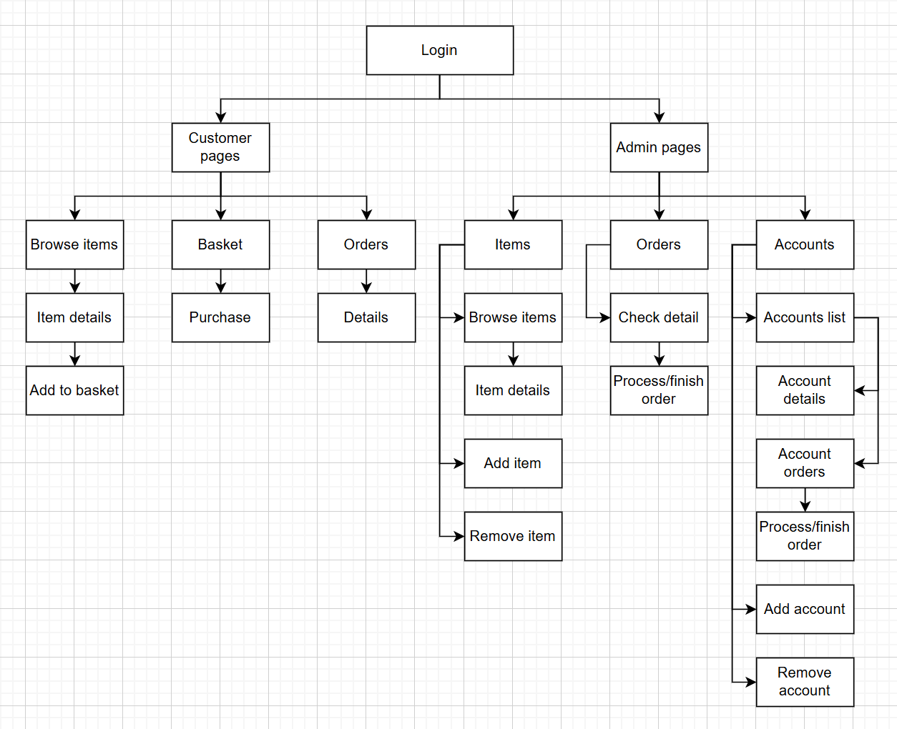

### Justification

Overall, the structure of the website has been carefully designed to break the system down into manageable parts, making development more organised and efficient. The top-down design allows the overall functionality of the site to be split into smaller, individual problems that are easier to solve with computational methods. Each section of the site is clearly defined, meaning that the development process can focus on one area at a time, which improves clarity, planning, and testing.

The first point of interaction for any user will be the login page. From here, the system will recognise whether the user is a customer or an admin, and redirect them to their appropriate pages. This ensures the content and features available to each type of user are tailored to their needs. The separation between customer and admin pages makes it easier to manage access rights and streamline user experiences, while also simplifying the backend logic.

The customer area is designed with user experience as the priority. It is broken down into logical sections such as browsing items, managing the basket, and viewing orders. These pages are closely connected and follow a typical shopping flow, starting from browsing, moving to item details, and then allowing the user to add products to their basket. Once items are added, the basket page allows for final review before completing a purchase. Customers can also view their previous orders in the orders section. This clear breakdown mirrors how real users interact with online shopping websites and allows each function to be developed as a separate module, making the site more reliable and easier to maintain.

The admin side of the site includes pages that give staff control over the items available, order processing, and account management. For example, they can add or remove items from the system, check details of current orders and process them, or view and manage customer accounts. By separating these into individual components, each part can be programmed, tested, and maintained independently. This also means that more advanced features, such as analytics or filters, could be added later without needing to rewrite large parts of the system.

By using a top-down design, the website becomes more logical and efficient to develop. Every page has a clear purpose and fits into the wider structure, making it easier to identify what needs to be done and how users will interact with the system. The diagram not only helps guide development but also ensures that the website is functional, well-organised, and ready to be implemented through code.

## A diagram of a computer AI-generated content may be incorrect.Entity Relationship Diagram

## Tables of database

TblUsers:

|  |  |  |  |  |
| --- | --- | --- | --- | --- |
| Field Name | Data Type | Validation | Typical Data | Justification |
| UserID | INT(4) UNSIGNED AUTO_INCREMENT PRIMARY KEY | Auto-generated | 1 | Unique identifier for each user |
| Firstname | VARCHAR(30) | Required | Nick | Used for identification |
| Lastname | VARCHAR(30) | Required | Cheepchiewcharnchai | Used for identification |
| Username | VARCHAR(40) | Required | Cheepchiewcharnch.k | Used for login |
| Password | VARCHAR(250) | Required | N780EV$%&n709y34 | Stored as a hashed value for security |
| Authority | TINYINT(1) | Required | 0 | Controls access level between customer and admin pages |

TblItems:

|  |  |  |  |  |
| --- | --- | --- | --- | --- |
| Field Name | Data Type | Validation | Typical Data | Justification |
| ItemID | INT(4) UNSIGNED AUTO_INCREMENT PRIMARY KEY | Auto-generated | 9 | Unique identifier for each item |
| ItemName | VARCHAR(30) | Required | T-shirt | Shown to users when browsing items |
| ItemDescription | VARCHAR(500) |  | A comfortable cotton t-shirt | Helps customers decide what to buy |
| ItemType | VARCHAR(1) | Required | T | Allows for filtering system |
| ItemCost | DECIMAL(5,2) | Required | 19.99 | Cost with up to 2 decimal places for currency accuracy |
| PicFront | VARCHAR(255) | Required | Picfront-1.jpg | For displaying the front image of the product |
| PicBack | VARCHAR(255) | Required | Picback-1.jpg | For displaying the back image of the product |

TblBaskets:

|  |  |  |  |  |
| --- | --- | --- | --- | --- |
| Field Name | Data Type | Validation | Typical Data | Justification |
| BasketID | INT(4) UNSIGNED AUTO_INCREMENT PRIMARY KEY | Auto-generated | 45 | Unique identifier for each basket |
| UserID | INT(4) UNSIGNED FOREIGN KEY |  | 1 | Links the basket to a specific user |
| IsOrdered | TINYINT(1) | Auto-generated | 0 | Tracks whether the basket has been converted into an order, default = 0 |

TblBasketItems:

|  |  |  |  |  |
| --- | --- | --- | --- | --- |
| Field Name | Data Type | Validation | Typical Data | Justification |
| BasketID | INT(4) UNSIGNED AUTO_INCREMENT PRIMARY KEY | Auto-generated | 26 | Unique identifier |
| BasketID | INT(4) UNSIGNED FOREIGN KEY |  | 25 | Identifies the basket |
| ItemID | INT(4) UNSIGNED FOREIGN KEY |  | 1 | Identifies a product in the basket |
| ItemSize | VARCHAR(3) | Required | XXL | Clothing size variation for purchase |
| Quantity | INT(1) | Required | 2 | Controls how many of the same item are bought |

TblOrders:

|  |  |  |  |  |
| --- | --- | --- | --- | --- |
| Field Name | Data Type | Validation | Typical Data | Justification |
| OrderID | INT(4) UNSIGNED AUTO_INCREMENT PRIMARY KEY | Auto-generated | 2 | Unique identifier for each order |
| UserID | INT(4) UNSIGNED FOREIGN KEY |  | 4 | Links the order to a customer |
| BasketID | INT(4) UNSIGNED FOREIGN KEY |  | 83 | Links the order to a basket |
| Status | VARCHAR(11) | Auto-generated | Unprocessed | Used to track the stage of the order |
| TotalCost | DECIMAL(6,2) |  | 2858.53 | Total price for the order’s contents, for ease of calculations |

## Page Design

### A login screen with black and white text AI-generated content may be incorrect.Login page

#### Usability Features:

* Users will be able to log in to their accounts by entering the correct username and password.
* The login system is straightforward, requiring only a username and password, which makes the process quick and user-friendly.
* If incorrect login details are provided, an appropriate error message is displayed to inform the user.
* Upon successful login, users are automatically redirected to the correct homepage based on their account type (e.g. admin or customer).

#### Data Structure and Variables:

Tables:

TblUsers - checking entered details against saved details

Variables:

Username – required for login

Password – required for login

Validation:

Refer to tables of database

#### Algorithm:

If enteredUsername == Username and enteredPassword == Password

LoggedIn = True

If authority == 0

Branch to customer home page

Else

Branch to admin homepage

Else

Print(“Incorrect email or password”)

**Justification**: This algorithm will be necessary to check the credentials that the user enters, as well as updating the session variable and directing the user to the correct home page.

#### Test Data:

Refer to post development data

### A screenshot of a web page AI-generated content may be incorrect.Generic Browse page

#### Usability Features:

* A fixed navigation bar at the top of the page provides users with a consistent and familiar interface, making it easy to navigate across different sections of the website.
* A search bar, along with dropdown menus for category filters and sorting options, helps users quickly find the items they are looking for.
* Each item is displayed with an image, name, and cost, allowing customers to easily identify products and understand what they are purchasing.
* Users can click on any item to be redirected to a dedicated item details page, where they can view more information before making a purchase decision.

#### Data Structure and Variables:

Tables:

TblItems – To display items and their details on the page

Variables:

LoggedIn – Session variable. If set to true, then user is logged in

Search – If user searches for an item using the search bar, this variable is updated

SelectedCategory – If user chooses a category for an item, this variable is updated

Validation:

Refer to tables of database

#### Algorithm:

Search Algorithm:

If user searches for item

Search = input()

Display Image, Itemname, Cost from Items where Itemname == Search

Filter Algorithm:

If user selects category

selectedCategory = select input(Tops, Bottoms, etc.)

Display Image, Itemname, Cost from Items where Category == SelectedCategory

Sort Algorithm:

If user selects sort

Sort = select input(price, name, etc.)

Order = input(ascending/descending)

Display Image, Itemname, Cost from Items OrderBy Sort Order

**Justification**: These algorithms will allow users to find the items that they want quickly and with ease

Item details Algorithm:

onClick Item

Go to item details page

**Justification**: this algorithm will be necessary for allowing users to see the item in more detail and will also allow them to add the item to their basket (for customers)

#### Test Data:

Refer to post development data

### A screenshot of a computer AI-generated content may be incorrect.Generic Item Details page

#### Usability Features:

* A fixed navigation bar at the top of the page provides users with a consistent and familiar interface, making it easy to navigate across different sections of the website.
* Enlarged images of the front and back of the item, so that the user can see the item better.
* All details of the item to inform the user of the item’s details.
* User required to choose a size and a quantity.
* User can add the item to their basket by clicking the ‘Add to Basket’ button. (customer)

#### Data Structure and Variables:

Tables:

TblItems – To display items and their details on the page

TblBaskets – To add item into their the basket

TblBasketItems – To add item into their the basket

Variables:

LoggedIn – Session variable. If set to true, then user is logged in

ItemID – Content details on this page will depend on the ItemID

SelectedSize – If user chooses a size for the item, this variable is updated

SelectedQuantity – If user chooses a quantity for an item, this variable is updated (default 1)

Validation:

Refer to tables of database

#### Algorithm:

Select Size:

If user selects size

SelectedSize = select input(XXS, XS, etc.)

Select Quantity:

If user selects size

SelectedQuantity = select input(1, 2, etc.)

Add to basket (customer):

onClick AddToBasket

If SelectedSize != null

add item, quantity, size to basket

else

show message to select size for item

**Justification**: A size and a quantity must be selected before the item is allowed to be added to the basket, to prevent errors in the system.

#### Test Data:

Refer to post development data

### A screenshot of a computer AI-generated content may be incorrect.Generic Basket page

#### Usability Features:

* A fixed navigation bar at the top of the page provides users with a consistent and familiar interface, making it easy to navigate across different sections of the website.
* Added items are displayed in a list format, each item showing an image, name, cost, total cost, size, quantity.
* A cancel button on each item to get rid of it from their basket. (customer)
* A total cost of the entire basket is displayed at the bottom to allow users to see how much money will be paid.
* A confirm purchase button, which will convert the basket into an order before clearing the basket for the new one. (customer)
* A process button, which will change the status of the order to the next. (admin)

#### Data Structure and Variables:

Tables:

TblItems – To display correct items and their details on the page

TblBaskets – To display correct items and their details on the page

TblBasketItems – To display correct items and their details on the page

TblOrders – To convert the basket into an order

Variables:

LoggedIn – Session variable. If set to true, then user is logged in

Total – Session variable, to sum up total cost of basket

BasketID – will be used to create an order

OrderID – will be used to create an order

Validation:

Refer to tables of database

#### Algorithm:

Calculate total:

Total = 0

For each item

Total = Total + (Itemcost * Quantity)

Return Total

**Justification**: This algorithm allows customers to know how much they will be spending and admins to see how much the customer needs to pay.

Cancel item (customer):

Delete item from basket

Recalculate Total

**Justification**: This algorithm will get rid of an item from the basket, then recalculate total to make sure that the displayed total is correct.

Confirm purchase (customer):

onClick ConfirmPurchase

Create Order with BasketID and Total

**Justification**: This algorithm will be used to send the order details to the database, ready to be processed.

Process order (admin):

onClick Process

update order status (to processed or finished)

**Justification**: This algorithm will be used to process orders of customers, allowing them to see how far along, their order is.

#### Test Data:

Refer to post development data

### A screenshot of a computer AI-generated content may be incorrect.Purchases page

#### Usability Features:

* A fixed navigation bar at the top of the page provides users with a consistent and familiar interface, making it easy to navigate across different sections of the website.
* Display of all orders in each status.
* Unprocessed orders can be cancelled.
* On click, bring to order details page, which the generic basket page layout but no purchase button. Instead, the button will be to cancel or none at all.

#### Data Structure and Variables:

Tables:

TblOrders – To display orders and into the correct status

Variables:

LoggedIn – Session variable. If set to true, then user is logged in

OrderID – Used to delete correct order

Validation:

Refer to tables of database

#### Algorithm:

Cancel order:

Delete Order from database using OrderID

**Justification**: This algorithm will get delete any order from the database, in a case where the customer made a mistake or changes their mind.

#### Test Data:

Refer to post development data

### A screenshot of a computer AI-generated content may be incorrect.Admin homepage

#### Usability Features:

* A fixed navigation bar at the top of the page provides users with a consistent and familiar interface, making it easy to navigate across different sections of the website.
* Links to different managing sections pages.

#### Data Structure and Variables:

Tables:

None

Variables:

LoggedIn – Session variable. If set to true, then user is logged in

Validation:

Refer to tables of database

#### Algorithm:

-

**Justification**: -

#### Test Data:

Refer to post development data

### A screenshot of a computer AI-generated content may be incorrect.Items page

#### Usability Features:

* A fixed navigation bar at the top of the page provides users with a consistent and familiar interface, making it easy to navigate across different sections of the website.
* Links to different item management pages (item list page will use the generic browse page and generic item details page structure).

#### Data Structure and Variables:

Tables:

None

Variables:

LoggedIn – Session variable. If set to true, then user is logged in

Validation:

Refer to tables of database

#### Algorithm:

-

**Justification**: -

#### Test Data:

Refer to post development data

### A screenshot of a computer AI-generated content may be incorrect.Add Item page

#### Usability Features:

* A fixed navigation bar at the top of the page provides users with a consistent and familiar interface, making it easy to navigate across different sections of the website.
* A form for the admin to add details of a new item to be added onto the database. Form consists of item name, cost, description, category (to be selected from a drop down list) and 2 images (front and back).

#### Data Structure and Variables:

Tables:

TblItems – To add data of the new item to the database

Variables:

LoggedIn – Session variable. If set to true, then user is logged in

InputData – Itemname, Itemcost, Itemdescription, Itemtype, Picfront, Picback

Validation:

Refer to tables of database

#### Algorithm:

Adding new item:

onClick AddItem

Insert InputData into database

**Justification**: This algorithm will handle the submitting of data into the database, adding a new item to the item list.

#### Test Data:

Refer to post development data

### A screenshot of a computer AI-generated content may be incorrect.Remove item page

#### Usability Features:

* A fixed navigation bar at the top of the page provides users with a consistent and familiar interface, making it easy to navigate across different sections of the website.
* A copy of the generic browse page, however each item has a remove button on them, on click the item will be deleted form the database.
* Clicking on the item will bring the admin to a remove item details page (look at generic item details page with a delete button instead of an add to basket button).

#### Data Structure and Variables:

Tables:

TblItems – To remove data of the item from the database

Variables:

LoggedIn – Session variable. If set to true, then user is logged in

InputID – ItemID of the chosen item

Validation:

Refer to tables of database

#### Algorithm:

Removing item:

onClick RemoveItem

Delete Item from TblItems where ItemID == InputID

**Justification**: This algorithm will allow the admins to delete items from the database, which will be helpful when an item is being discontinued or if there had been an input mistake when adding the item.

#### Test Data:

Refer to post development data

### A screenshot of a computer AI-generated content may be incorrect.Orders page

#### Usability Features:

* A fixed navigation bar at the top of the page provides users with a consistent and familiar interface, making it easy to navigate across different sections of the website.
* Links to different orders pages for each order status.

#### Data Structure and Variables:

Tables:

None

Variables:

LoggedIn – Session variable. If set to true, then user is logged in

Validation:

Refer to tables of database

#### Algorithm:

-

**Justification**: -

#### Test Data:

Refer to post development data

### A screenshot of a computer AI-generated content may be incorrect.Generic Orders page

#### Usability Features:

* A fixed navigation bar at the top of the page provides users with a consistent and familiar interface, making it easy to navigate across different sections of the website.
* List of orders, linked labelled with name of customer who placed the order, when clicking on the link, redirects the admin to the order details page (which bill use the generic basket page).

#### Data Structure and Variables:

Tables:

TblOrders - To display correct orders onto the page

Variables:

LoggedIn – Session variable. If set to true, then user is logged in

Status – Orders on this page will depend on the Status of the order

Validation:

Refer to tables of database

#### Algorithm:

Showing correct orders:

Display all orders where Status == InputStatus

**Justification**: This algorithm will make the page only show orders in the correct status which will help admins find baskets quicker, by working on the same level of processing on different baskets without needing to find them one by one.

#### Test Data:

Refer to post development data

### A screenshot of a computer AI-generated content may be incorrect.Accounts page

#### Usability Features:

* A fixed navigation bar at the top of the page provides users with a consistent and familiar interface, making it easy to navigate across different sections of the website.
* Links to different account management pages.

#### Data Structure and Variables:

Tables:

None

Variables:

LoggedIn – Session variable. If set to true, then user is logged in

Validation:

Refer to tables of database

#### Algorithm:

-

**Justification**: -

#### Test Data:

Refer to post development data

### A screenshot of a computer AI-generated content may be incorrect.Accounts List page

#### Usability Features:

* A fixed navigation bar at the top of the page provides users with a consistent and familiar interface, making it easy to navigate across different sections of the website.
* List of all customer accounts displaying their full name, when clicked will redirect you to account detail page.

#### Data Structure and Variables:

Tables:

TblUsers – Used to display accounts onto the page

Variables:

LoggedIn – Session variable. If set to true, then user is logged in

Authority – To make sure that accounts on the list are only customer accounts

Validation:

Refer to tables of database

#### Algorithm:

Showing only customer accounts:

Display all accounts where Authority == 0

**Justification**: The account list will only display customer accounts since admins don’t have the ability to place orders and does not need to have their order processed. Limiting the list to customers ensures a cleaner, more focused interface for managing user-related tasks.

#### Test Data:

Refer to post development data

### A screenshot of a computer AI-generated content may be incorrect.Account Details page

#### Usability Features:

* A fixed navigation bar at the top of the page provides users with a consistent and familiar interface, making it easy to navigate across different sections of the website.
* Links to account info page for detail of customer
* Links to different specific account orders pages (Unprocessed, processed and completed orders will be the same as the generic order page).

#### Data Structure and Variables:

Tables:

TblUsers – Used to display accounts onto the page

Variables:

LoggedIn – Session variable. If set to true, then user is logged in

UserID – To show to correct account

Validation:

Refer to tables of database

#### Algorithm:

-

**Justification**: -

#### Test Data:

Refer to post development data

### A screenshot of a computer AI-generated content may be incorrect.Account Info page

#### Usability Features:

* A fixed navigation bar at the top of the page provides users with a consistent and familiar interface, making it easy to navigate across different sections of the website.
* Display of the user’s Firstname, Lastname, Username and Password.

#### Data Structure and Variables:

Tables:

TblUser

Variables:

LoggedIn – Session variable. If set to true, then user is logged in

UserID – The displayed details will depend on the UserID that taken from the account detail page

Validation:

Refer to tables of database

#### Algorithm:

Display correct details:

Select all from TblUsers where UserID == InputID

Display selected details

**Justification**: This algorithm will make sure than the displayed details are from the correct account

#### Test Data:

Refer to post development data

### A screenshot of a computer AI-generated content may be incorrect.Add Account page

#### Usability Features:

* A fixed navigation bar at the top of the page provides users with a consistent and familiar interface, making it easy to navigate across different sections of the website.
* A form for the admin to add details of a new account to be added onto the database. Form consists of Firstname, Lastname, Username, Password and Authority (to be selected from a radio type input).

#### Data Structure and Variables:

Tables:

TblUsers – To add data of the new account to the database

Variables:

LoggedIn – Session variable. If set to true, then user is logged in

InputData – Firstname, Lastname, Username, Password, Authority

Validation:

Refer to tables of database

#### Algorithm:

Adding new item:

onClick AddAccount

Insert InputData into database

**Justification**: This algorithm will handle the submitting of data into the database, adding a new account to the account list.

#### Test Data:

Refer to post development data

### A screenshot of a computer AI-generated content may be incorrect.Remove Account page

#### Usability Features:

* A fixed navigation bar at the top of the page provides users with a consistent and familiar interface, making it easy to navigate across different sections of the website.
* A copy of the accounts list page, however each account has a remove button on them, on click the item will be deleted form the database.
* Clicking on the item will bring the admin to a remove account info page (same as account info page but with a delete button at the bottom).

#### Data Structure and Variables:

Tables:

TblUsers – To remove data of the account from the database

Variables:

LoggedIn – Session variable. If set to true, then user is logged in

InputID – UserID of the chosen account

Validation:

Refer to tables of database

#### Algorithm:

Removing account:

onClick RemoveAccount

Delete Item from TblUsers where UserID == InputID

**Justification**: This algorithm will allow the admins to delete accounts from the database, which will be helpful whenever a student graduates and should no longer have access to the website or if there had been an input mistake when adding an account.

#### Test Data:

Refer to post development data

## Testing data

### Iterative Development Test Data

During my iterative development process, I will frequently need to add and remove data from the tables in my database. To facilitate this, I will create an install file that generates the necessary tables and populates them with default data. This will enable me to quickly reset the database by running the install file, ensuring I can conduct multiple tests without the concern of accumulating redundant data.

#### Customer Default Data

(To be created and inserted into relevant table by the install page)

UserID: 1

Firstname: Nick

Lastname: Cheepchiewcharnchai

Username: Cheepchiewcharnch.k

Password: 1234

Authority: 0

**Justification**: I chose to use my own details since I am used to them, allowing for straightforward and quick testing of customer-related functionality without introducing unnecessary complexity. It serves as a solid foundation for testing the most common user scenarios throughout iterative development.

#### Customer Input Test Data

During development, I will need to test that the add user system works correctly for customers.

FirstName: Will

Surname: Smith

Username: WS

Password: asd

**Justification**: This data will allow me to test the functionality of adding user system. Admins should be able to create accounts.

#### Admin Default Data

(To be created and inserted into relevant table by the install page)

UserID: 3

Firstname: Admin

Lastname: Install

Username: admin

Password: admin

Authority: 1

**Justification**: This data will allow me to test the overall usability of the admin content management system. I will use these credentials to log in and verify that user authorisation is functioning correctly.

#### Items Default Data

(To be created and inserted into relevant table by the install page)

|  |  |  |  |  |  |
| --- | --- | --- | --- | --- | --- |
| **ItemID** | 1 | 2 | 3 | 4 | 5 |
| **Itemname** | Item 1 | Item 2 | Item 3 | Item 4 | Item 5 |
| **Itemdescription** | The first item | The second item | The third item | The fourth item | The fifth item |
| **Itemtype** | T | T | B | A | O |
| **Itemcost** | 10.00 | 25.00 | 50.00 | 100.00 | 199.99 |
| **Picfront** | 1-front.jpg | 2-front.jpg | 3-front.jpg | 4-front.jpg | 5-front.jpg |
| **Picback** | 1-back.jpg | 2-back.jpg | 3-back.jpg | 4-back.jpg | 5-back.jpg |

**Justification:**

As I have not been given details of the specific items that the house want to sell, I will be limited to these items. This will allow me to test both the customer and management features.

For customers, the items will need to be displayed in a suitable format on a page that will allow them to browse the available items. This includes the images for each item, as well as their price and a description. Users should also be able to search the items by name, filter the items by category, and sort the items, either by alphabetical or price order. This will enable users to quickly find the items that they are looking for.

For admin users, these items will allow me to test essential content management features such as adding new products, editing existing details, and removing items from the database.

#### Items Input Data

Itemname: Item 6

Itemdescription: The sixth item

Itemtype: O

Itemcost: 5.00

Picfront: 6-front.jpg

Picback : 6-back.jpg

**Justification**: These data will be used on the item management page on the admin system to test that admin can add items. The data should be inputted into a form and then be displayed on the customer items page.

### Post Development Test Data

#### Login page

Customer:

Correct Username: cheepchiewcharnch.k

Correct Password: 1234

Admin:

Correct Username: admin

Correct Password: admin

Both:

Incorrect Username: Cheep

Incorrect Password: ABCD

**Justification:** This data will enable me to test the functionality and robustness of the login system. It allows for validation of both successful and unsuccessful login attempts. When correct credentials are provided, the system should authenticate the user and redirect them to their appropriate homepage. Conversely, incorrect login attempts should result in a clear and informative error message, ensuring that the system handles authentication securely and effectively.

#### Generic Browse page

The page where available items are displayed will be one of the most important pages of the website. Therefore, I will need to conduct several tests to ensure all expected functionalities are met.

To begin with, I will need to test that all available items and their relevant details are displayed correctly. For this, I will simply use the default data that will be created by my install file:

|  |  |  |  |  |  |
| --- | --- | --- | --- | --- | --- |
| **ItemID** | 1 | 2 | 3 | 4 | 5 |
| **Itemname** | Item 1 | Item 2 | Item 3 | Item 4 | Item 5 |
| **Itemdescription** | The first item | The second item | The third item | The fourth item | The fifth item |
| **Itemtype** | T | T | B | A | O |
| **Itemcost** | 10.00 | 25.00 | 50.00 | 100.00 | 199.99 |
| **Picfront** | 1-front.jpg | 2-front.jpg | 3-front.jpg | 4-front.jpg | 5-front.jpg |
| **Picback** | 1-back.jpg | 2-back.jpg | 3-back.jpg | 4-back.jpg | 5-back.jpg |

**Justification**: This page will serve as the main area for customers to browse available items, so the layout must be clear, user-friendly, and visually appealing. Displaying the items in a structured grid format, styled using Bootstrap, will ensure consistency and responsiveness across different devices. This approach enhances usability by making it easier for customers to view product details such as images, prices, and descriptions at a glance.

#### Searching, Filtering and Sorting

Search: Item 1

Filter: Tops

Order: Ascending prices

**Justification:** This data will be used as input to test the search, filter, and sort functionalities on the item browsing page. By including a variety of item names, categories, and prices, I will be able to verify that users can effectively search for specific items and then refine their results using sorting and filtering options. This ensures the system supports efficient navigation and helps users quickly locate the products they are interested in.

#### Generic Item details page

ItemID: 1

**Justification**: When a user clicks on an item, they should be redirected to a dedicated item details page. This page should display more in-depth information about the selected item, such as a larger image, full description, available sizes, and price. This allows users to make more informed purchasing decisions and ensures that the system correctly handles item selection and data retrieval based on the ItemID.

#### Adding items to the basket (customer)

ItemID: 1 (default data)

Itemsize: XXL (input data)

Quantity: 2 (input data)

**Justification**: This data will allow me to test the functionality of adding items to a user's basket by specifying both the item size and quantity. By varying the size and quantity inputs, I can confirm that the system correctly handles different combinations and accurately updates the user's basket with the appropriate details.

#### Generic Basket page

Users should be able to view the items that they have added to their basket.

|  |  |  |  |
| --- | --- | --- | --- |
| **ItemID** | 1 | 2 | 5 |
| **Itemname** | Item 1 | Item 2 | Item 5 |
| **Itemcost** | 10.00 | 25.00 | 199.99 |
| **Itemsize** | M | XL | XXL |
| **Quantity** | 2 | 1 | 1 |

**Justification**: I will use abstraction for the items in the basket, only displaying the necessary details of each item (name, price and quantity). This will make the page look much more simplistic and easier for customers to view.

#### Total price of each item in the basket

|  |  |  |  |
| --- | --- | --- | --- |
| **Itemcost** | 10.00 | 25.00 | 199.99 |
| **Quantity** | 2 | 1 | 1 |

**Justification**: The total price for each item should be calculated by multiplying the item’s price and to it’s quantity.

#### Total price of all basket

|  |  |  |  |
| --- | --- | --- | --- |
| **Itemcost** | 10.00 | 25.00 | 199.99 |
| **Quantity** | 2 | 1 | 1 |

**Justification**: The total price for the should be calculated by multiplying the item’s price and to it’s quantity, I will be doing this by using a session to add the total price of each items to the session every time it is calculated. This will allow customer users to know the total price of their order without having to calculate it manually.

#### Cancel Items (customer)

|  |  |
| --- | --- |
| **ItemID** | 5 |
| **UserID (default data)** | 1 |

**Justification**: If a user decides that they no longer want to purchase an item, they should be able to cancel the item. I will use the ItemID to find which item to cancel and the UserID to find the correct basket to delete from.

#### Confirm purchase (customer)

UserID: 1 (default data)

**Justification**: The items in the UserID will be used to find the user’s basket and summit and it as an order.

#### Purchases page (customer)

Users should be able to see all of the baskets that they have ordered:

UserID: 1 (default data)

**Justification**: The UserID (stored as session when logging in) will be used to display all of the baskets that belongs to the user.

#### Purchases Details page (customer)

Users should be able to see the contents in a basket that they have ordered:

BasketID: 1 (default data)

**Justification**: The BasketID will be used to display all contents in the basket.

#### Add Item page (admin)

Itemname: Item 6

Itemdescription: The sixth item

Itemtype: O

Itemcost: 5.00

Picfront: 6-front.jpg

Picback : 6-back.jpg

**Justification**: These data will be used on the add item page on the admin system to test that admin users are able to add items. The data should be inputted into a form and then be displayed on the customer items page.

#### Remove Item page (admin)

ItemID: 6 (default data)

**Justification**: This data will be used on the remove item page on the admin system to test that admin users are able to remove items. The ItemID will be used to delete the item from the database.

#### Generic Orders page (admin)

Status: Unprocessed

**Justification**: This data will be used to search for all unprocessed orders from TblOrders.

#### Generic Order Details page (admin)

BasketID: 1

**Justification**: The BasketID will be used to find and display the contents of the basket.

#### Processing Order (admin)

BasketID: 1

**Justification**: The BasketID from the page will be used to find the order in the database, so the status of the order may be changed.

#### Accounts List page (admin)

Authority: 0

**Justification**: The Authority will be used to find all customer accounts from Tblusers to be displayed on this page.

#### Account Details page (admin)

UserID: 1

Firstname: Nick

Lastname: Cheepchiewcharnchai

**Justification**: The UserID will be used to find the account from Tblusers, the firstname and lastname will be displayed on this page.

#### Account Info page (admin)

UserID: 1

Firstname: Nick

Lastname: Cheepchiewcharnchai

Username: cheepchiewcharnch.k

Password: 1234

**Justification**: The UserID will be used to find the account from Tblusers, the firstname, lastname, username and password will be displayed on this page.

#### Add Account page (admin)

Firstname: Test

Lastname: User

Username: TestUser

Password: 5678

Authority: 0

**Justification**: These data will be used on the add accounts page on the admin system to test that admin users are able to add new accounts.

#### Remove Account page (admin)

UserID: 2

**Justification**: This data will be used on the remove account page on the admin system to test that admin users are able to remove accounts. The UserID will be used to delete the account from the database.

## Usability Testing Plan

To evaluate the effectiveness of my solution, the stakeholders will be invited to interact with the completed system by performing typical tasks—such as customers placing orders and administrators managing processing orders. Additionally, each user will have 10 minutes to freely explore the system.

Following their interaction, users will be asked to complete feedback forms designed to assess the system’s usability. A general questionnaire will be provided to all participants, while more targeted questionnaires will be given to each stakeholder (customer and administrator) to gather insights specific to their experiences.

Users will rate their level of agreement with various statements using a scale from 1 to 10, where 1 means “Strongly Disagree” and 10 means “Strongly Agree.” Space will also be provided for written comments.

### General Questionnaire

(To be asked to all users)

|  |  |  |
| --- | --- | --- |
| No. | Statement | Score (1-10)  1: Strongly Disagree  10: Strongly Agree |
| 1 | I am satisfied with how easy it is to use this system |  |
| 2 | I was able to complete my tasks quickly using the system |  |
| 3 | I felt comfortable using the system |  |
| 4 | It was easy to learn to use this system |  |
| 5 | The interface of the system was visually attractive |  |
| 6 | The system has all the functions and capabilities I expected |  |
| 7 | I am satisfied with this system overall |  |

### Customer Questionnaire

(To be asked to customer stakeholder only)

|  |  |  |
| --- | --- | --- |
| No. | Statement | Score (1-10)  1: Strongly Disagree  10: Strongly Agree |
| 1 | It was easy to log into my account |  |
| 2 | The top navigation bar helped me navigate the website |  |
| 3 | I could quickly find and choose the items I needed |  |
| 4 | The basket page was easy to locate and order |  |
| 5 | I could see all the necessary details about my order |  |

### Admin Questionnaire

(To be asked to admin/management users only)

|  |  |  |
| --- | --- | --- |
| No. | Statement | Score (1-10)  1: Strongly Disagree  10: Strongly Agree |
| 1 | It was easy to log into my account |  |
| 2 | The top navigation bar helped me navigate the website |  |
| 3 | It was easy to manage items (view, add, remove) |  |
| 4 | It was easy to manage orders through each status (view, process) |  |
| 5 | It was easy to manage accounts (view, add, remove) |  |
| 6 | It was easy to manage orders through specific accounts (view, process) |  |

# Development

## Setup

### Connection.php

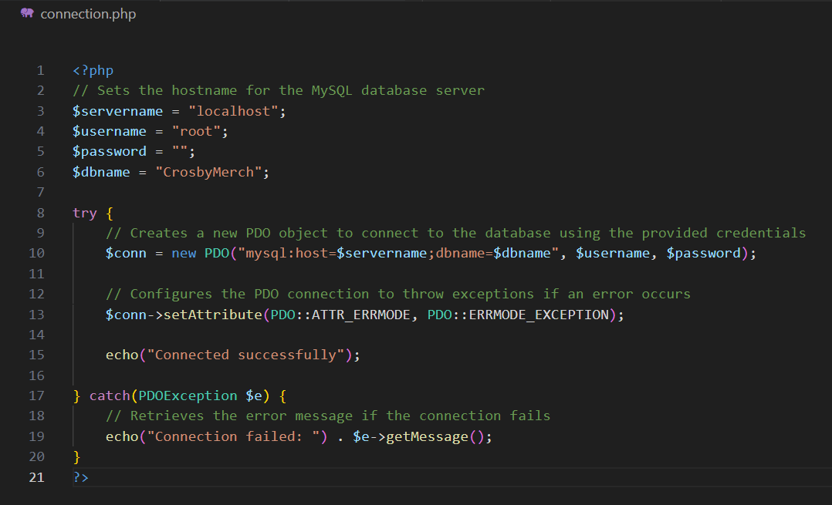To enable the rest of my code to interact with the database, I will first create a dedicated PHP page responsible for establishing a connection. This connection page will act as a central point that other scripts can include whenever they require database access. By using this approach, I ensure consistency and avoid repeating the connection code in multiple places, making the project more organized and easier to maintain.

I chose to name the website “CrosbyMerch” since this website is for the Crosby house.

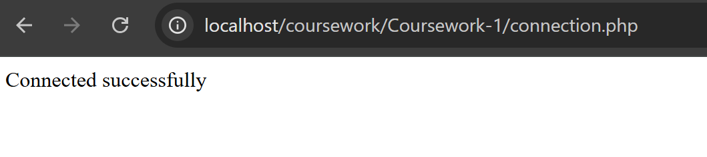When I run the code, it displays a confirmation message indicating that the connection has been successfully established. This confirms that the connection file is functioning correctly and is able to access the database without any issues.

## Creating Tables

### Install.php

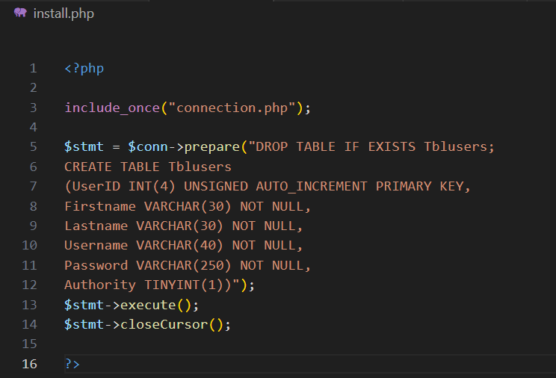I started by writing SQL code to create a single table in the database. This allowed me to ensure the structure and syntax were correct before replicating the approach to create the remaining tables. Starting with one table helps confirm that the setup works as expected before expanding further.

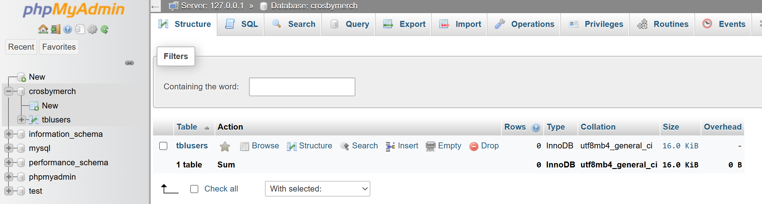This code has successfully created my TblUsers, which will store user accounts details.

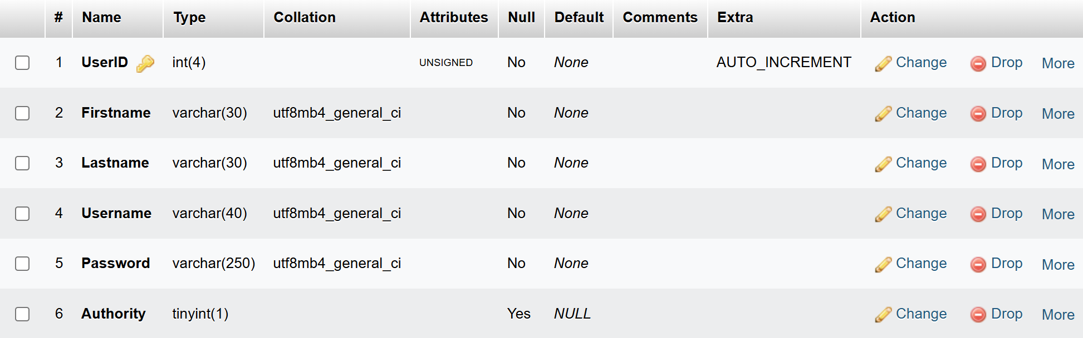

Once I am sure that my table was correct, I wrote code to insert the test accounts into the table.

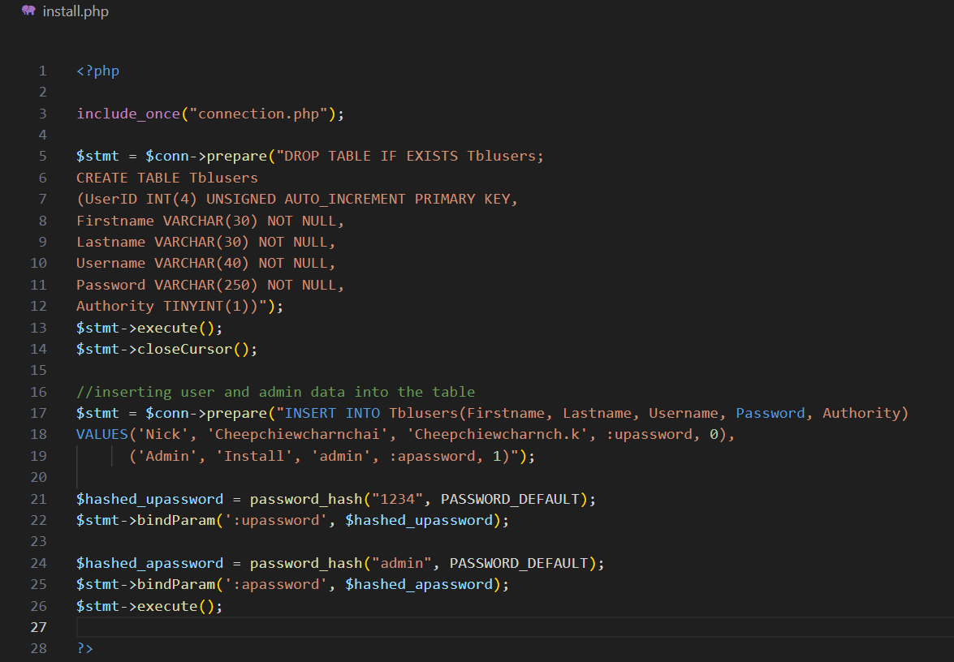 This code has successfully added the two accounts into the table, one customer and one admin.

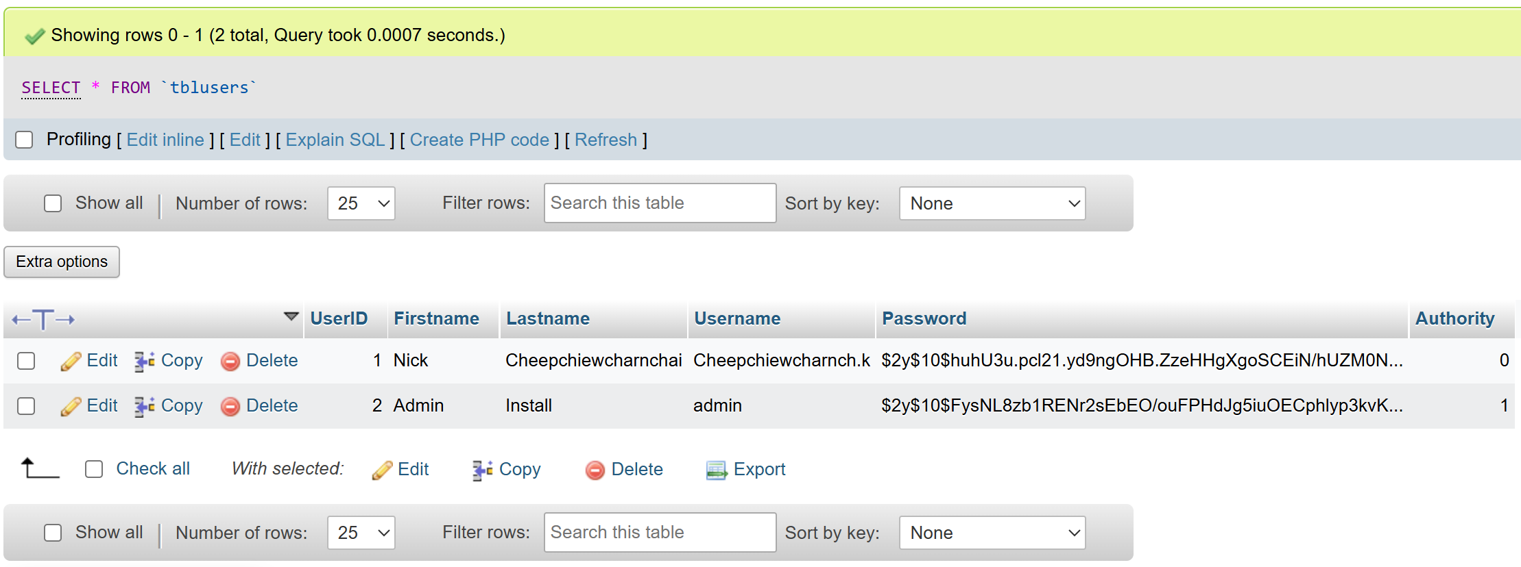

Now that I know how to set up a table an insert test data into them, I will create the rest of the tables in the came manner.

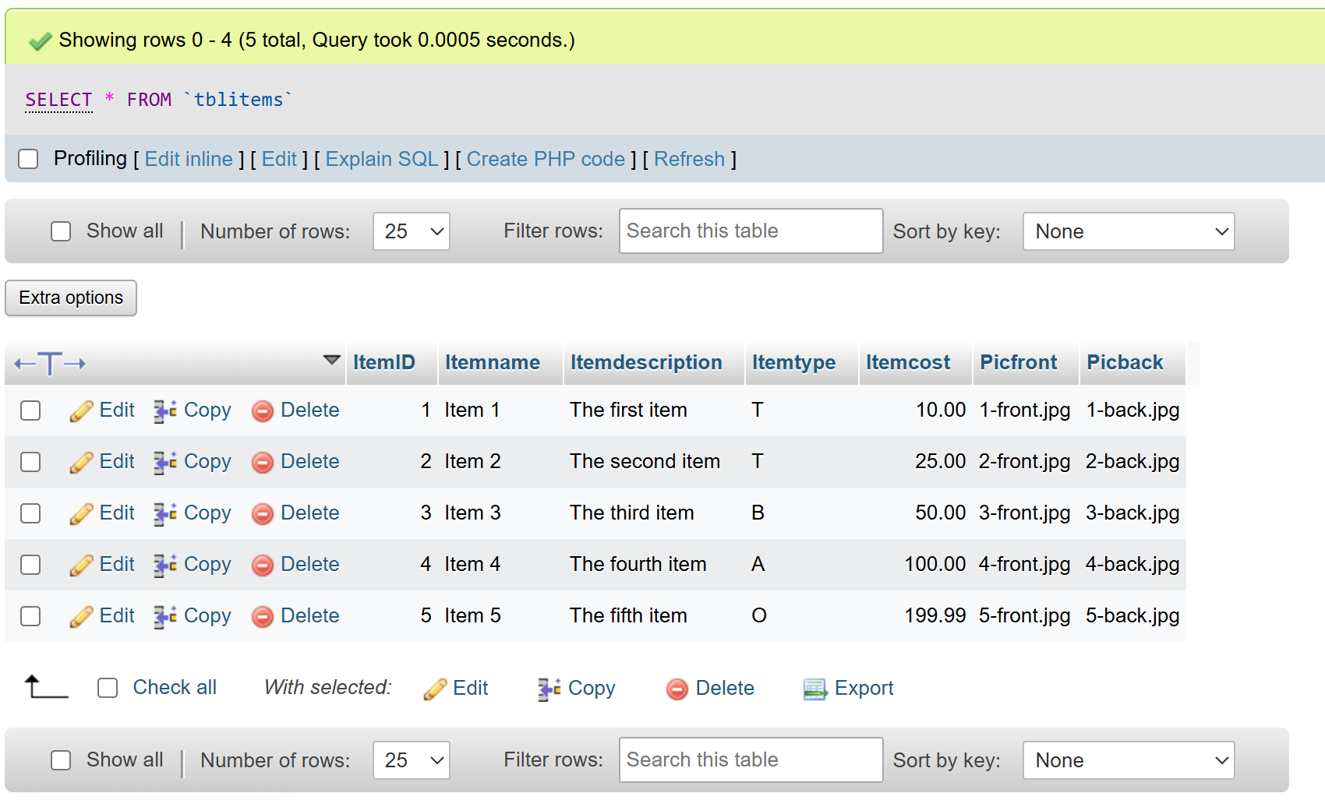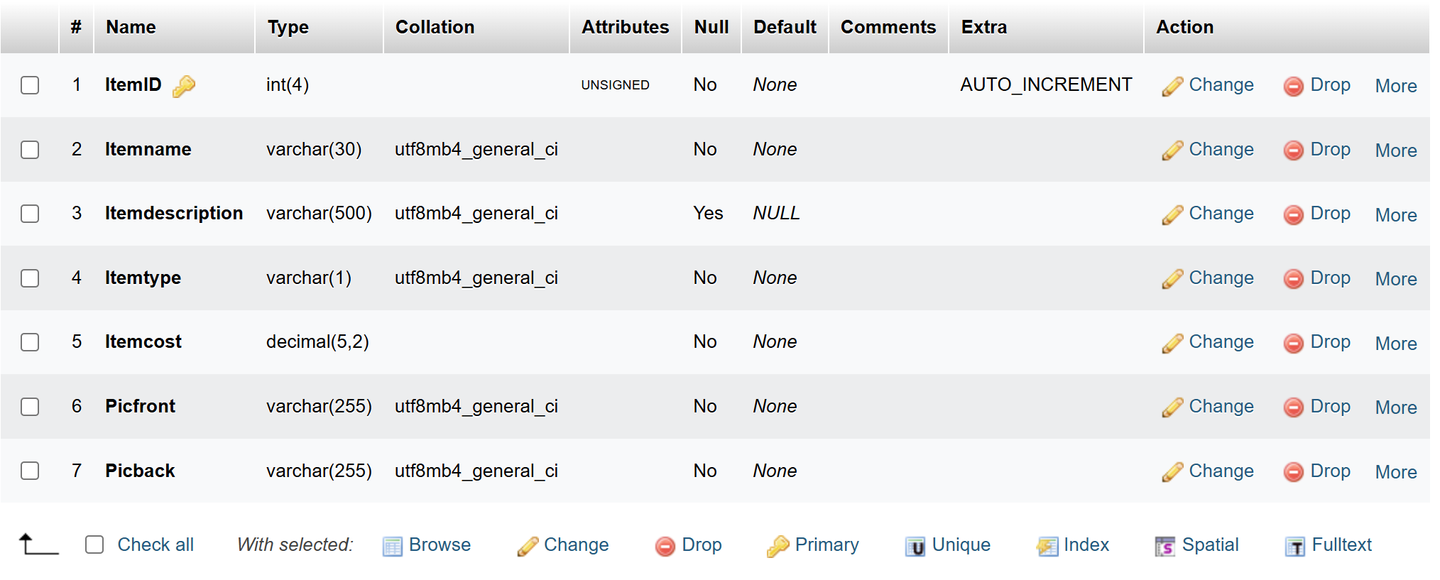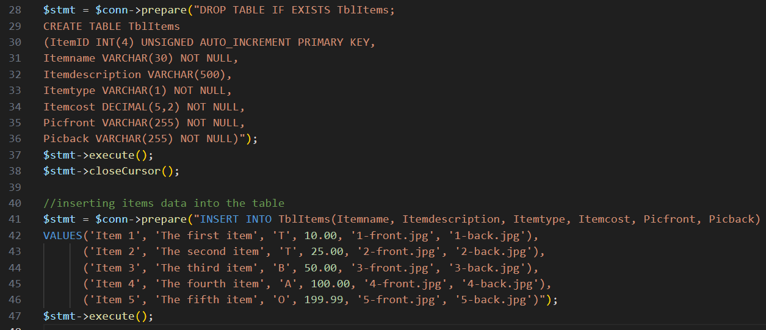This code has successfully created TblItems and added the five items into the table.

This code has successfully created TblBaskets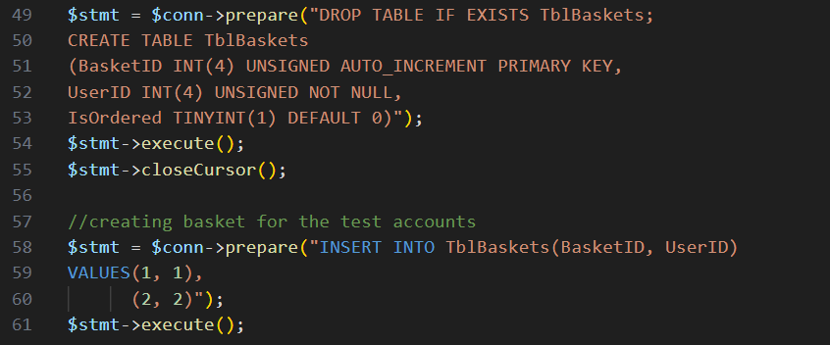, I also added baskets for each account so that I can do some testing with them later on.

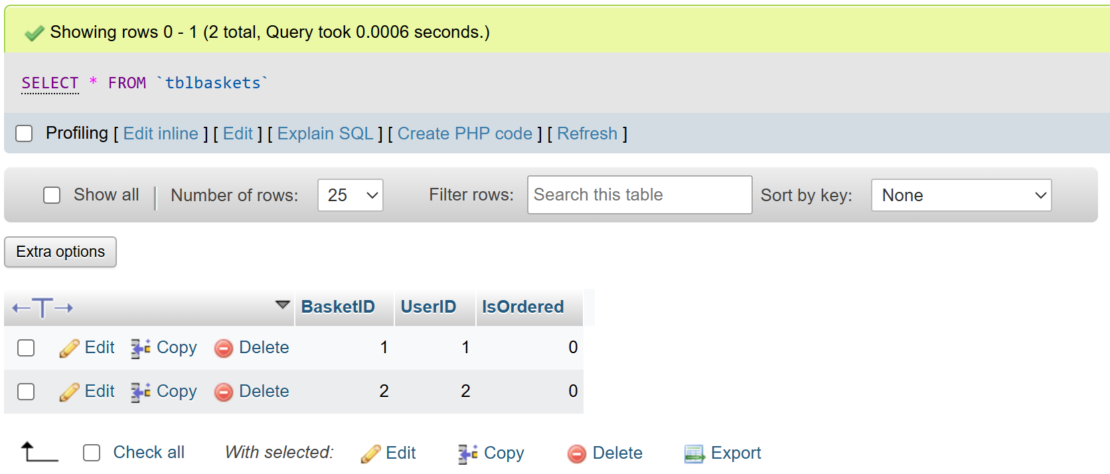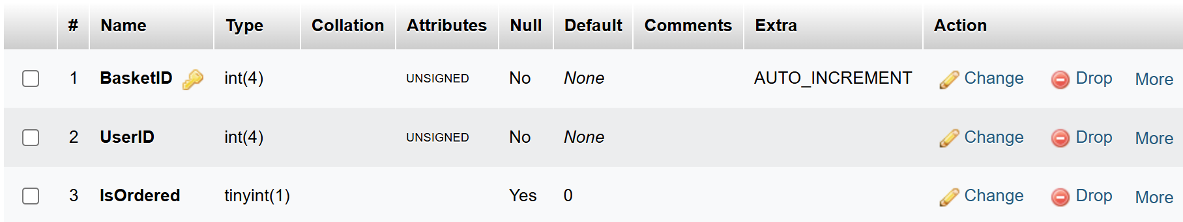

.

This code has successfully created TblBaskets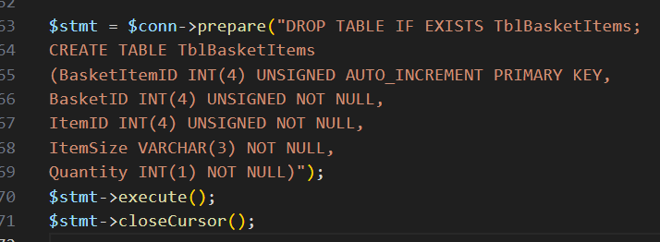Items.

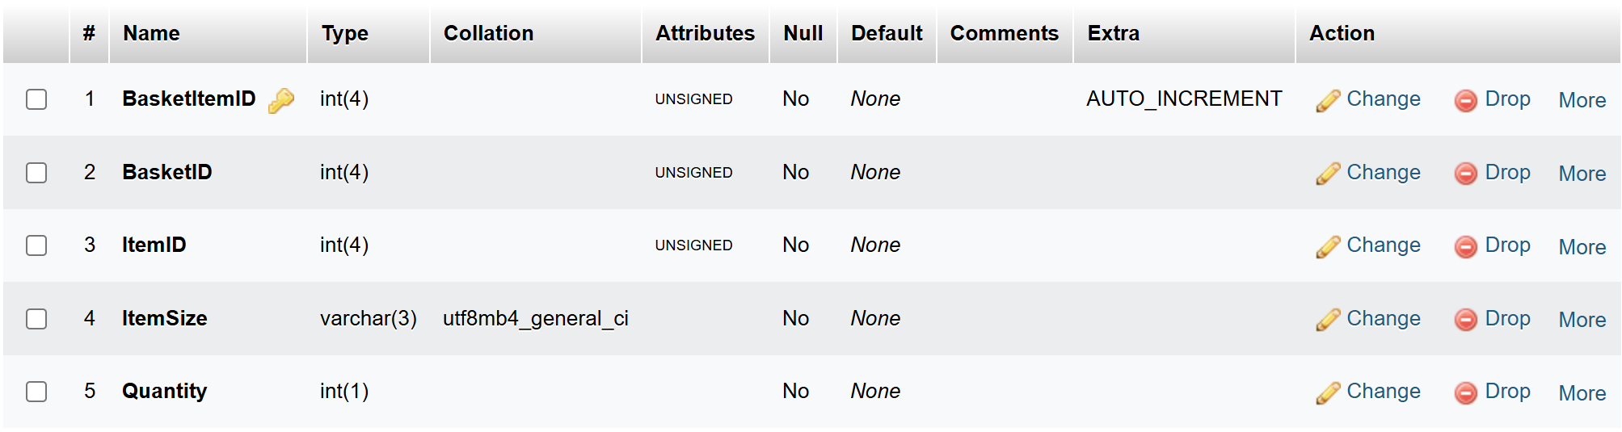

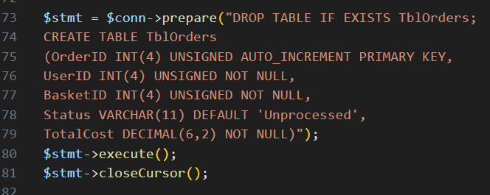

This code has successfully created TblOrders

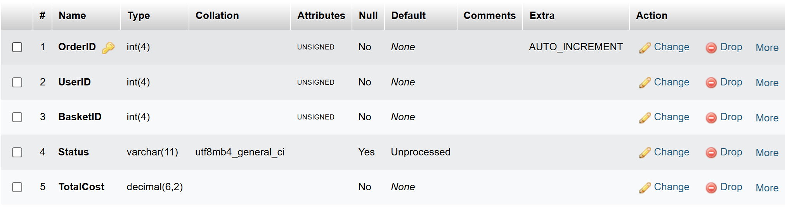With this I have completed my install.php page.

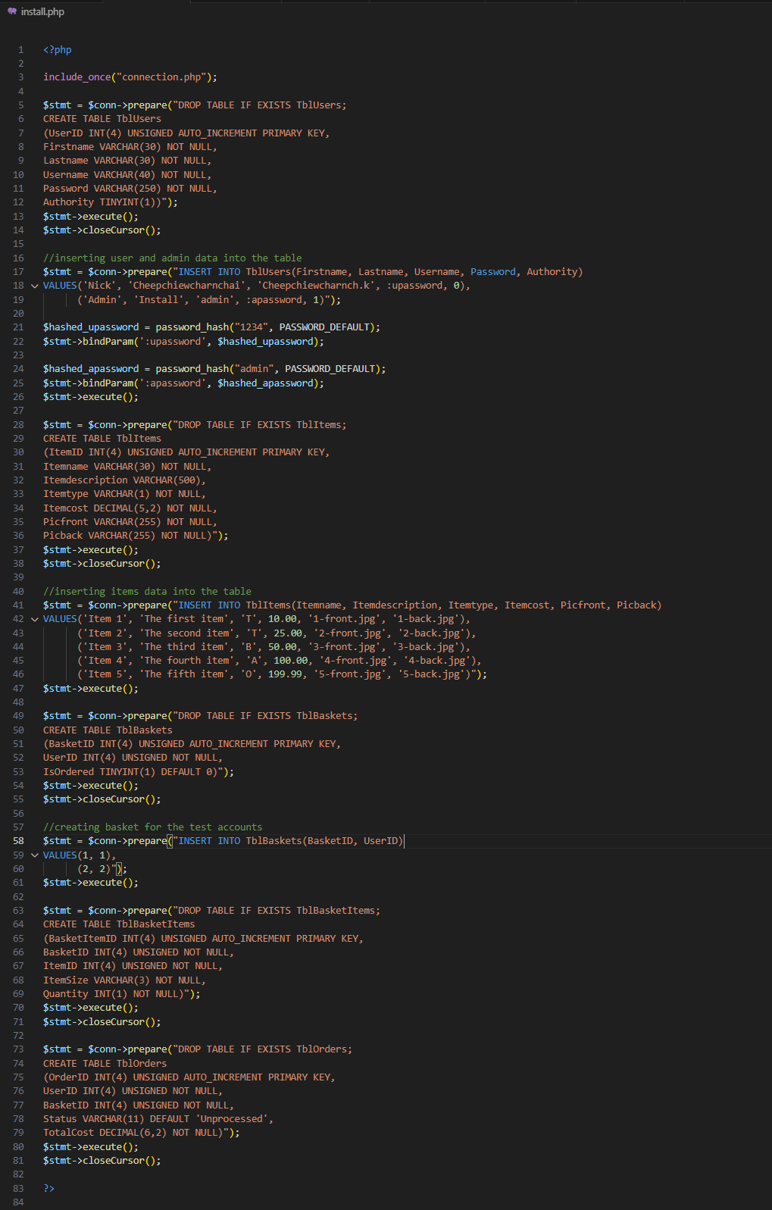 Final Annotated Code:

## Login

I will start with the login page since it’s the first page a real user would see when they enter the website.

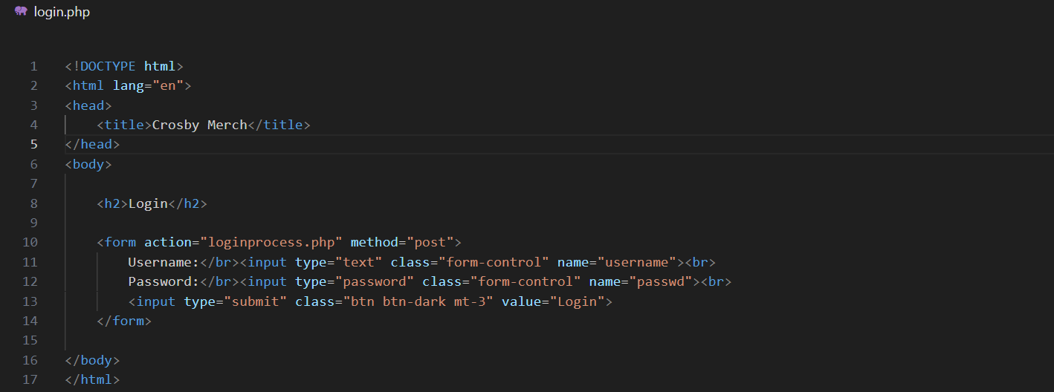Initial code:

Although login.php does not currently have any php code, I still decided to make the doctype .php just in case I make a change to it in the future.

On the loginprocess.php page, I have comment out the header and using echoes for now since the homepages don’t exist yet. The echo will allow me to test the login process effectively.

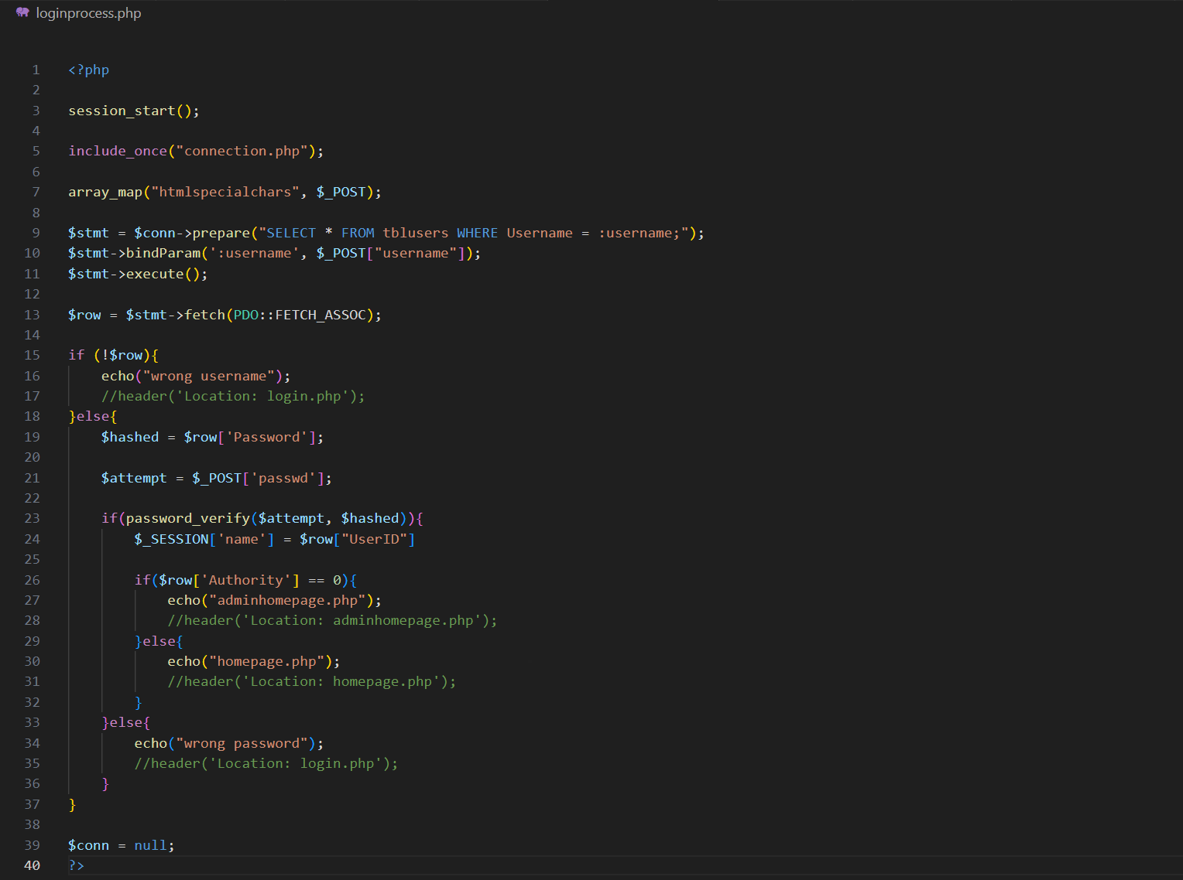

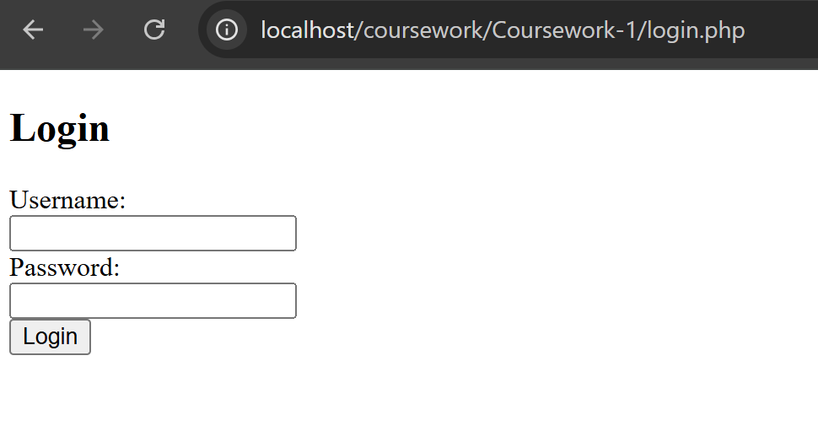Currently my login page looks like this:

However when testing it for the first time, I encountered a syntax error:

Looking through my code I realised that I was missing a semicolon on line 24

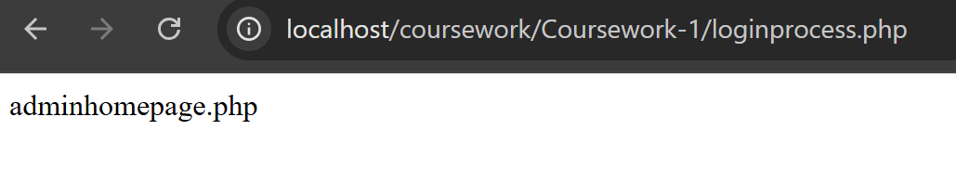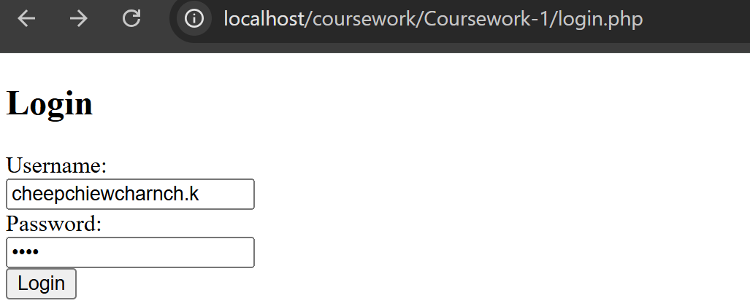When testing I found a logic error since correct customer login is leading to adminhomepage.php

When checking my code I realised that I had wrote: if($row['Authority'] == 0)

I changed the zero to a 1 and then the login system started to work without a problem

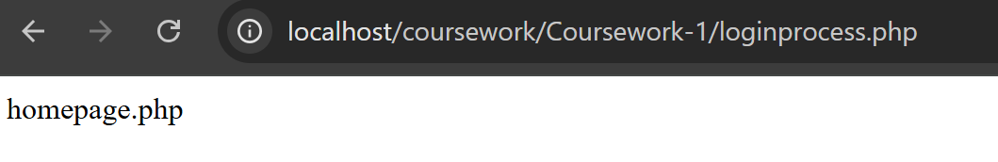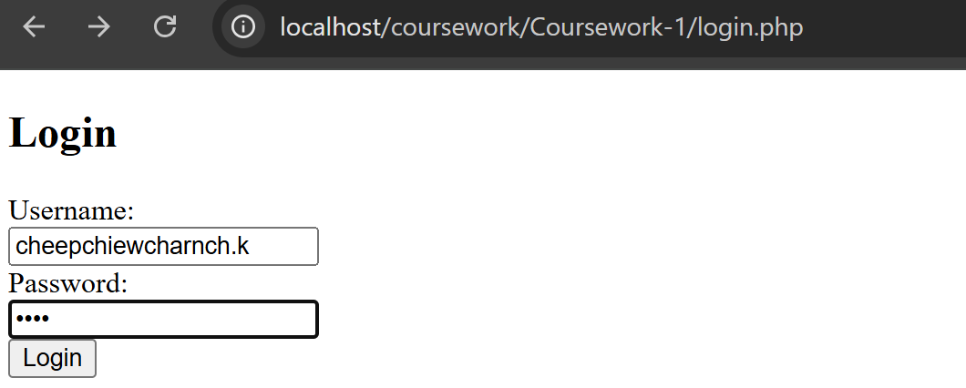Testing:

Correct customer login details works correctly:

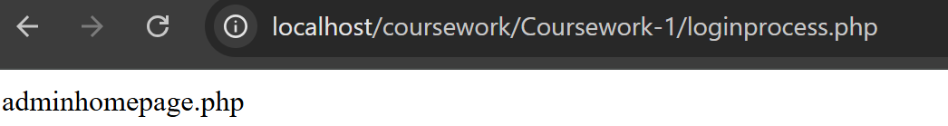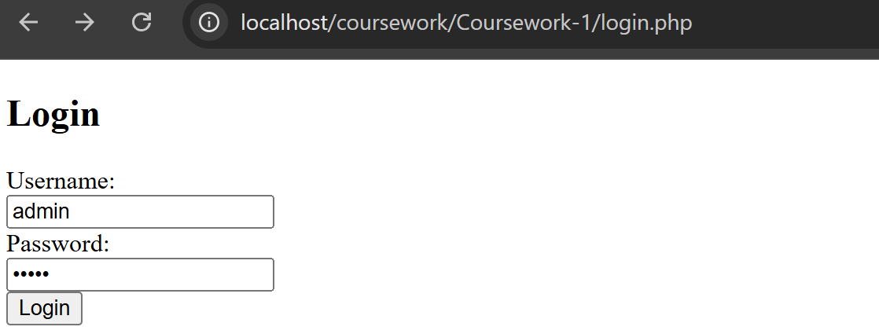Correct admin login details works correctly:

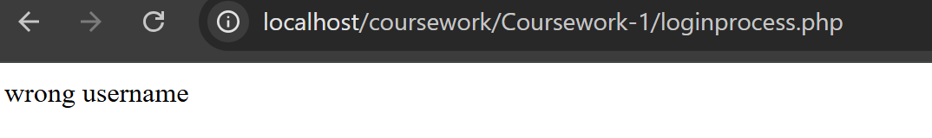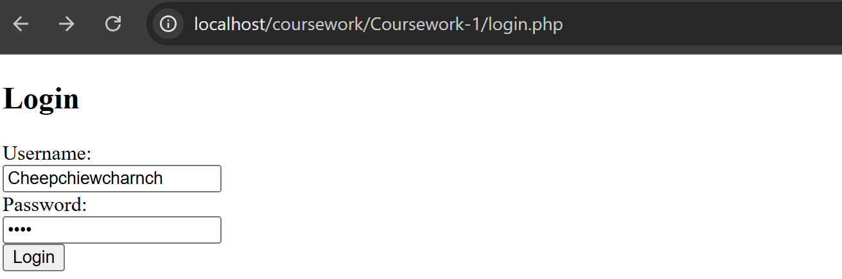Incorrect username works correctly:

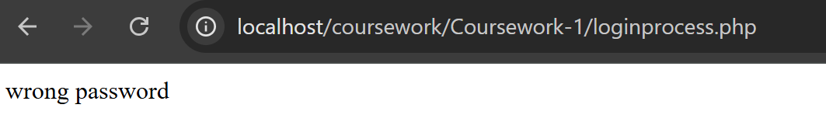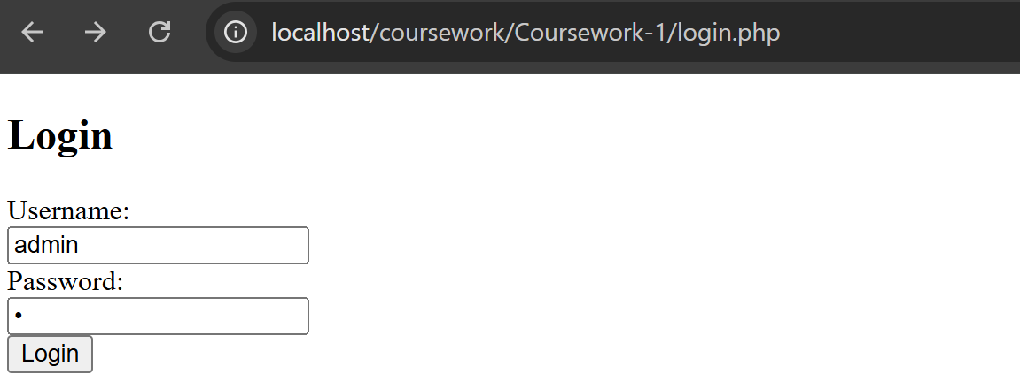Incorrect username works correctly:

With this, I conclude that my login works successfully.

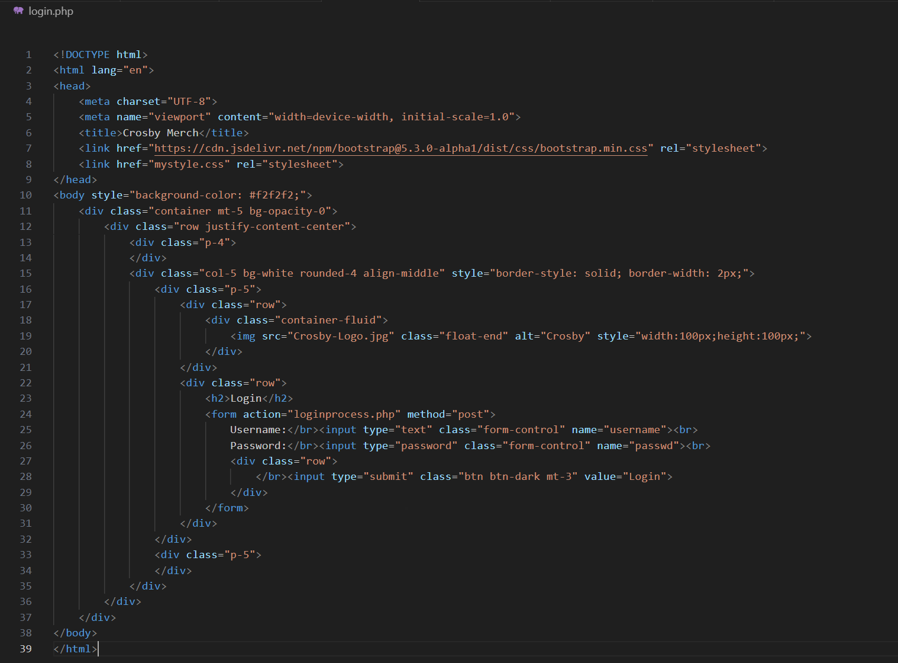**Bootstrap and CSS**

A lot of Bootstrap and CSS, this is how the login page looks like now:

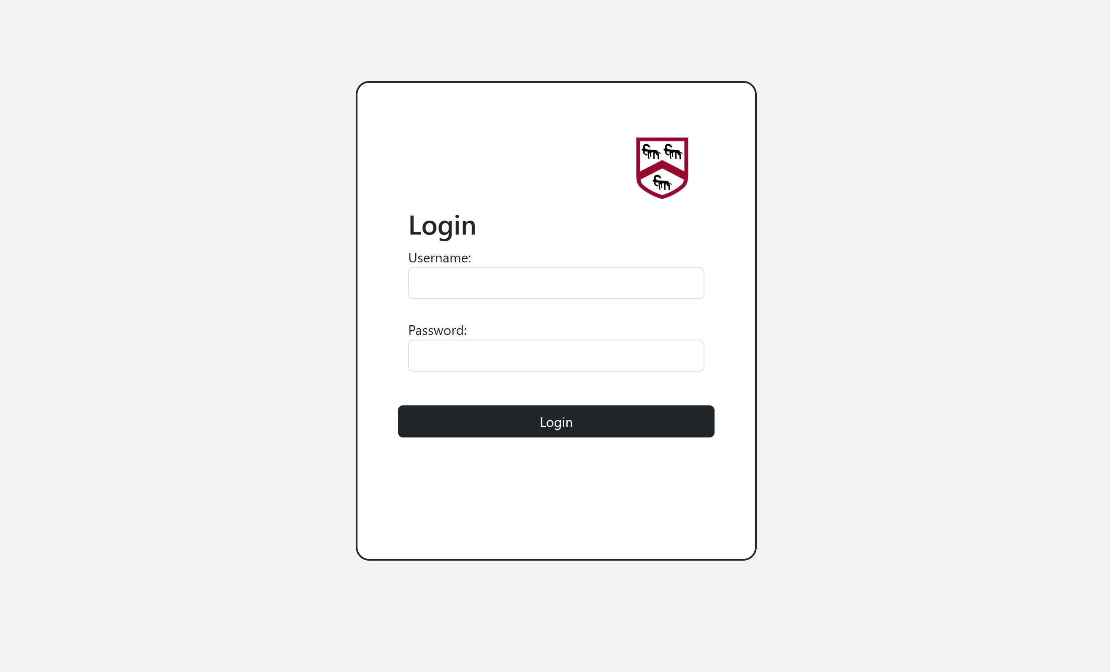

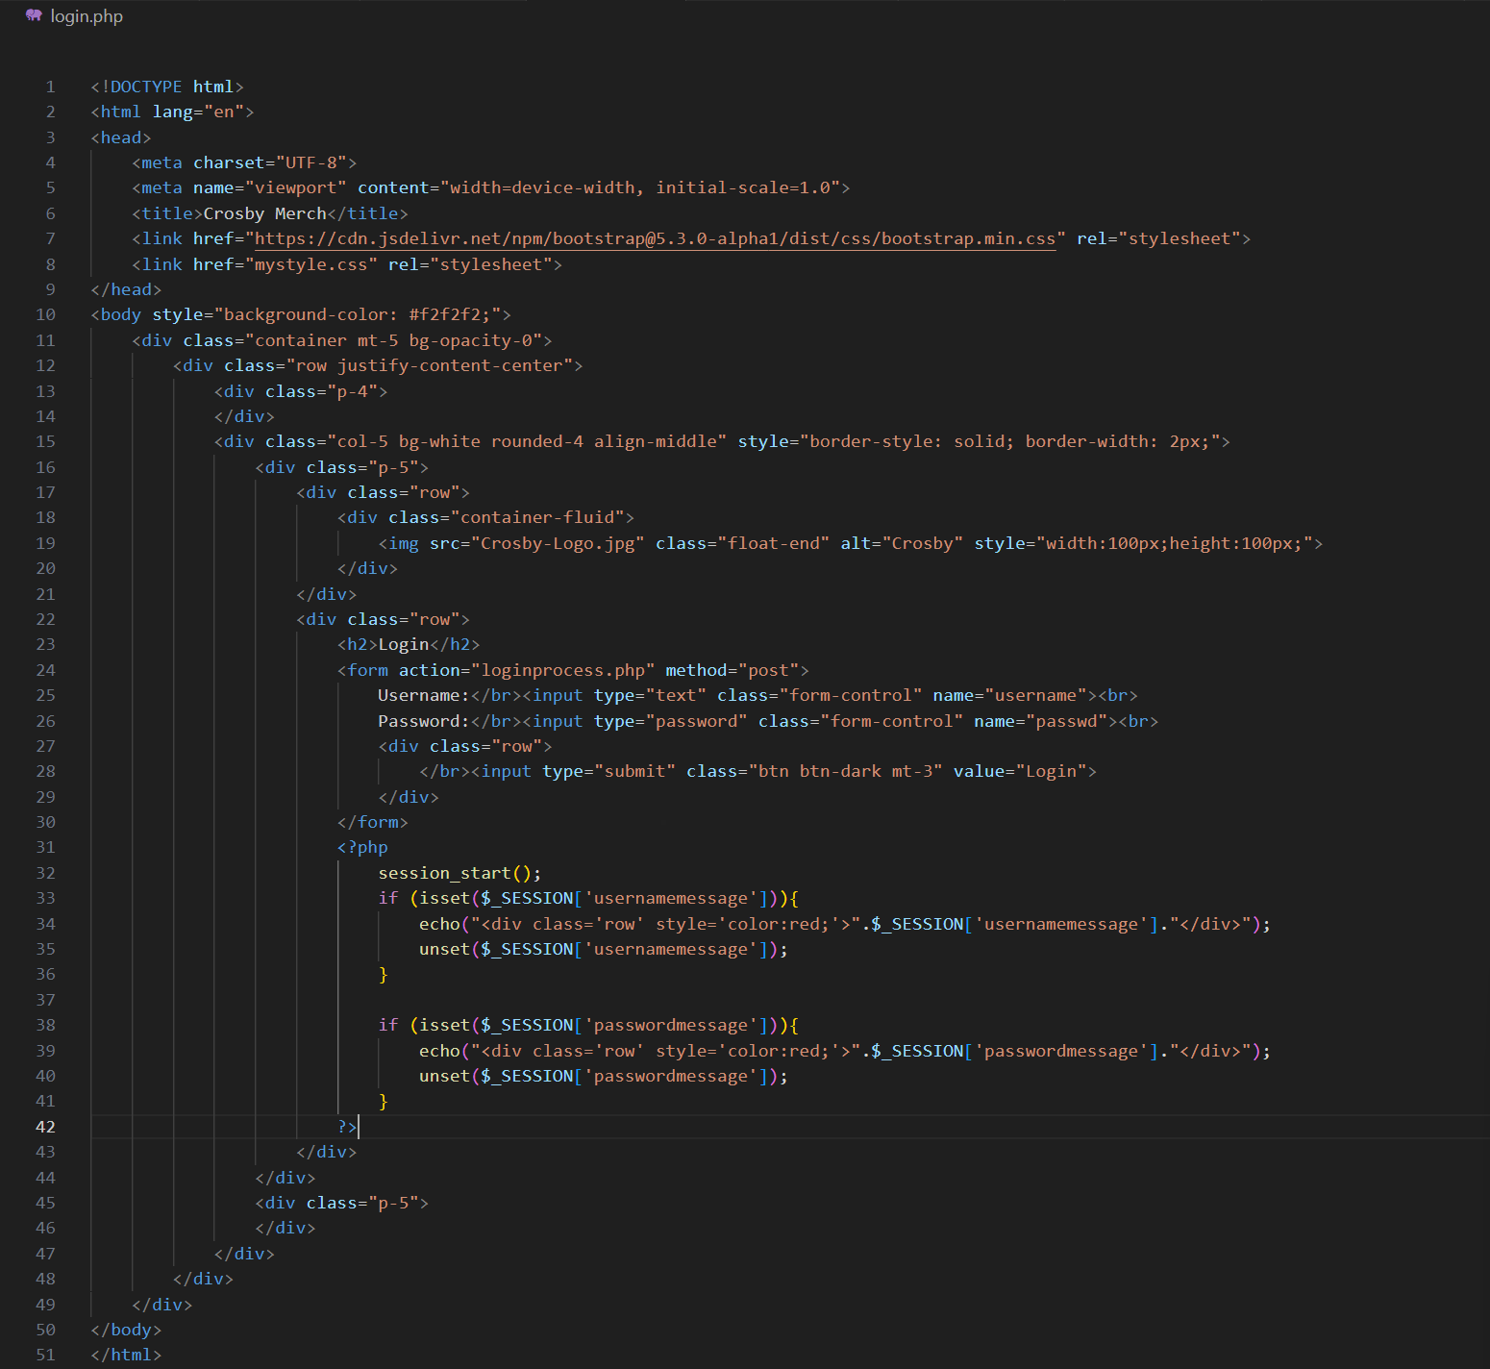To properly show error messages when incorrect login attempt has been made, I made use of sessions:

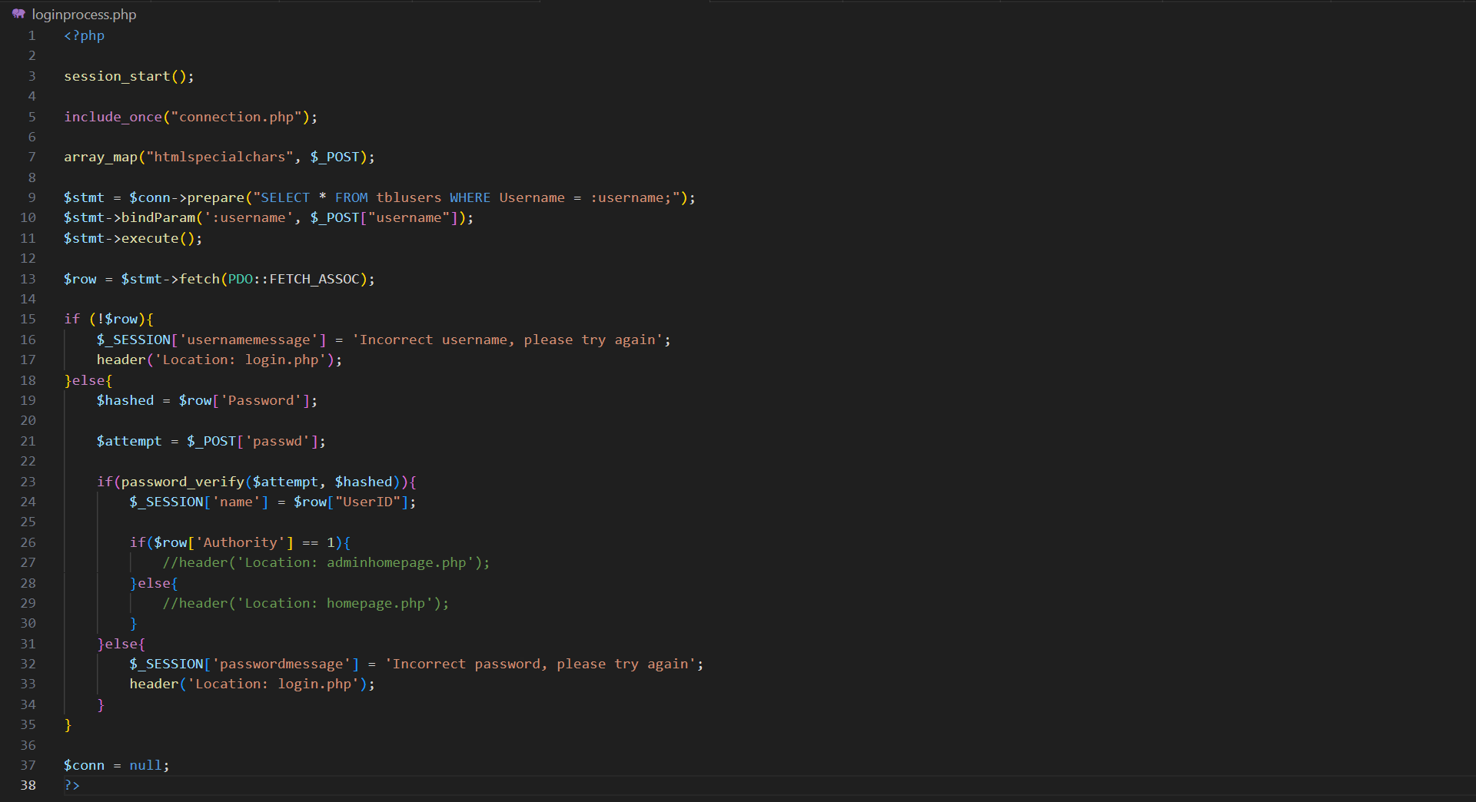

Testing:

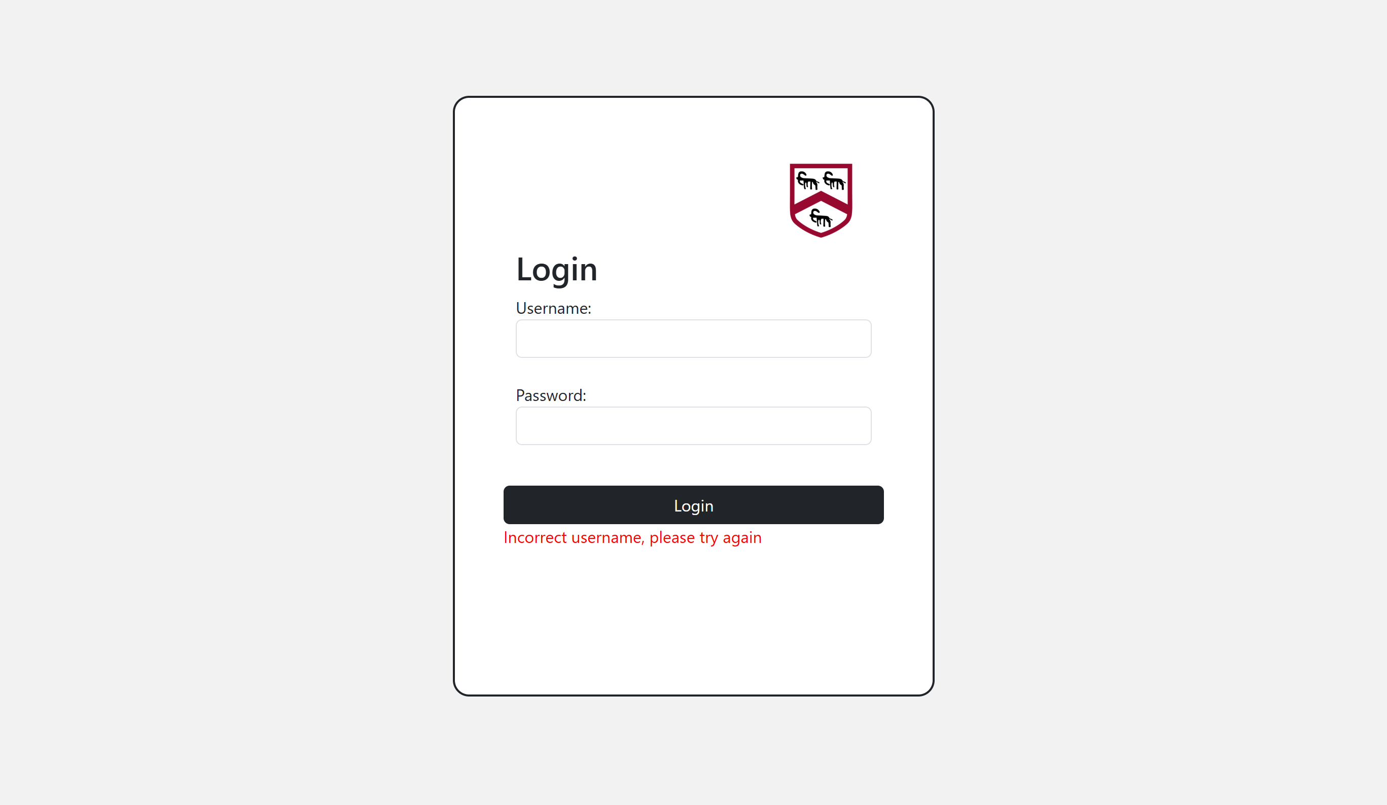Incorrect username massage displays properly:

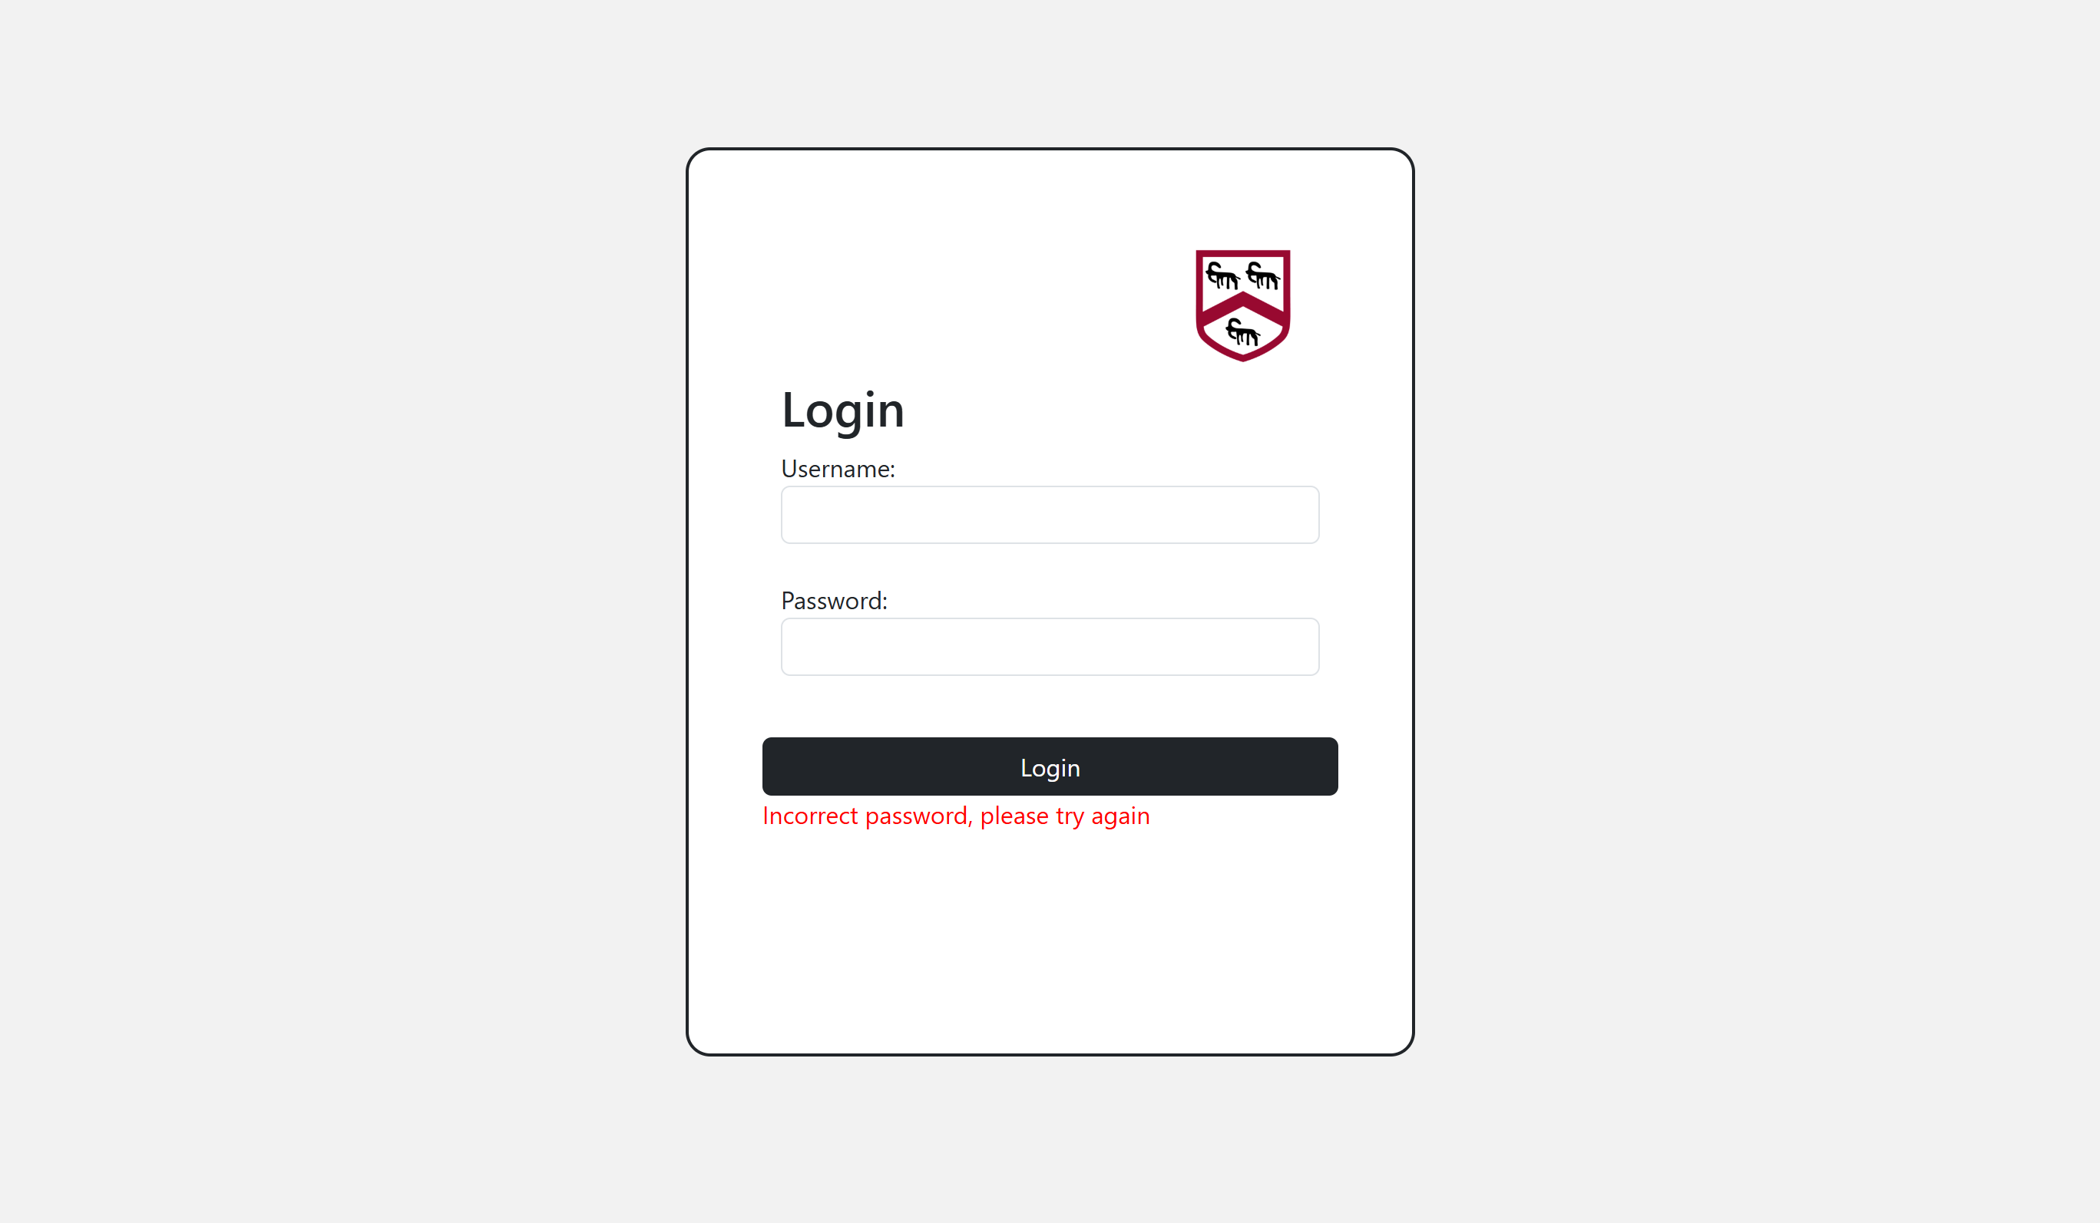Incorrect password massage displays properly:

Final Annotated Code:

Login.php

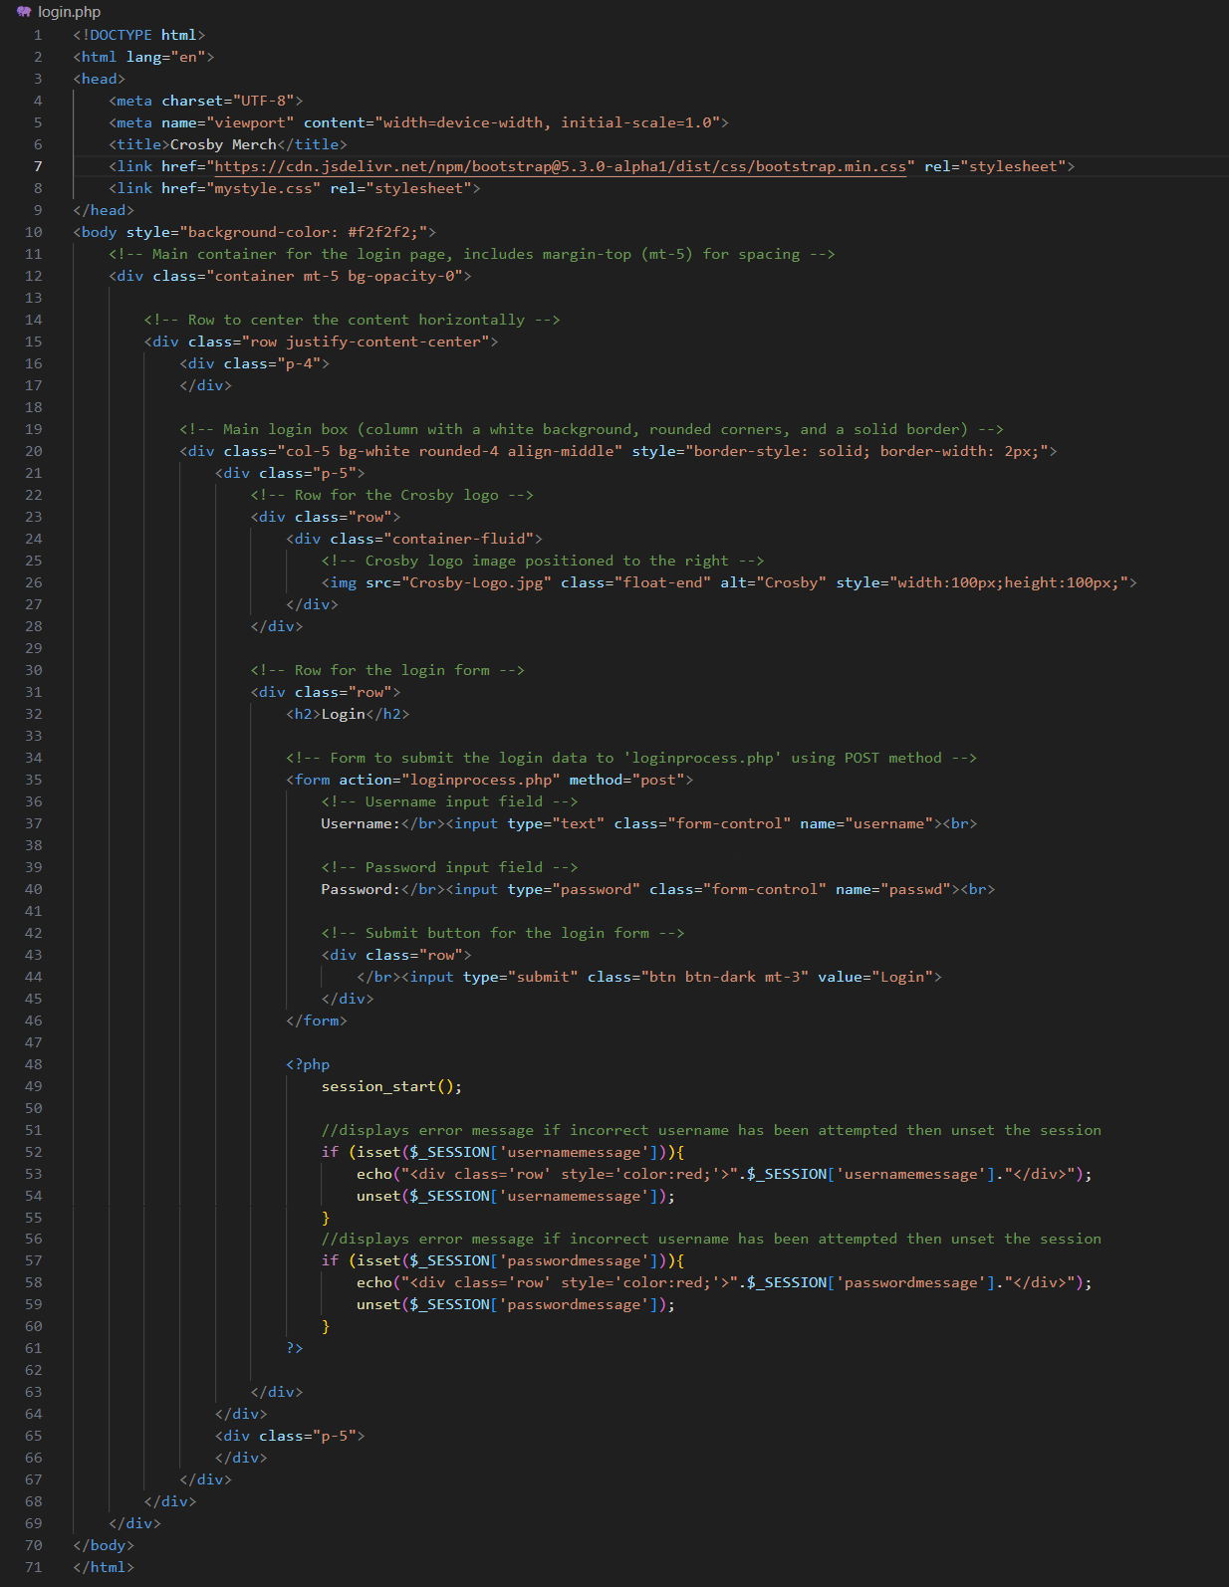

Loginprocess.php

## A screen shot of a computer program AI-generated content may be incorrect.Logout

The logout process is a very easy one to tackle. Since in my login process I had created a session called ‘name’ (holds the UserID) which I will use later on the check if a logged in, all I have to do in the logout process was to unset that session and send the user back to the login page.

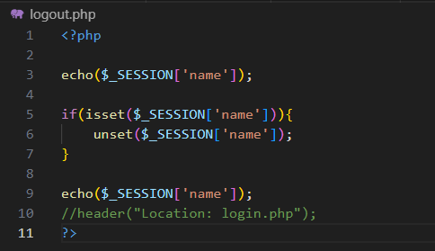Initial code:  
To be able to test out the code I commented out the header and adding in an echo which will show the content of the session before and after the logout process.

When trying it out, I ran into this error:  
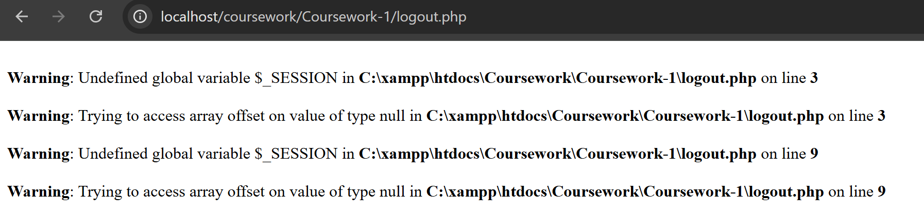I realised that I forgot to start the session at the top of the page, so I started sessions at the top of the page and then tested out the code:  
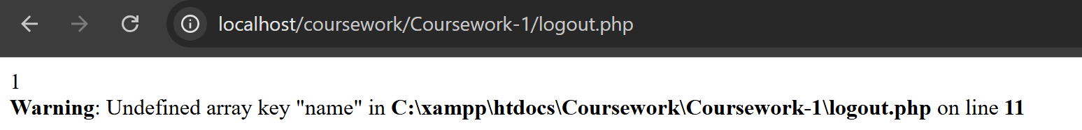At first I thought that an error has occurred again, but then I understood that the error message meant that my code was working since It indicates that the session ‘name’ has been unset, therefore the user has been logged out.

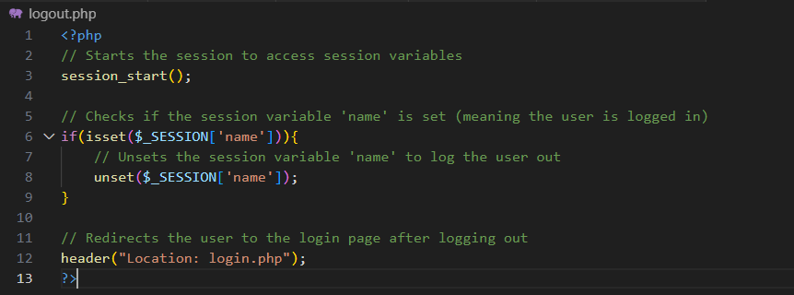 Final Annotated Code:

## Preventing bypass

In this page I will create a php code that will check whether a user is logged in or not. This code will be useful to stop users from bypassing to pages simply by entering a page directly through a URL. It will also be used to stop customers form going onto admin pages and vice versa.

Firstly I will tackle the code to prevent bypass since it is very simple. We have already created a way to check if some one is logged in or not by setting a session which I have called ‘name’ when someone logs in and unsetting the session when they log out. This means that to check if someone is logged in or not all I have to do is to check if the session ‘name’ has been set or not.

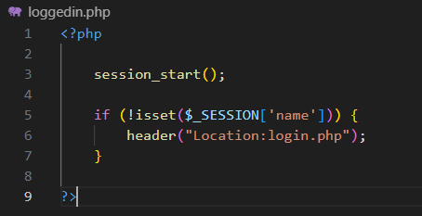Code:

Then tried to create the code to prevent customers form going onto admin pages and vice versa.

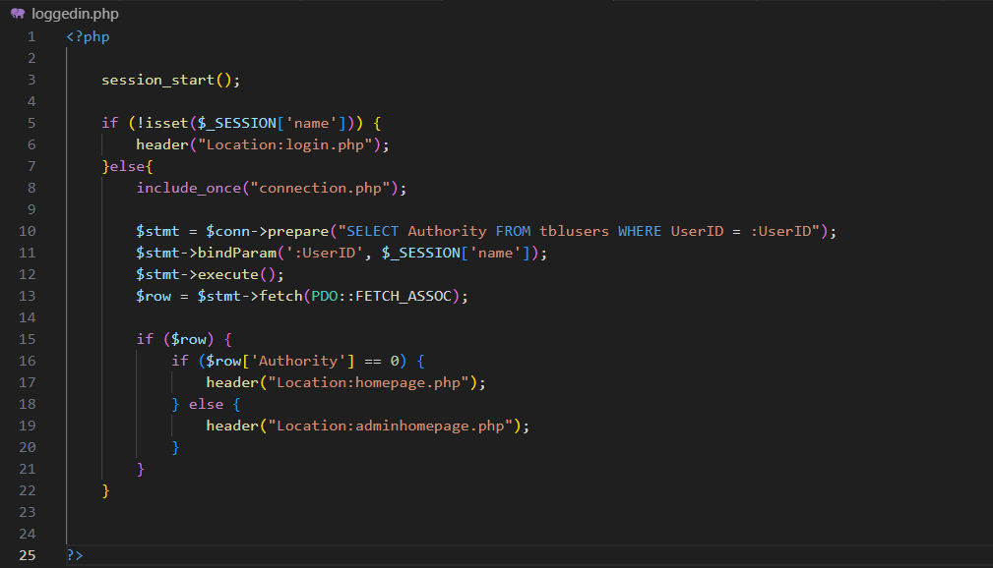 Initial code:

This code will first check whether a user is logged in or not, if they are then the code will check whether you are a customer and redirects you to the correct page.

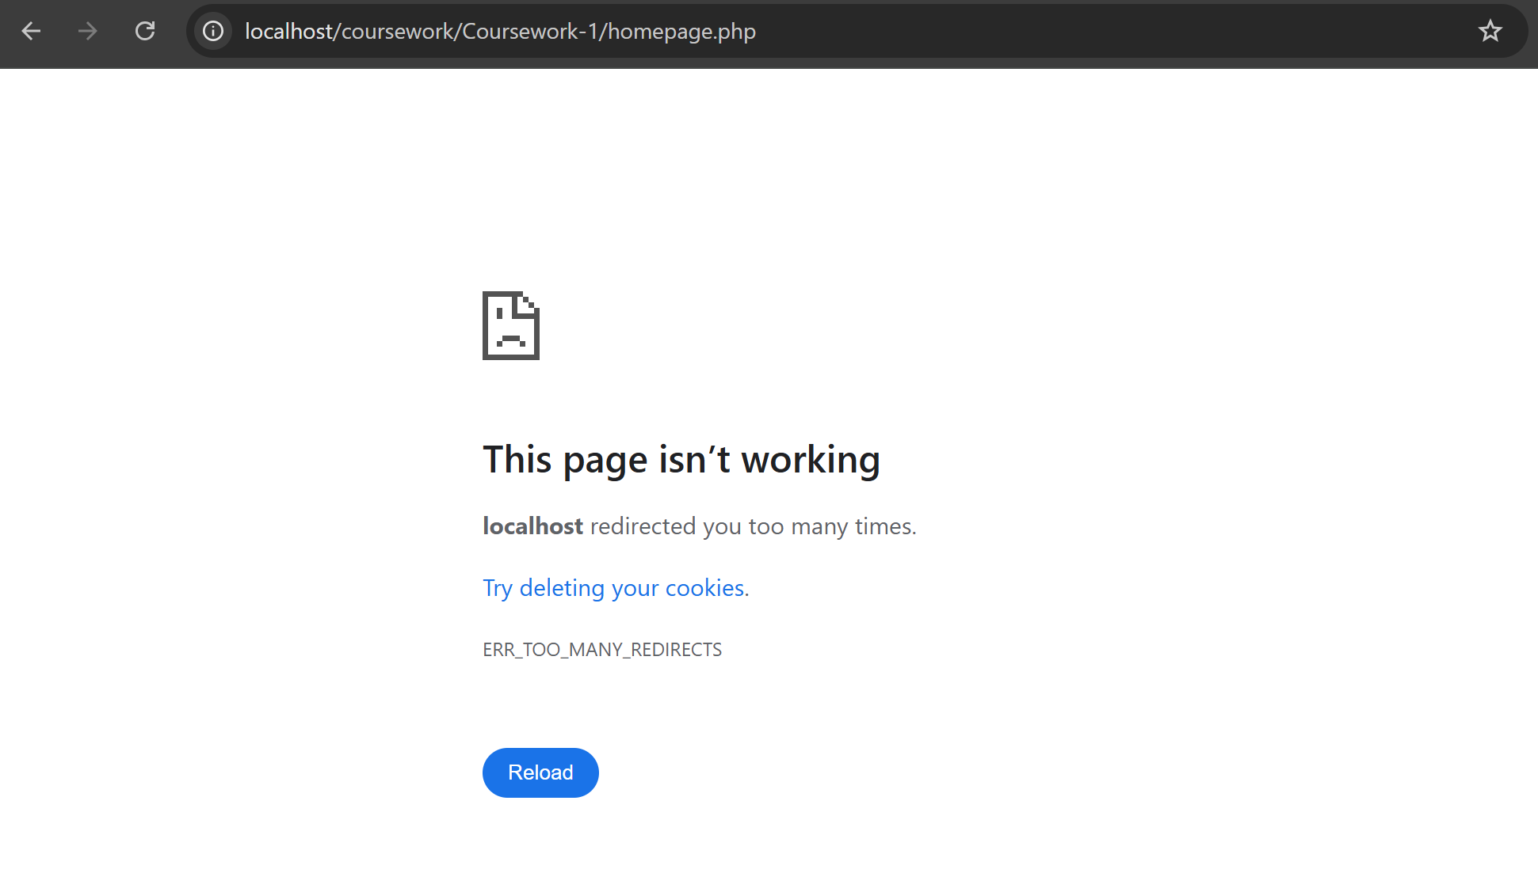However now when I try to enter homepage,php an error occurred:

The page said that localhost had redirected me too many times. Upon closer inspection, I found a logic error in my code trapping me end up in a redirect loop.

To fix this I will need to separate the code into two pages, one for customers which will redirect them to their homepage if they enter an admin page, and the other for admins which will redirect them to their homepage if they enter an customer page.

I decided to call one customerloggedin.php (added to customer pages) and the other adminloggedin.php (added to admin pages)

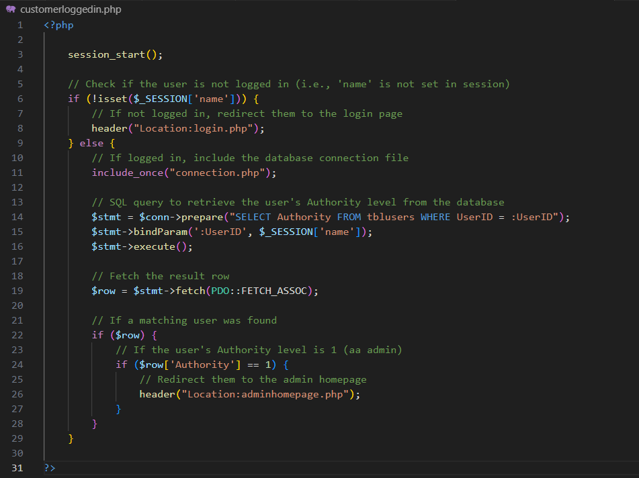Final Annotated Code:

customerloggedin.php:

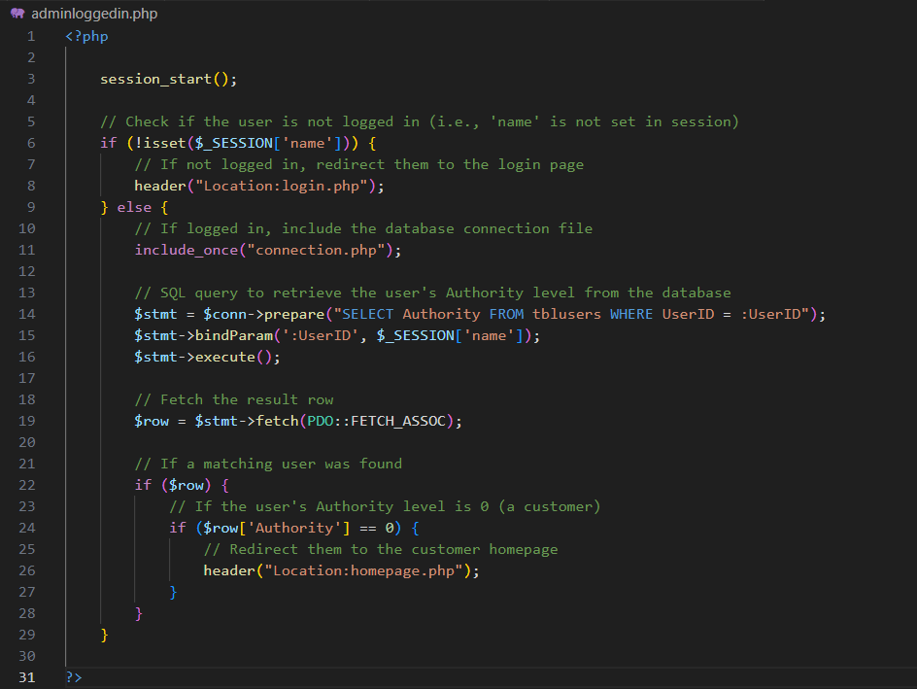adminloggedin.php:

## Customer

I will begin by creating all of the customer-facing pages before moving on to the admin pages. This approach ensures that the core functionality of the website—the customer experience—is fully working and testable early on. Since the majority of users interacting with the site will be customers, it makes sense to prioritise the parts of the system that they rely on most.

### Navbar.php

I am creating the navbar first because it is a key part of the website's layout and user experience. It will appear on every page and provide consistent navigation across the site. By building it early, I can integrate it into each new page as I create them, saving time and ensuring a smooth, user-friendly structure throughout the website. To start developing the Navbar I have created a page called navbar.php to hold the code for the navbar, this will allow me to use php to recreate the navbar on any page without having to write it all out again. I then created the homepage.php and included the php to include the navbar

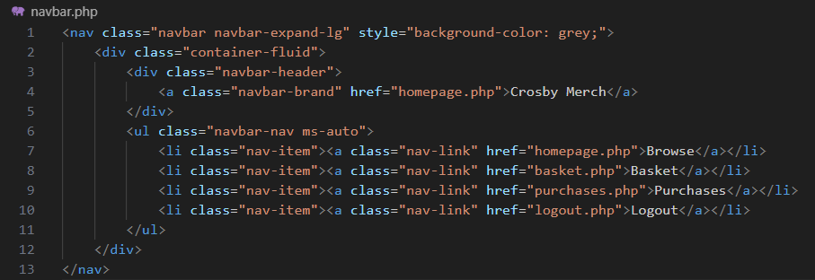Initial code:

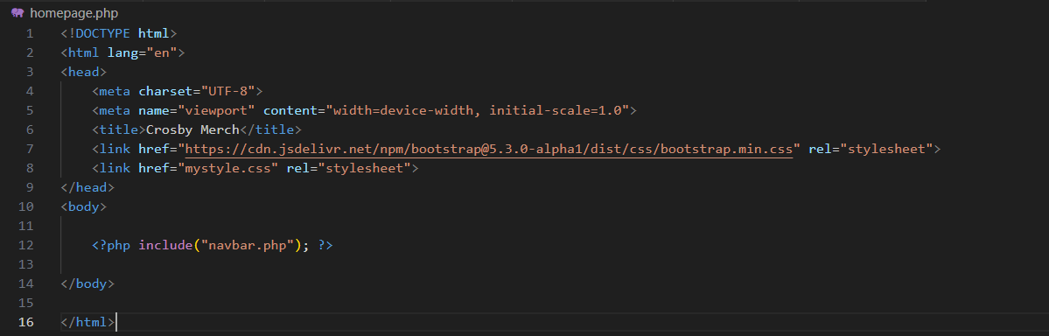

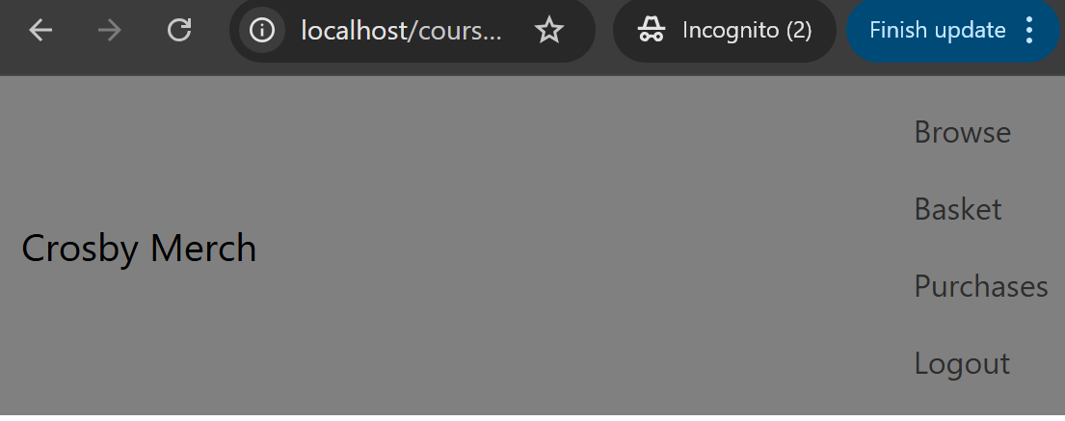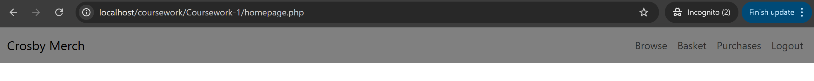Currently I have set the navbar background colour to grey to allow me to see the area that It will take up. I was also able to the use bootstrap navbar class, which will also allow my navbar to be responsive and collapse, which will be useful for thin screens like a phone.

To test if each link works, I have created basket.php and purchases,php which currently only displays the word basket and purchase on them.

Clicking on “Crosby Merch” and “browse” directed to me the same page, clicking “basket” directed me to the basket page, clicking "purchases” directed me to the purchases page and clicking "logout”, directed me to the login page. This means that the navigation is working properly.

Since the navbar is working properly, I decided to create some CSS for the “custom-navbar” class to it to make it look like what I designed.

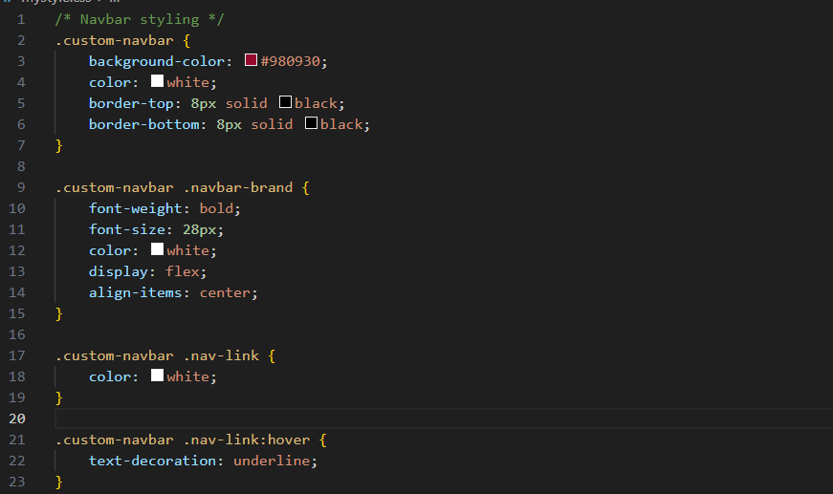CSS code that I added to mystyle.css:

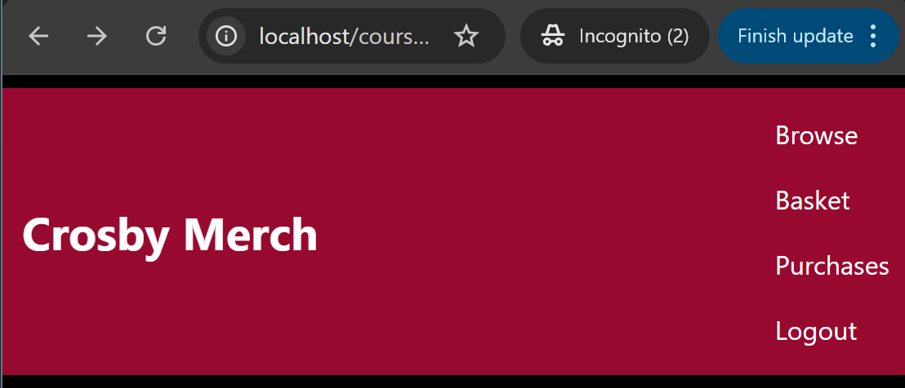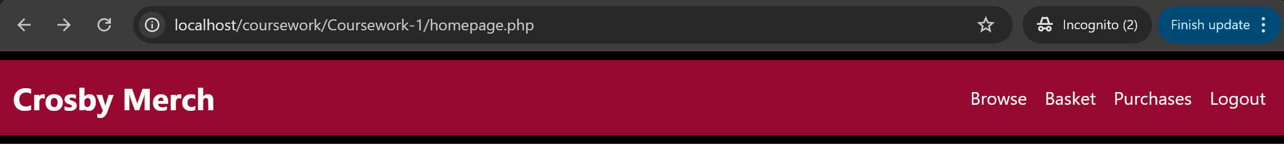What the navbar looks like now:

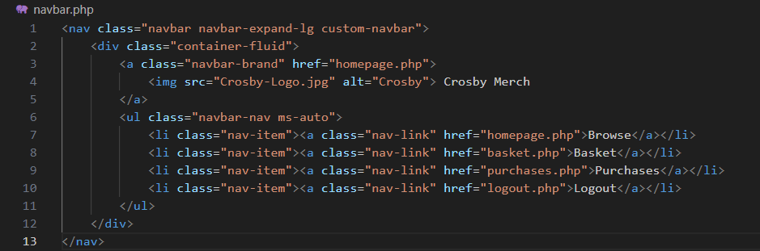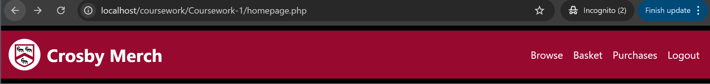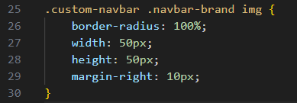To add the circular Crosby house logo on the very left of the navbar, I created a CSS and slightly tweaked my navbar code:

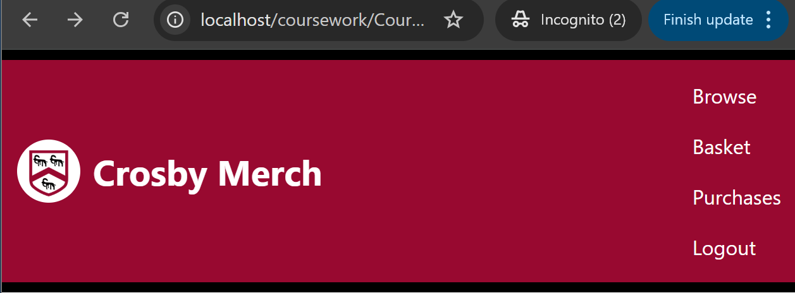

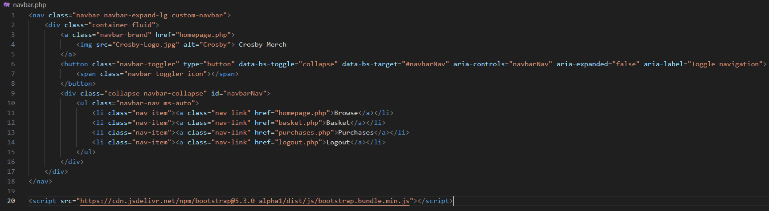Then I decided that I did not like how it looks like when it is in the phone formatting, since it is too thick and takes up too much space. To tackle the problem I used bootstrap which uses some javascript to replace the links with a drop down button, allowing the links to be hidden unless the user wants to see them.

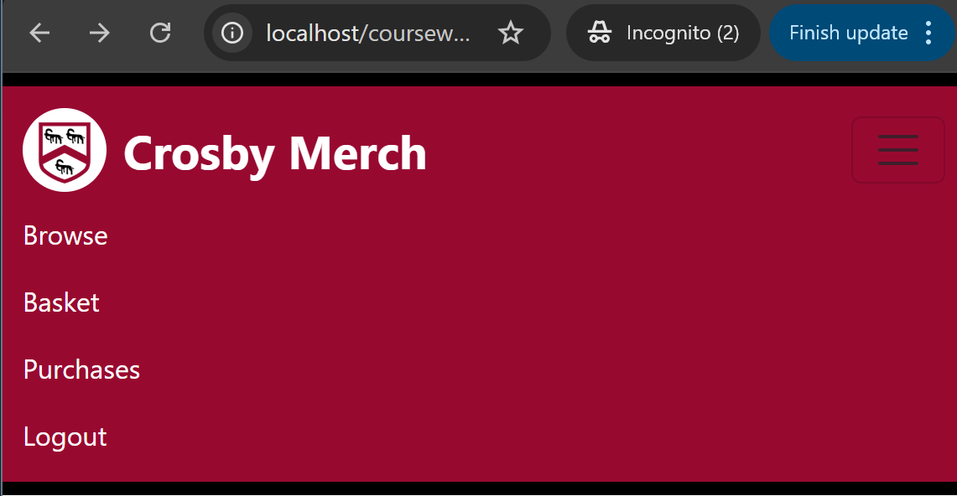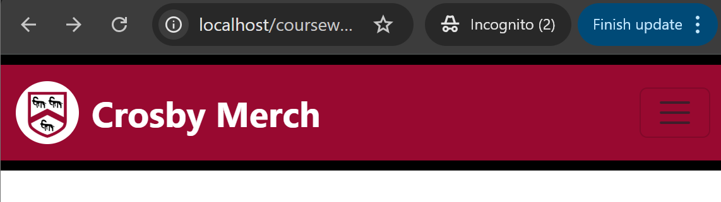

Final Annotated Code:

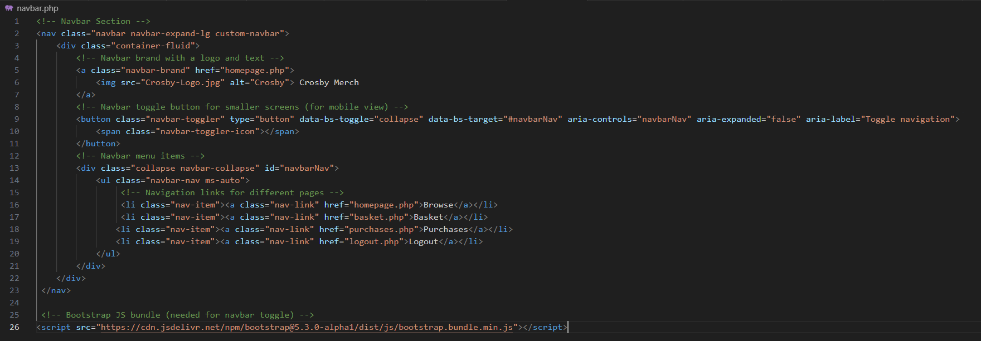Navbar.php

### Homepage.php

The home page is the landing page for users after they have successfully logged in, therefore this is the first page I will be creating. The homepage will serve as the main browsing area for customers. It displays all available items in a clear and organized grid format. Customers can view item names, images, and prices at a glance, making it easy to explore products. The page also includes features like search, sorting, and filtering to help users quickly find specific items they're interested in.

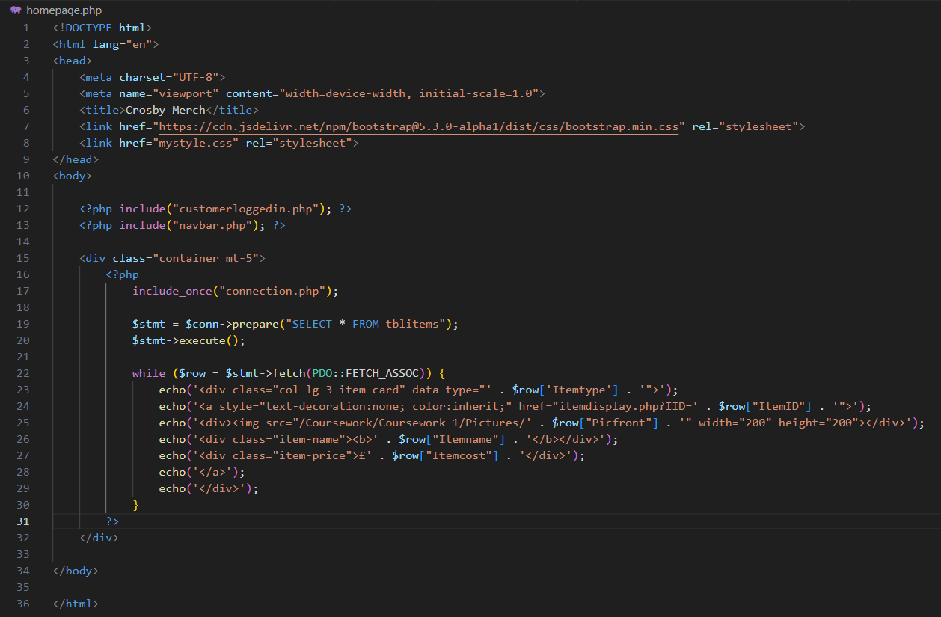 Initial code:

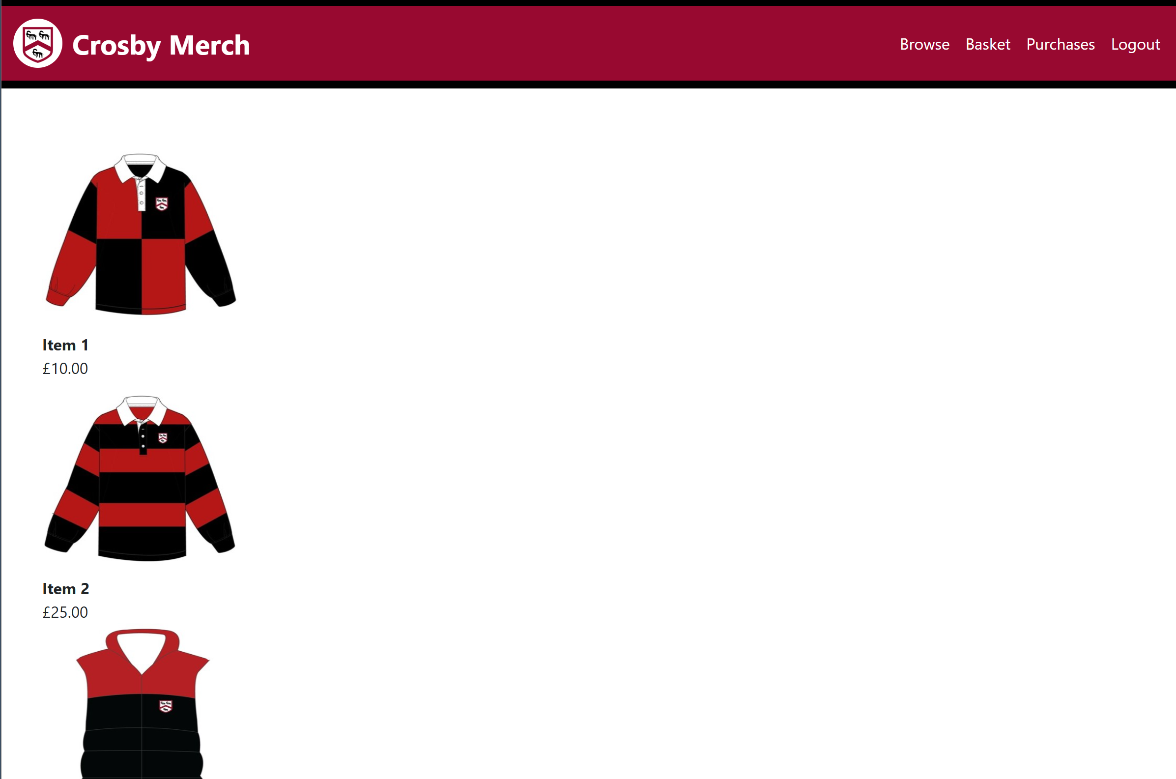I started by including customerloggedin.php and navbar.php, then I started writing php code that will fetch the data of all items, then displaying them onto the page. The display is linked so that it will send you to the item details display page. To make sure that each item display page is unique, I have used a query string and made the parameter value the ItemID of the displayed item.

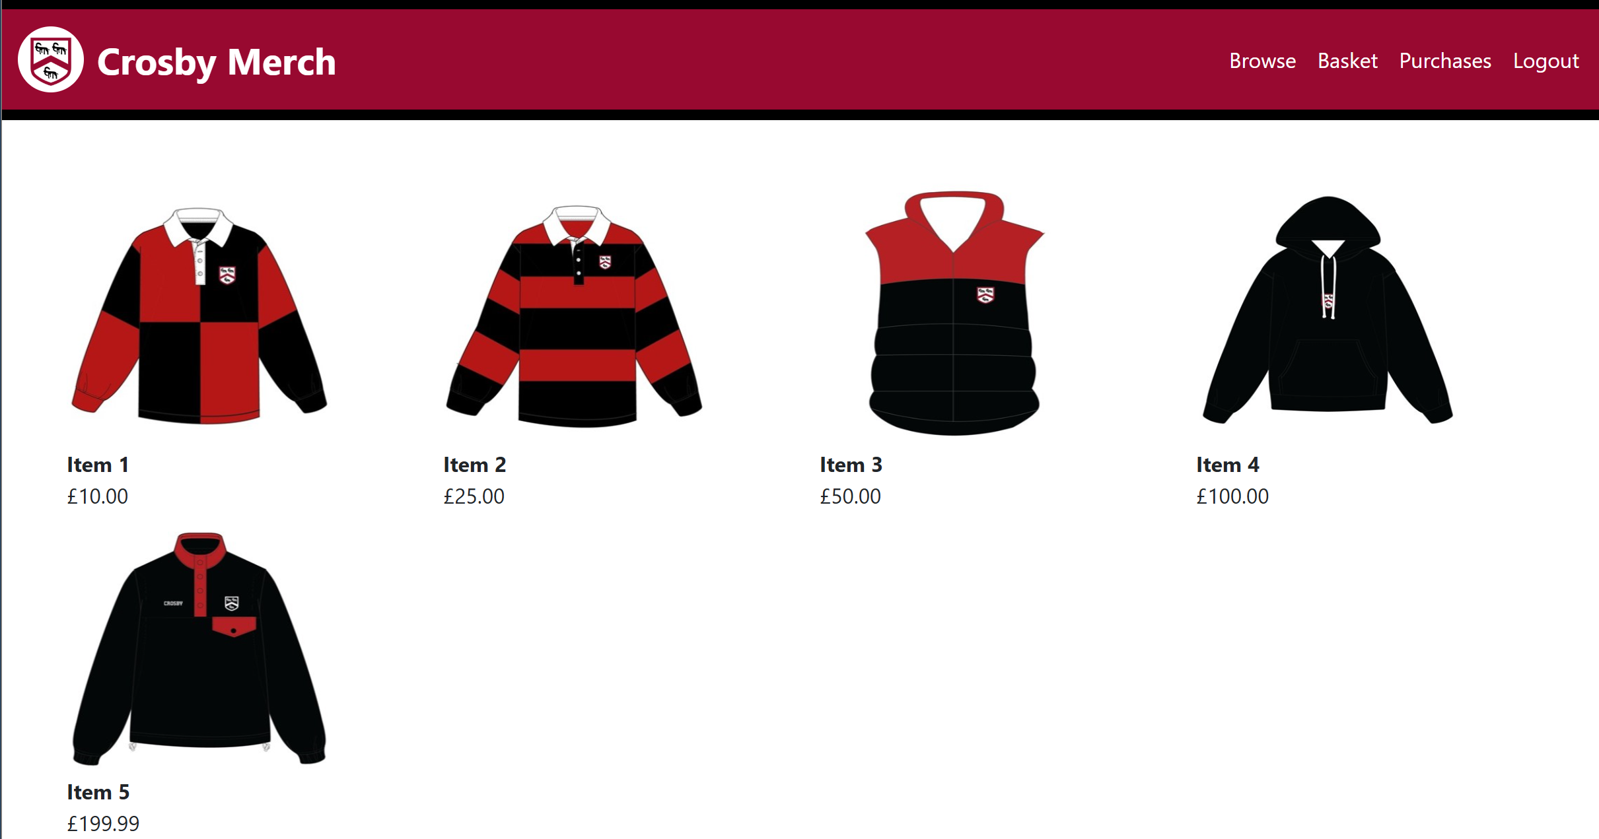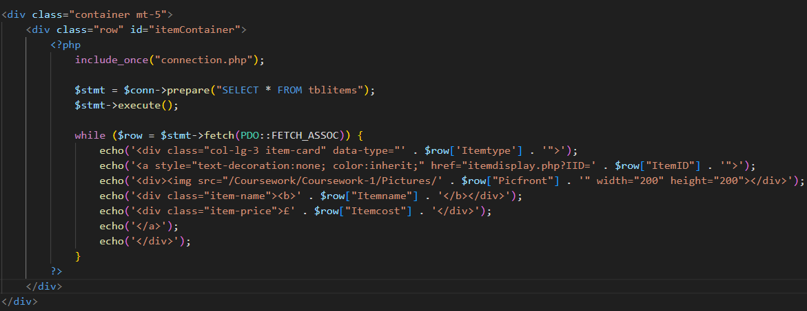I used bootstrap to displayed items into a grid, having 4 items in each row.

Now, I will implement searching, filtering and sorting functionality. This will allow customers to find what they are looking for with ease.

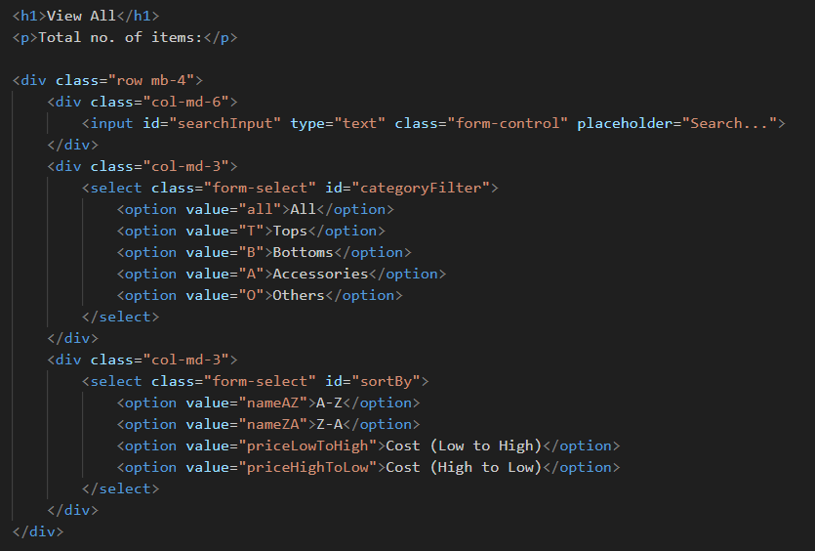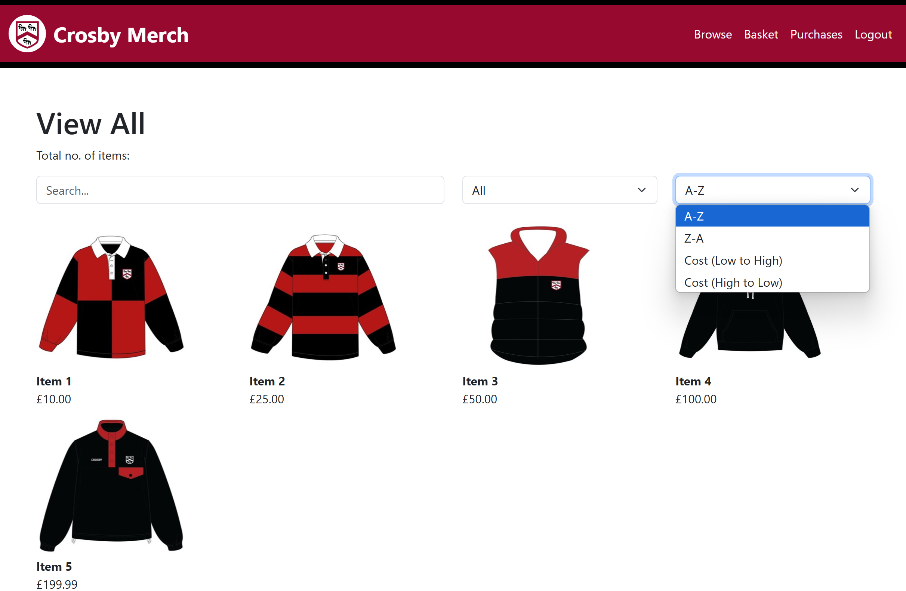 To begin, I created the placeholders in which the customers will be giving the inputs:  
Currently these don’t do anything but it is just put into the correct positions, using bootstrap allowed me to create the input box and the drop down select for the filter and sorting list.

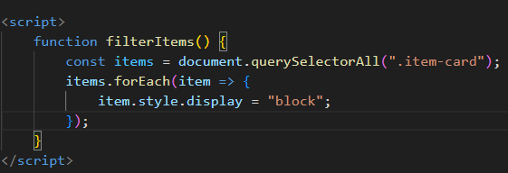To give functionality to those features, I decided to use JS to dynamically change the page:

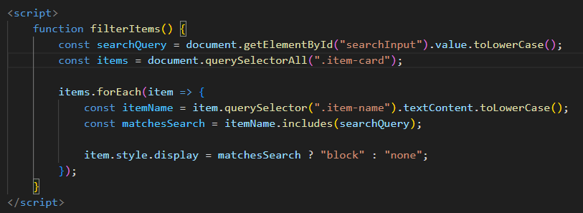 This code just prepares the function and confirms the JS is working. It will just loop through every item and make sure to make sure it’s visible.

To make a function to search, I took in the input from the user and compare them to the names off all the items. The input is not case sensitive because .toLowerCase() is used on both the search input and the item names before comparing them.

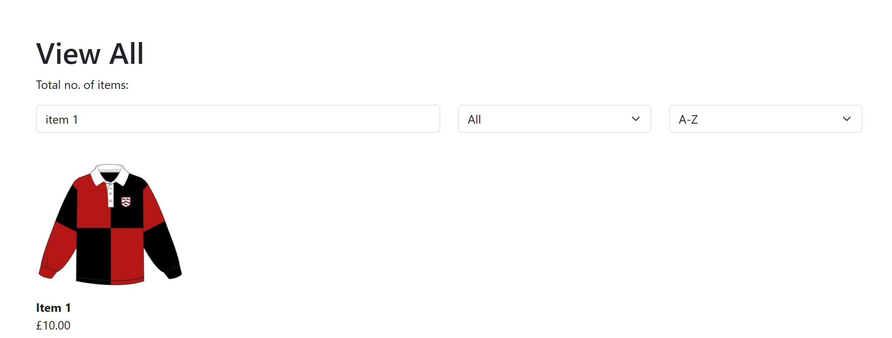This connects the function to the search bar to test it.

This code integrates the function to the filter system items by category (e.g., Tops, Bottoms, etc.) into the code 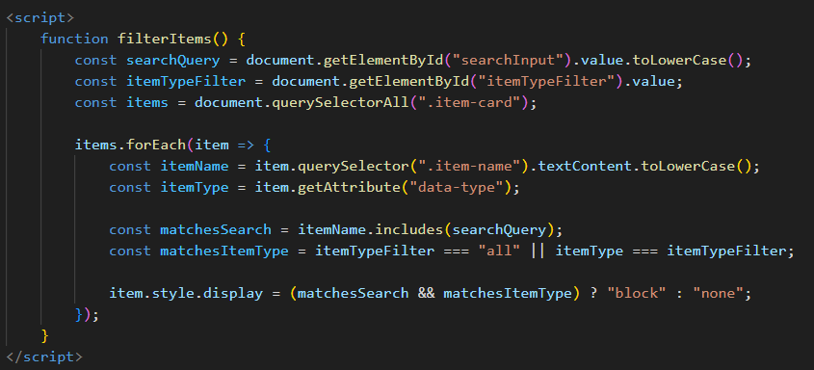by comparing the chosen category of the drop down to the type of item. Items are displayed only if the category **and** the name of the item matches the user’s input.

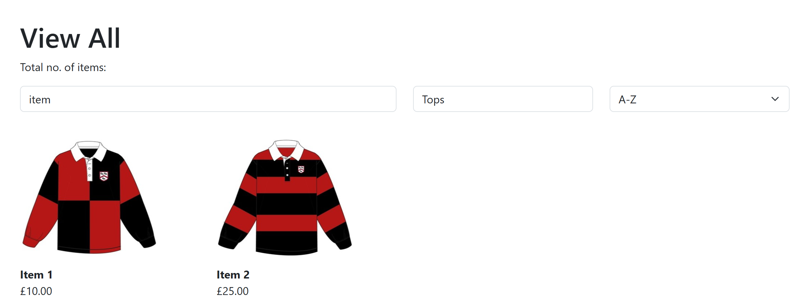This connects the function to the category drop down list to test it.

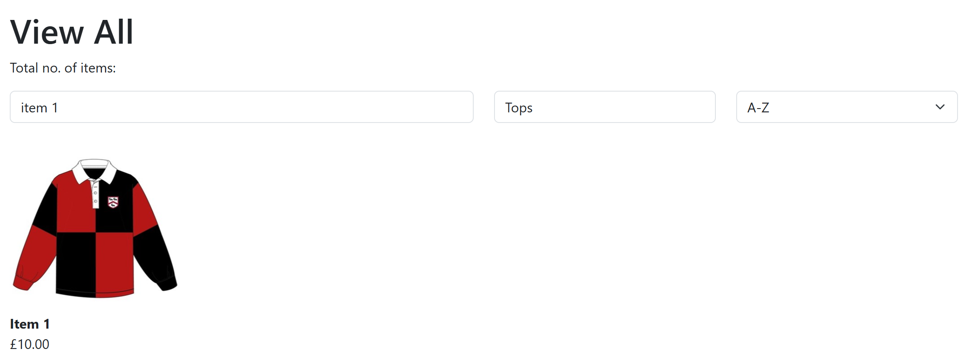This proves that the filtering function works properly

This proves that items that show up must match both the category and the search input.

 With the filtering function I would also like to change the heading (“View All”) to match whatever category the user has inputted, since it does not make sense it the chosen category was “Accessories” but the heading still said “View All”.

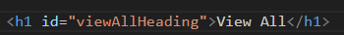This JS code takes the category of the input and changes the heading to whatever is selected.

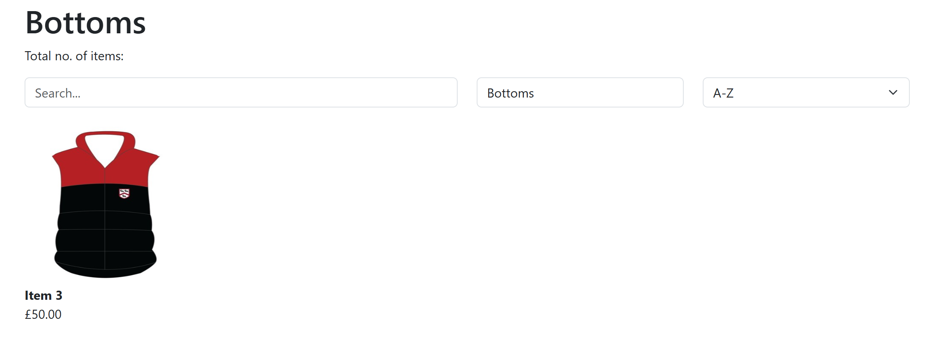This connects the function to the Heading.

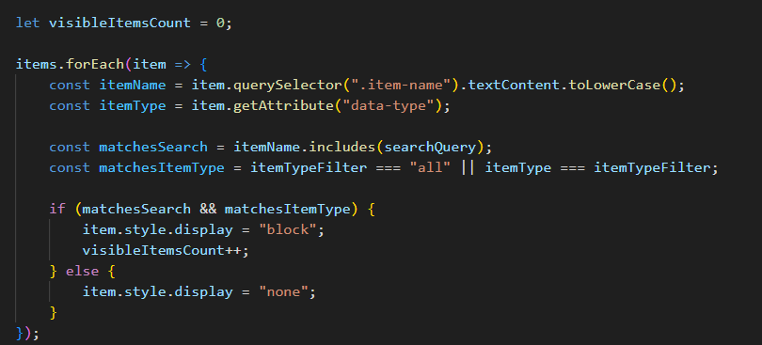Now I will add a counting function and display how many items are visible after filtering. This will be good for the future when there are a lot more items, users might be more likely to refine or change their search based on how many results they see. For example, if there are too many results (e.g. 100+), they might narrow their search. If there are too few, they might broaden it.

By changing the filtering code to this one, I am able to start a counter at 0 then add 1 to the counter every time an item is displayed on the page, meaning the count will match the number of items displayed.

This connects the function to the total count to test it.

However, when I tested it, I found that the total item count only starts working after I chose a category for the first time.



This code fixes the problem by running filterItems() automatically when the page is done loading. So even before the user types anything or selects a category, the default item count will match correctly to the total number of “All” items.

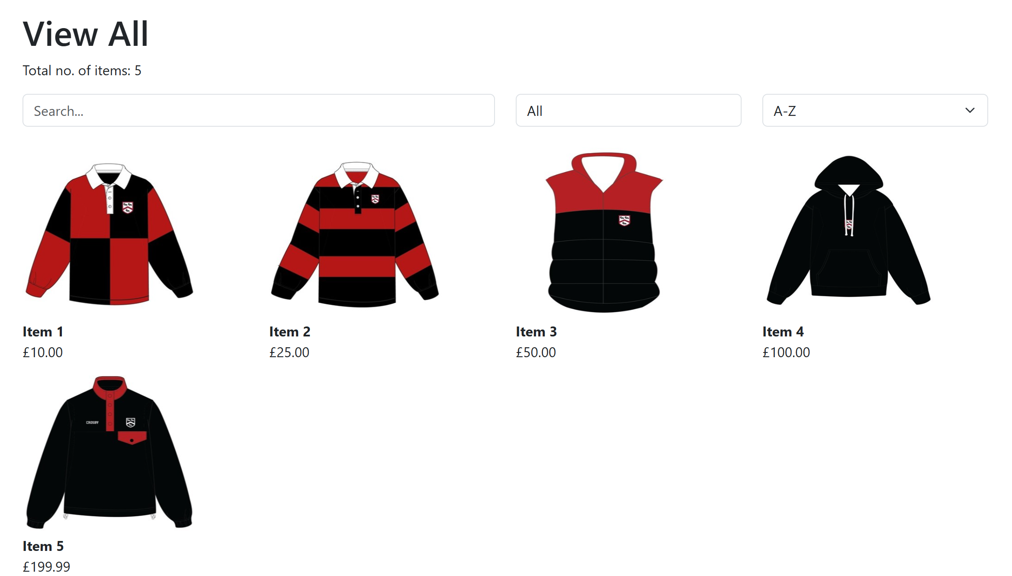The total item count is now correctly displayed upon entry to the page without having to choose a category.

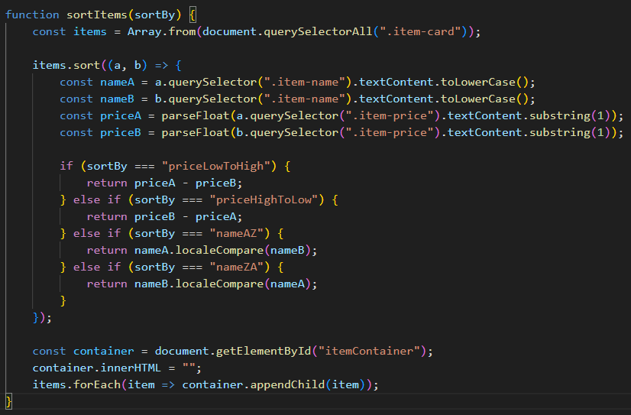To tackle the sorting function, I have created another function called sortItems(), which is included into the filterItems() function.

This JS will sort out the items and display them correctly onto the page.

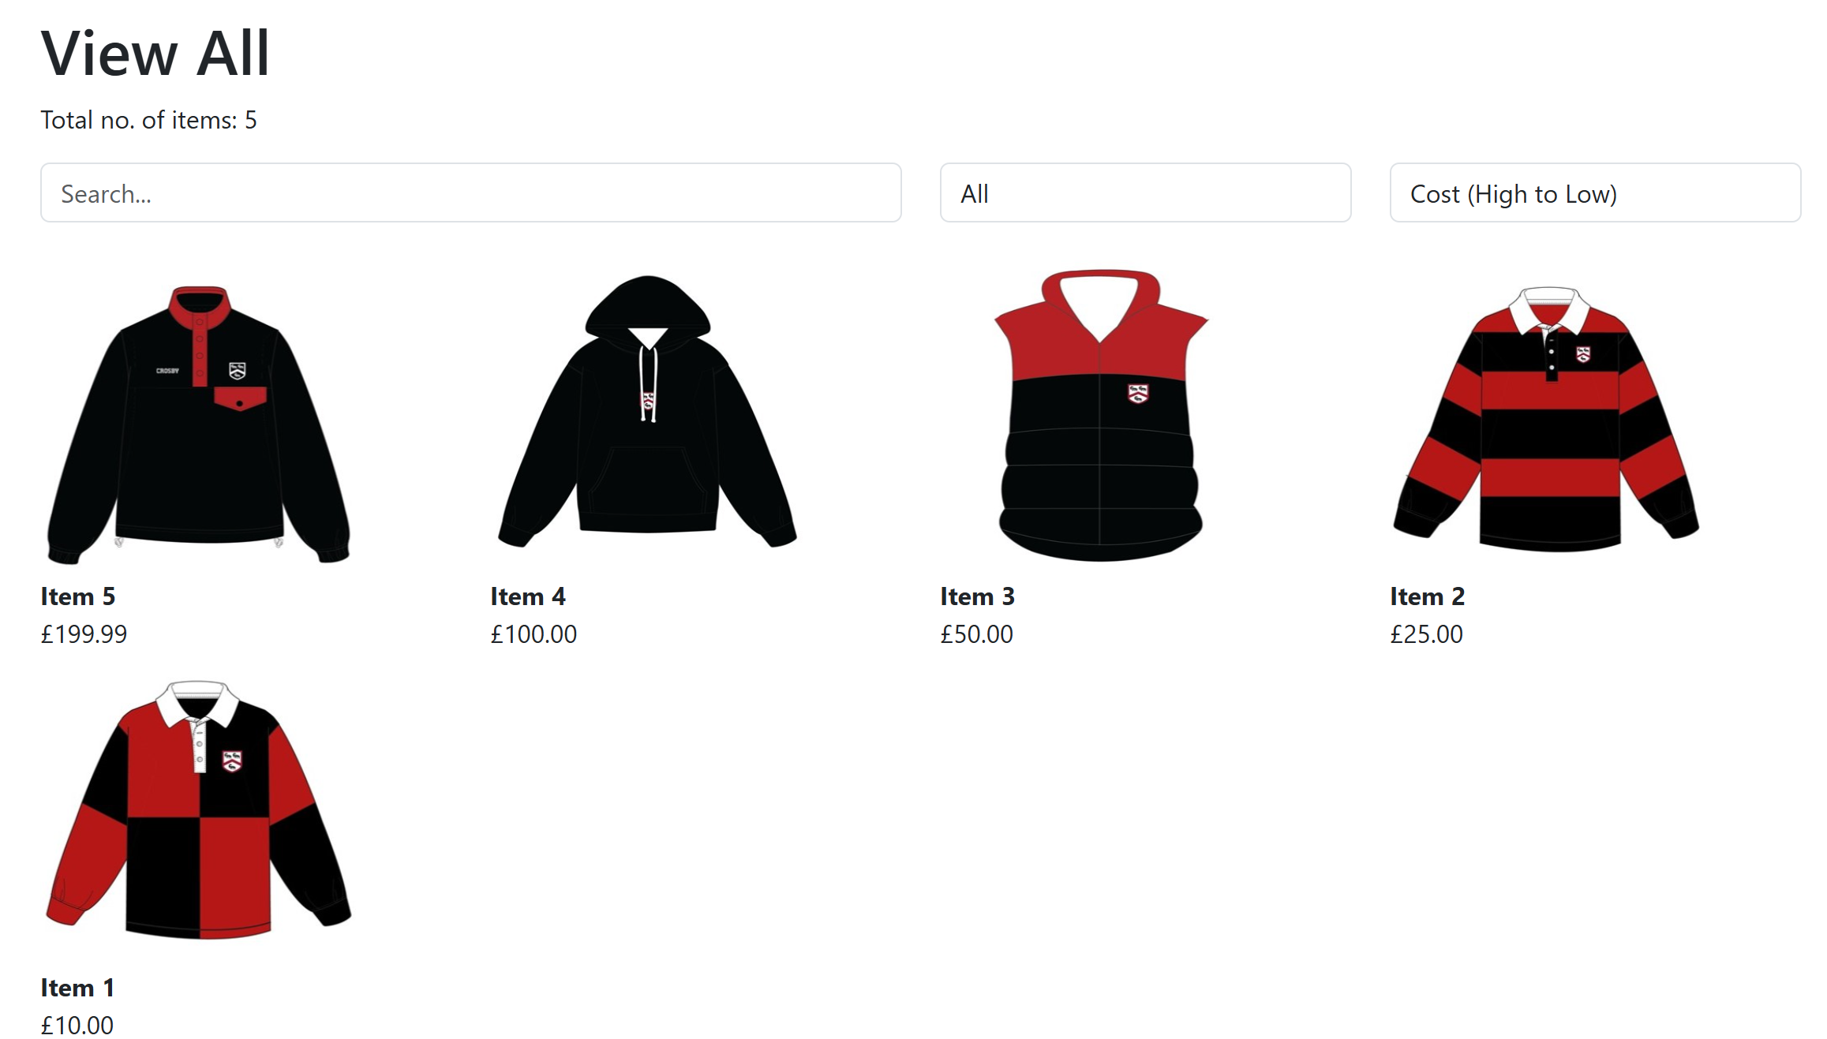This connects the function to the sort drop down list to test it.

Final Annotated Code:

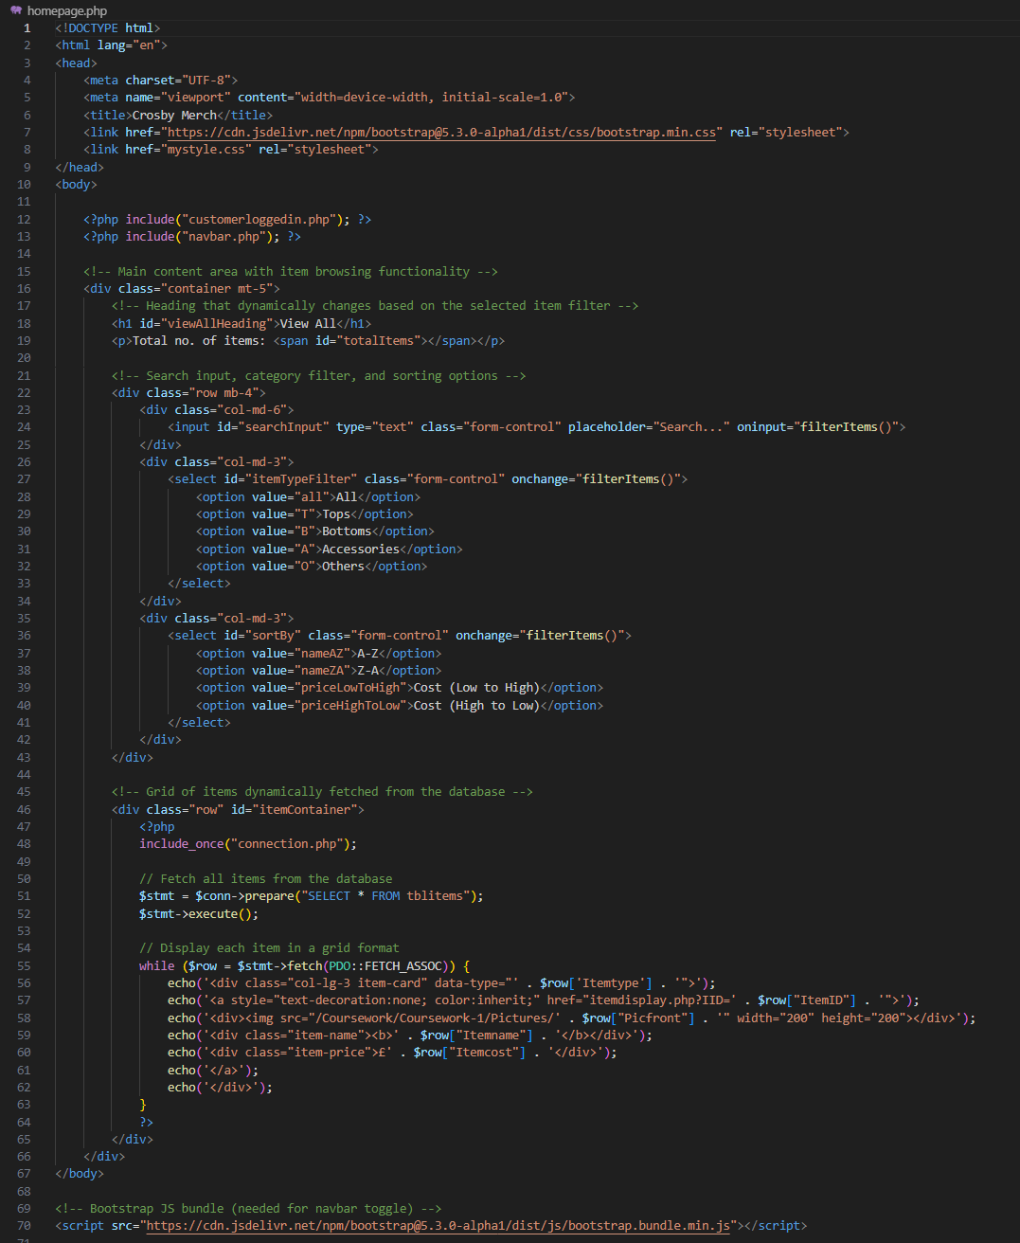

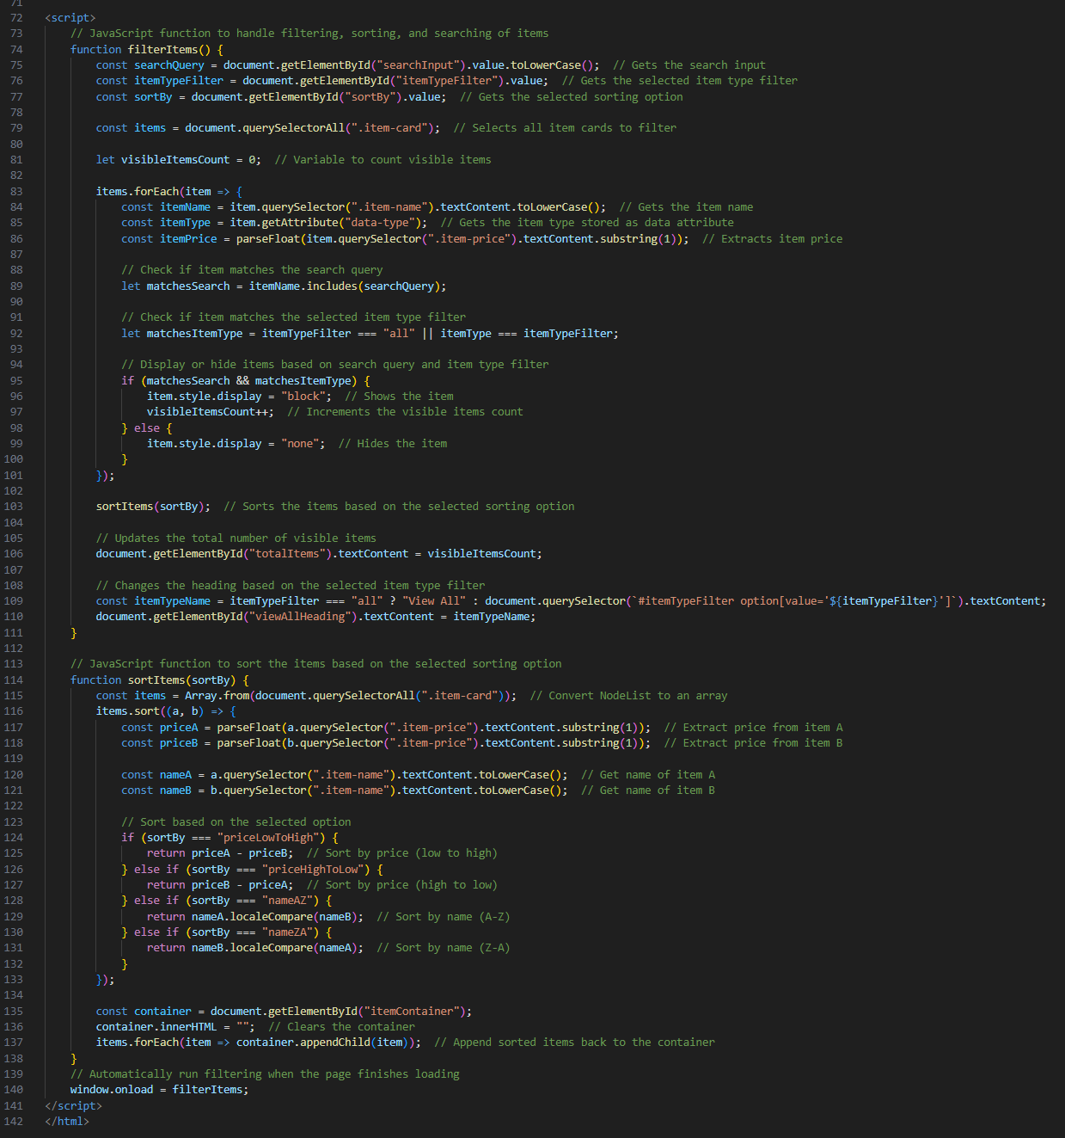

### Itemdisplay.php

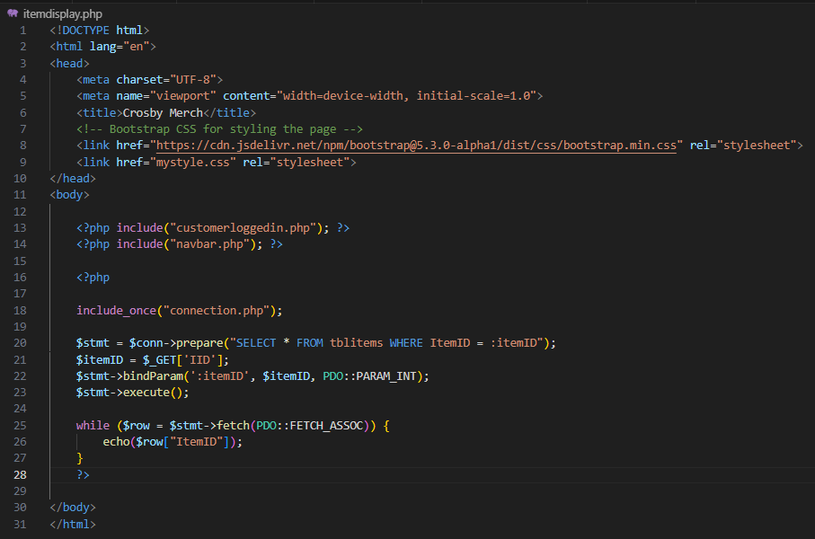This is the page that the user will be directed to when once they click on an item on the homepage.php. This page’s purpose is to display the details of the item, making sure the customer knows more about the item before they add it to their basket.

I started by including customerloggedin.php and navbar.php, then I started writing php code that will fetch the data of the specific item (taken from the query string of homepage.php). To test that I have the correct item, for now I chose to echo the ItemID of the fetched item.

Now that I know that data fetched is of the correct item, I can display it onto the page

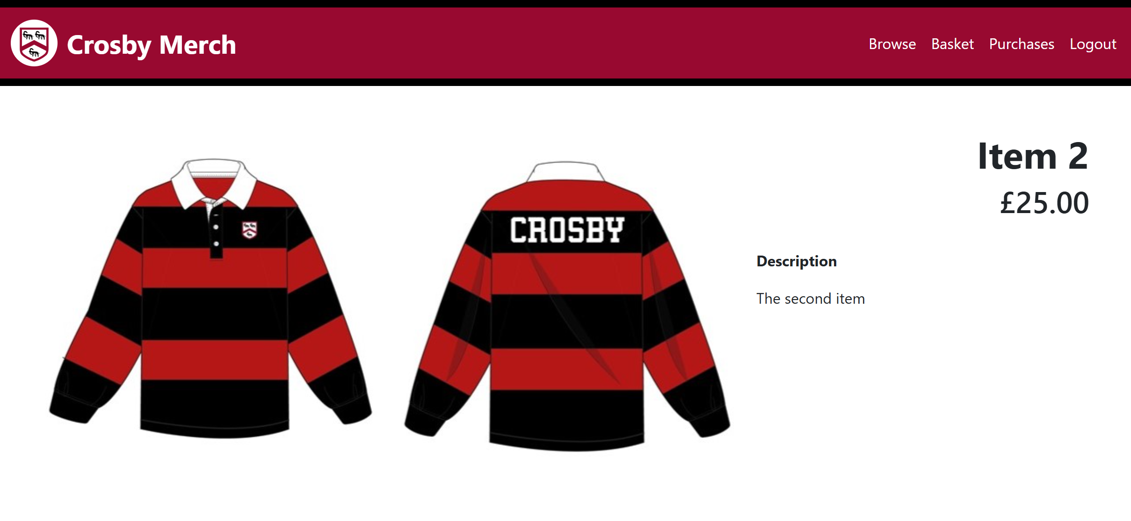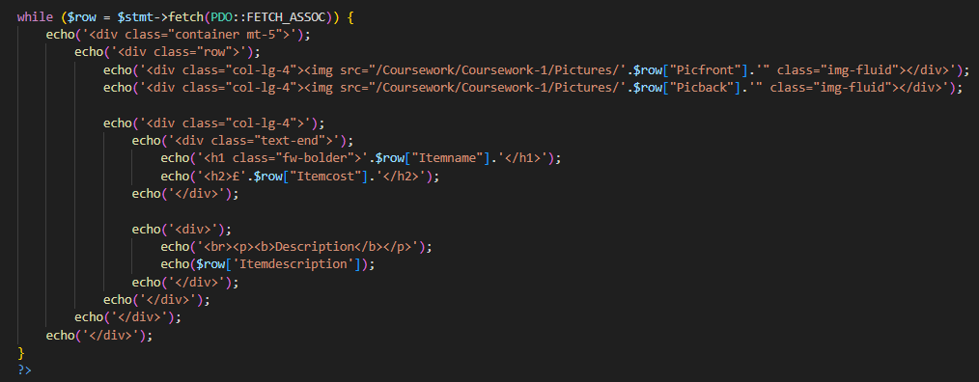Then I will need to add a form the will add the item into the customer’s basket. This form will need the size and quantity to be inputted by the user.

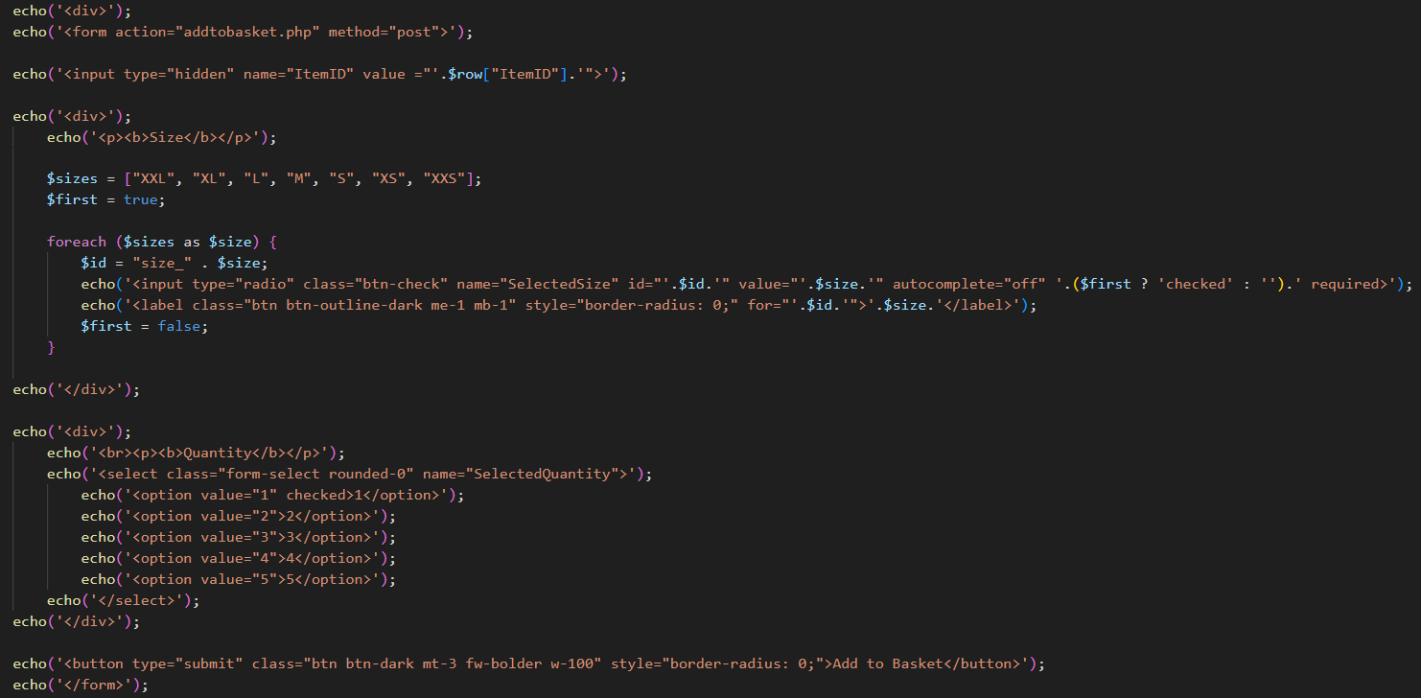 This is the code for the form that will send data to addtobasket.php which will add the item to the customer’s basket. The ItemID is a hidden input whilst the size and quantity is inputted by the user. I used bootstrap to decorate the form.

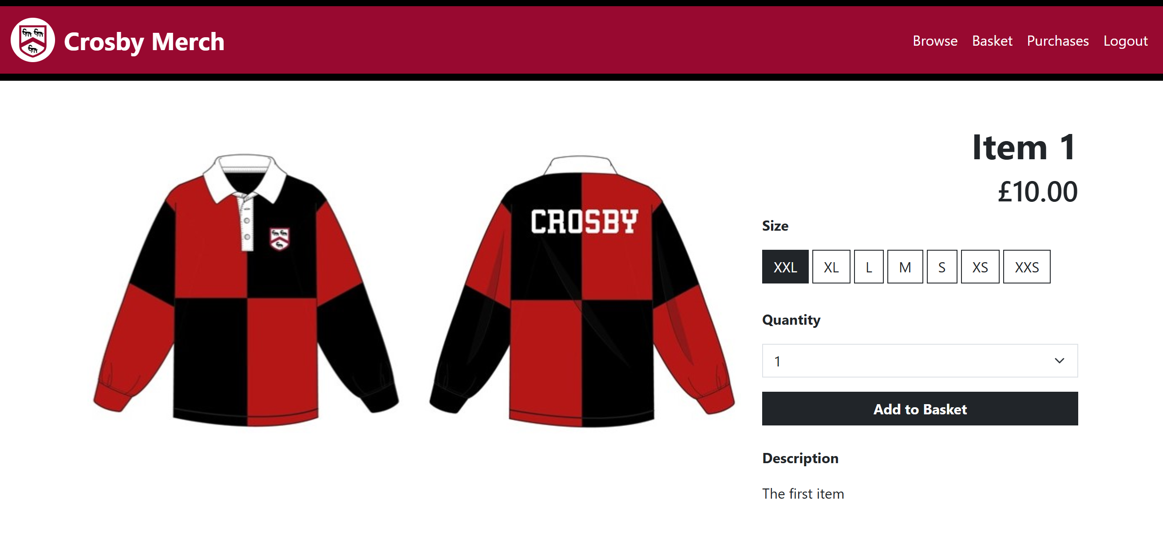

Final Annotated Code:

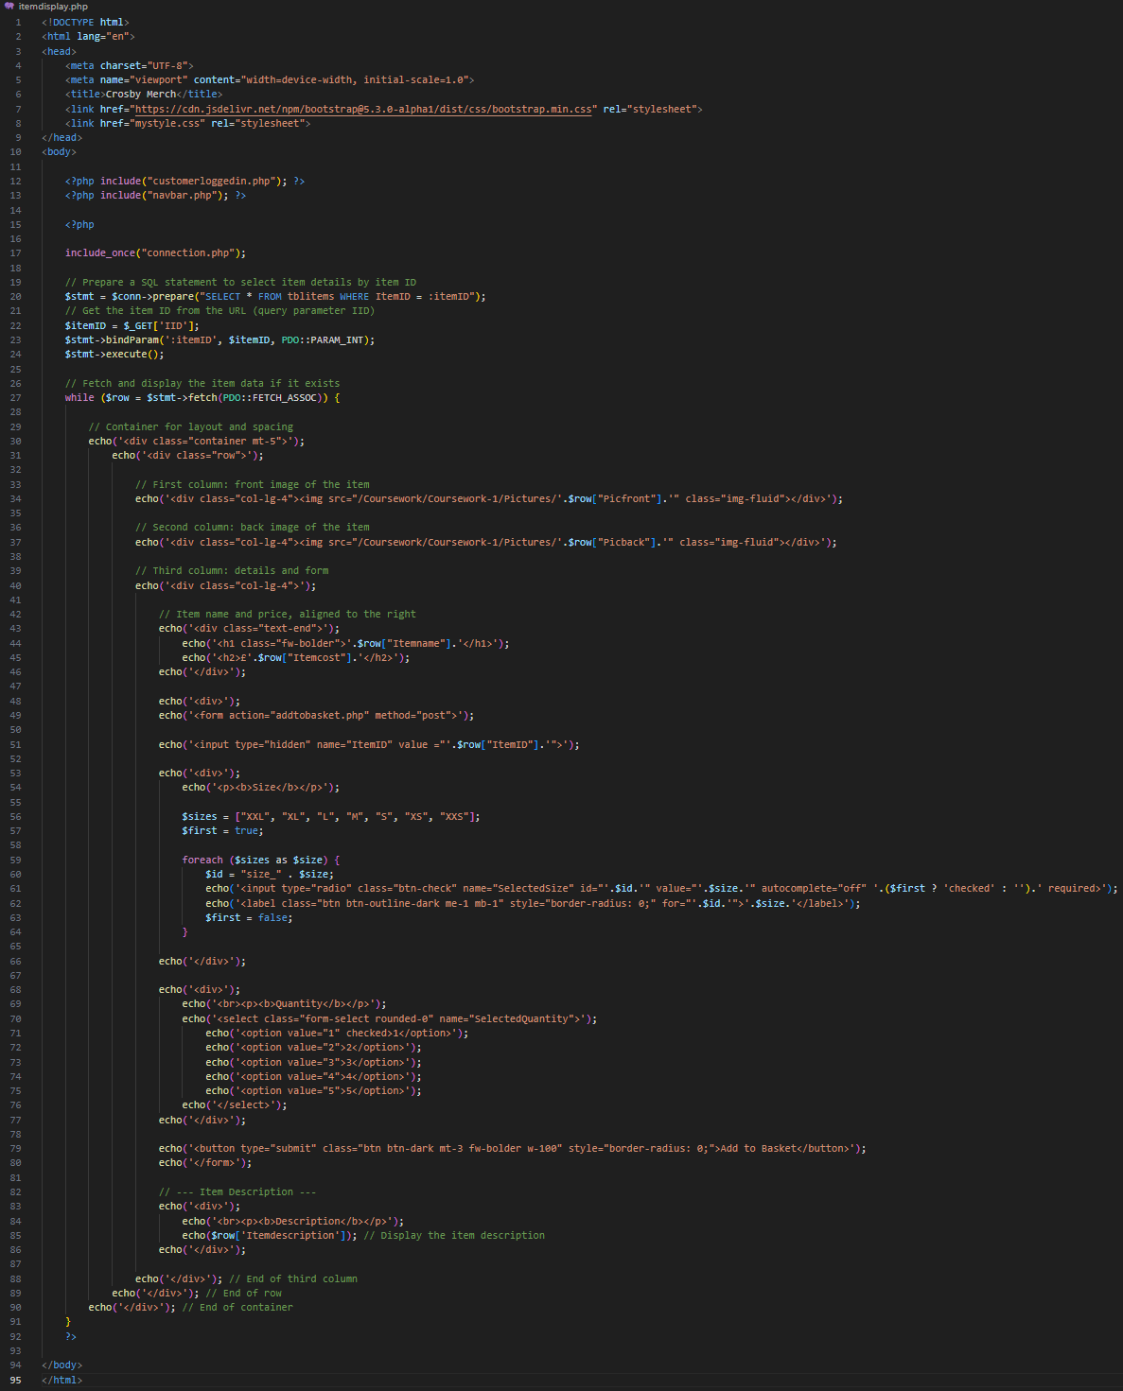

### Addtobasket.php

This page will handle the form that has been sent from itemdisplay.php, using SQL to add the correct item, size and quantity to the customer’s basket in the database.

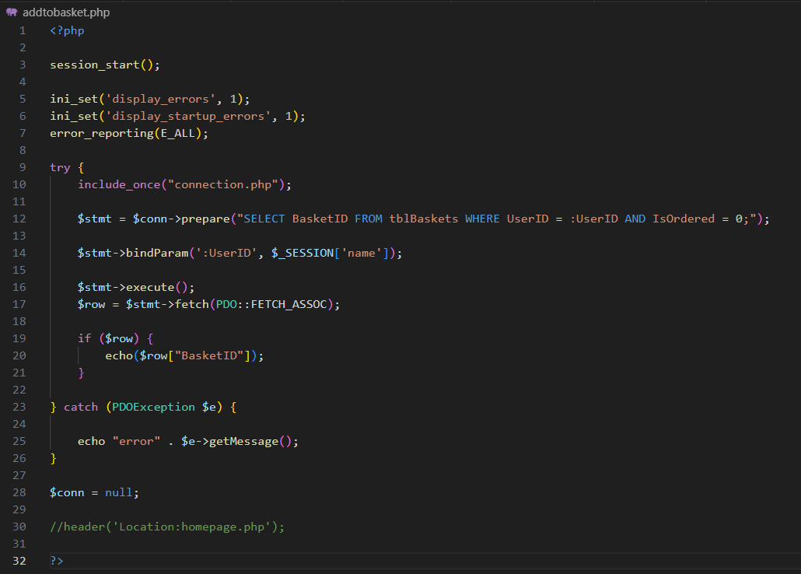Firstly I had to find the BasketID that I will be adding the item to:

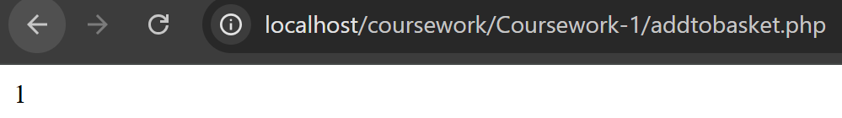This code finds the correct BasketID (unordered) through the session “name” which stores the user’s UserID. In this code, I have commented out the header since I want to test that it will be added to the correct basket. To check this, I will echo the BasketID that has been read from the data base.

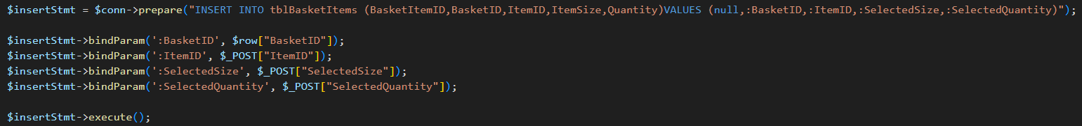Now that I have the correct BasketID, I will write the SQL that will replace the echo and uncomment the header back into the code.

This SQL will insert BasketID, ItemID, ItemSize and Quantity into TblBasketItems.

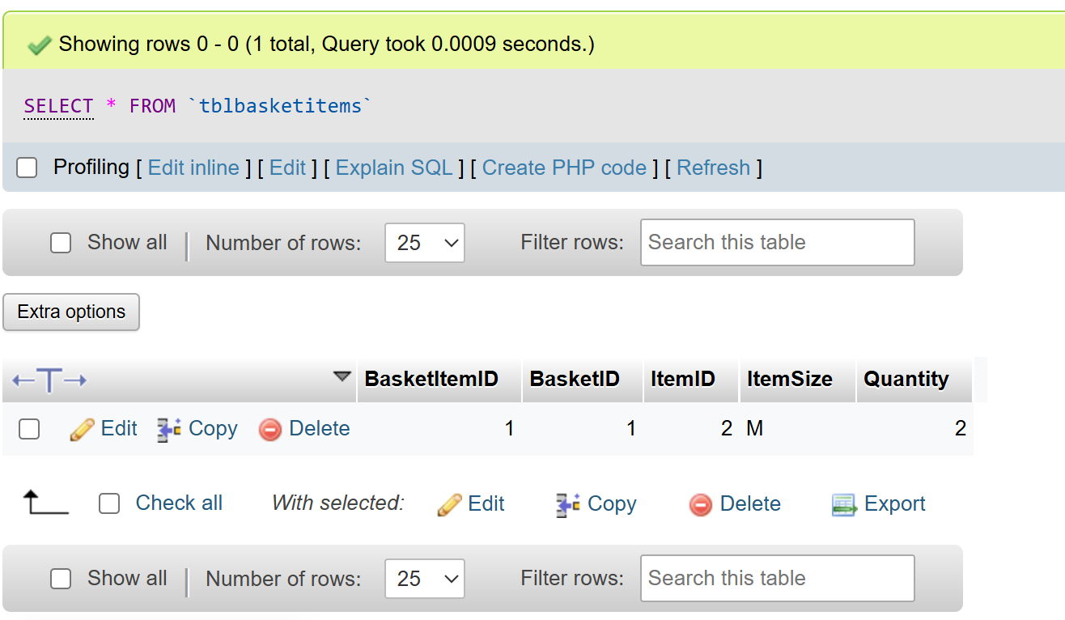After running the code, I checked the TblBasketItems on phpMyAdmin and the data has been entered into the database correctly, indicating that my code works properly.

Final Annotated Code:

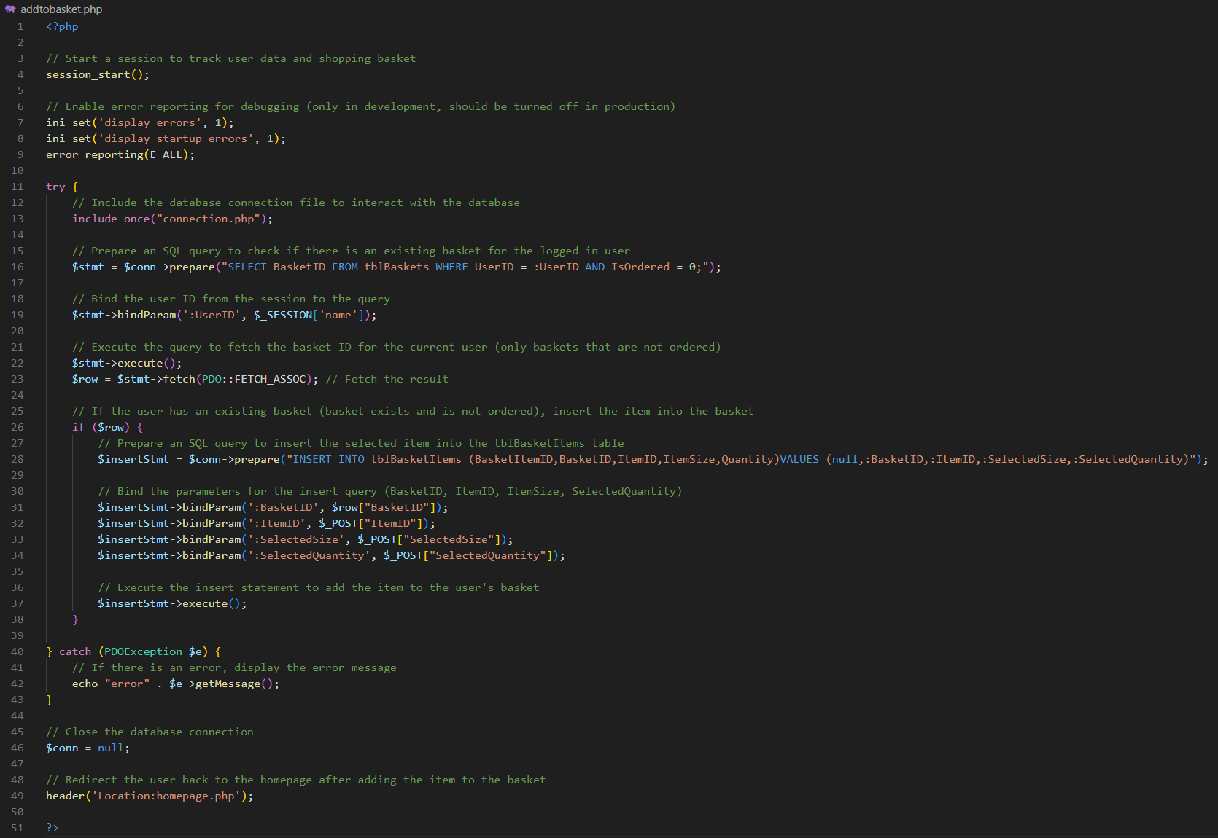

### Basket.php

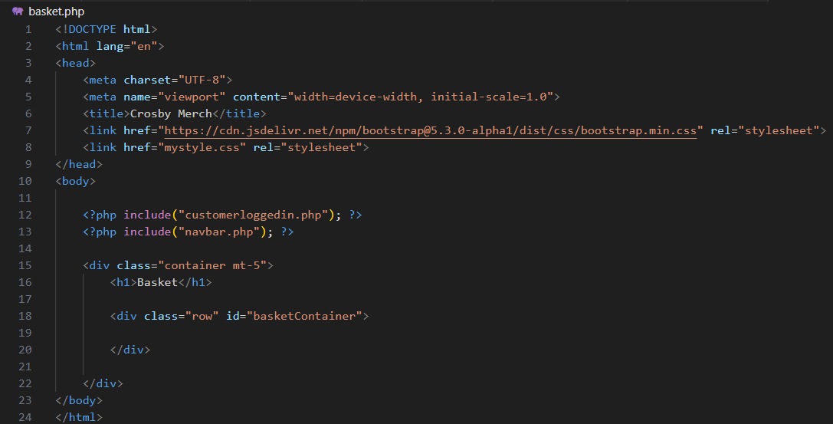This page’s purpose is to display details of the items added to the basket. It provides the customer with a clear and organized view of all the products they have selected to purchase, including important information such as item names, sizes, quantities, individual prices, and the total cost.

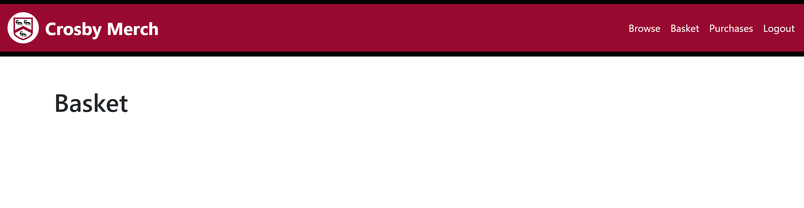I chose to code the page layout before implementing the PHP functionality because it allows me to focus first on the structure, design, and user experience of the webpage.

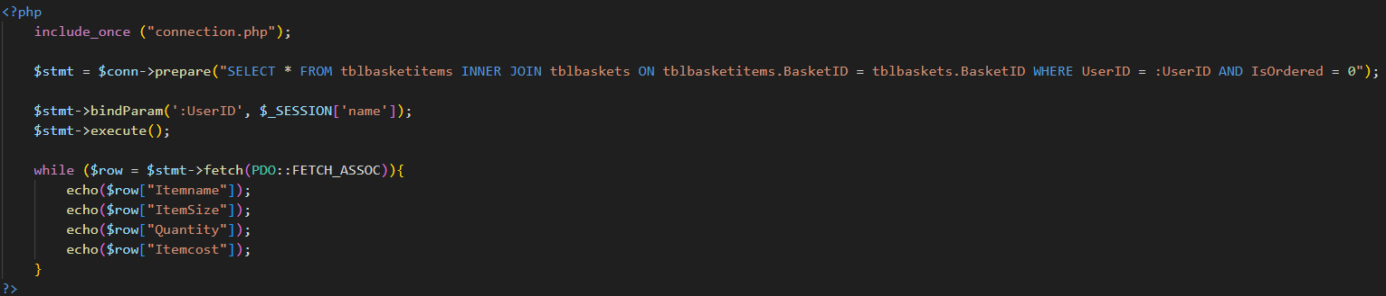With the layout correctly set, I carry on to write the SQL to select the data from the data base to be displayed onto the page.

This is the SQL that I wrote, it will use session “name” as the UserID, then it will find the inactive BasketID that belongs to that user. Then, using that BasketID it will select the data required to be displayed (e.g. Item name, quantity, size). To check that the correct data needed has been selected, I use echoes to display them.

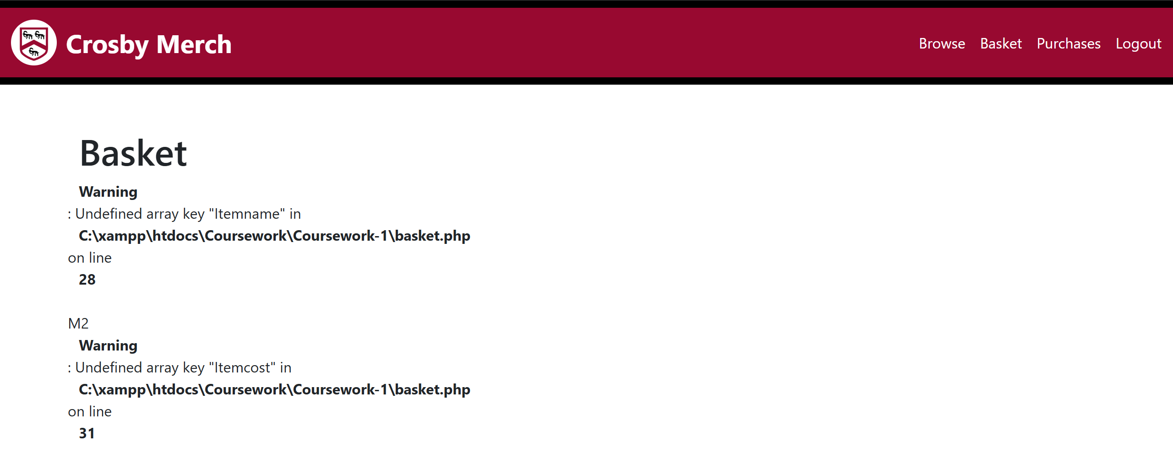When I ran the code, an error occurred. Upon closer inspection of my code I realised that I have not inner joined TblItems which meant that I was not able to get the item name and cost.

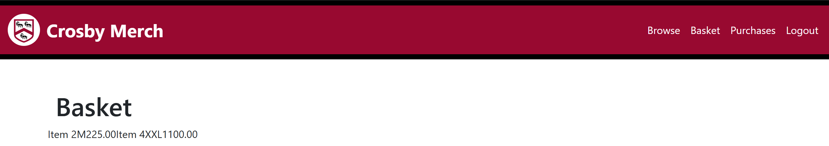This new SQL code includes an inner join to the TblItems.

Now that I know I have all the correct data that I need, I will make it display nicely in the main contents area.

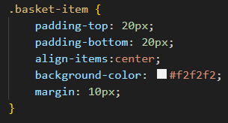I created a CSS class for items to be displayed nicely since the item will be displayed in a similar fashion in many of the other pages.

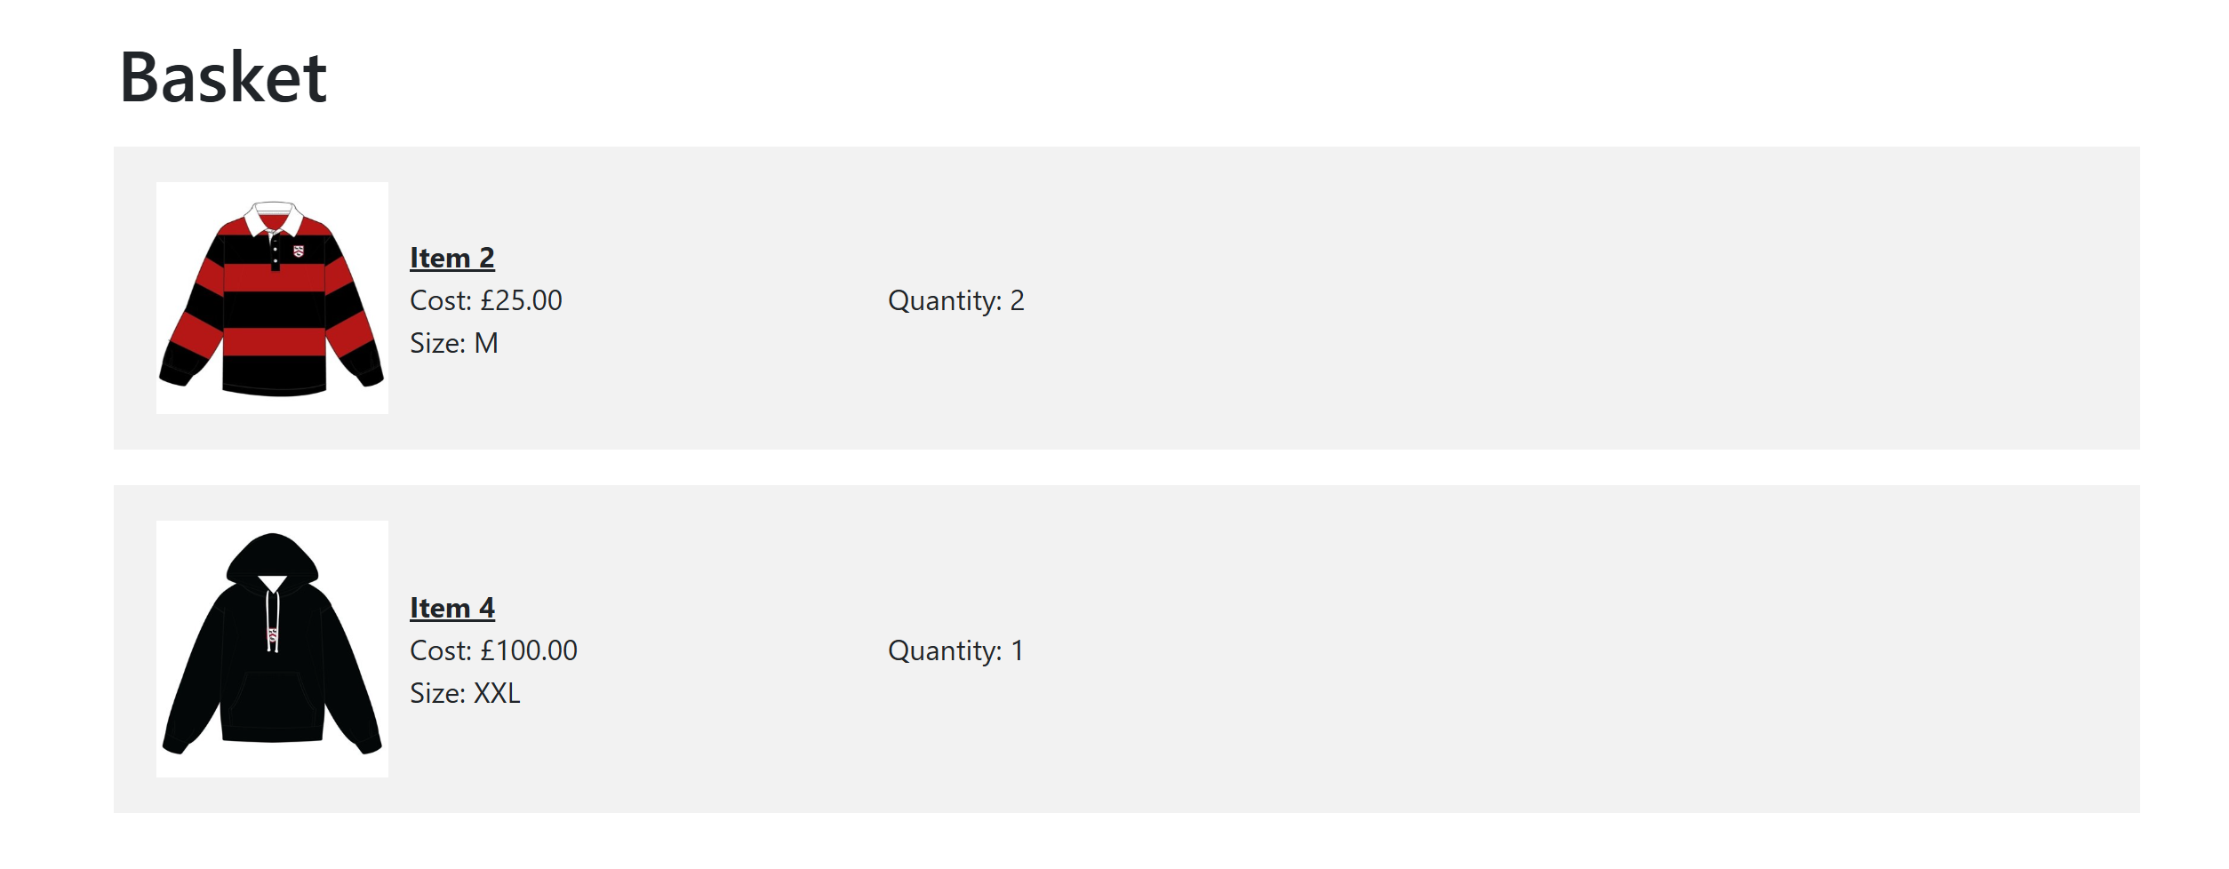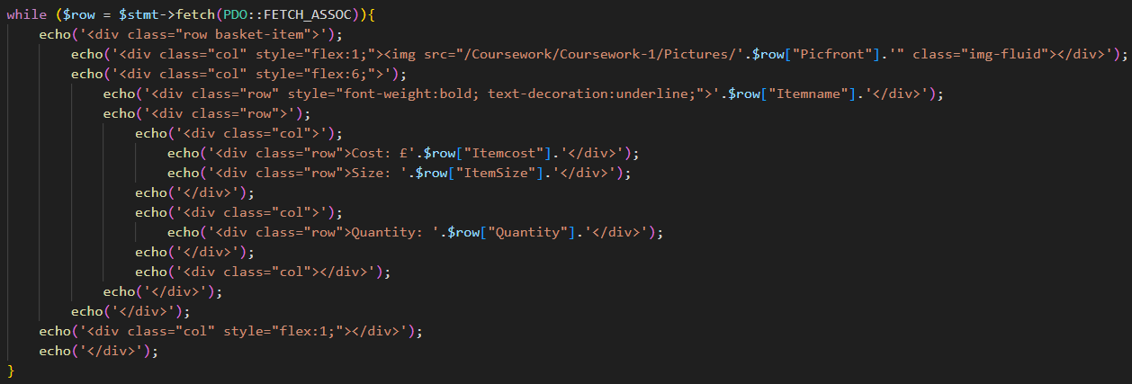This code sets the layout for the items display.

To find the total cost of the basket, I must sum up the total cost of each item, which is the product of the item cost and selected quantity.

This is the code to calculate individual items costs then display them.

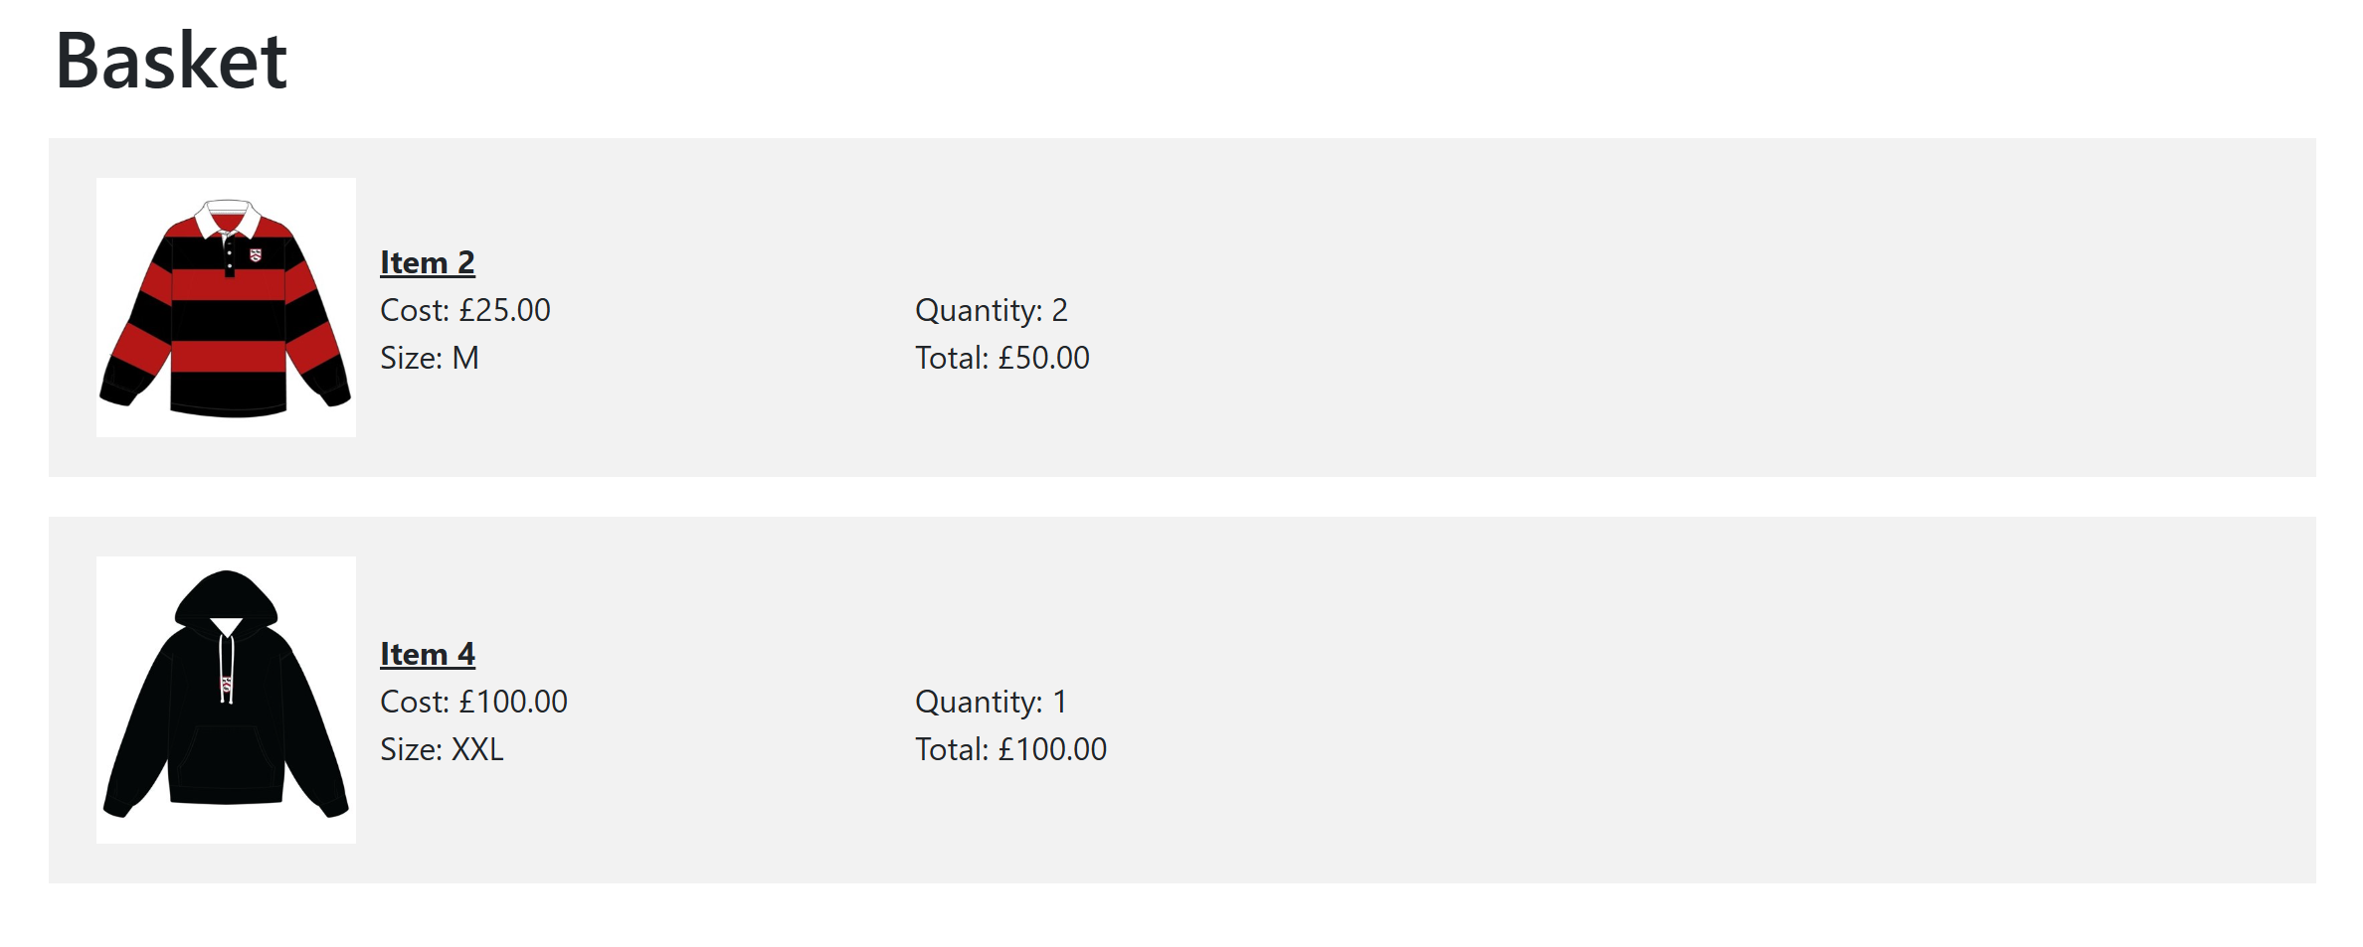Now I need to sum up all of the total individual items costs to get the total cost of the basket.

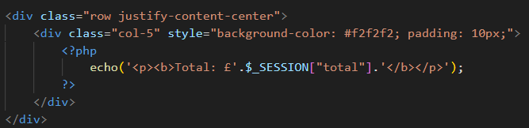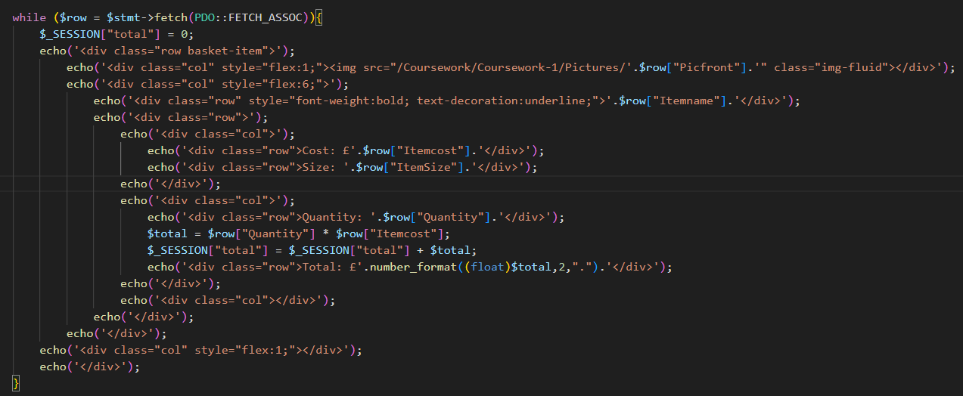I added a session called total set to 0, and every time a total for an item is calculated, it will be added to the session total.

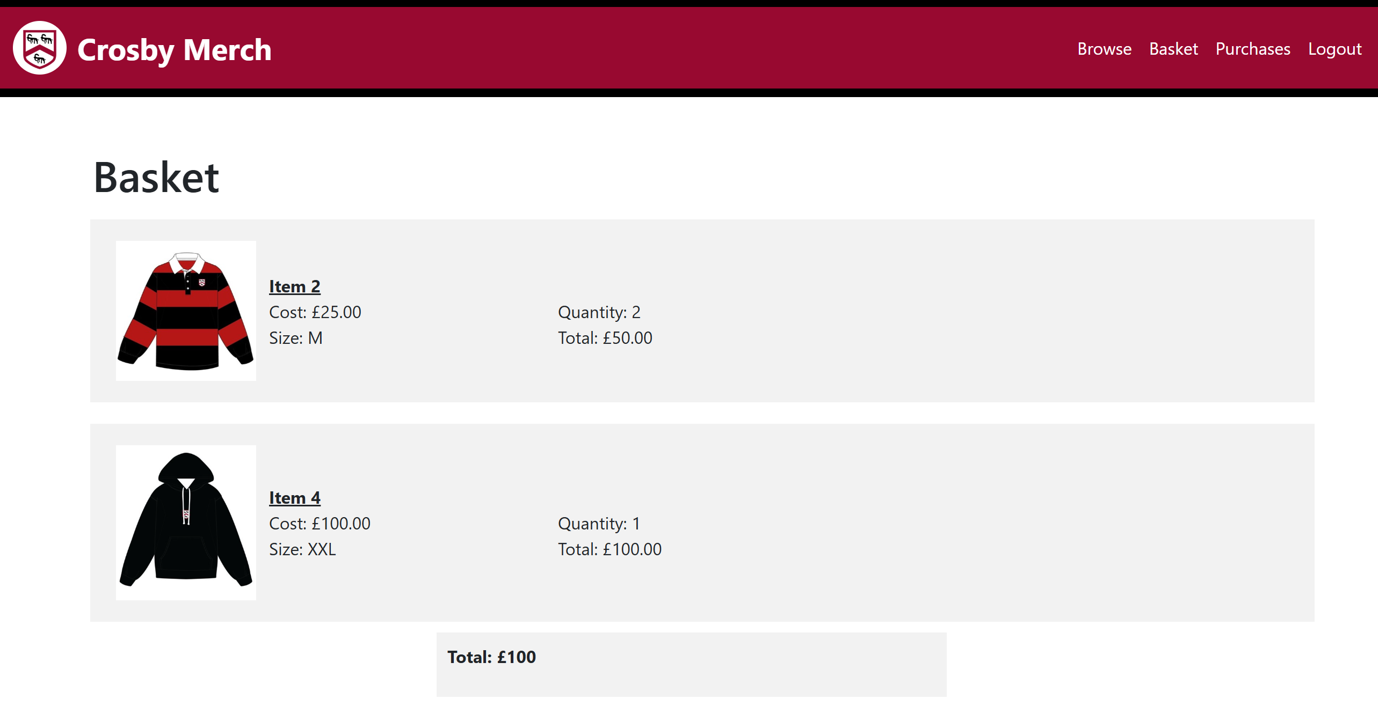This is the code for a section to display the Basket total (taken from session total).

However when I ran the code, the total was incorrect (displaying 100 instead of 150).

Going through the code I found out that the error is due to creating the session inside of a loop, meaning that it is reset back to zero every time a new item is being displayed.

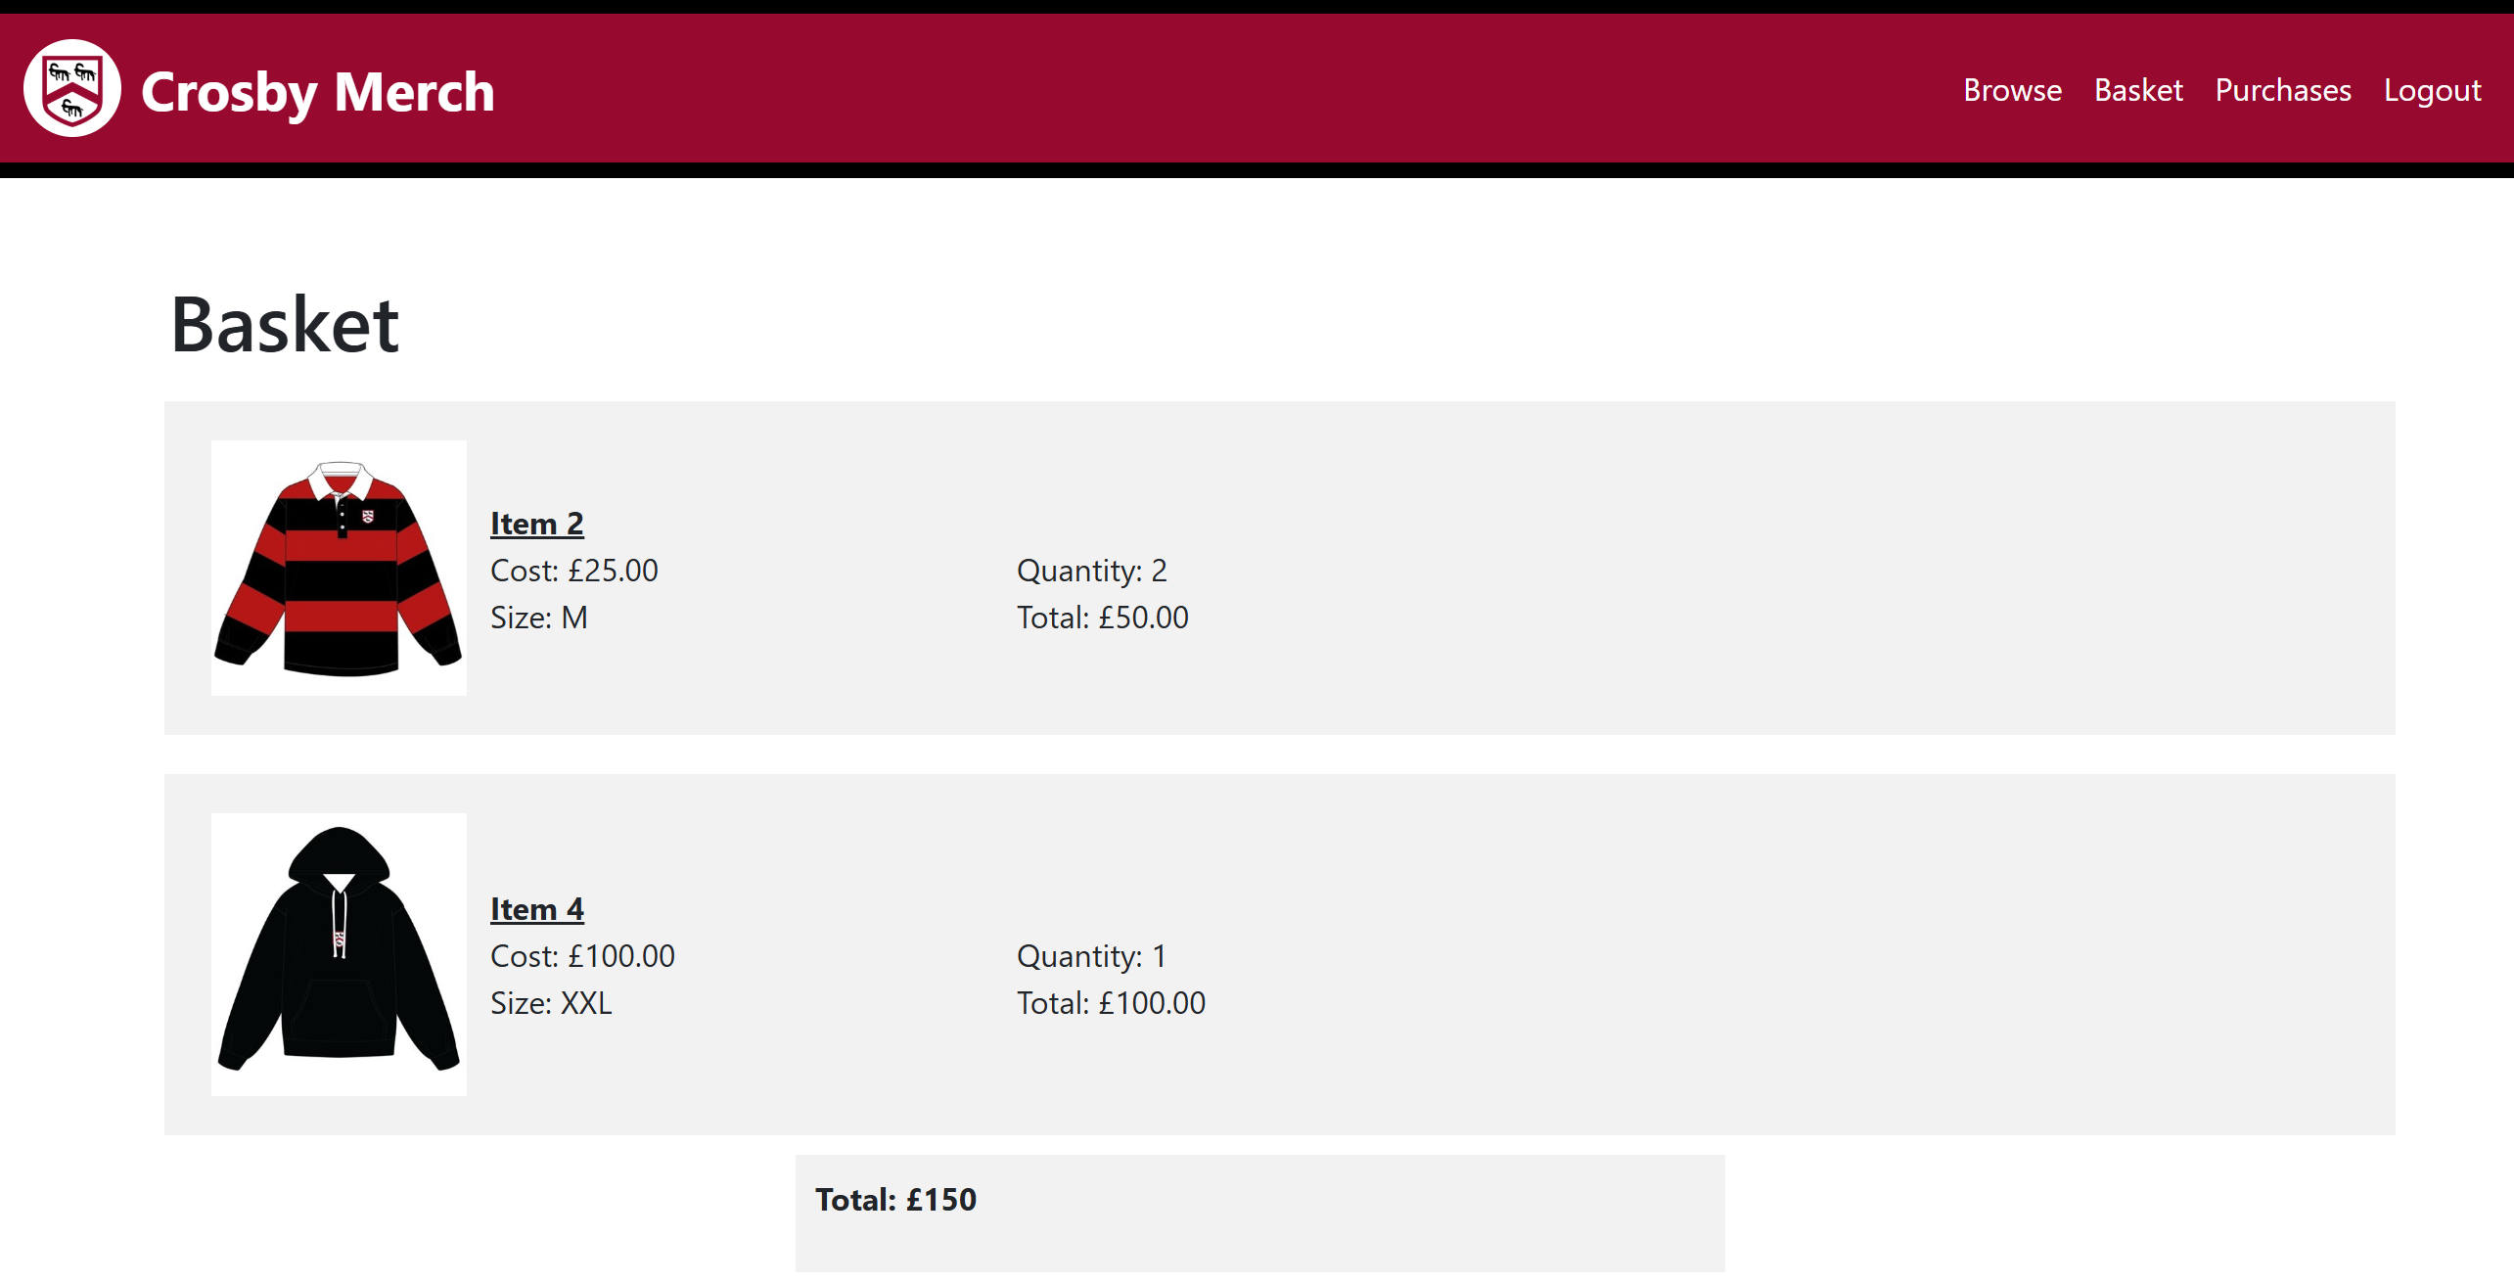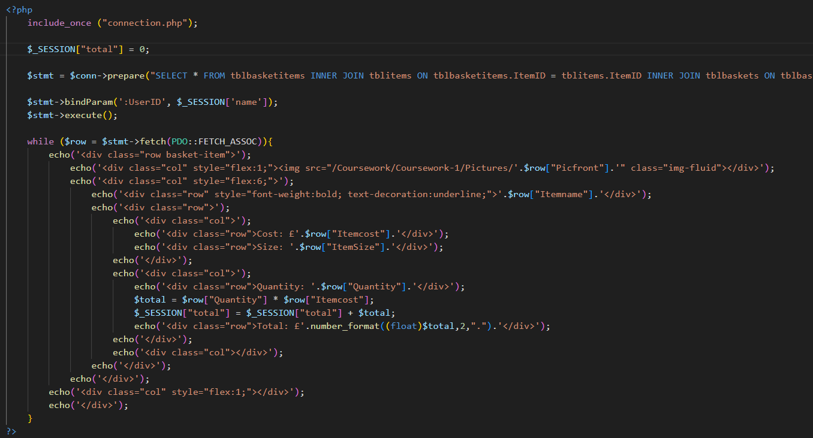To fix this, I set the session before the loop.

Now that everything is ready, I will set up a form to send all the data to confirmpurchase.php which will be some SQL to purchase the basket, making it into an order. This form will send in the BasketID and the total cost. However to make it simpler, I decided to send over the details through sessions instead since the total cost was also already in a session.

Starting a session to hold the BasketID.

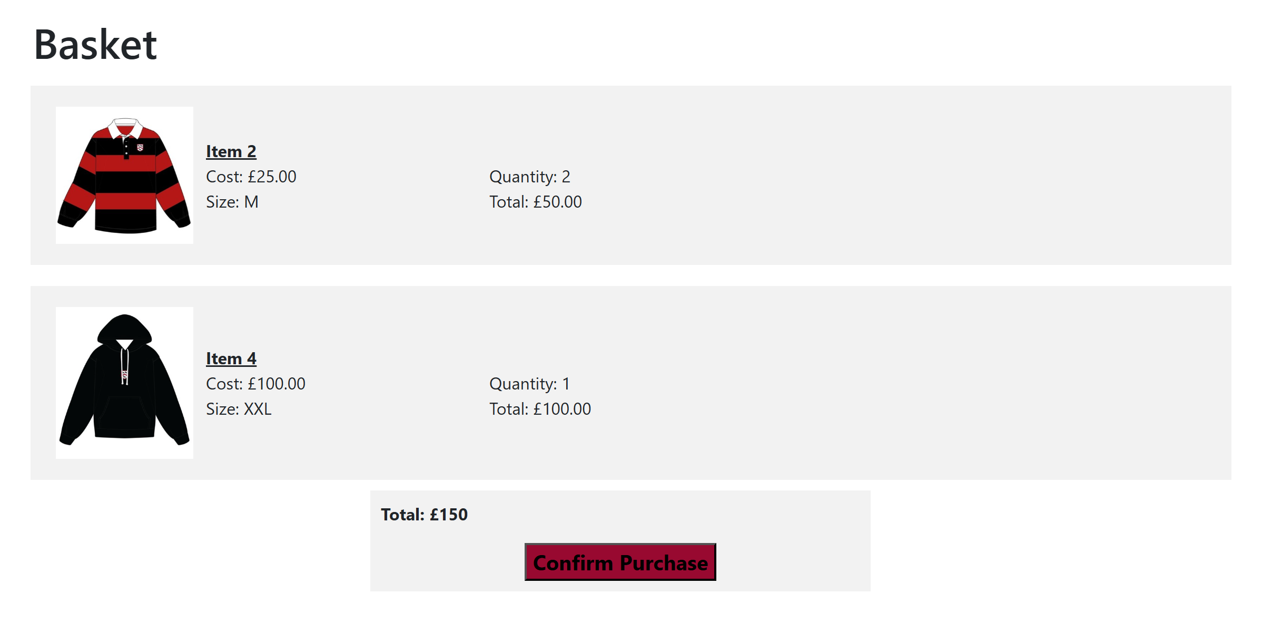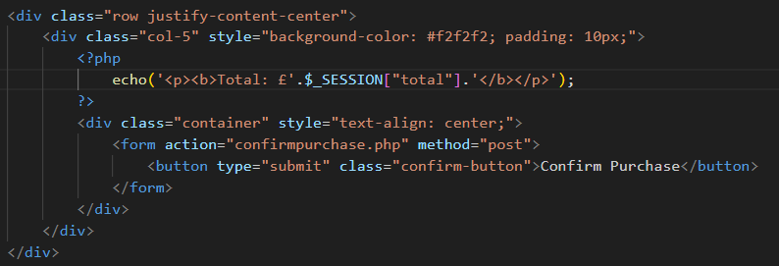Code to display and submit form.

Final Annotated Code:

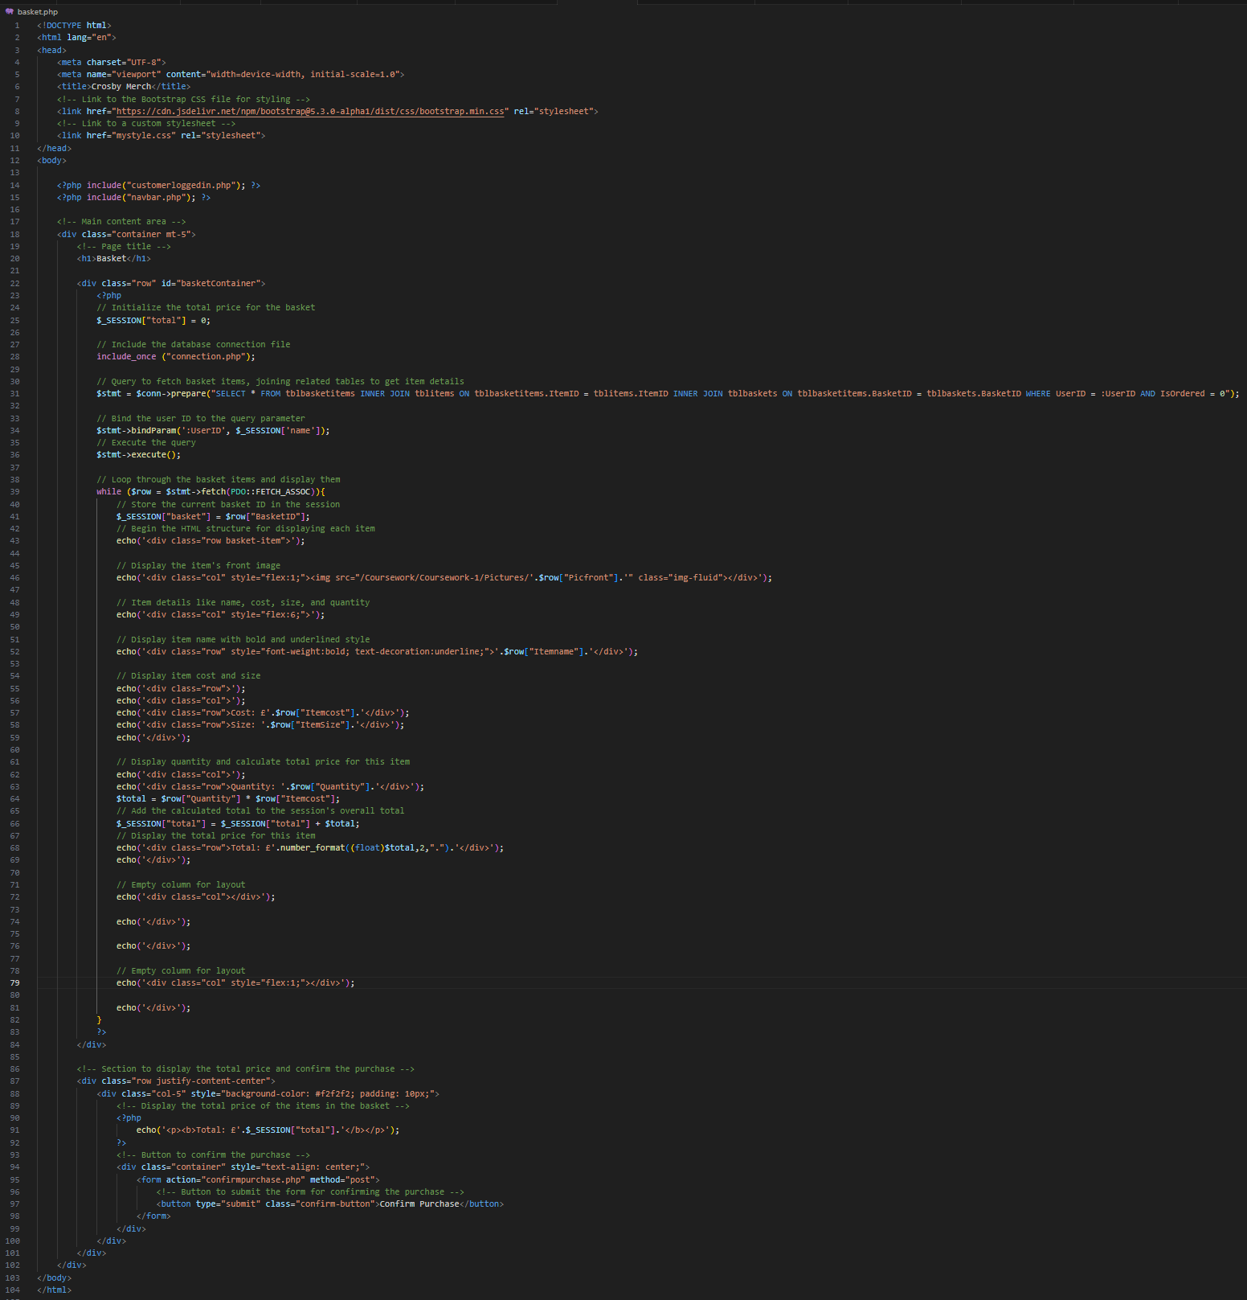

### Confirmpurchase.php

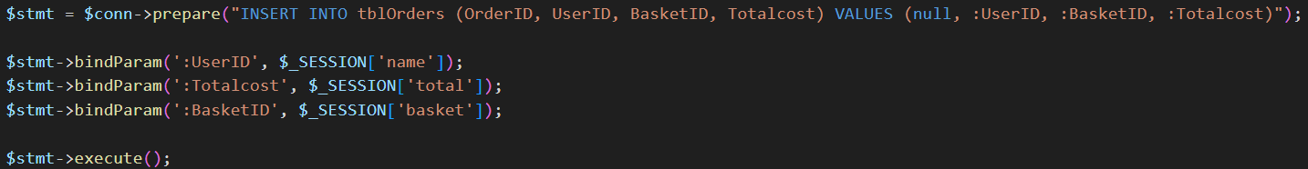This page will handle the processing of the basket. Using the sessions set in the basket.php page, this page will turn the basket into an order in using three main parts, inserting the UserID BasketID and Totalcost into TblOrders, updating the basket to status to ordered, creating a new basket unordered for the user.

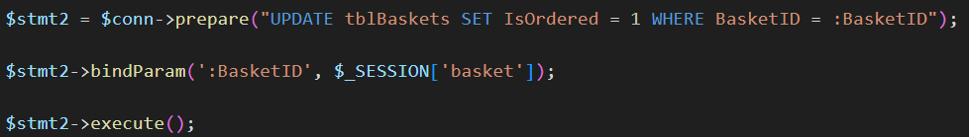This is the SQL that will insert UserID, BasketID and Totalcost into TblOrders, converting the basket to an order. The values are taken by the sessions set up in basket.php

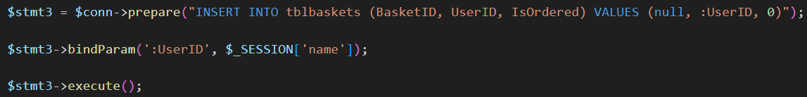This is the SQL that will update the status of the user’s basket to ordered, (0 → 1) this will stop the basket from being added to once it has been purchased. It will also be used in viewing purchases made.

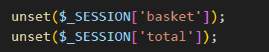This is the SQL that will create a new unordered (0) basket for the user by inserting UserID into TblBaskets, allowing the user to place more orders once their basket has been purchased.

After I have finished all of the SQL I will unset the sessions holding basket and total since they are no longer needed once the basket is confirmed.

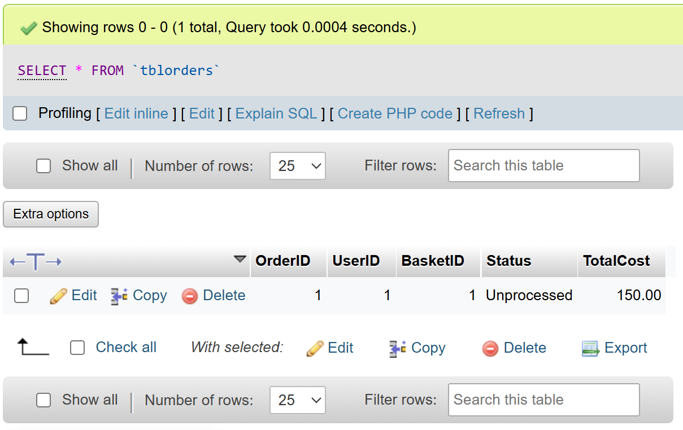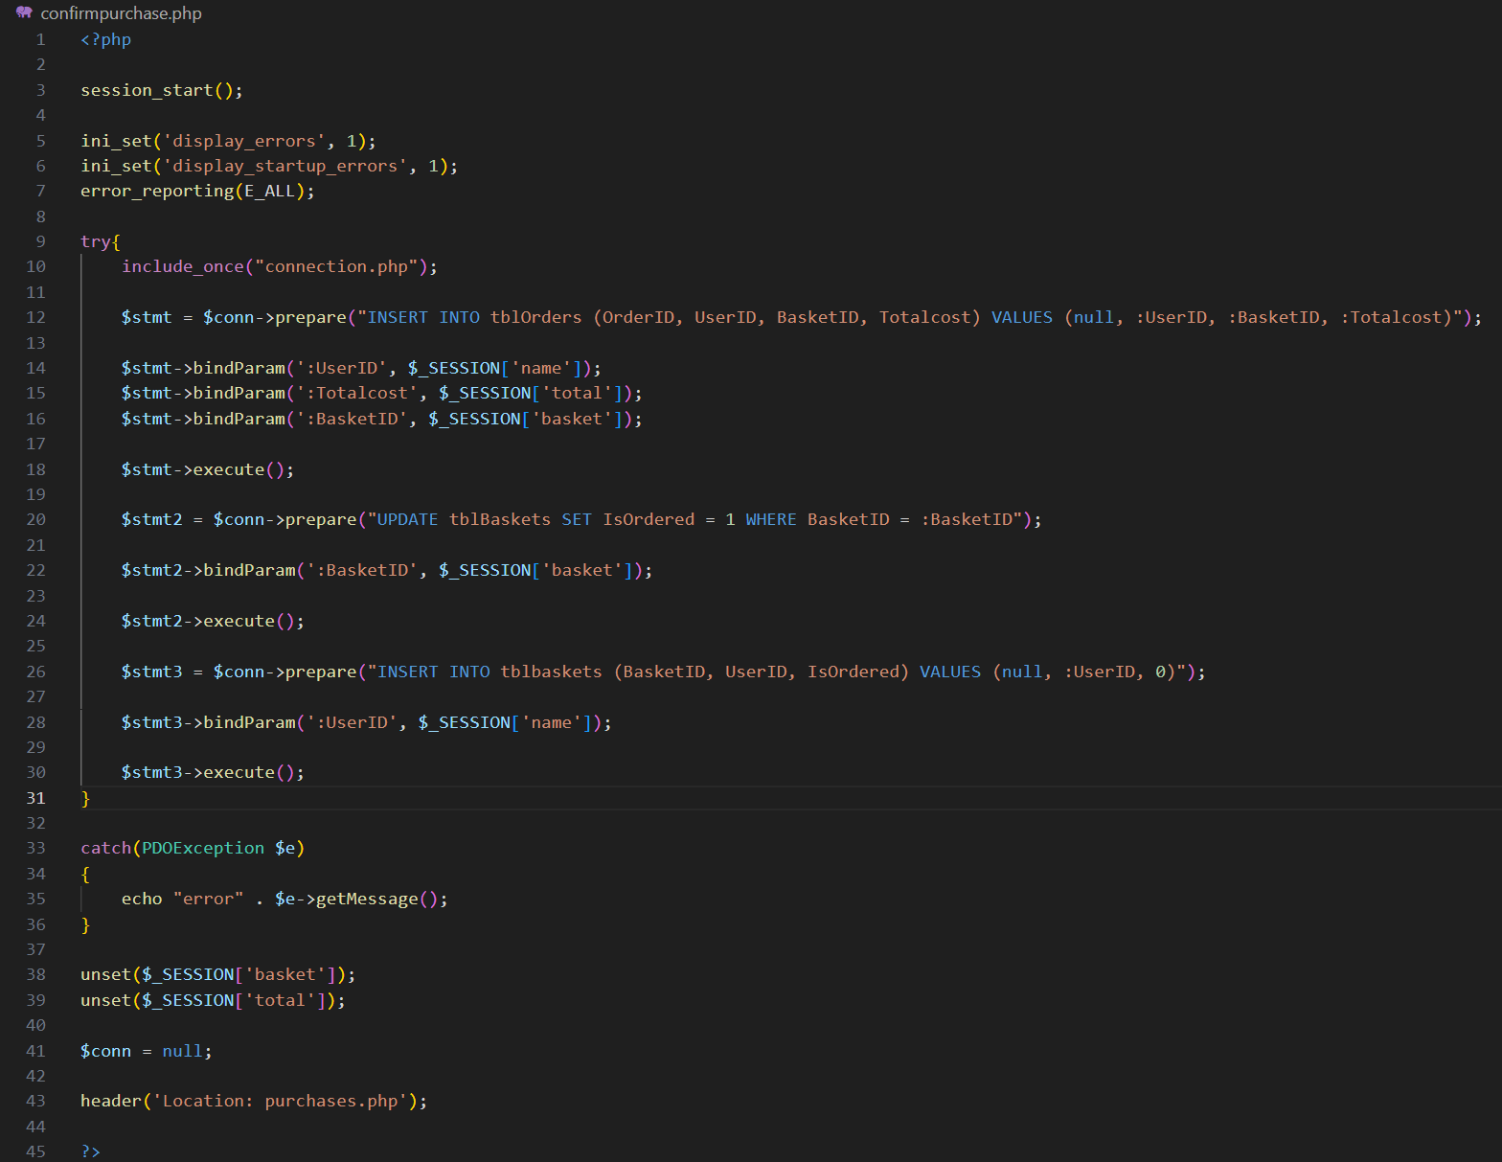I decided to add a header to the purchases page, this will show the user that their basket has been ordered. This is what my code looks like once I put all of it together.

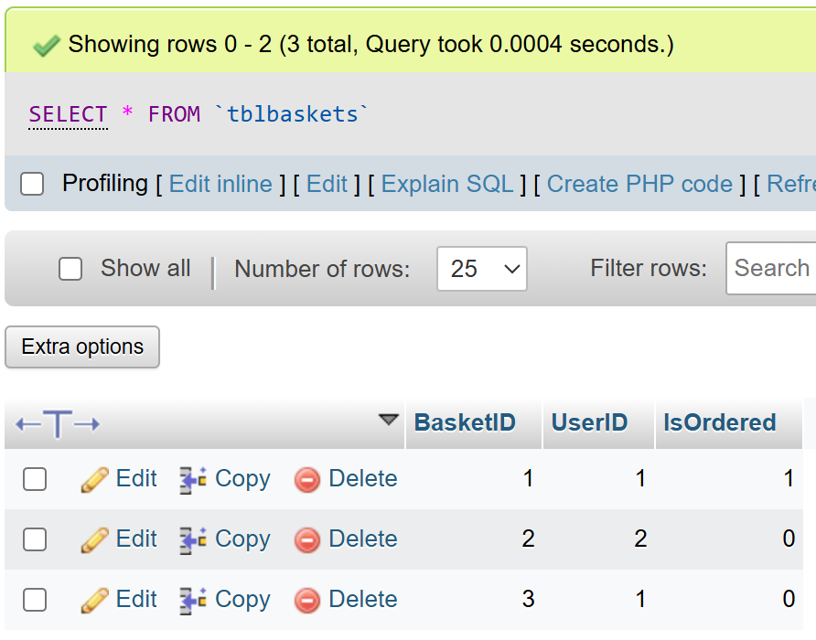After running the code, I checked the TblOrders and TblBaskets on phpMyAdmin and the data has been entered into the database correctly, indicating that my code works properly.

Final Annotated Code:

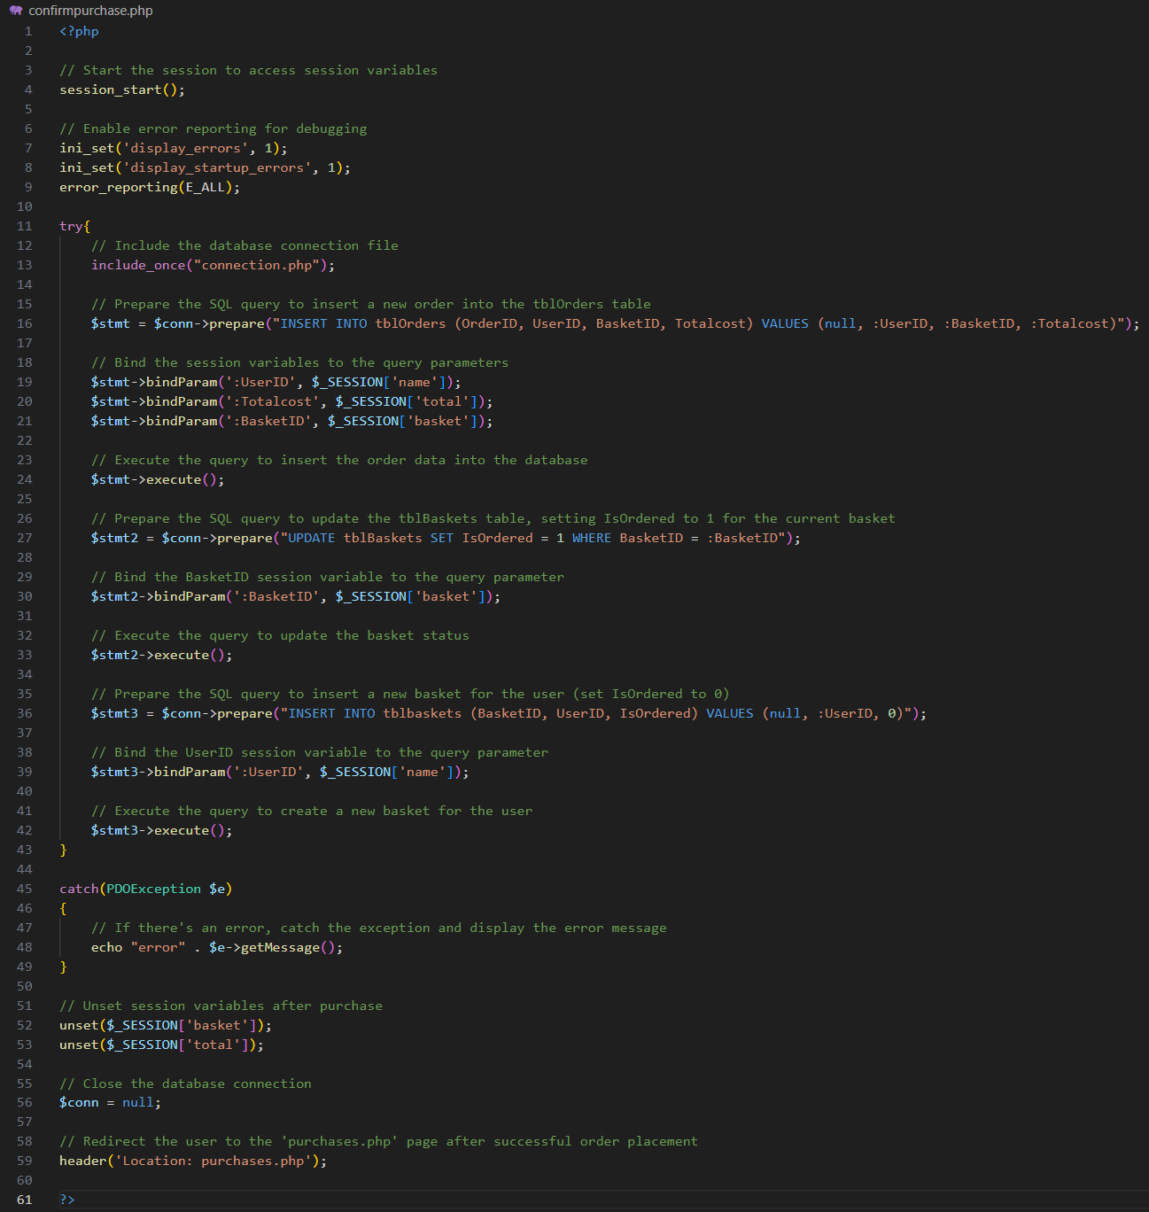

### Purchases.php

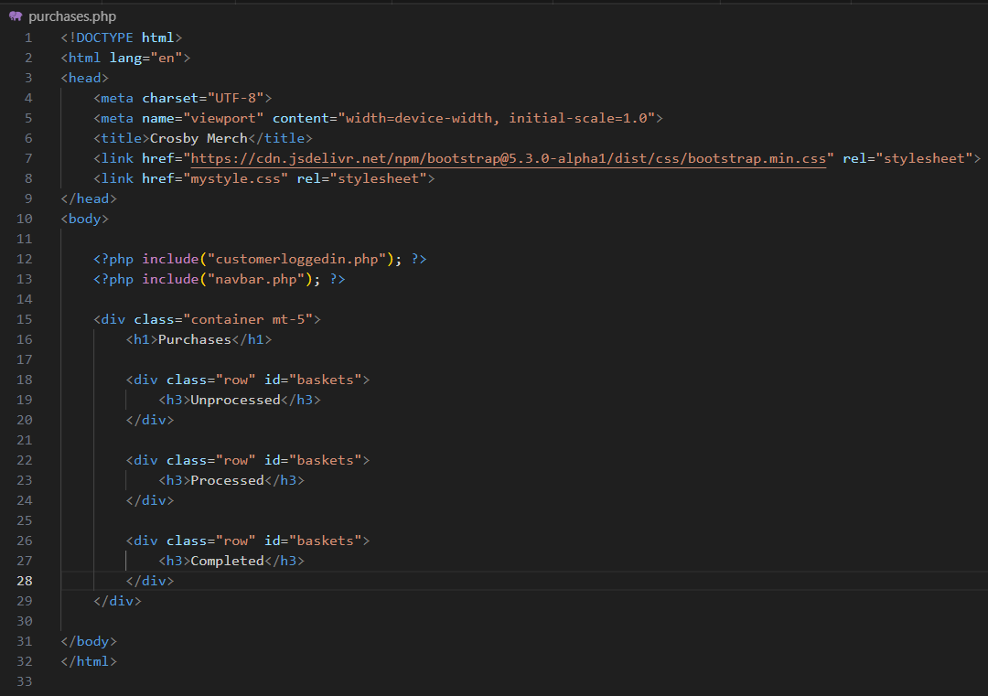This is the page that the user will be directed to when once they have ordered their basket. This page’s purpose is to display all of the orders that has been made by the user, displaying them based on the status of the order (unprocessed, processed, finished). The user should be able to click on each order to check its contents.

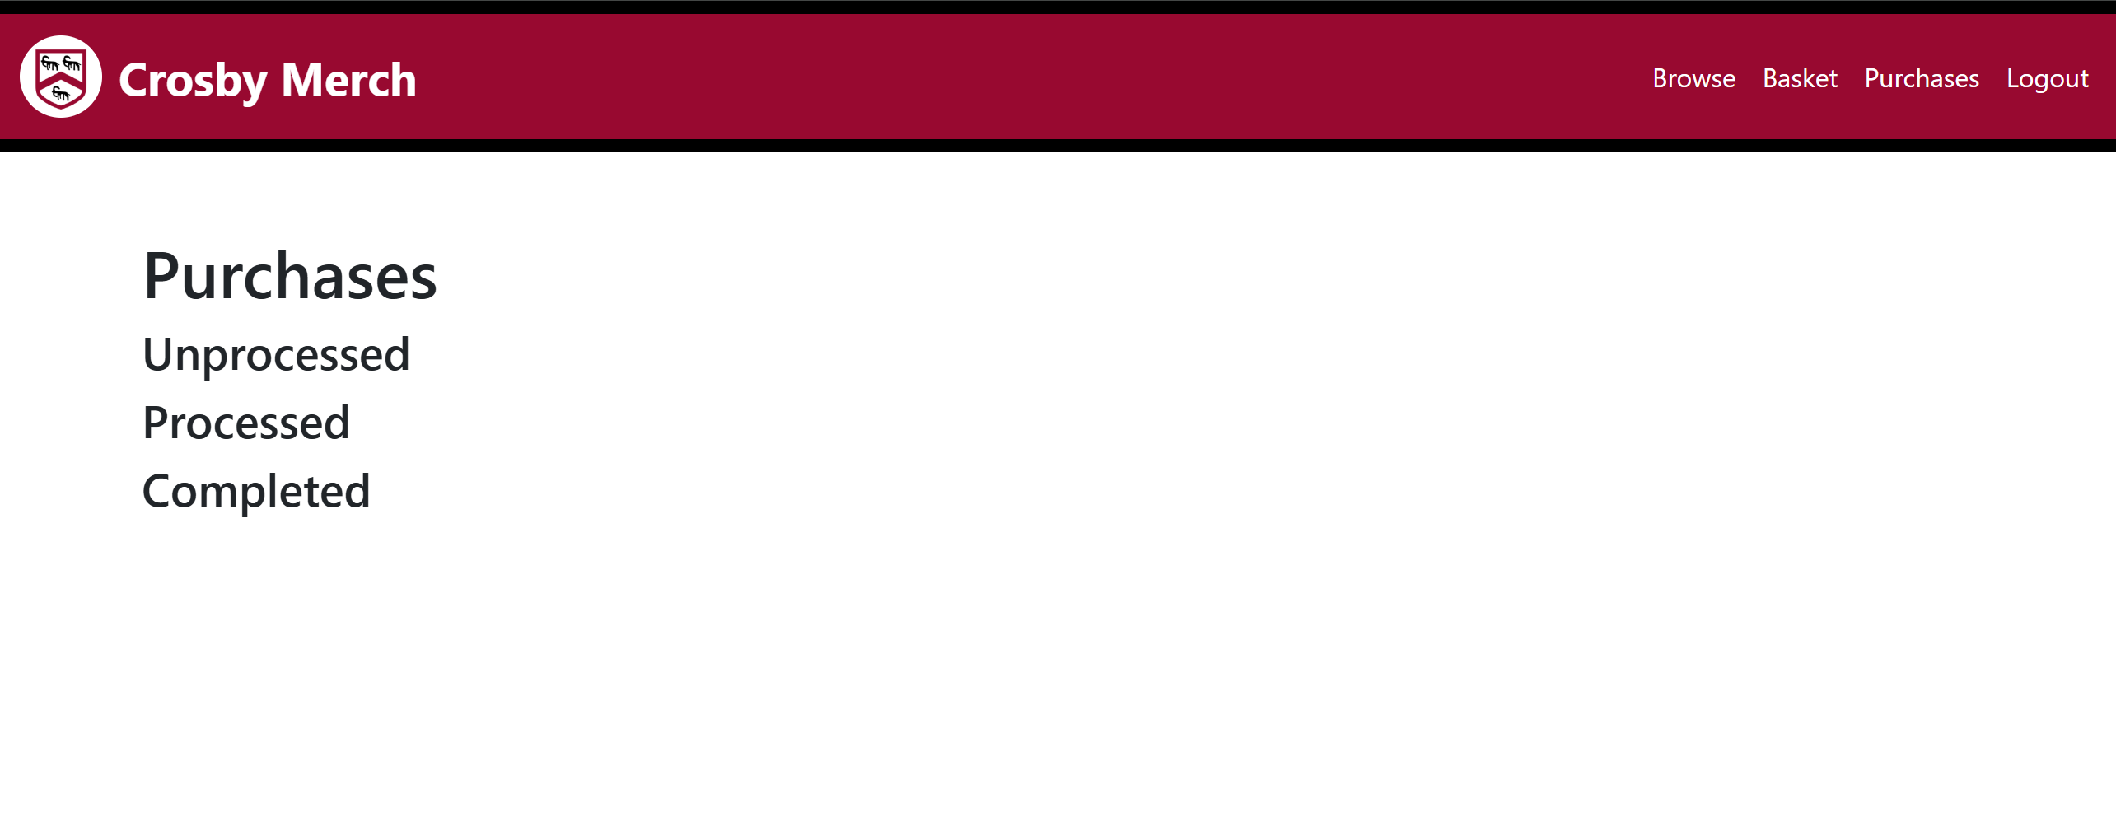I started by creating the layout that I would like this page to have, since it is the easier part to do and allows me to see what the final customer experience would look like, before I started coding the SQL.

This shows that the layout I want is correct.

Since the SQL to read each of the orders will be identical apart from the status of the order, I will focus on the unprocessed orders for now.

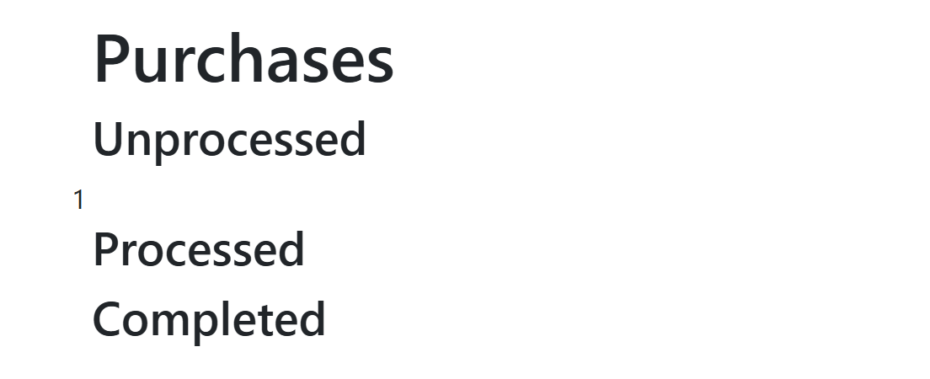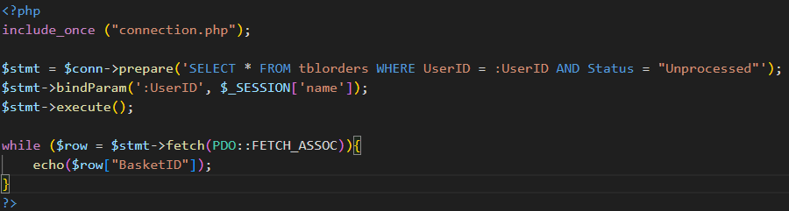This code will select all unprocessed orders that belongs to the user. I will echo selected BasketID to test that it works correctly.

Now that I know the code is working, I will display the order link it to a page which will show its contents.

This code will display the basket nicely and link it to the purchasebasket.php, sending a query string (called BID) containing the BasketID, which will allow it’s contents to be displayed properly.

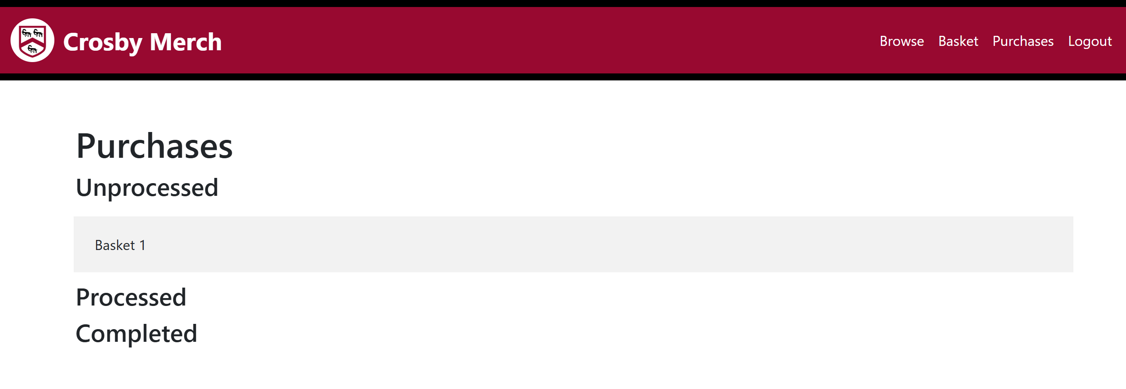This shows that the code is working.

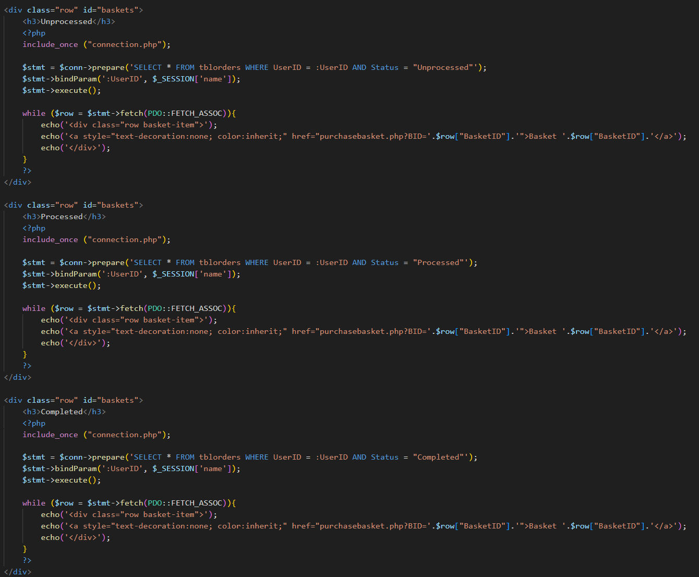Taking the code to display the unprocessed order, I can do the same thing for the processed and completed orders.

This shows the code to display all three statuses of orders side by side.

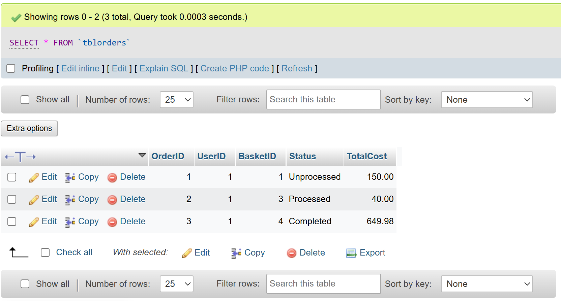To test that all the sections were actually working properly, I created two more orders and manually changed their status on phpMyAdmin.

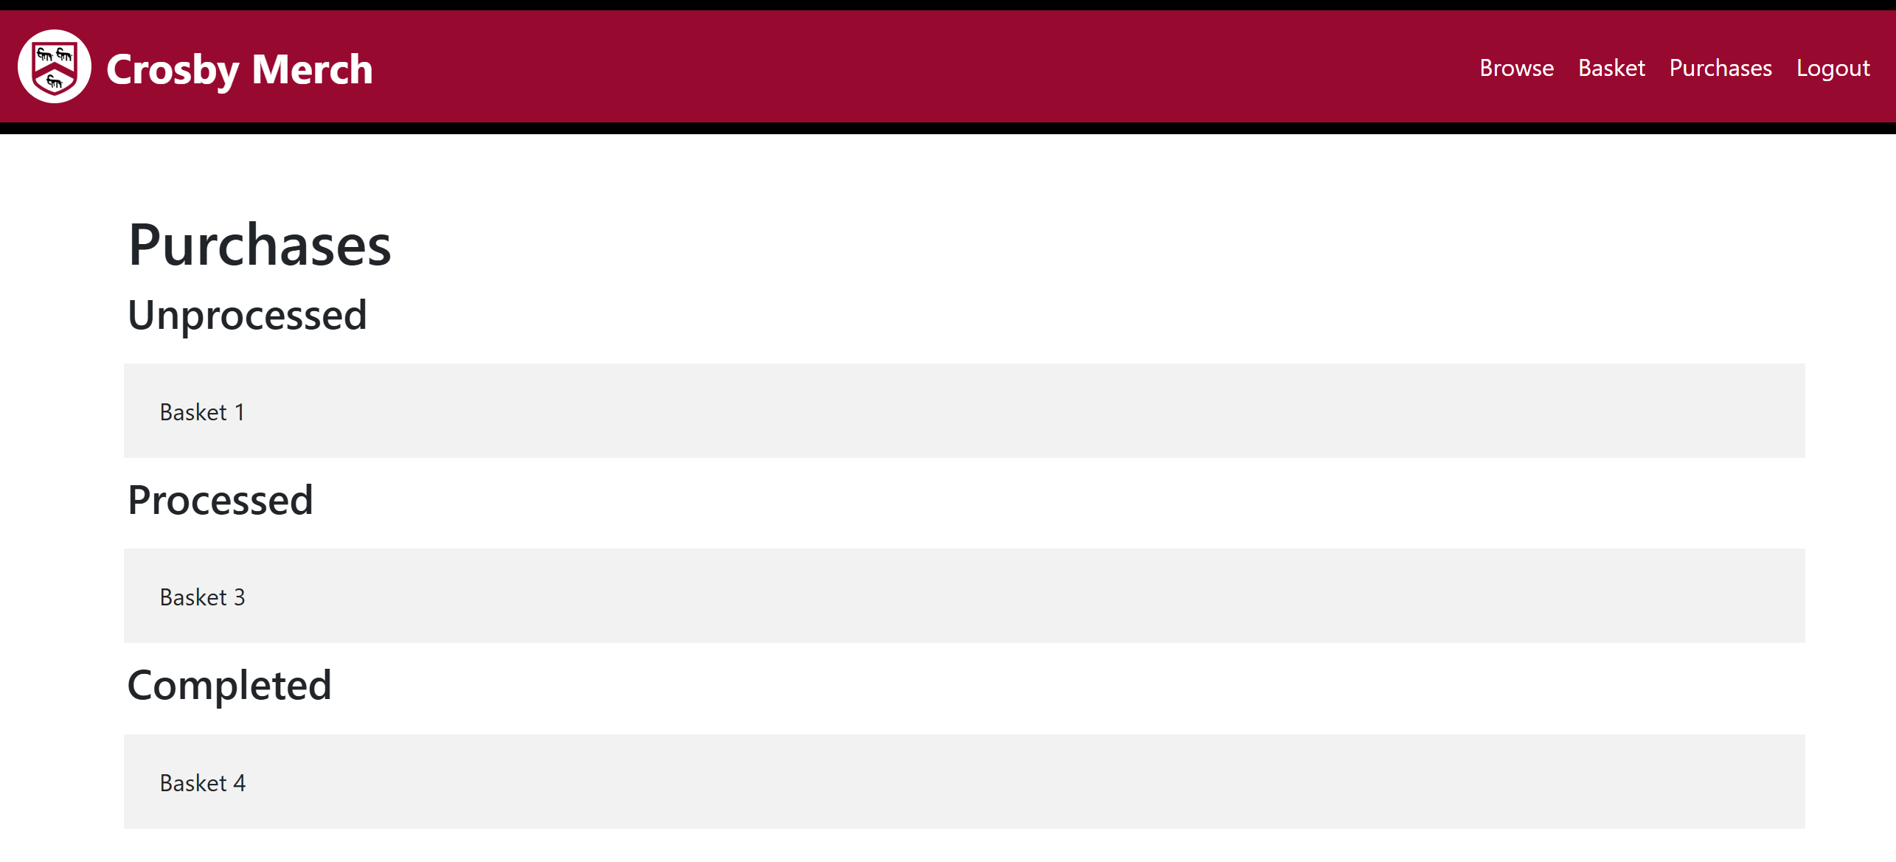This proves that each of the display works correctly.

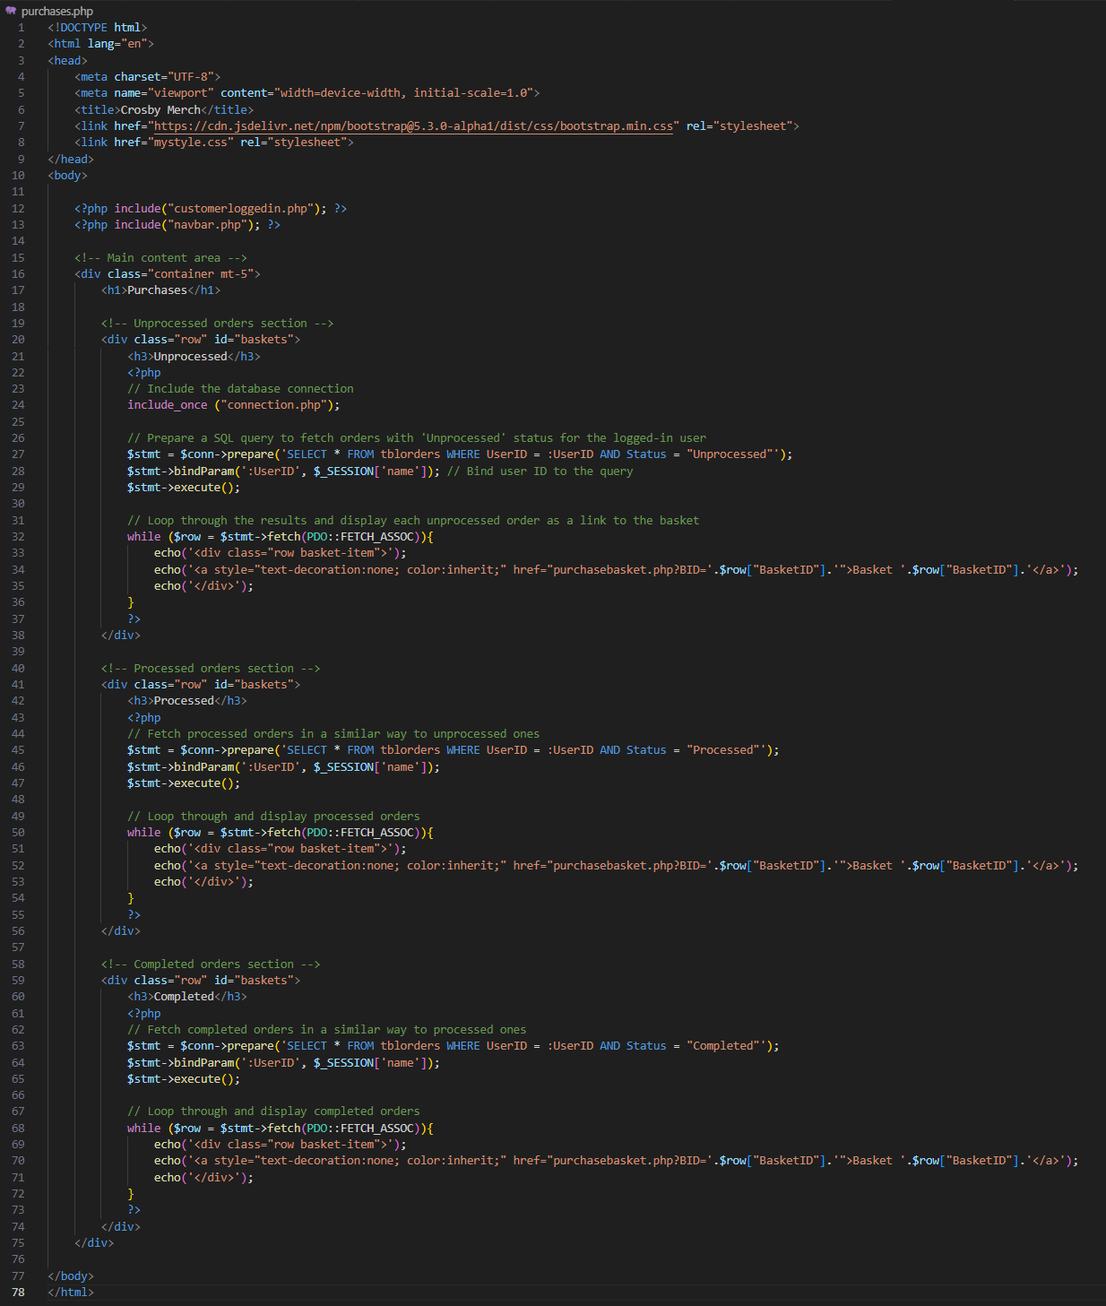Final Annotated Code:

### Purchasebasket.php

This page’s purpose is to display details of the items in the purchased basket.. It provides the customer with an ability to view details of all their purchased history, including important information such as item names, sizes, quantities, individual prices, and the total cost.

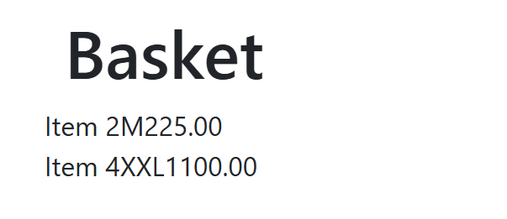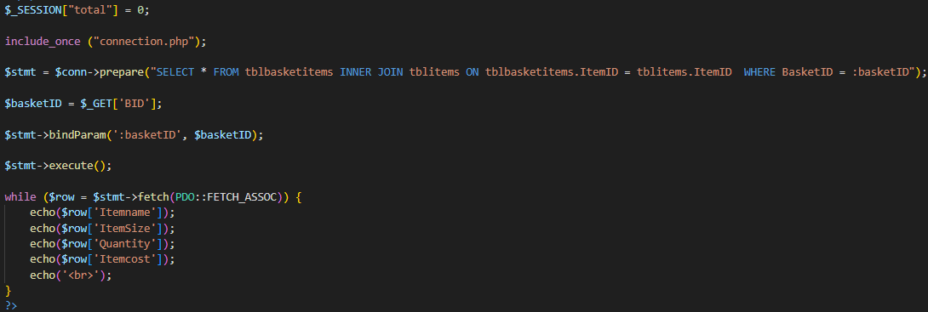This is the SQL that I wrote to select all required details to display the order’s contents. It takes the query string from purchases.php as the BasketID. I am echoing the details that I need to display onto the page to test that the fetched data are correct.

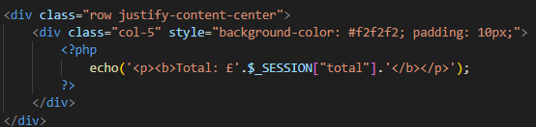This shows that the SQL has fetched all the required data to be displayed onto this page. Since this page has the generic basket layout (refer to Design → Page Design → Generic Basket page), I will be about to copy the code to display the items and the total cost from basket.php.

The total basket display code copied over from basket.php.

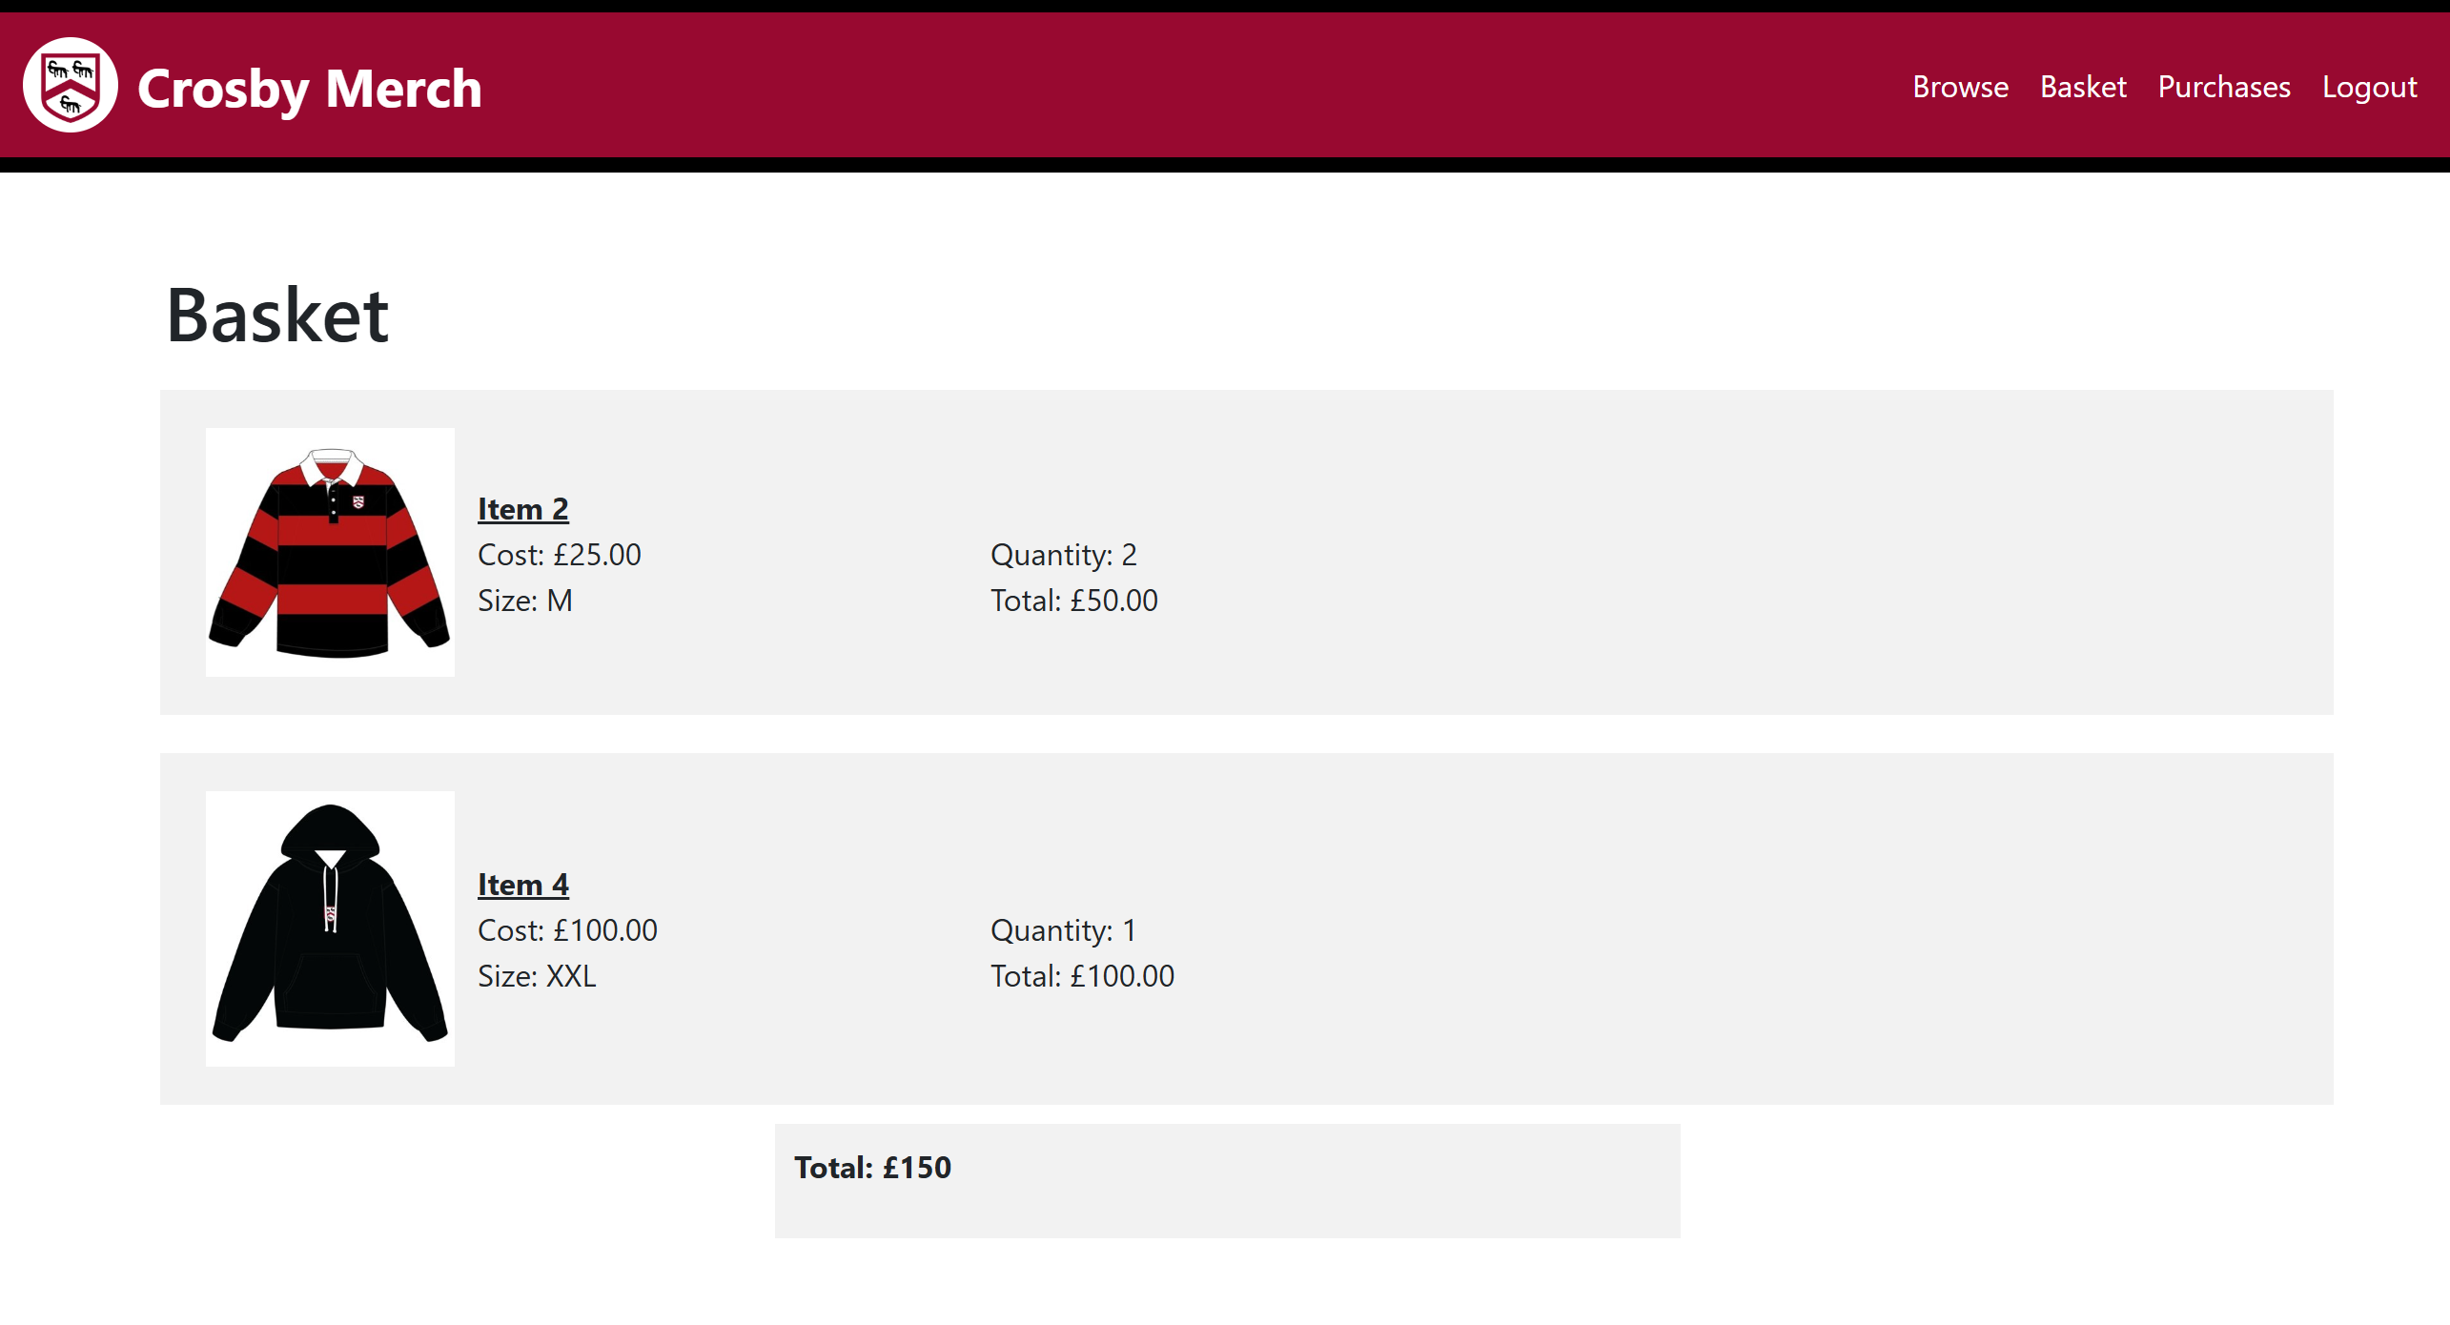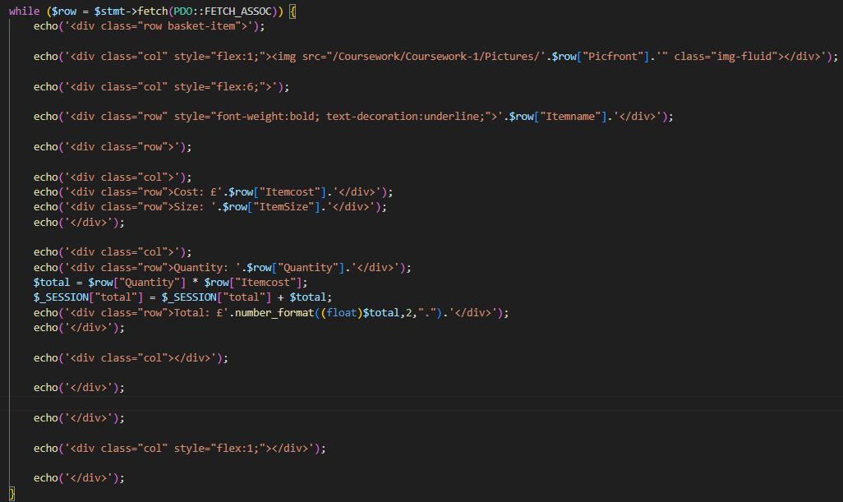The item display code copied over from basket.php.

This shows that the display codes copied over has been integrated properly.

Final Annotated Code:

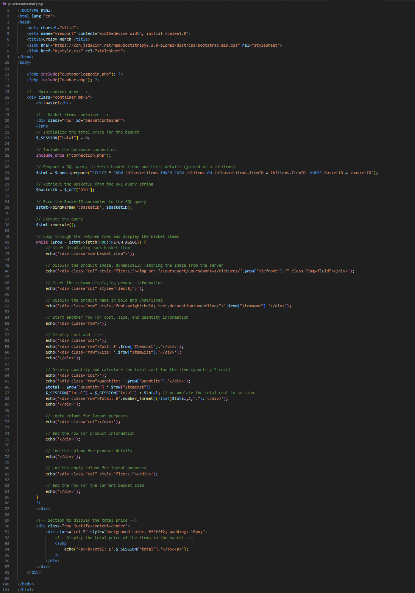

## Admin

### Adminnavbar.php

To create the navbar for admins, I created a new page called adminnavbar.php, I then copied and pasted the code of the customer’s navbar before proceeded to change the links

Final Annotated Code: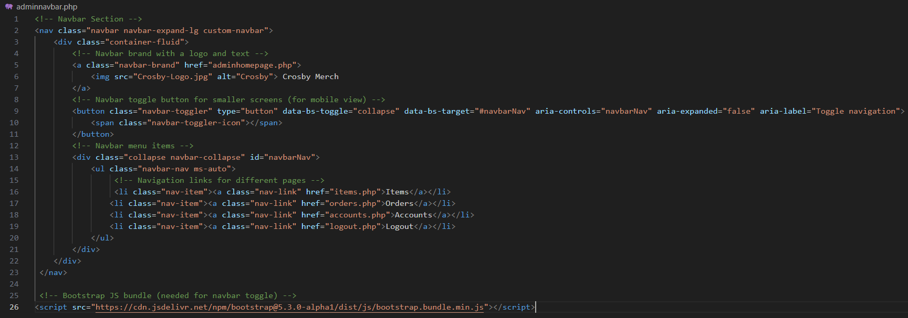

### Adminhomepage.php

The admin homepage is a clean and functional admin dashboard that gives admin users access to different management areas of the website. The design is very simple since the admin side of the website does not focus on aesthetics, and this page only displays links to other pages.

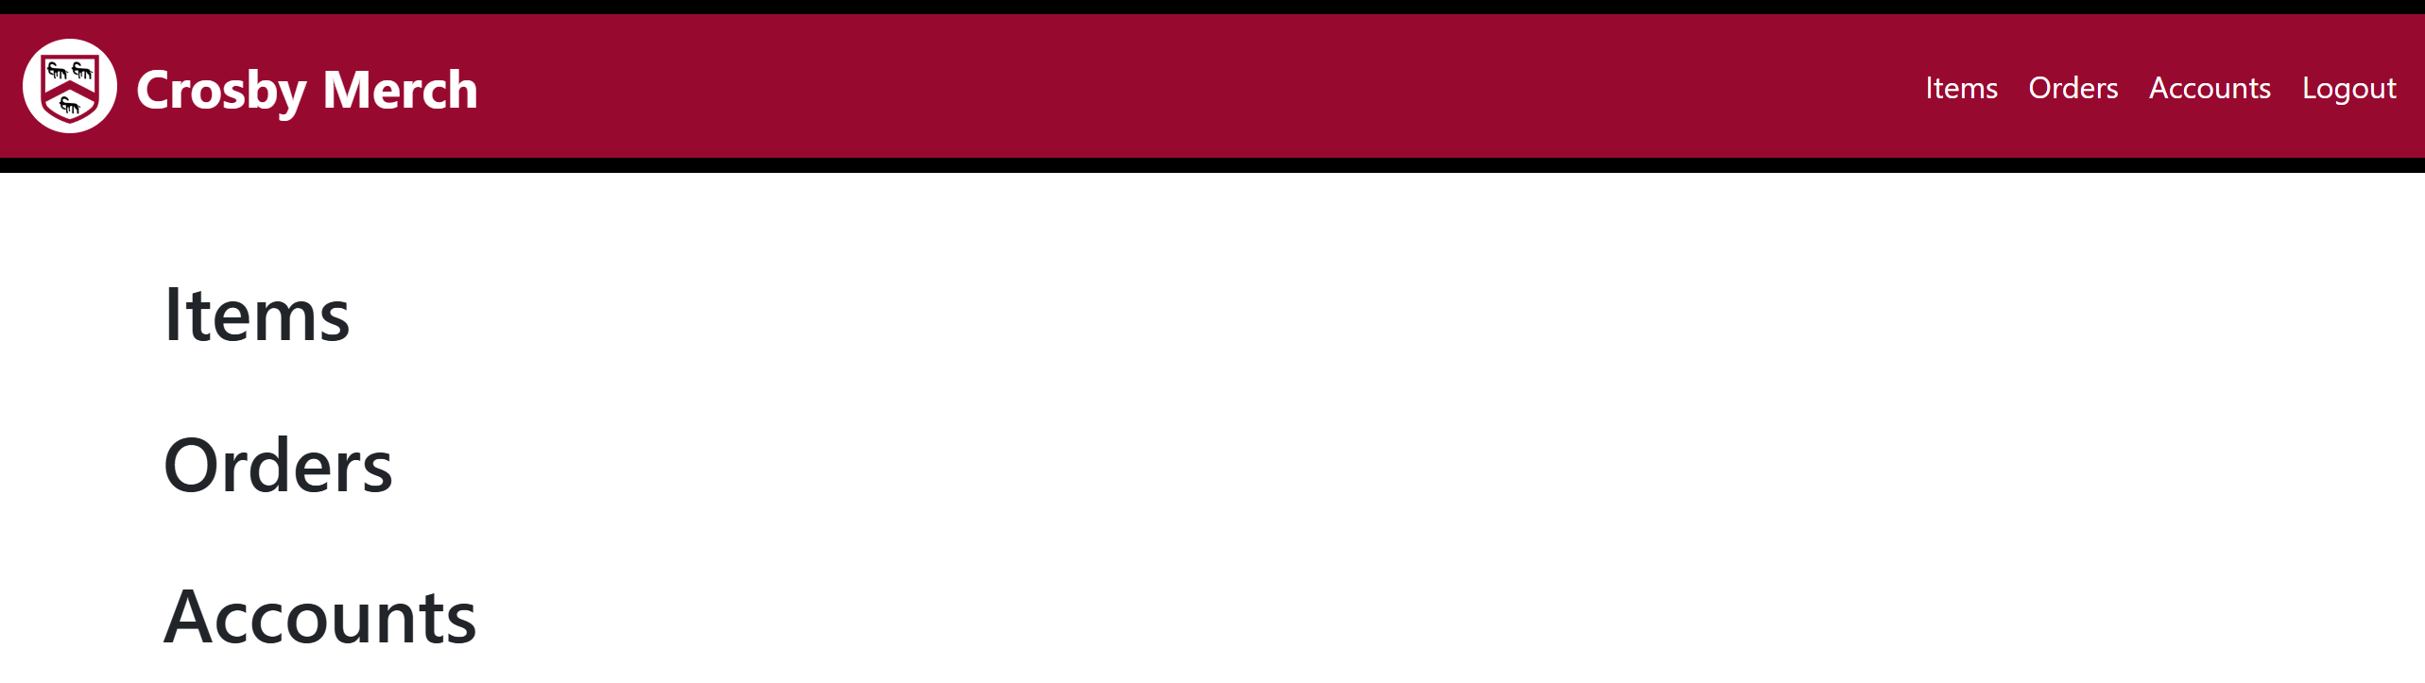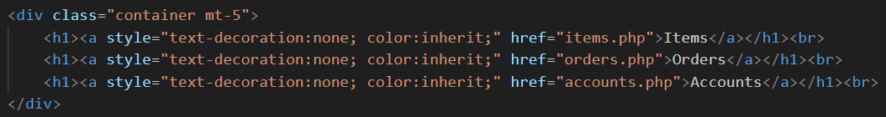This is the code to display the links to other management sections.

This shows the links displaying correctly onto the page. In testing the links lead to the correct pages.

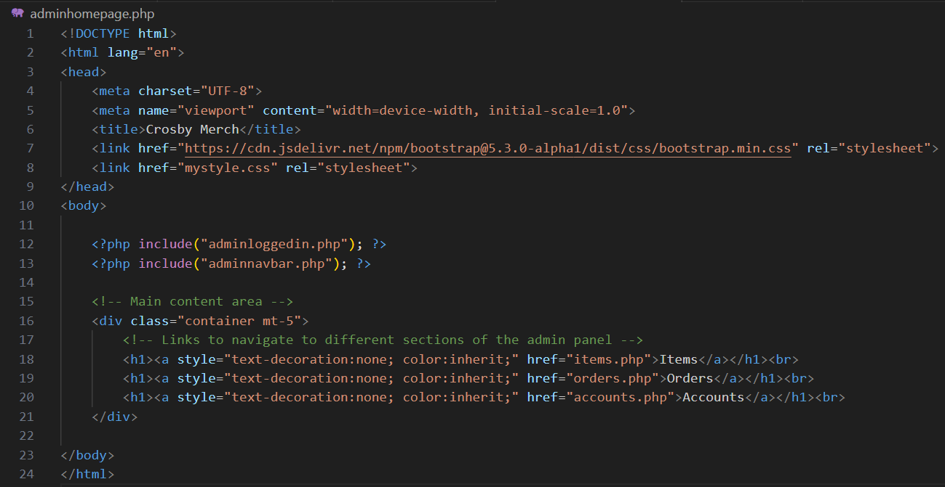Final Annotated Code:

### Items.php

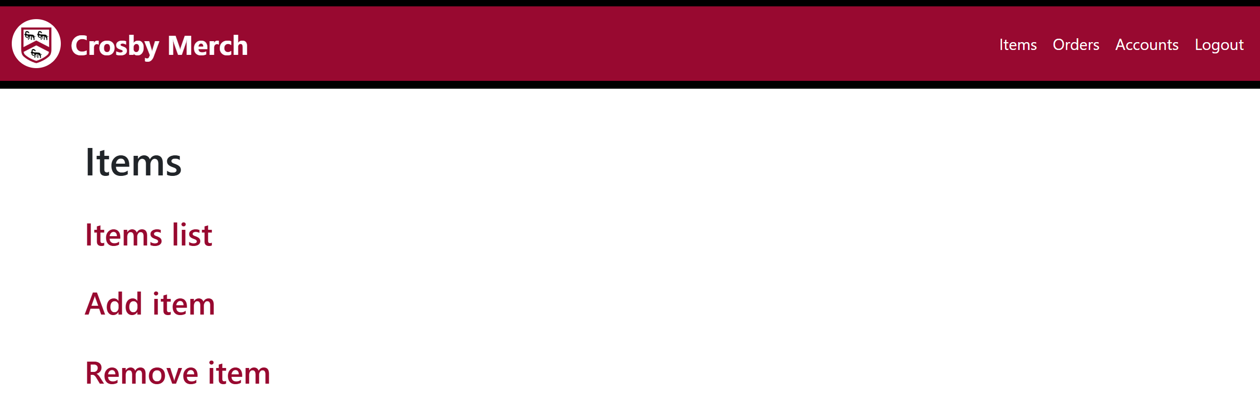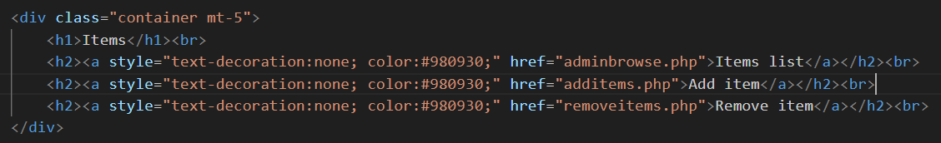This page is the navigating page for admin users to use to manage the items (view, add & remove). The design is very simple since the admin side of the website does not focus on aesthetics, and this page only displays links to other pages.

This is the code to display the links to different items management sections.

This shows the links displaying correctly onto the page. In testing the links lead to the correct pages.

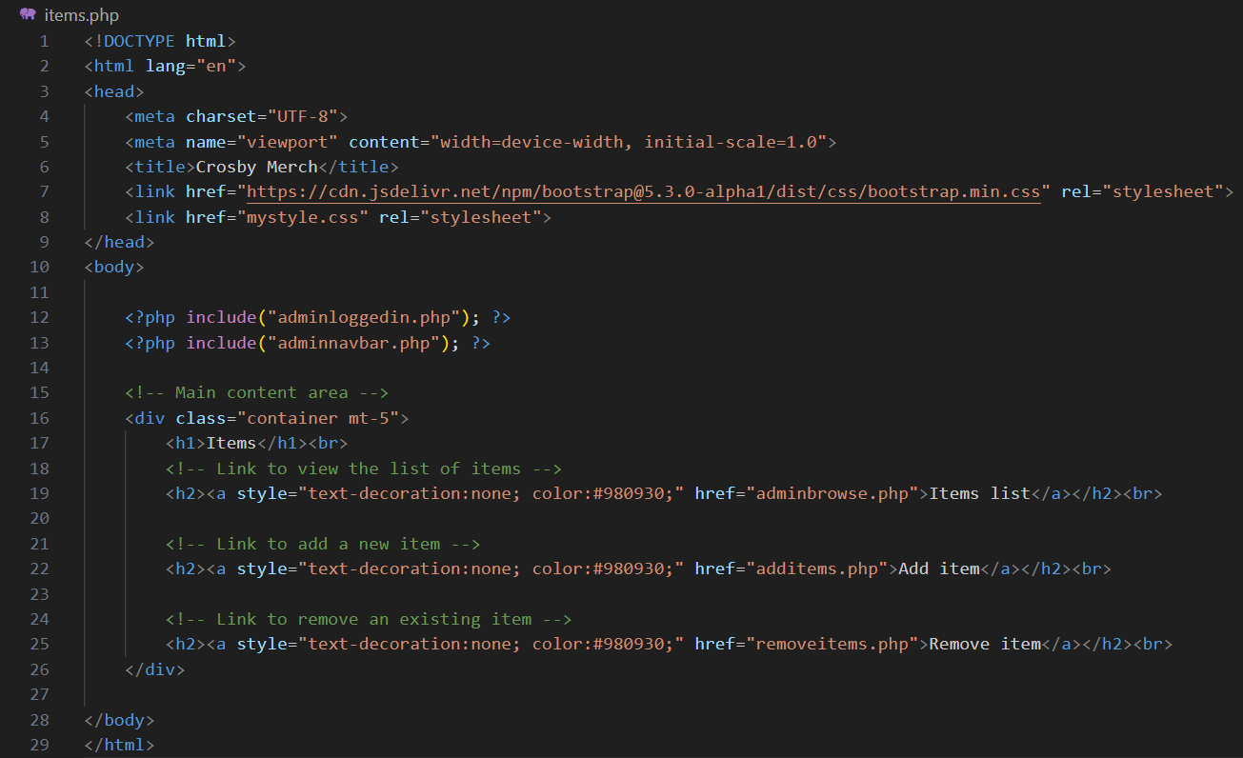Final Annotated Code:

### Adminbrowse.php

This page is a mirror of the customer homepage.php, allowing the admins to see all available items in a clear and organized grid format just as a customer would. This page will allow admins to view item names, images, and prices, to check that they have entered a correct.

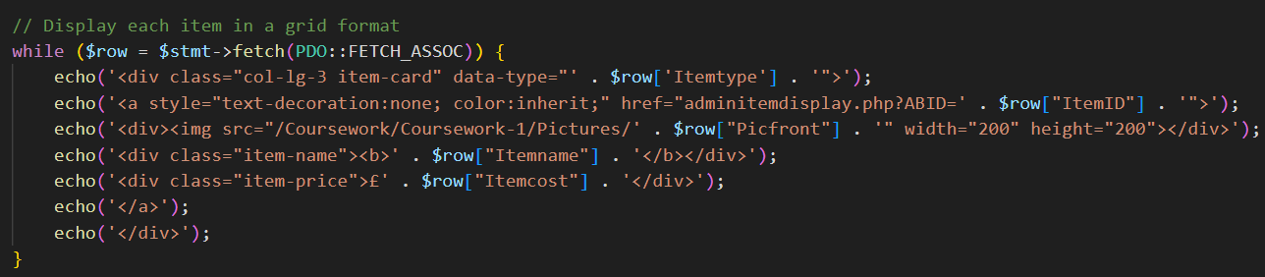Since this page will mirror the exact display of the customer homepage, I have copied across the entire homepage.php code, then change the links

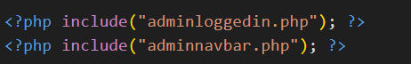This shows me relinking the item displays to a page called adminitemdisplay.php, and sending the query string called (ABID) to be used in the detailed item display.

Since this is an admin side page, I will use the admin logged in and admin nave bar instead of the customers’ ones.

Final Annotated Code:

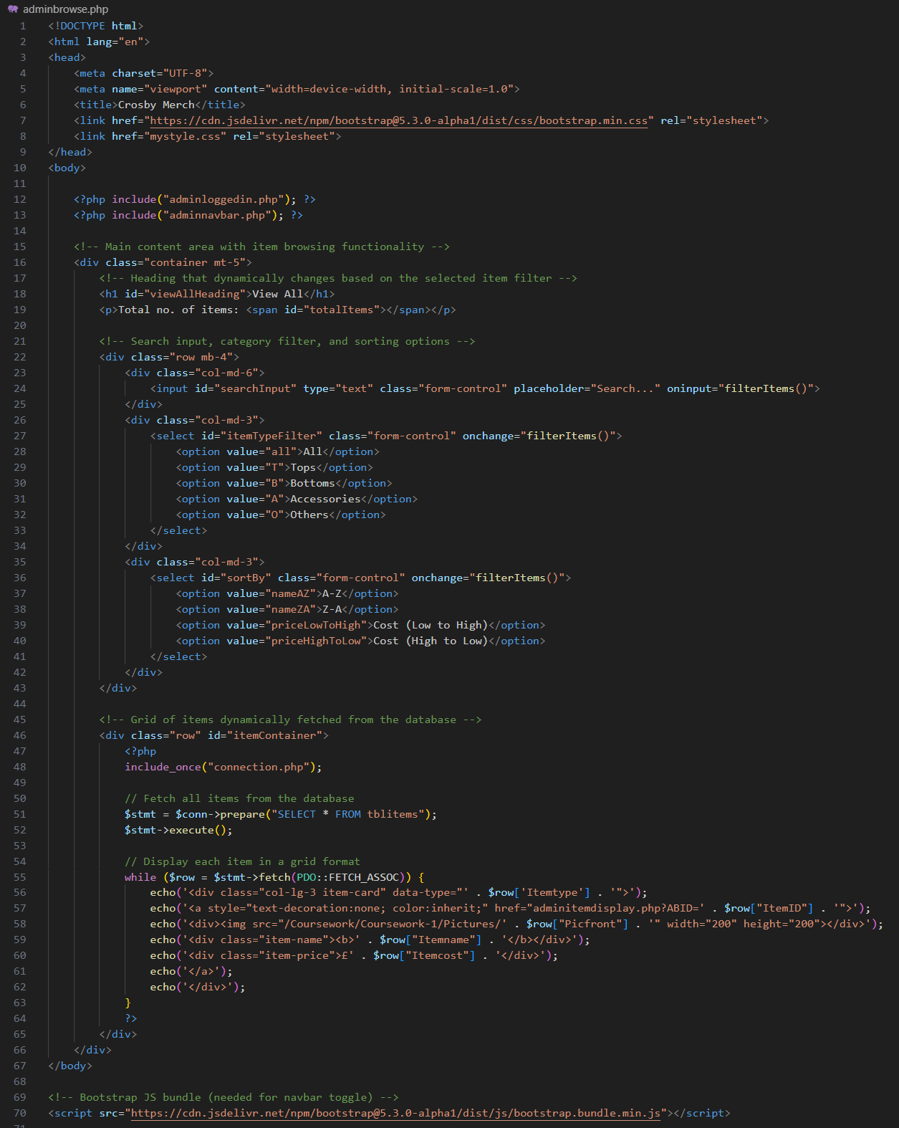

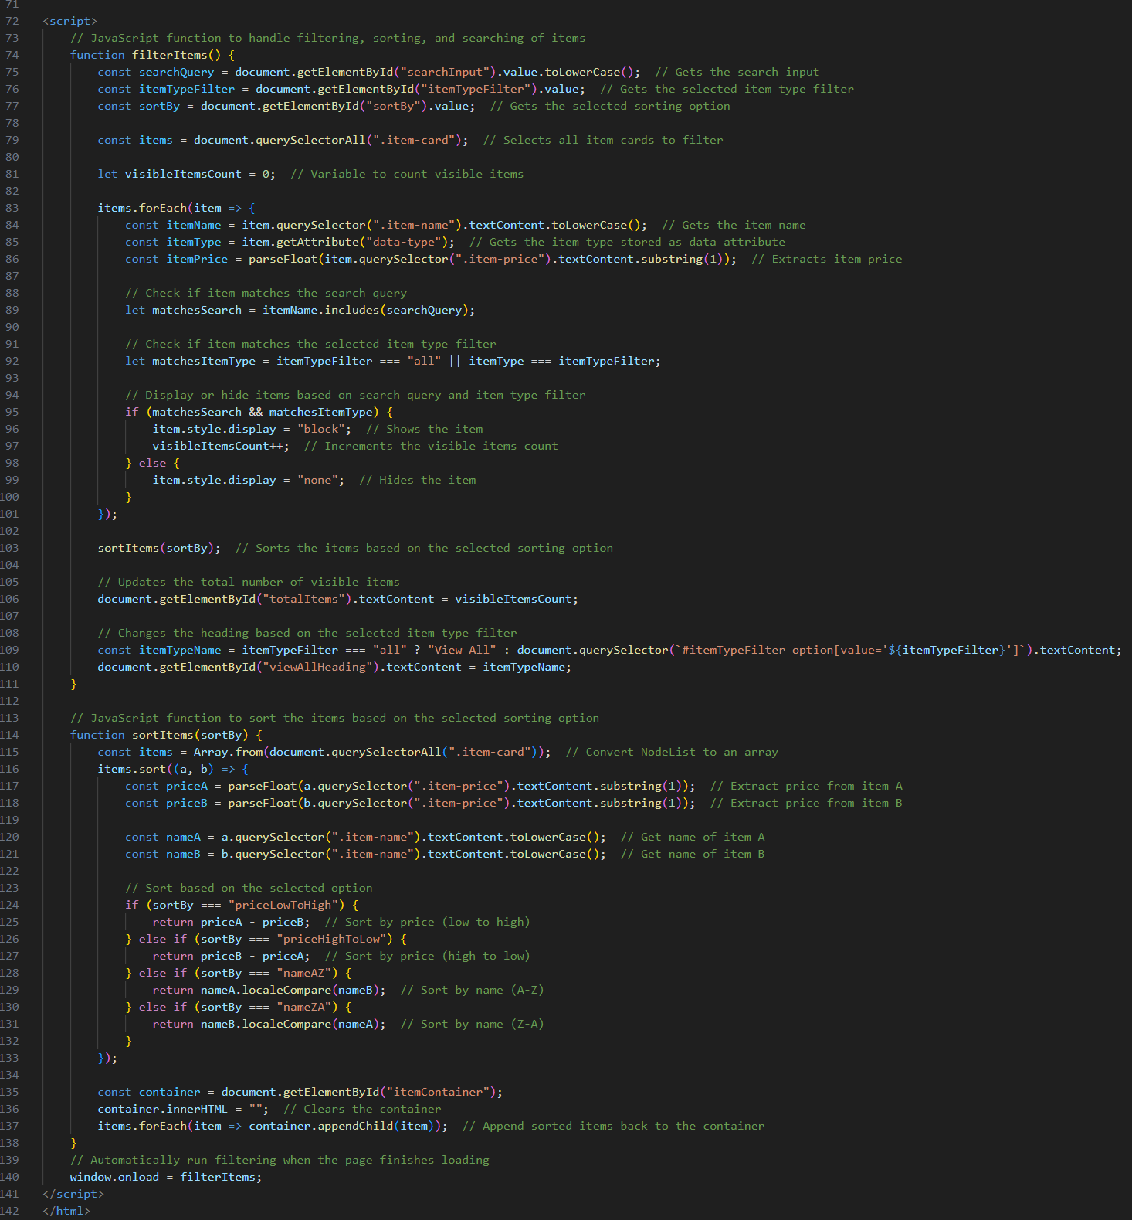

### Adminitemdisplay.php

This is the page that the admin will be directed to when once they click on an item on the adminbrowse.php. It is an exact mirror of the customer itemdisplay.php This page’s purpose is to display the details of the item, showing the admin some more details of the item that was not shown on the adminbrowse.php.

Since this page will mirror the exact display of the customer itemdisplay.php, I have copied across the entire itemdisplay.php code, then change out some code.

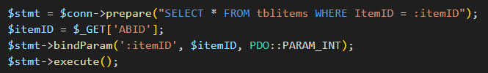Firstly I changed the SQL, binding $itemID to the new parameter name (ABID), allowing the code to fetch the correct data.

Then I deleted the code for the add to basket button, since admins are not supposed to be able to add items to a basket. However, I decided that I still wanted the display for size and quantity selection to allow the admins to see what the customer would be experiencing.

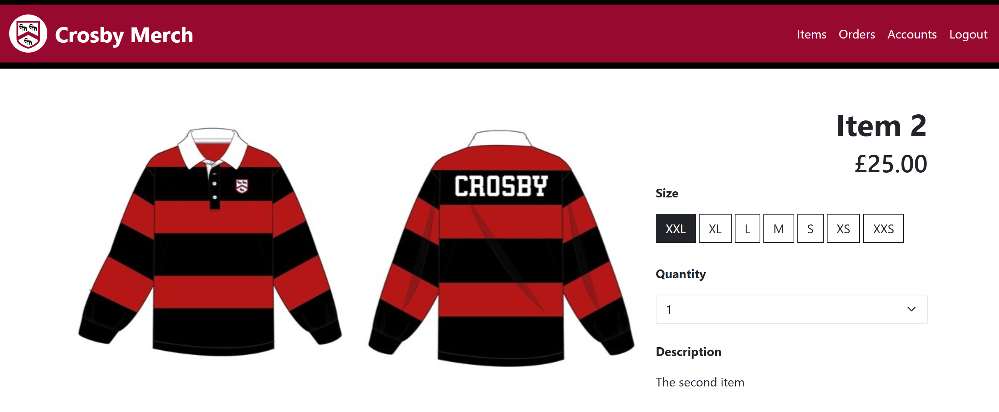This is what the page looks like after I deleted the form.

Finally, since admins cannot add these items to their basket anyways, I decided that I will disable the buttons and select options, making the page look cleaner and less distracting.

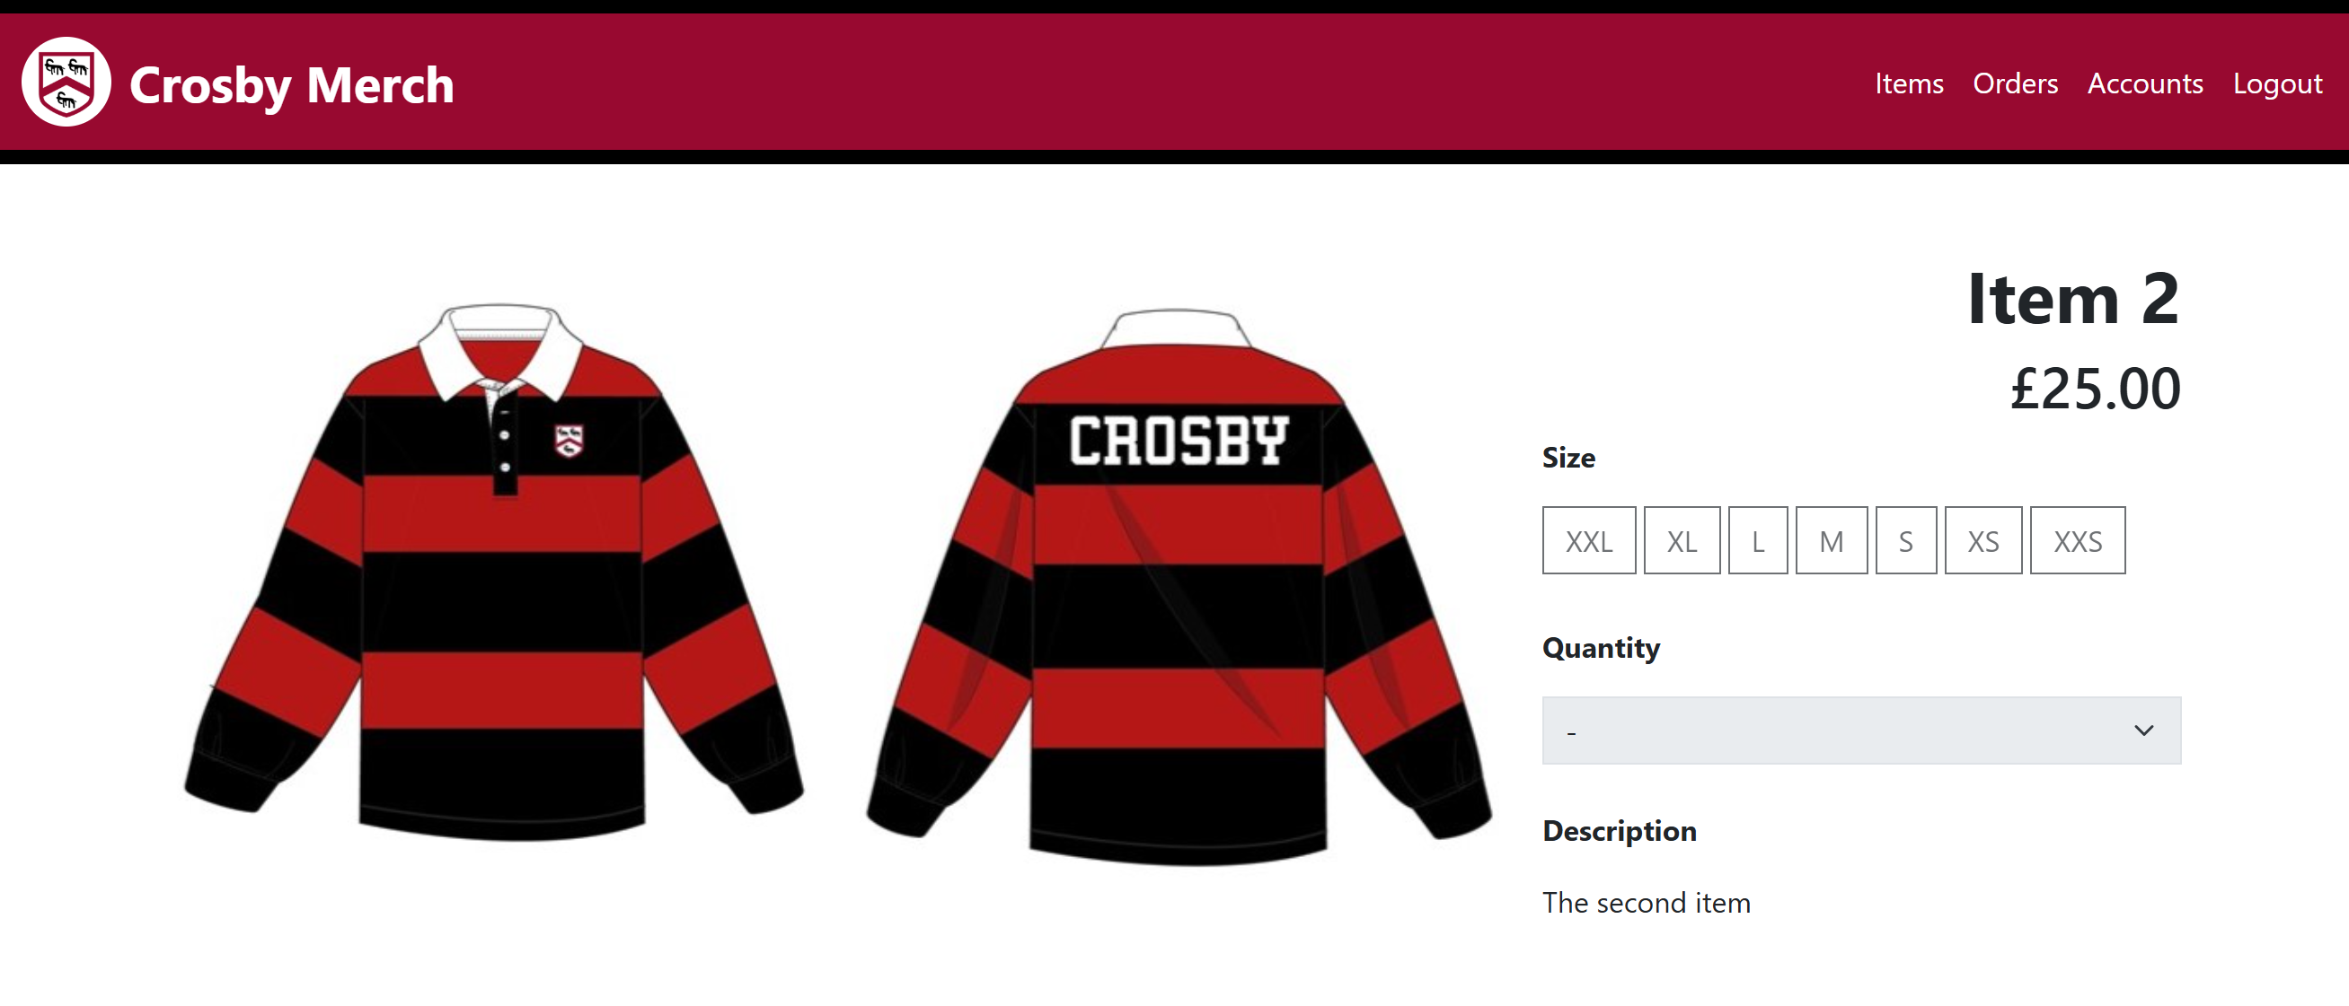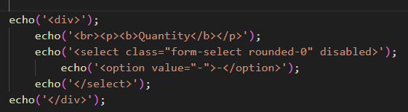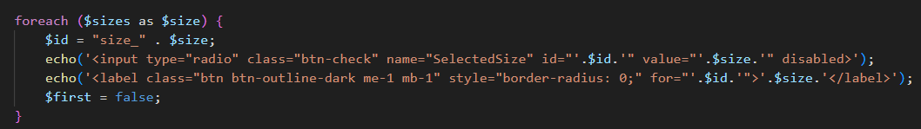I made these changes to my code to disabled the size buttons and the quantity select.

This is what the page looks like now with the buttons disabled.

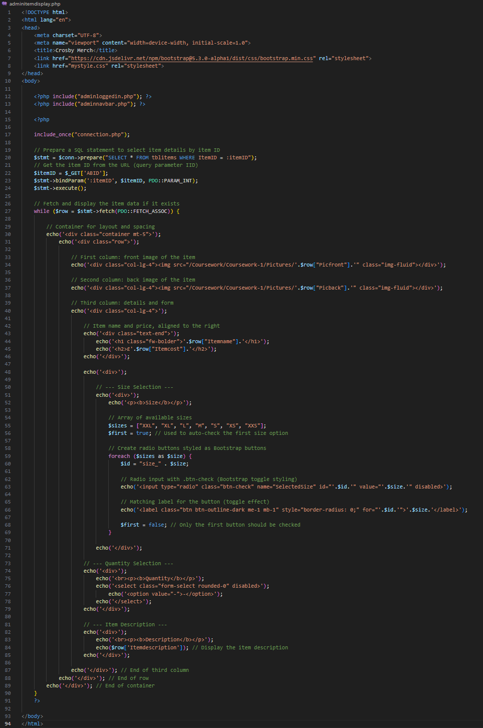Final Annotated Code:

### Additems.php

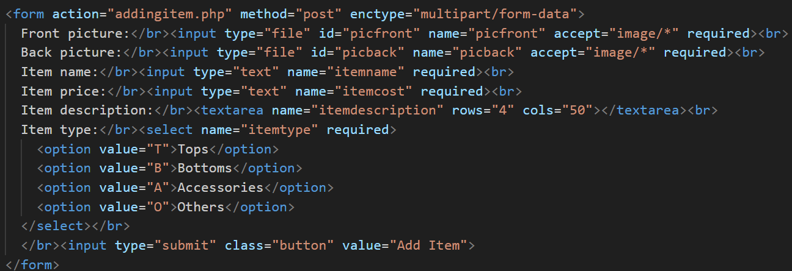This page will feature a form that will take information from the users to be added into the database as a new item.

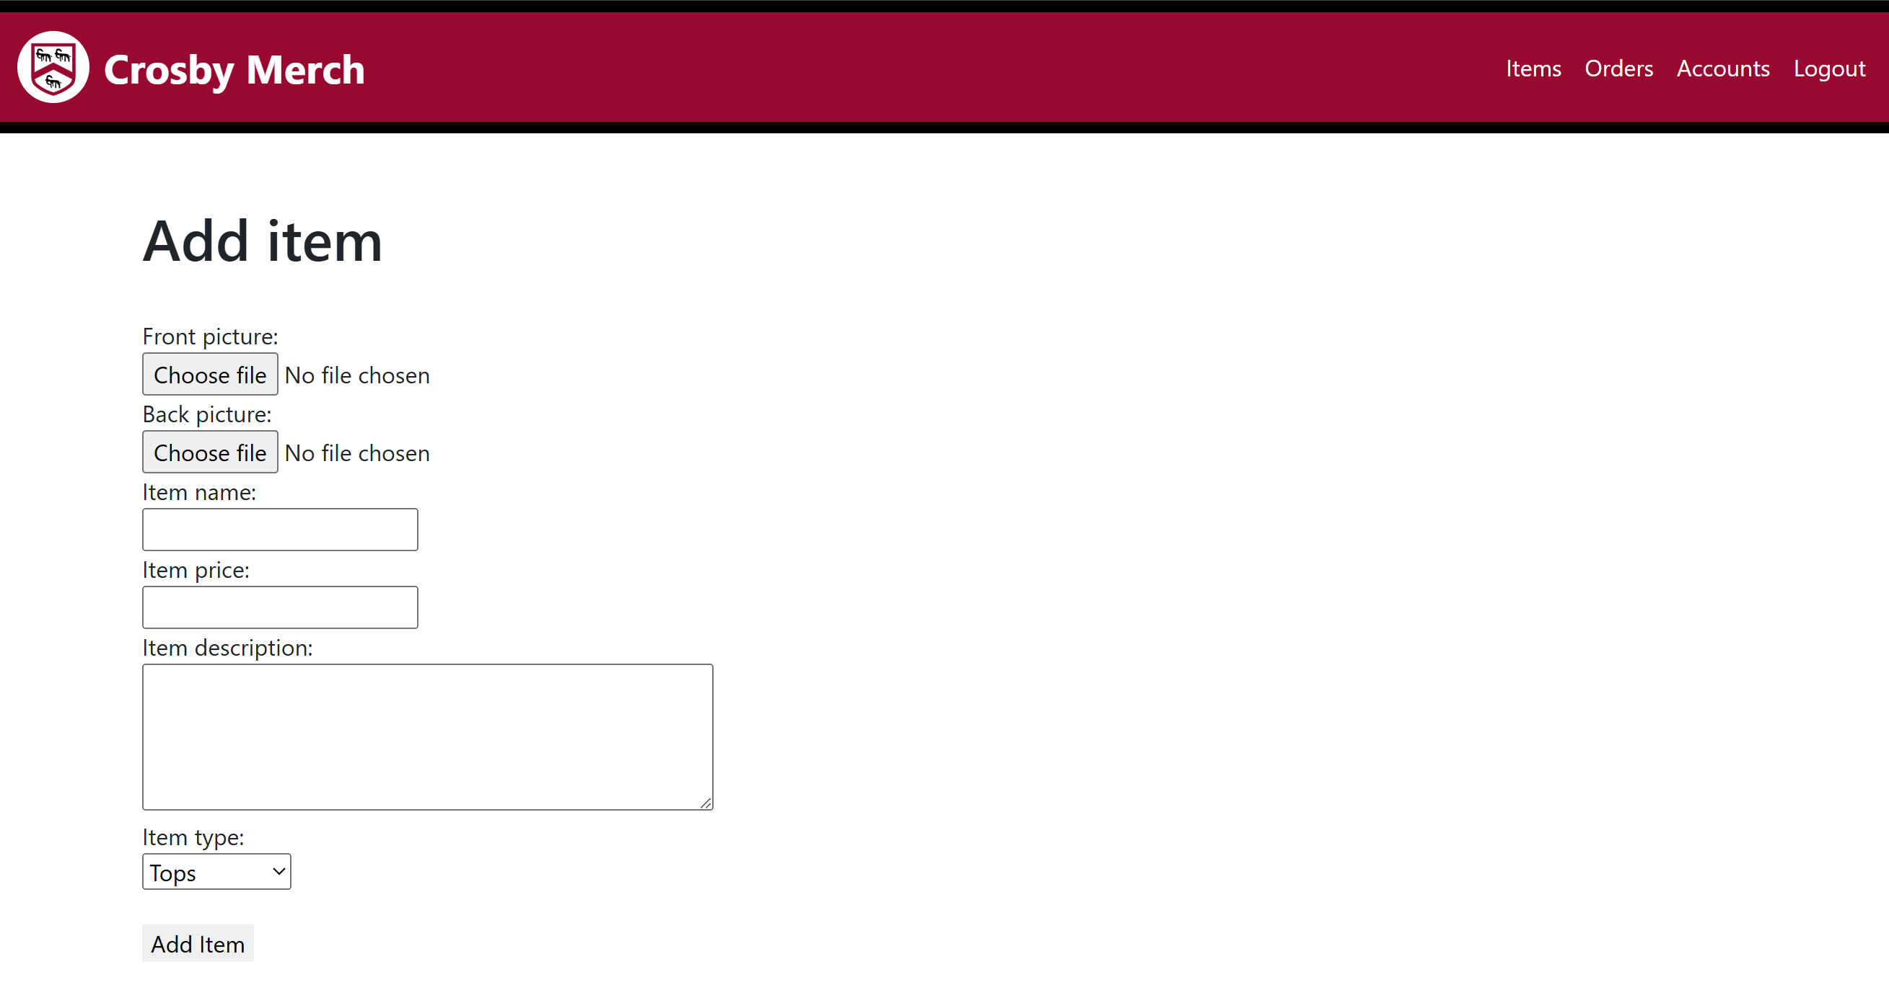I started by creating the form itself, making sure that all fields are required (as per tables of database).

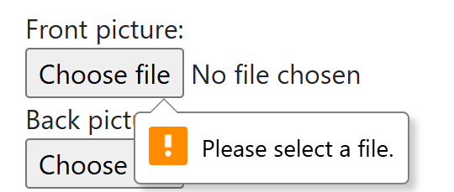This shows that the forms is correct

This shows that the fields are required to be filled in.

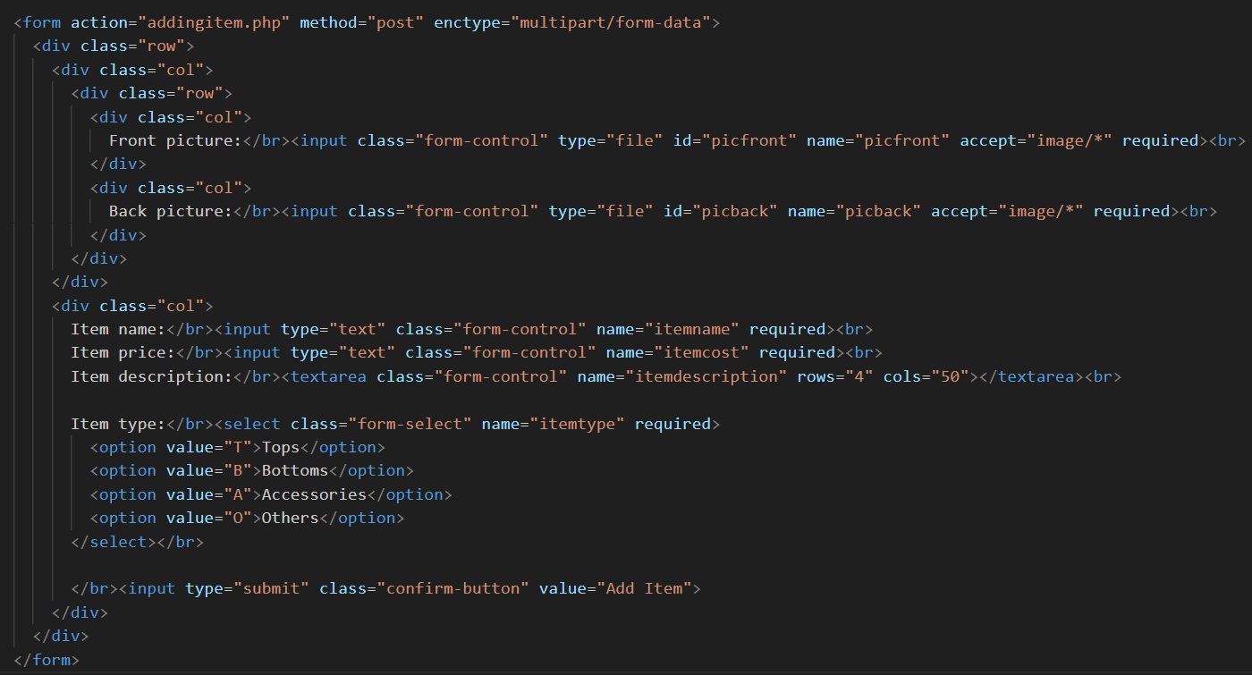I added bootstrap and CSS to display the form onto the page into how I want it to look like.

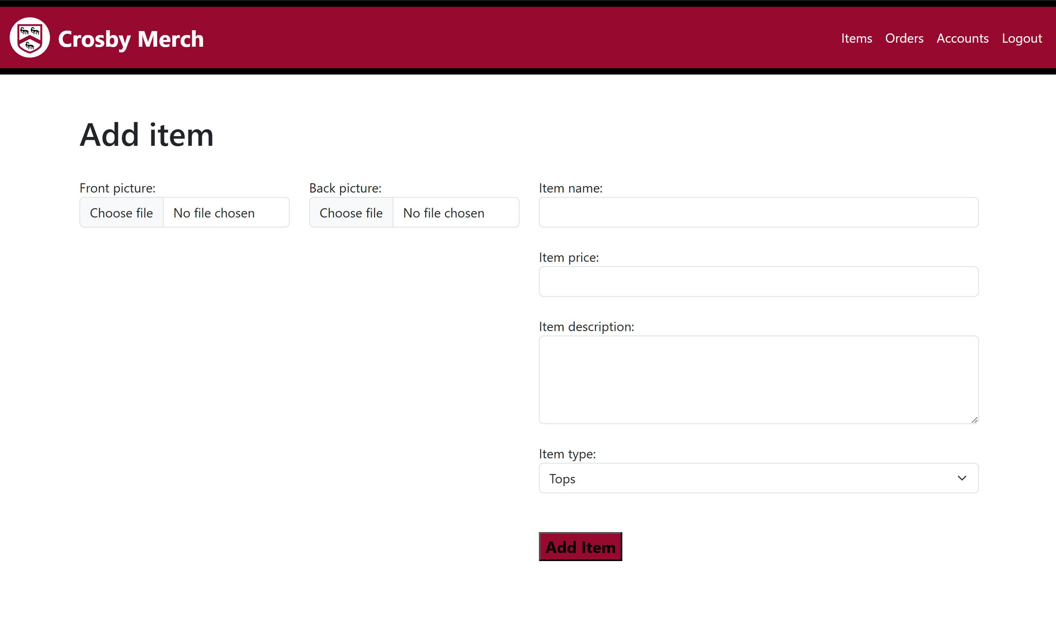

Final Annotated Code:

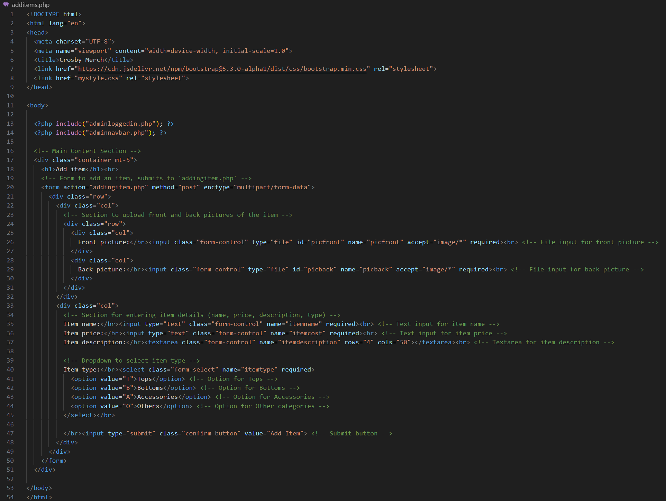

### Addingitem.php

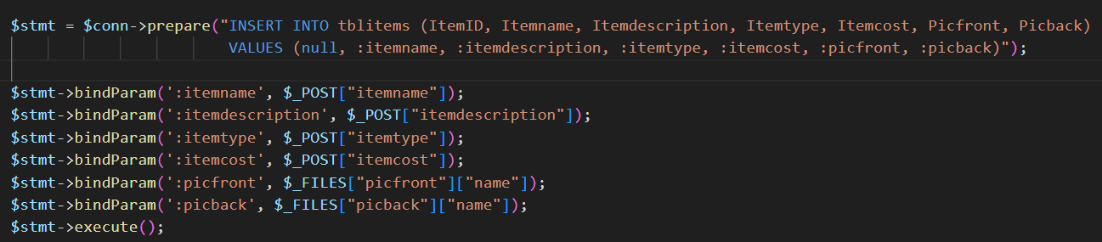This page will handle the form that has been sent from additem.php, using SQL to add the inputted item details (name, price, description, etc.) into the database. There are two main parts to this page, inserting the new item data into the database, uploading the pictures into the files. Since I am more comfortable with inserting the data into the database, I will be doing that first.

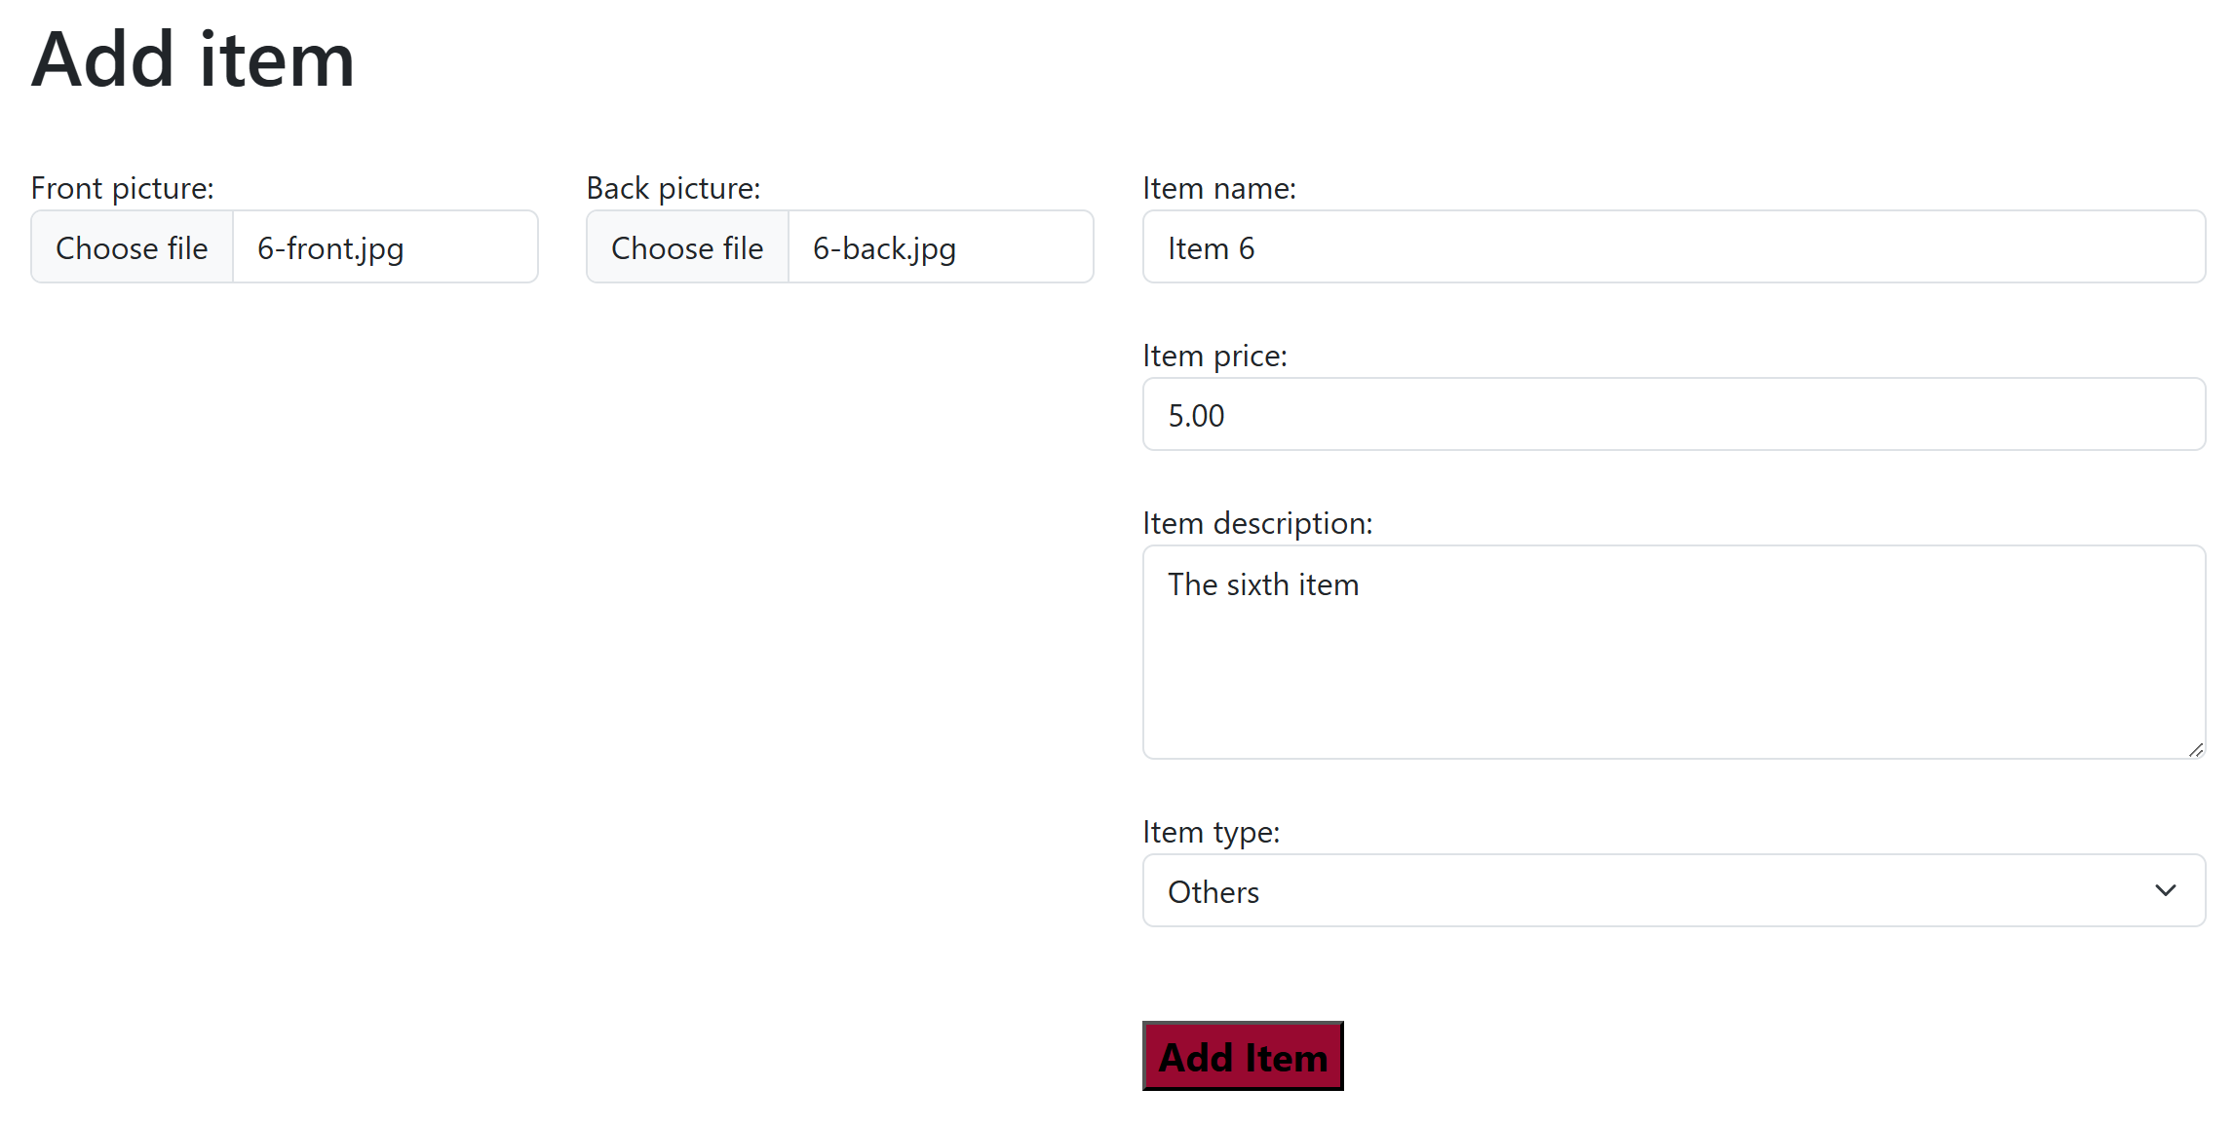This is the SQL that will take data summitted by the form in additems.php and insert it into TblItems in the database.

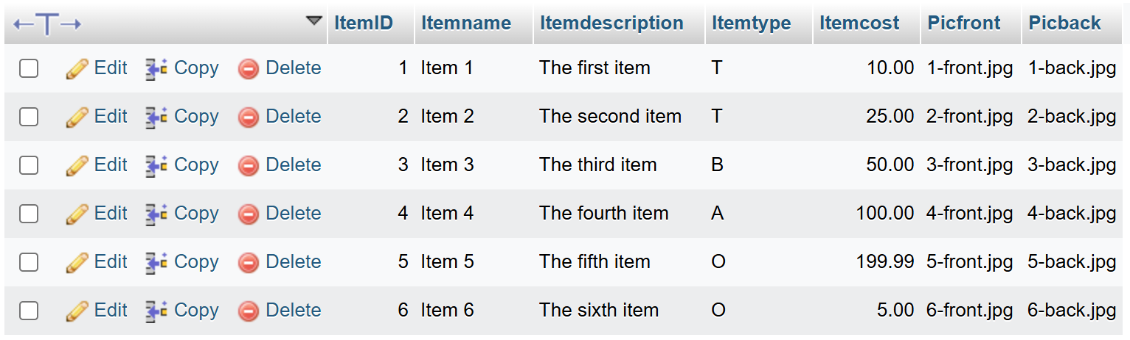This is what I entered into the form the test if my SQL works.

Checking TblItems on phpMyAdmin, this shows the item being added successfully, meaning that I will continue to work on the uploading the pictures.

 First I print the inputted files onto the page to allow me to check that they are the correct ones.

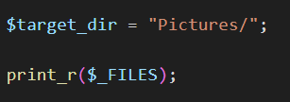This message shows that the images to be uploaded are the correct ones.

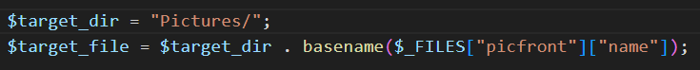Then I set up the upload directory, which is a folder in the same directory as my other codes.

This line creates the full path where the uploaded file will be saved on the server.

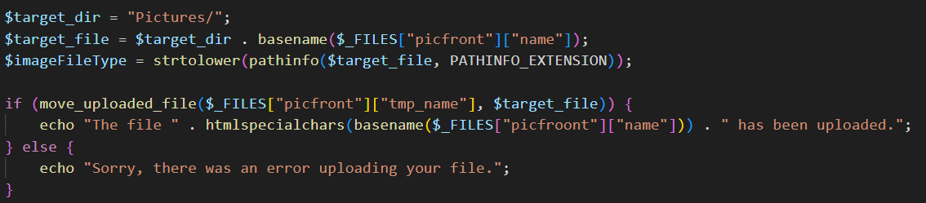 This line extracts just the file extension from the file path and converting it into lowercase to ensure consistency.

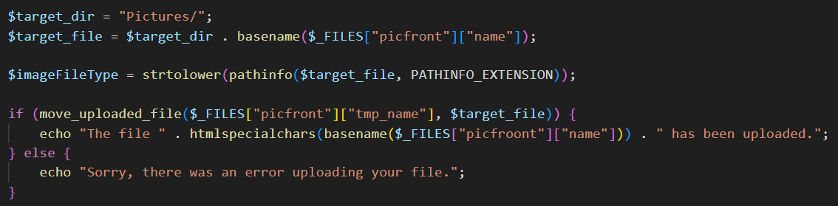Finally, this is the code to upload the file to the directory and returning a message to say whether the upload was successful or not.

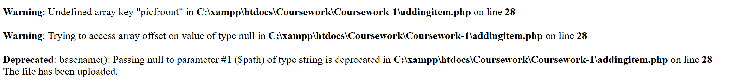This is the code when put together.

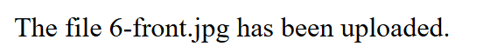However, I ran into an error when testing this code. This was because I had made a typo (“picfroont” instead of “picfront”).

I fixed the code and ran it again, this time it was successful.

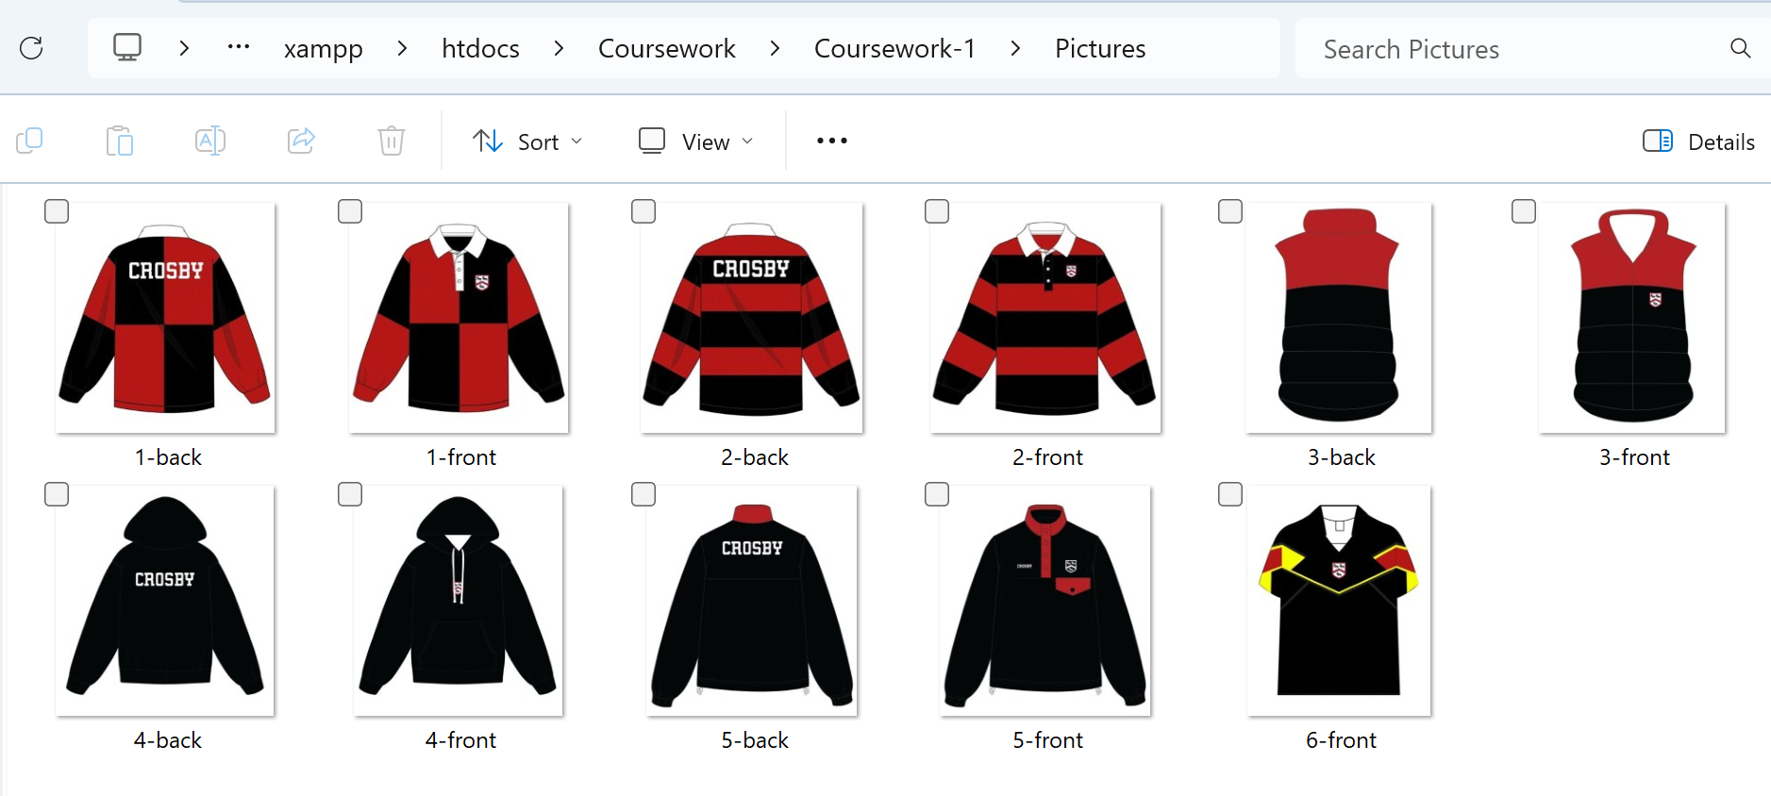I checked the folder directly to make sure that the picture had been uploaded successfully, which it was. Now that I know that the code works for uploading picfront, I can use the same structure to upload picback.

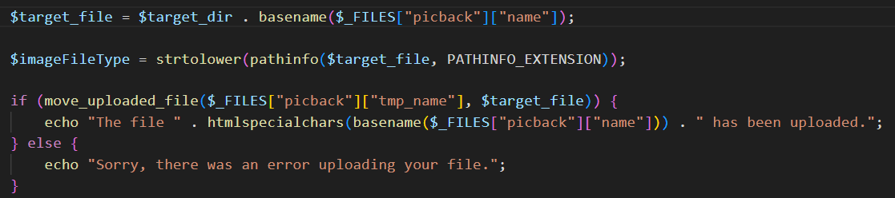With all the components finished, I can put them together to create the finished working page.

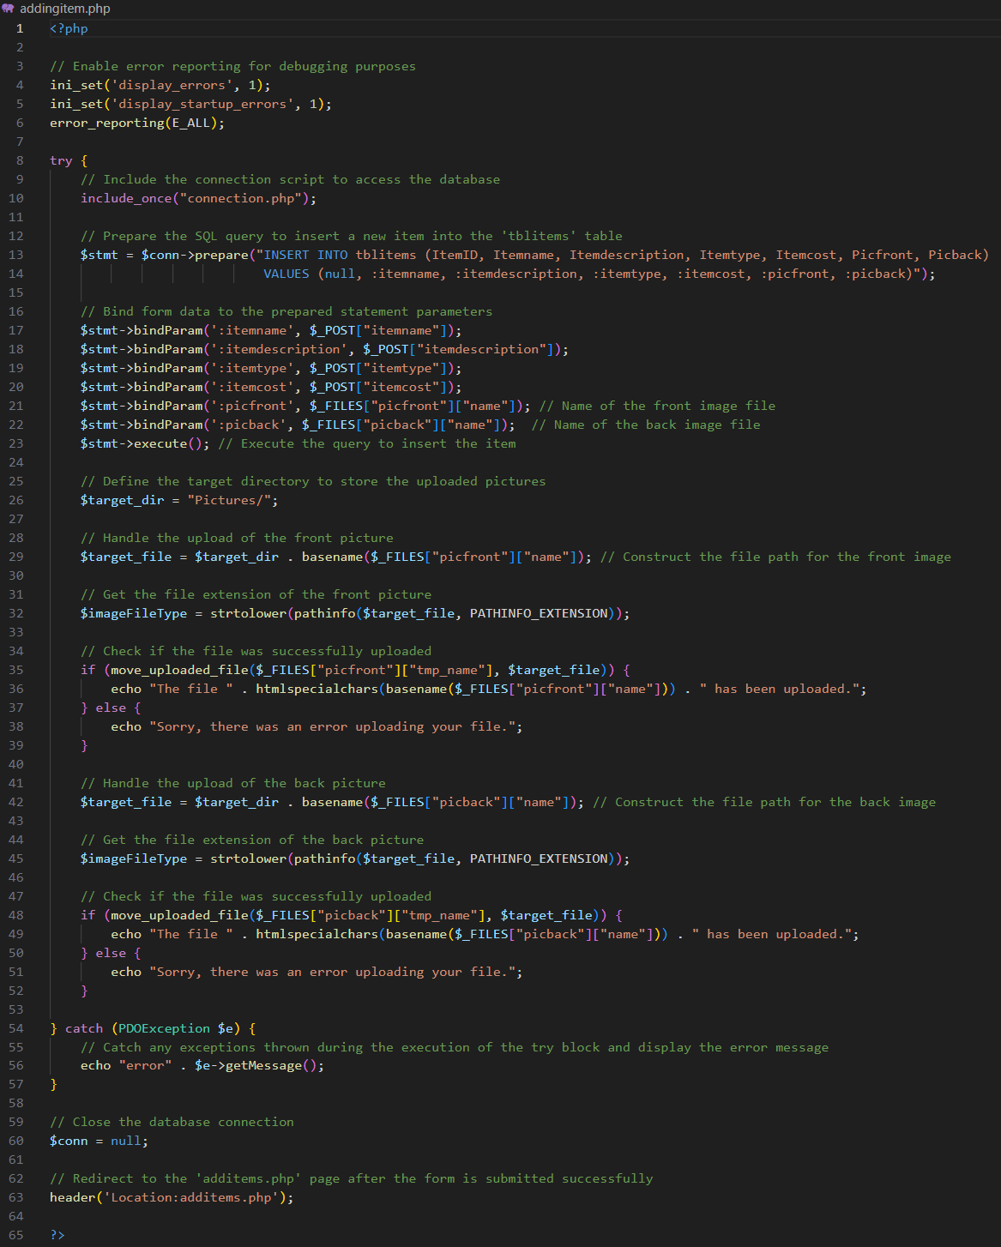 Final Annotated Code:

### Removing items

Unfortunately before I started developing the feature to remove items, I realised that deleting items’ data from the database will cause issue to surface with baskets and purchases that has been made containing the items, where the item that has been bought will not be displayed and instead, displaying an error.

I thought that perhaps if I deleted the item data and the data from any basket and orders that contains it, I will be able to fix that problem. However, when I realised that doing so will mess up the history of purchases made by customers, causing an inconsistency between the total cost of orders and the payment that has been made.

The solution that I came up with was to create an archiving mechanism for the items, which will not delete any data, causing no inconsistency. But during this point in my development, I was being pressured with time and did not want to have to think about and create a new part to my project. Therefore I have unfortunately chosen to not create a feature to delete items.

As a result of this, I have removed to link to remove items from items.php

Items.php Final Annotated Code:

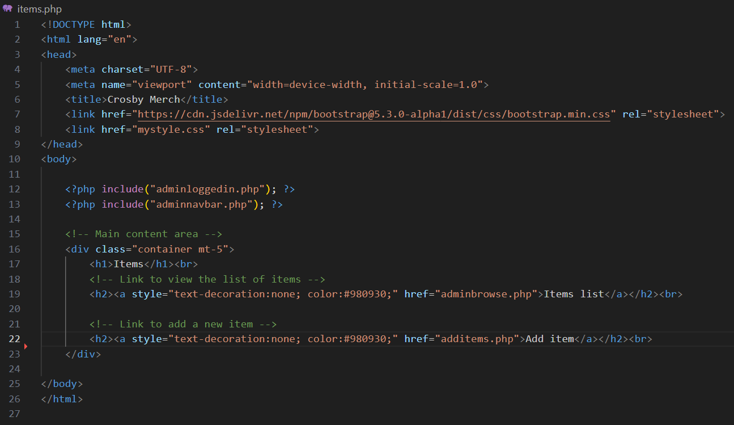

### Orders.php

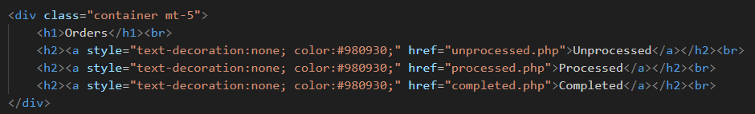This page is a navigating page for admin users to use to process orders, sending them to pages that contains orders a specific status (unprocessed, processed or completed). The design is very simple since the admin side of the website does not focus on aesthetics, and this page only displays links to other pages.

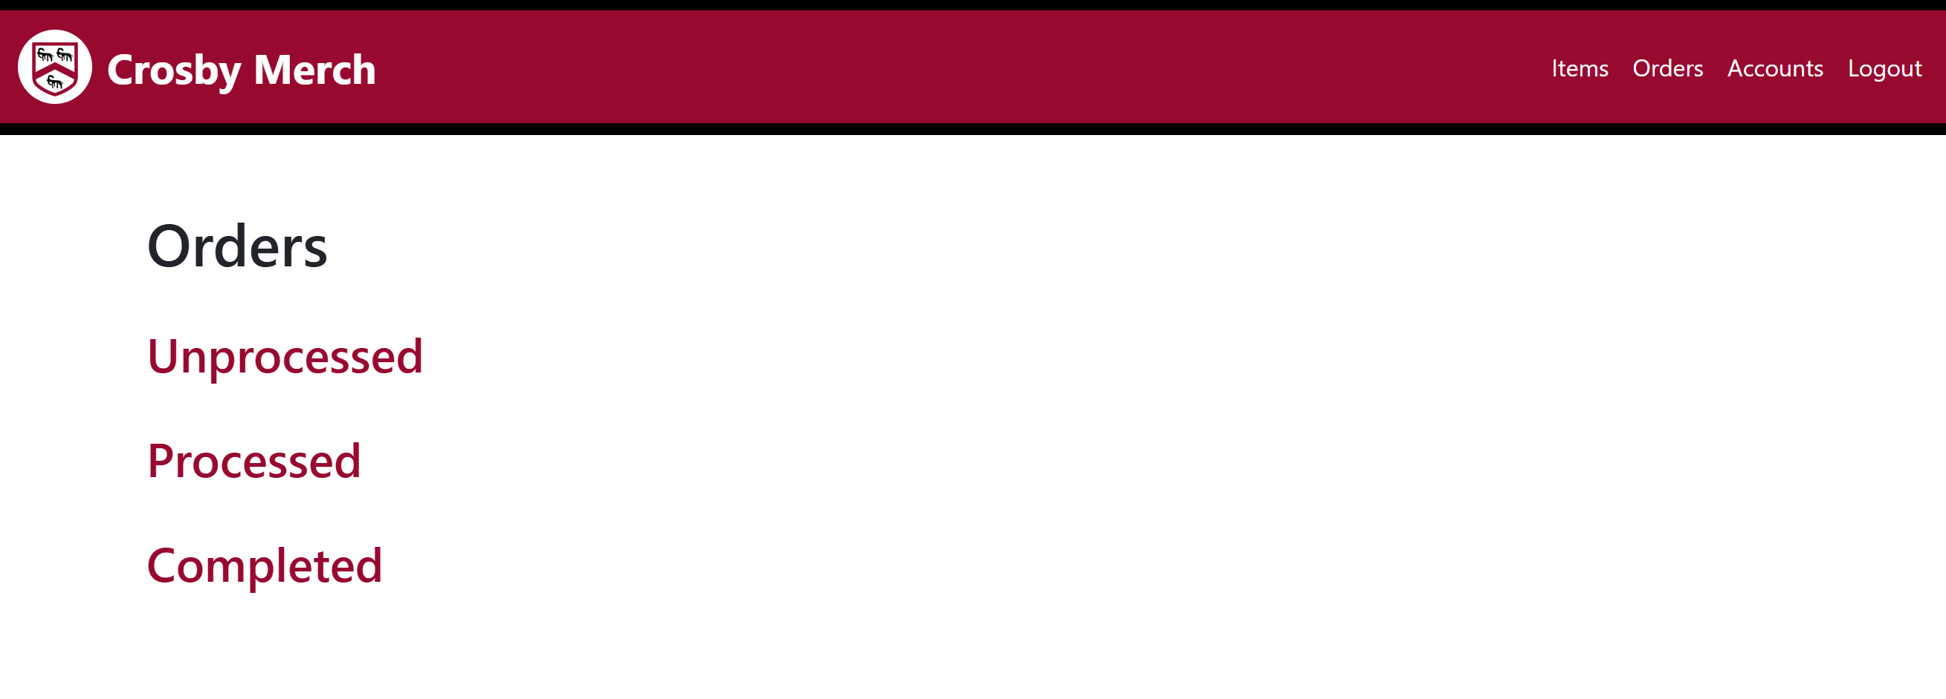This is the code to display the links to lists of orders of specific status.

This shows the links displaying correctly onto the page. In testing the links lead to the correct pages.

Final Annotated Code:

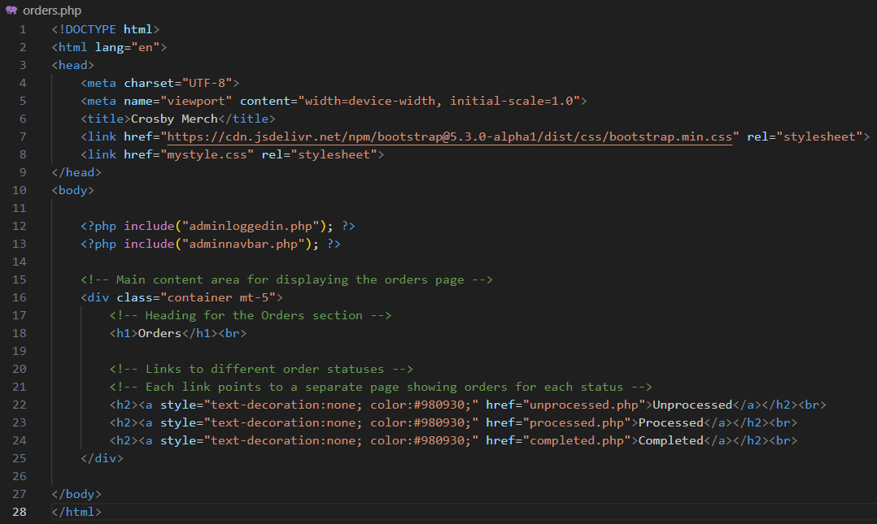

### Unprocessed.php

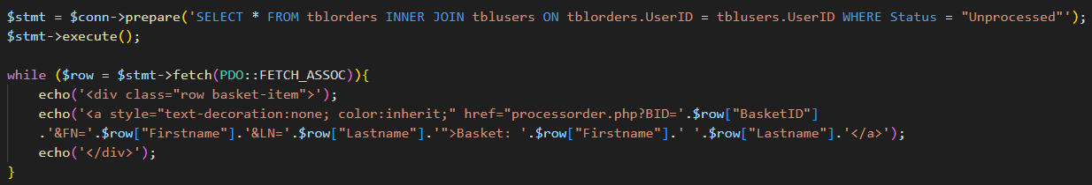This page will display all unprocessed orders, showing which customer each order belongs to. It will also allow orders the be clicked to check its contents and be processed.

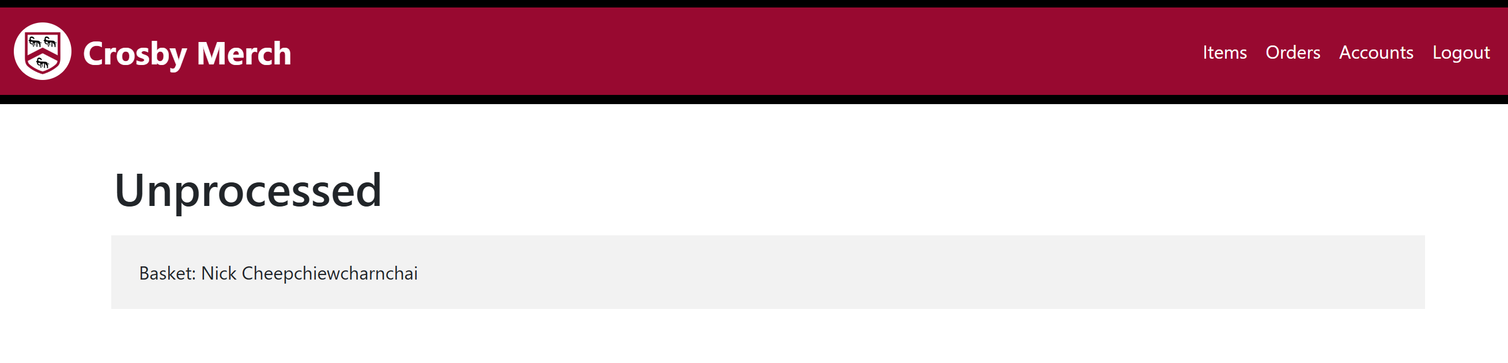This is the SQL needed to display all of the information of order onto the page. For the query string, I chose to pass through 3 different parameter values: the BasketID (BID), which will be used to display the contents of the order in processorder.php, then I chose to pass the firstname and lastname (FN & LN) to avoid unnecessary SQL in displaying the name in processorder.php. This code also contains the display of the order as a link leading to processorder.php page to display it’s details.

This shows that the code works correctly in displaying the basket.

Final Annotated Code:

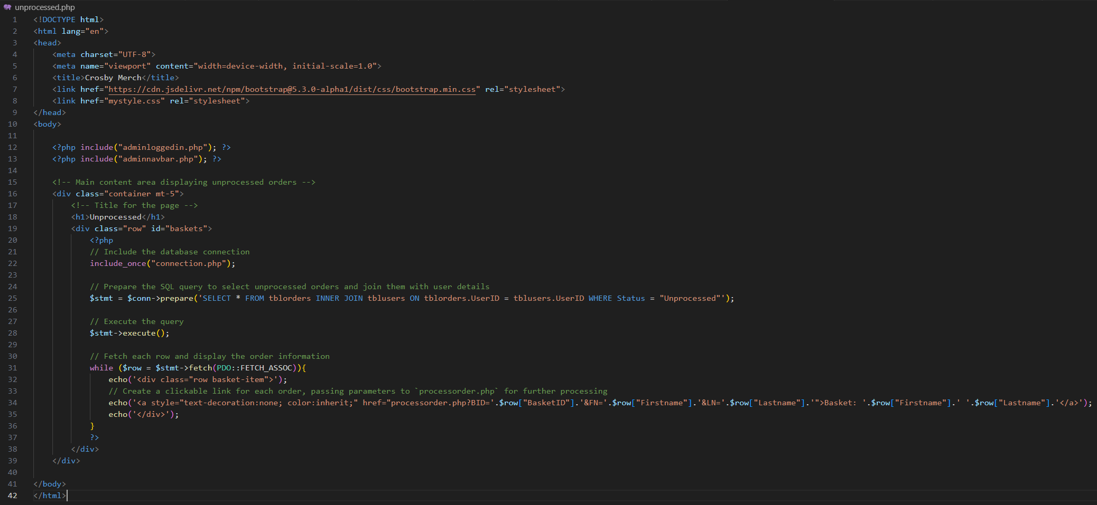

### Processorder.php

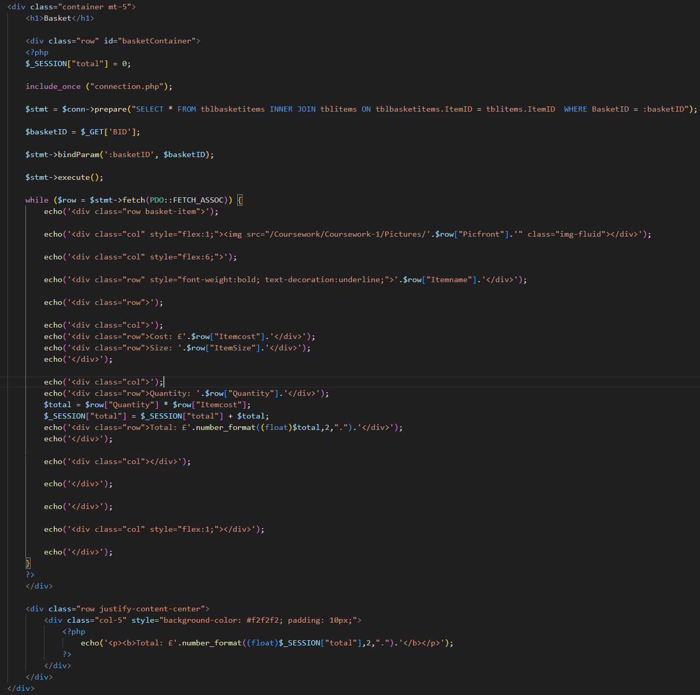This page displays the contents of the chosen unprocessed order. It has the generic basket layout (refer to Design → Page Design → Generic Basket page) which means that I can copy most of the code from the customer side purchasebasket.php.

Currently this is the code copied from the purchasebasket.php.

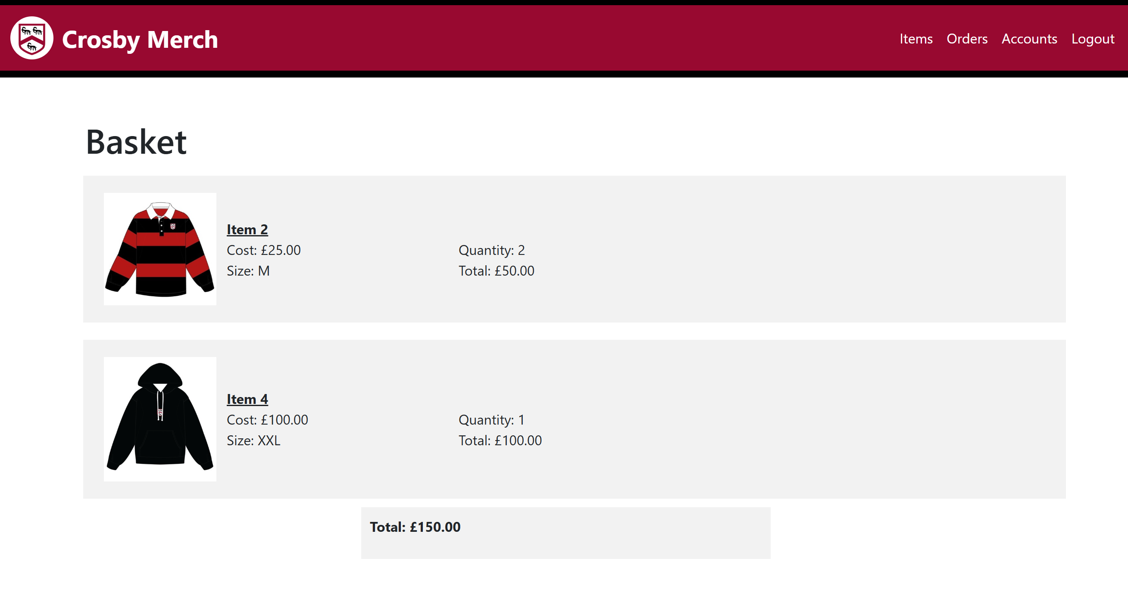This is what the page looks like so far. Next I need to add the customer name to the heading and add a process button which will send data to a different page foe the status or the order to be updated.

I move the <h1> tag into the php to be able to retrieve the FN & LN parameter from the query string passed through by unprocessed.php. This changes the heading to display what I wanted it to.

Then I need to create a form button to send the BasketID to a different page to update the status of the order.

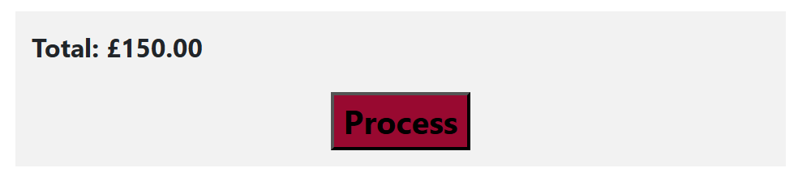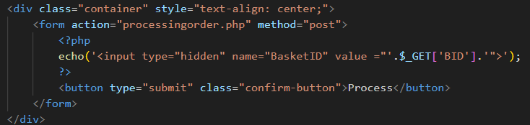Finally, this code adds the process button, sending the BasketID as a hidden input to processingorder.php, which will handle the SQL to update the status of this order.

This shows the process button being displayed onto the page correctly.

Together this is what the page looks like.

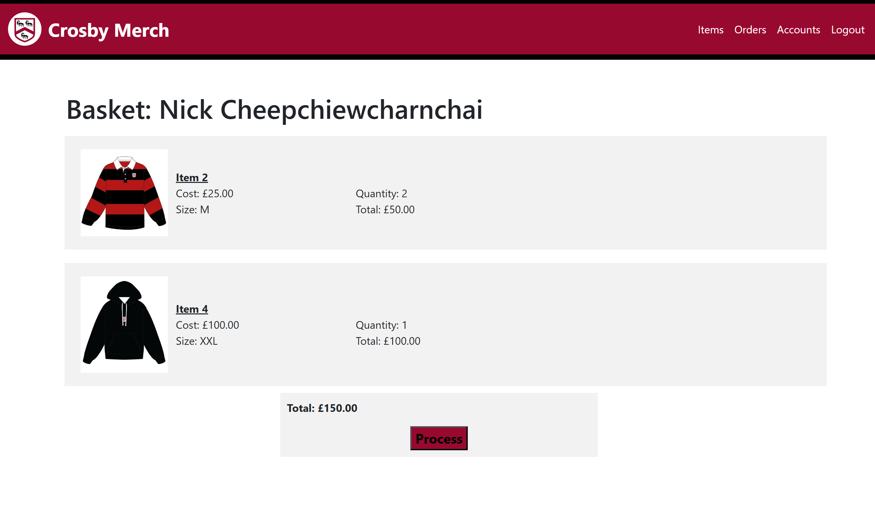

Final Annotated Code:

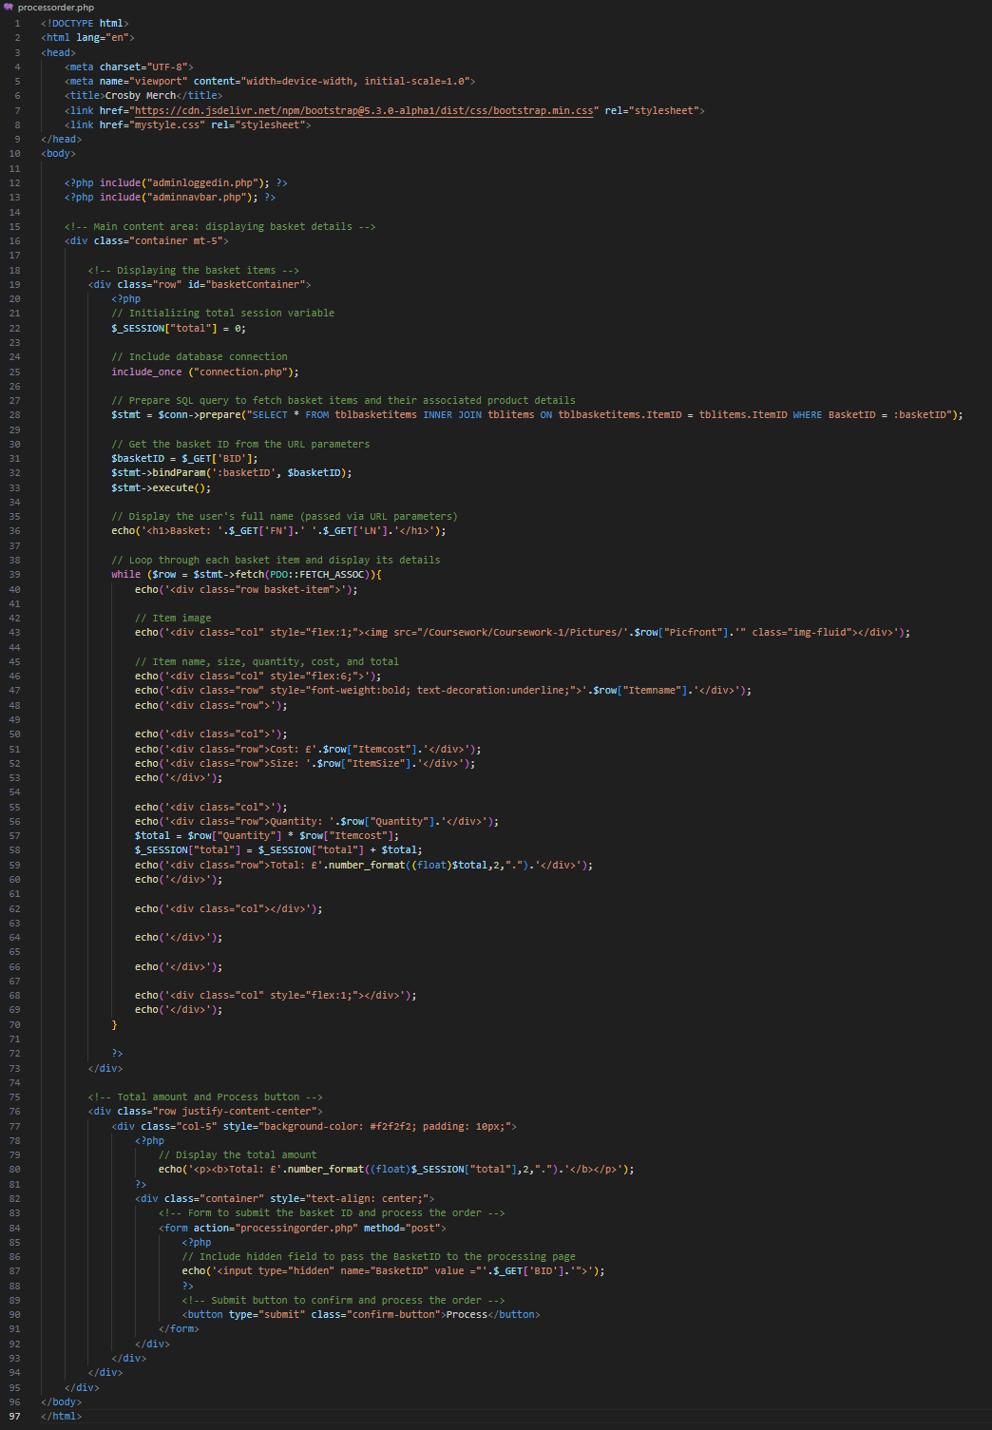

### Processingorder.php

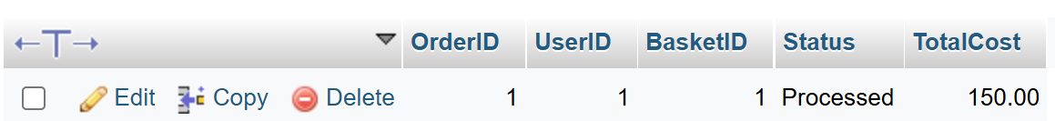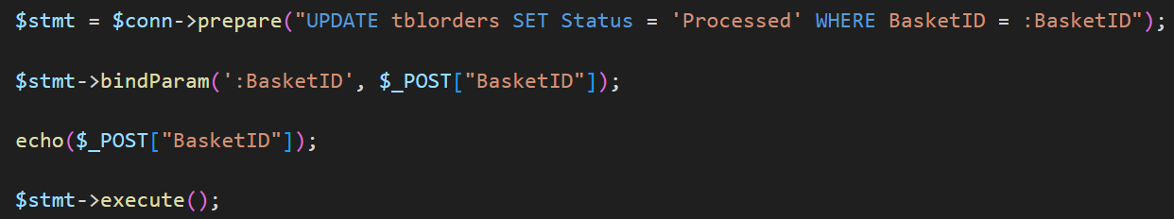This page will take the BasketID taken from the form submitted through processorder.php and will use it to update the status (unprocessed 🡪 processed) of the correct order.

This is the SQL that updates the status of the order.

After running the code, I checked phpMyAdmin to see that it worked correctly.

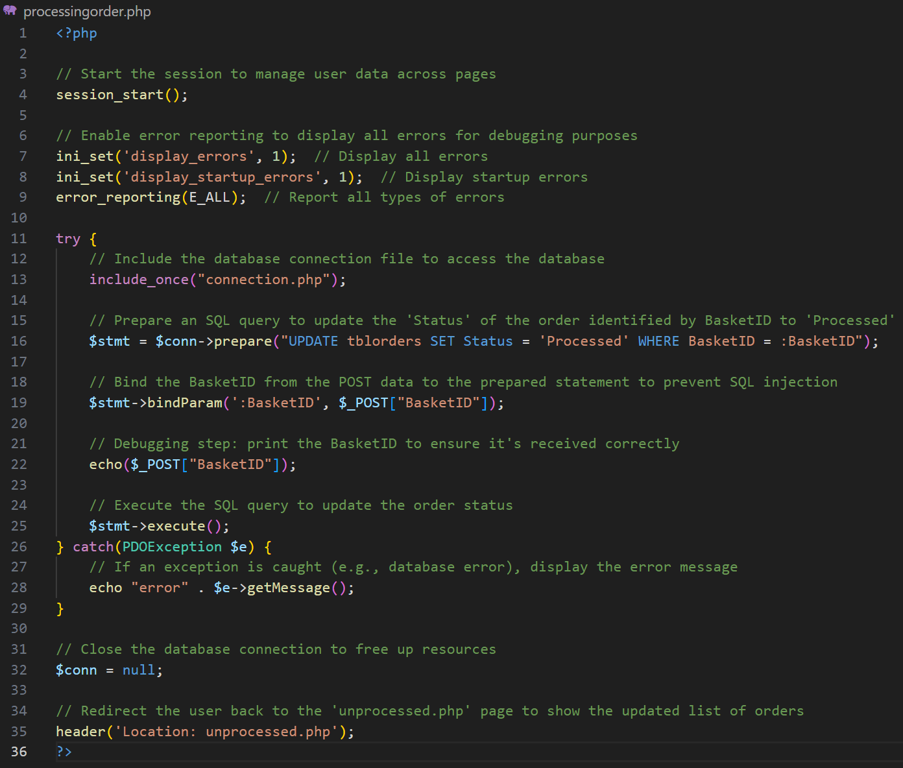Final Annotated Code :

### Processed.php

This page is the same as unprocessed.php but it will display processed orders, showing which customer each order belongs to. It will also allow orders the be clicked to check its contents and to complete them.

Due to this page having the exact same display as unprocessed.php I will copy most of the code over from that page and make some tweaks to it.

From the code that was copied from unprocessed.php, I changed to heading to match the page, and then I changed the SQL to select processed orders instead of unprocessed orders.

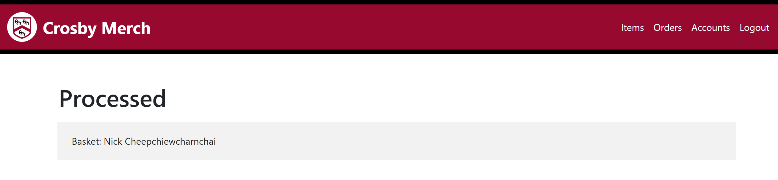This is what the page looks like now, displaying the correct order.

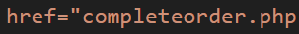Then I changed the link of the order, this time directing to a page to complete the order.

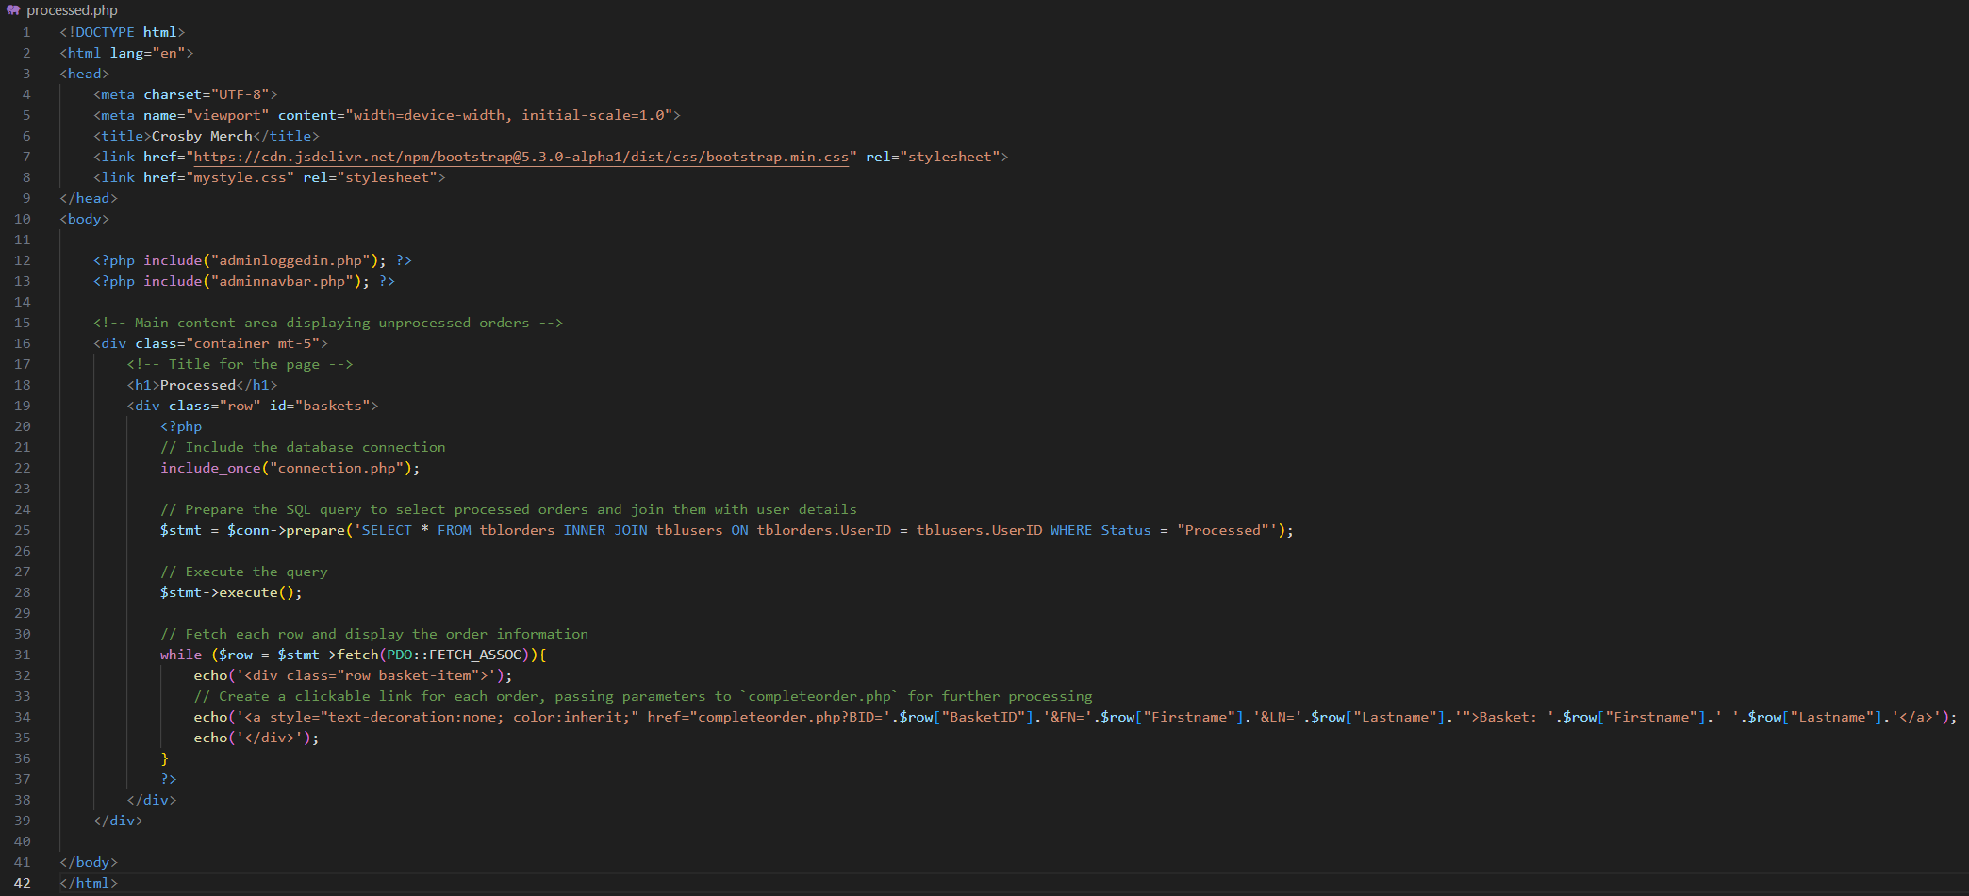Final Annotated Code :

### Completeorder.php

This page is the same as processorder.php but it have a complete button instead of a process button.

Due to this page having the exact same display as processorder.php I will copy most of the code over from that page and make some tweaks to it.

From the copied code, I will change the form to link it to a new page called completingorder.php and I changed the label on the button to say complete instead.

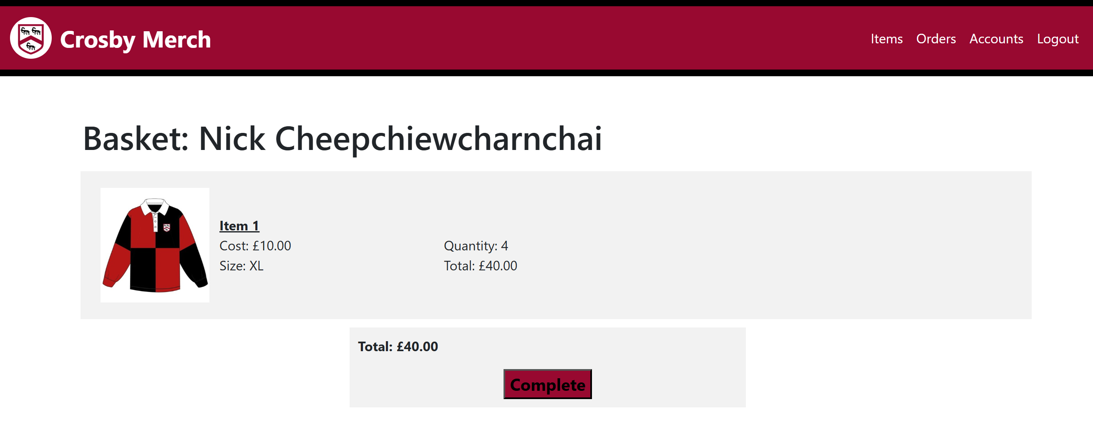

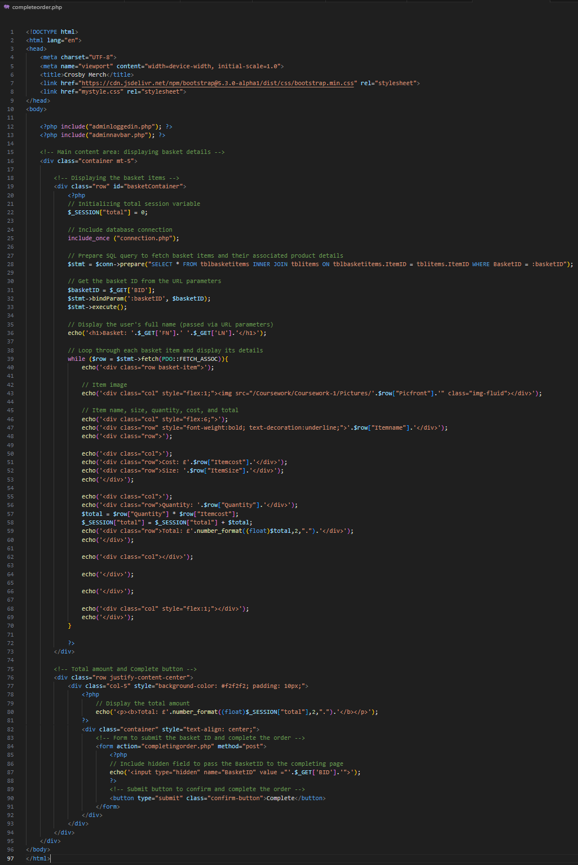Final Annotated Code:

### Completingorder.php

This page is the same as processingorder.php but it will update the order status to completed instead.

 Due to this page having a feature like processorder.php I will copy most of the code over from that page and make some tweaks to it.

From the copied code I change the SQL to update the status to complete and for the header to redirect to Processed.php, to carry on completing other orders.

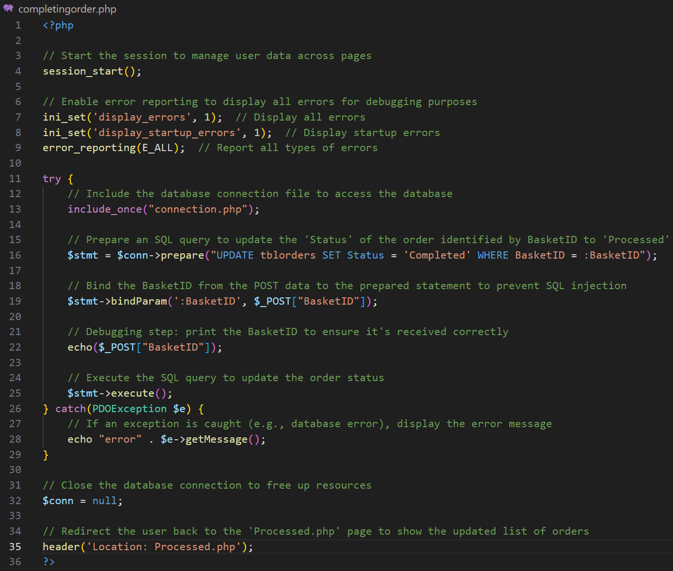Final Annotated Code:

### Completed.php

This page is the same as unprocessed.php and processed.php but it will display completed orders, showing which customer each order belongs to. It will also allow orders the be clicked to check its contents.

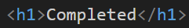Due to this page having the exact same display as unprocessed.php and processed.php I will copy most of the code over from that page and make some tweaks to it.

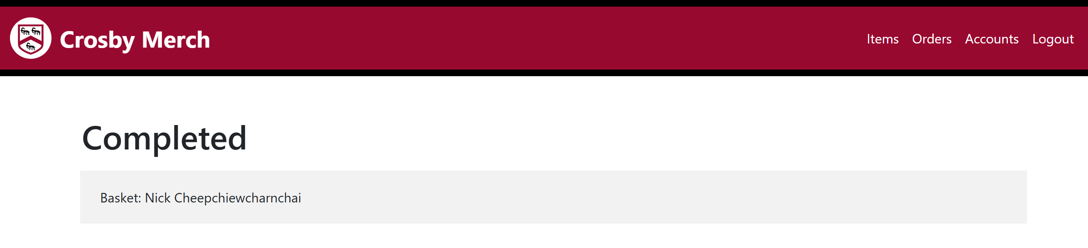From the code that was copied from unprocessed.php, I changed to heading to match the page, and then I changed the SQL to select completed.

 This is what the page looks like now, displaying the correct order.

Then I changed the link of the order, this time directing to a page to display details of the order.

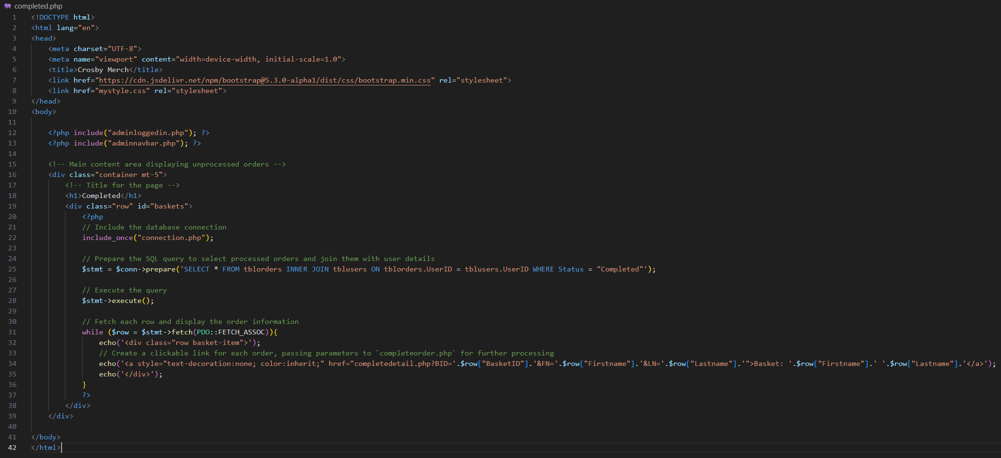Final Annotated Code:

### Completedetail.php

This page is the same as processorder.php and completeorder.php but it does not have a process button since the orders has been completely finished. Instead the page’s only function is to display contents details of orders as a way to store order history.

Due to this page having the exact same display as processorder.php and completeorder.php I will copy most of the code over from that page and make some tweaks to it.

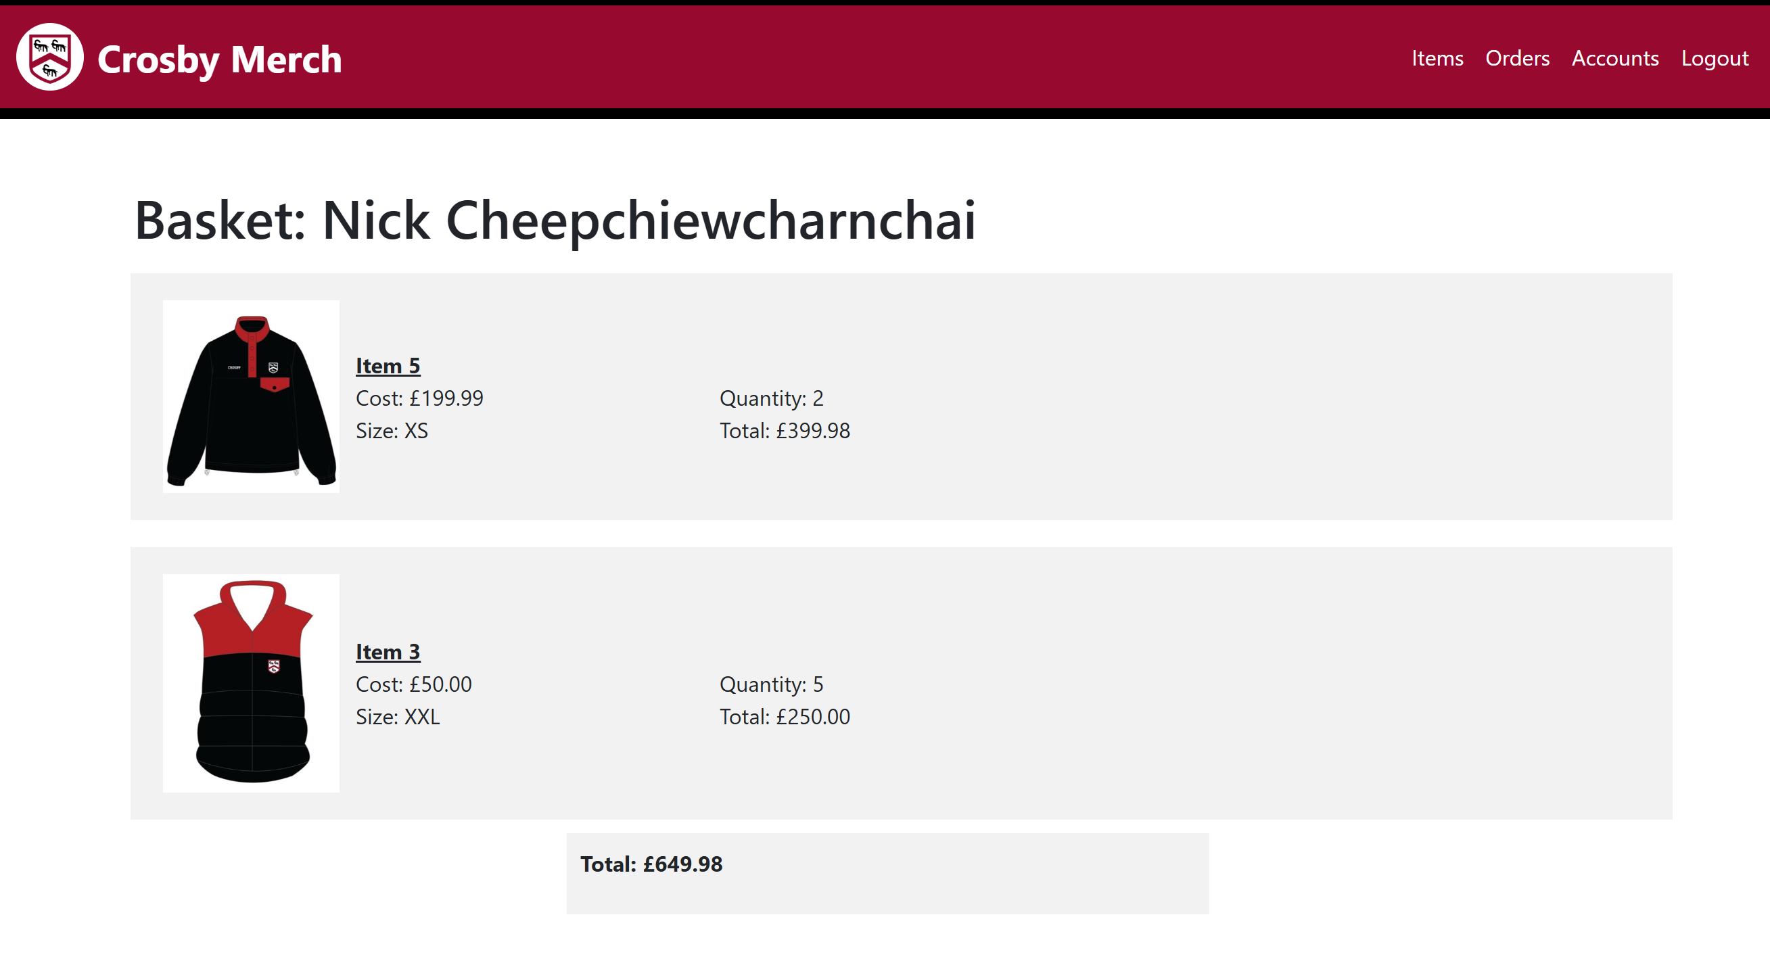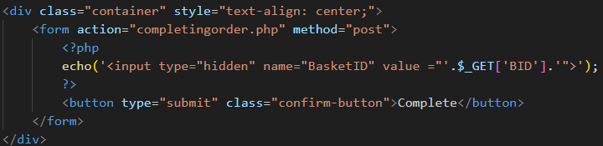From the copied code, this was the code that I deleted which will get rid of the button and the form.

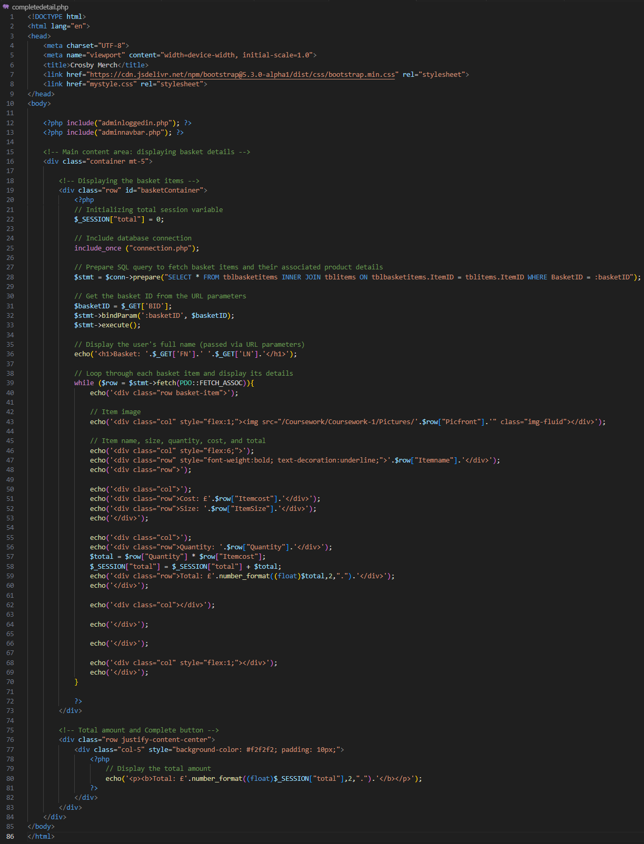 Final Annotated Code:

### Accounts.php

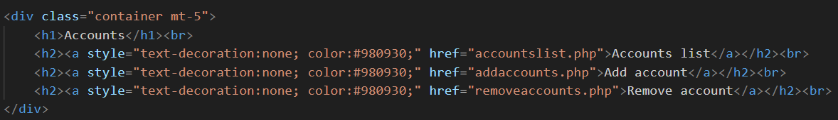This page is the navigating page for admin users to use to manage accounts (view, add & remove). The design is very simple since the admin side of the website does not focus on aesthetics, and this page only displays links to other pages.

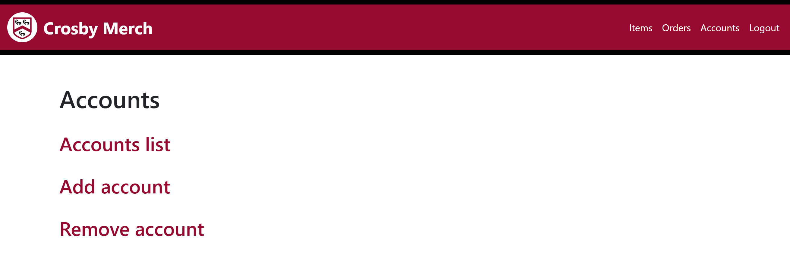This is the code to display the links to different accounts management sections.

This shows the links displaying correctly onto the page. In testing the links lead to the correct pages.

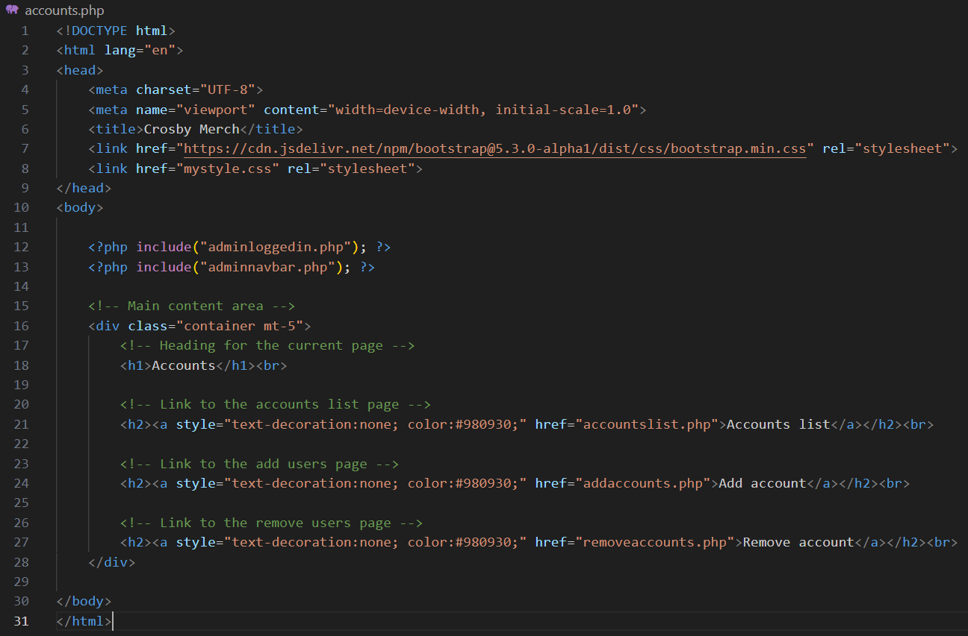Final Annotated Code:

### Accountslist.php

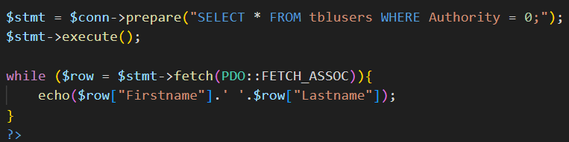This page’s purpose is to display a list of all non-admin user accounts from the database, allowing an admin to click on a user to view more detailed information about that account.

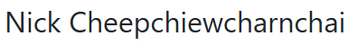Firstly I wrote the SQL to select data of customer accounts from TblUsers so that I can display them onto the page. To test the data was fetched correctly I will echo the firstname and lastname of the account.

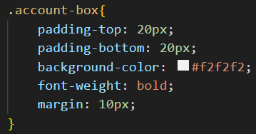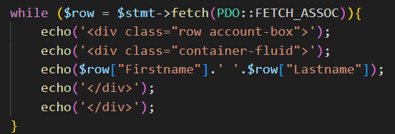This shows that the SQL logic is correct and is fetching what I want it to fetch.

 Then I used some bootstrap and CSS to decorate the display so that it fits what I want it to look like.

This show the display outcome that the code achieved.

Finally, I changed the name display into a link redirecting to accountdisplay.php and passing in the UserID (ADID – to allow for account specific display page), Firstname and Lastname (FN and LN – to avoid having to deal with an SQL in the display page) as a parameter for the query string.

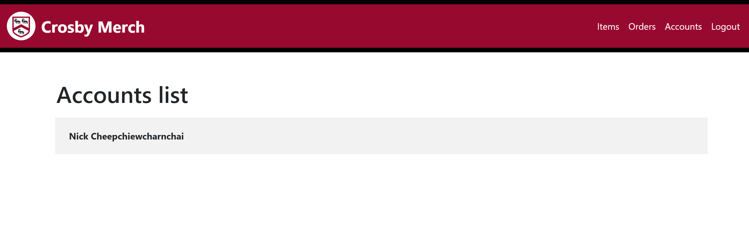 This is what the code looks like when I put it all onto a page together.

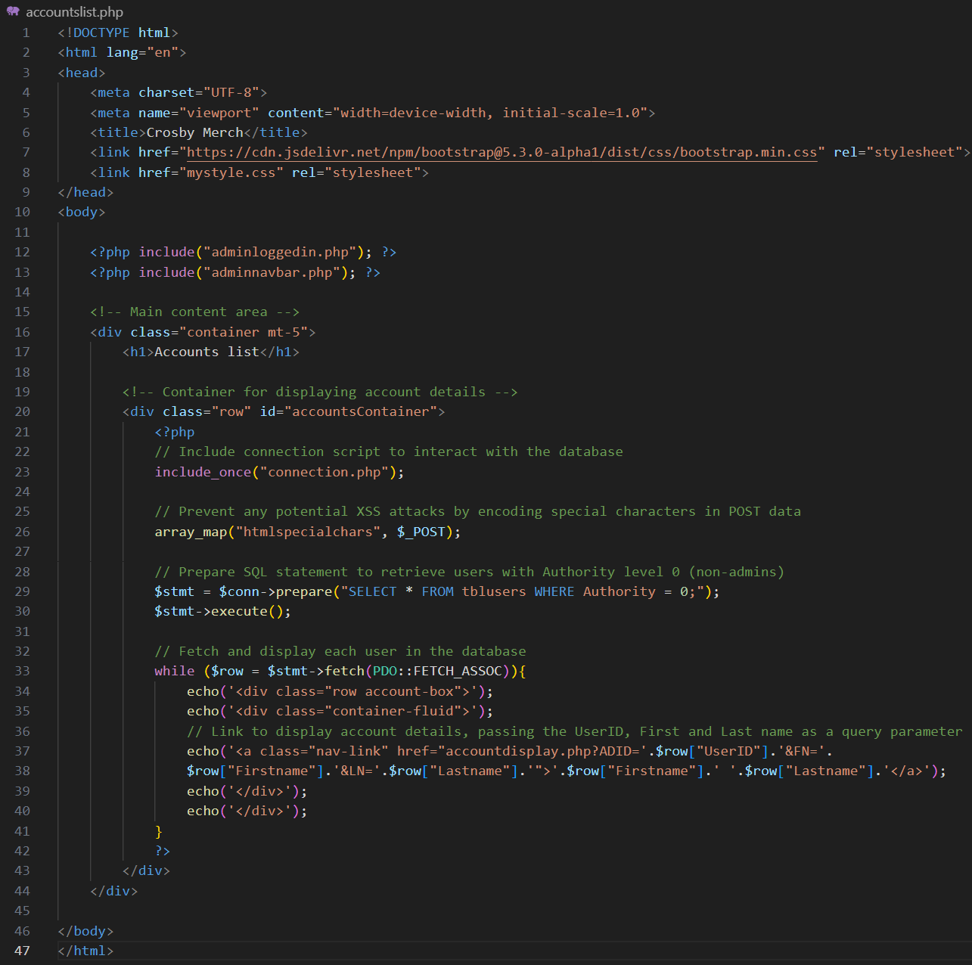Final Annotated Code:

### Accountdisplay.php

This page is the navigating page for admin users to use to manage a specific account (view info, process orders). The design is very simple since the admin side of the website does not focus on aesthetics, and this page only displays links to other pages.

To display the heading as the firstname and lastname of the user, I used GET parameters to fetch from the query string of the link.

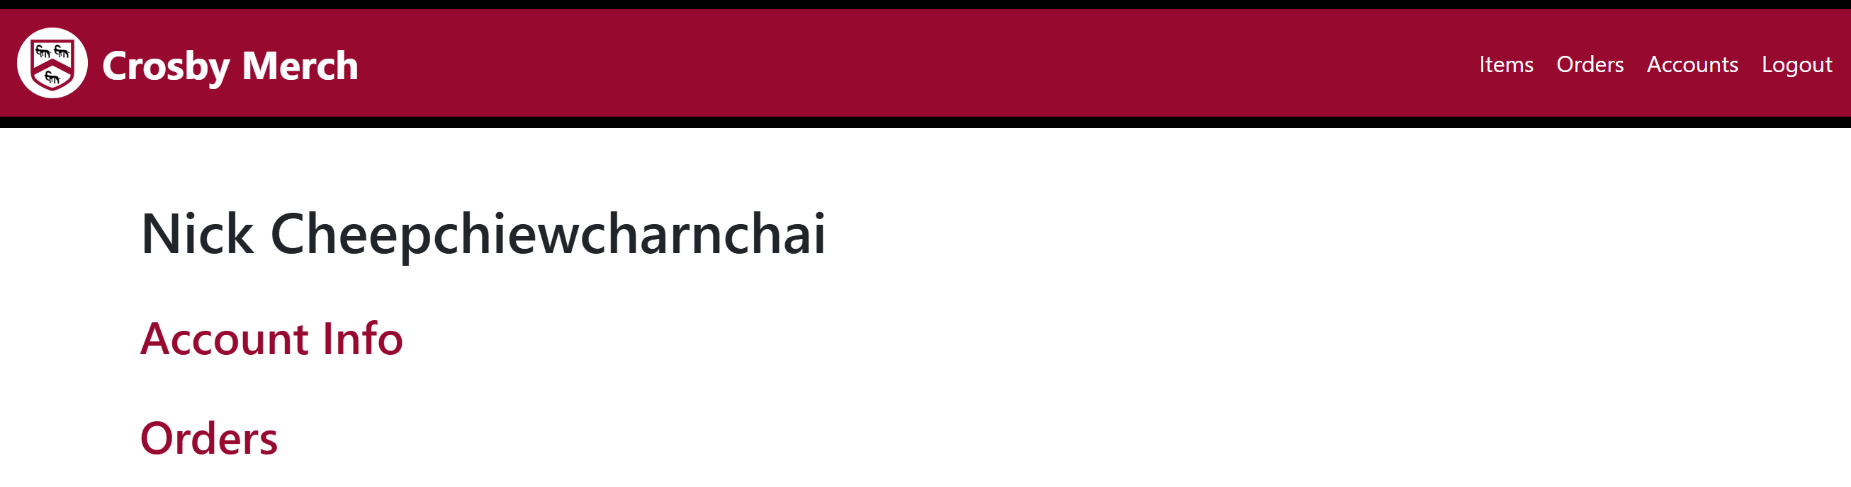Then I added the links for the that this page should direct to. I passed in the UserID into the query string so that each page will be displayed with specific user details.

This shows that all of the code works properly and is displaying onto the page correctly.

Final Annotated Code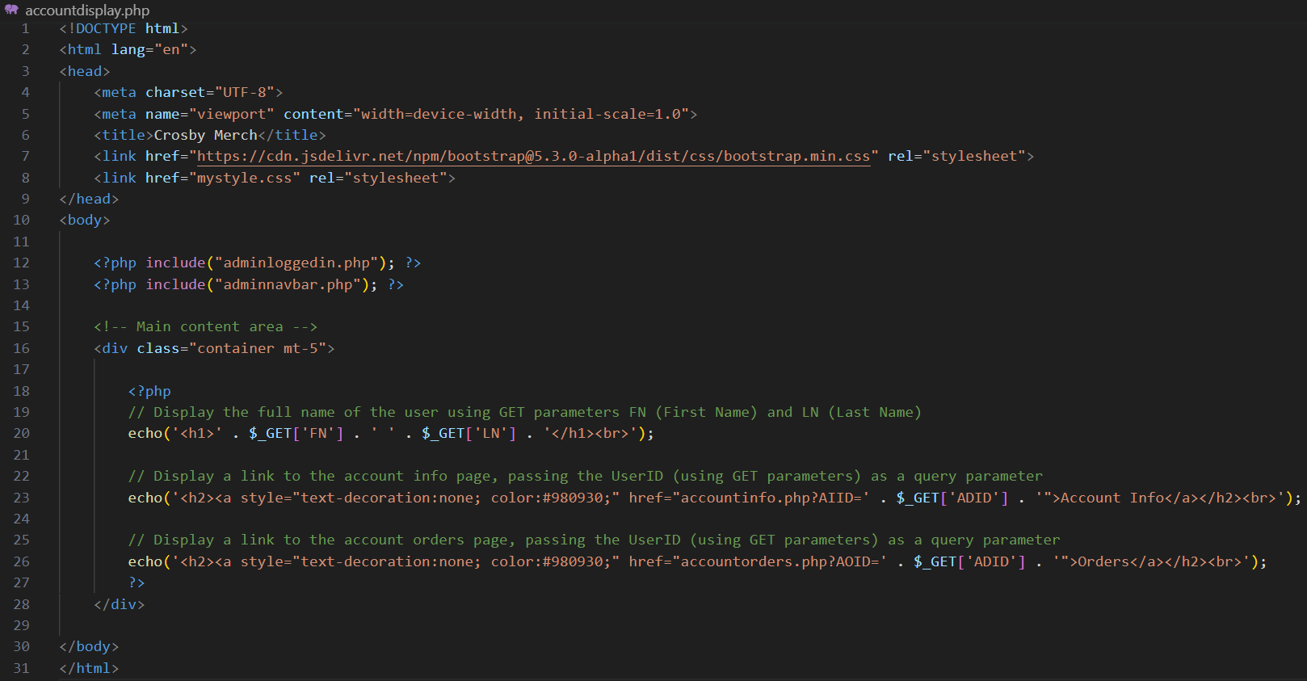:

### Accountinfo.php

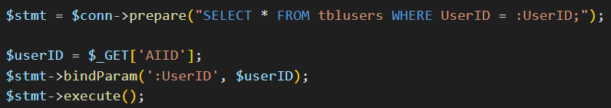This page is where info of the account (name, username, password) is displayed. This will most likely be used in a case where someone cannot remember their login credentials and needs to be reminded of them.

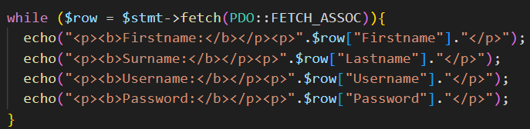This code uses the GET method, retrieve the 'AIID' parameter (containing the UserID) from the URL query string. Then Select from TblUsers all data about the account so that it can be displayed onto the page.

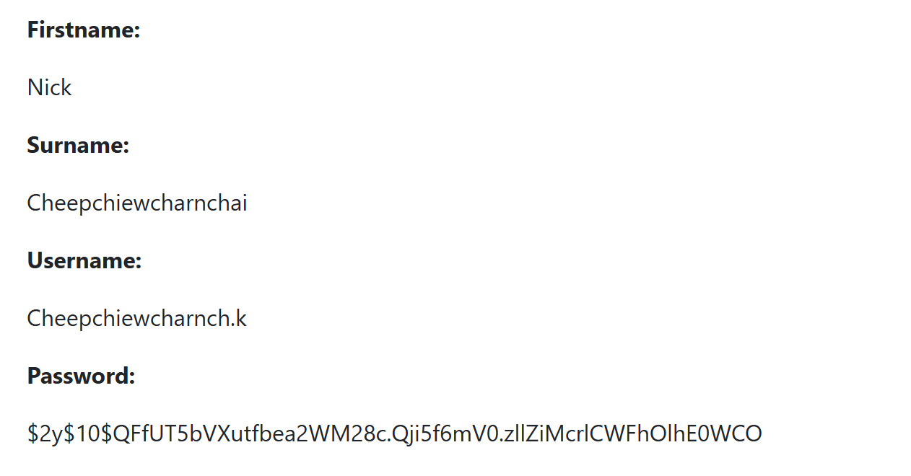This code will display the fetched data onto the page.

When running the code, I realised that the password displayed will be the hashed password, therefore there is no point in displaying it at all and I will delete the password display from the code.

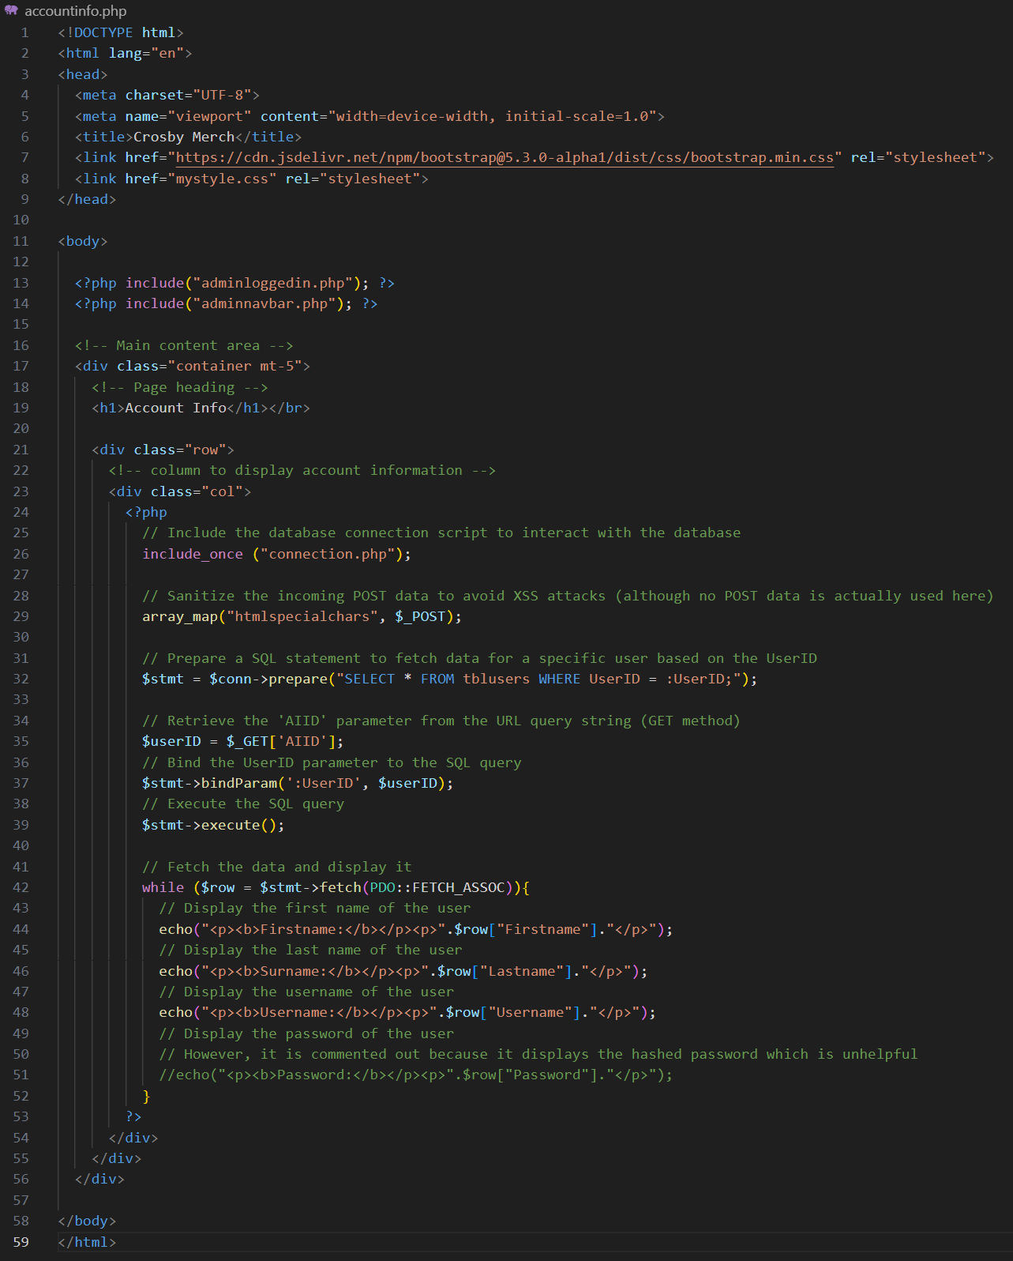Final Annotated Code:

### Accountorders.php

This page will display all the orders that belongs to an account, separating them by the status of the order. This will allow the admins to process orders by accounts if they wish to do so.

Since this page has the same feature to display baskets, I will be copying most of the code from the unprocessed.php, processed.php and completed.php and then making little changes to them.

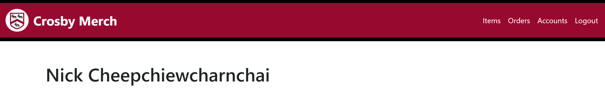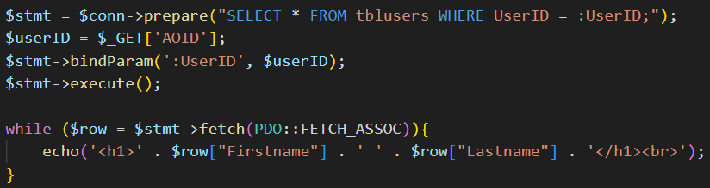Firstly, this is the code to display the name of the customer so that the admin can be sure that they are processing the correct person’s orders.

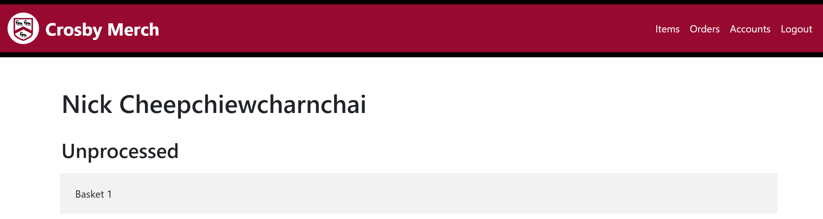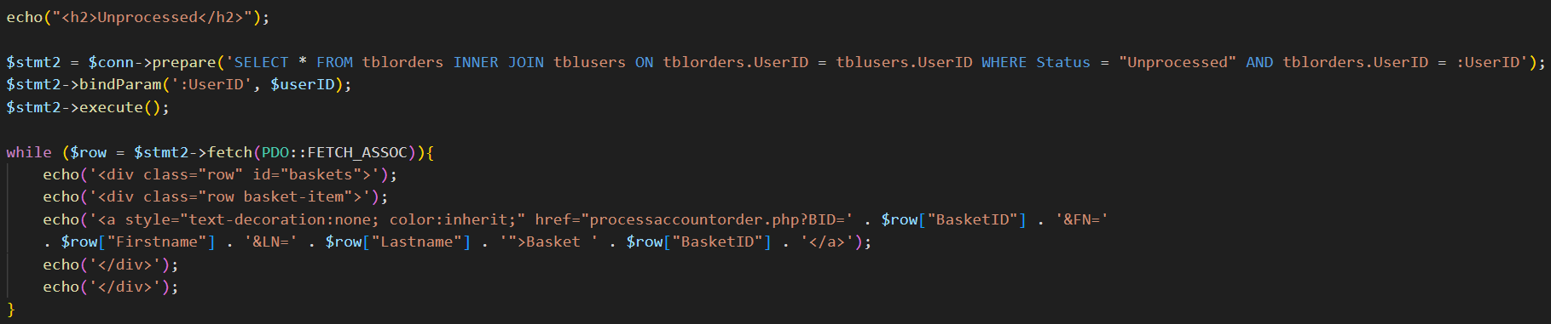This is the code to display the unprocessed orders that belongs to the account. Each order is linked to a page that will allow the admin to process the order.

This shows that the code works as intended. Therefore I can copy the code and relink them to display the processed and completed orders.

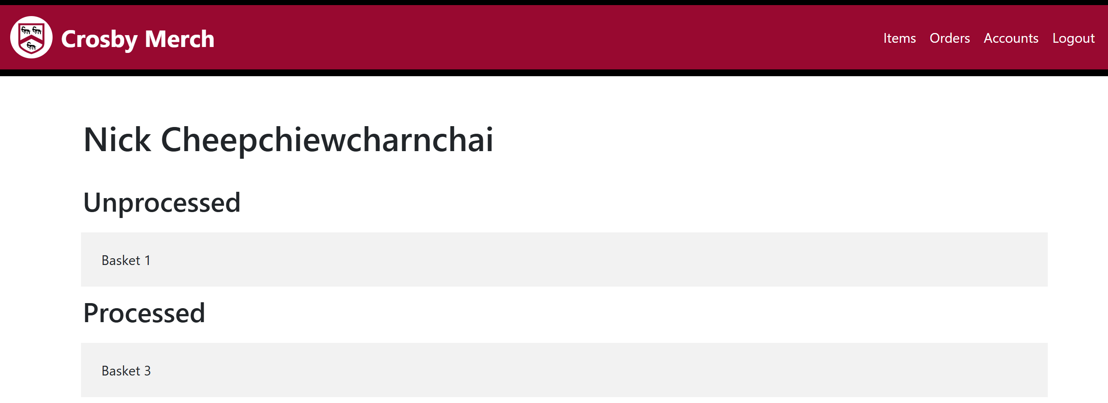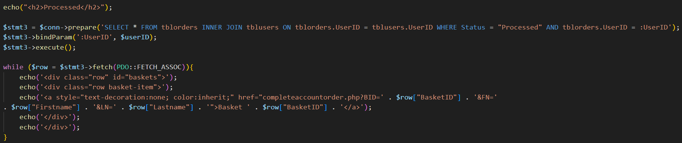This is the same code modified to display processed orders, and linked to a page that will allow the admin to complete the order

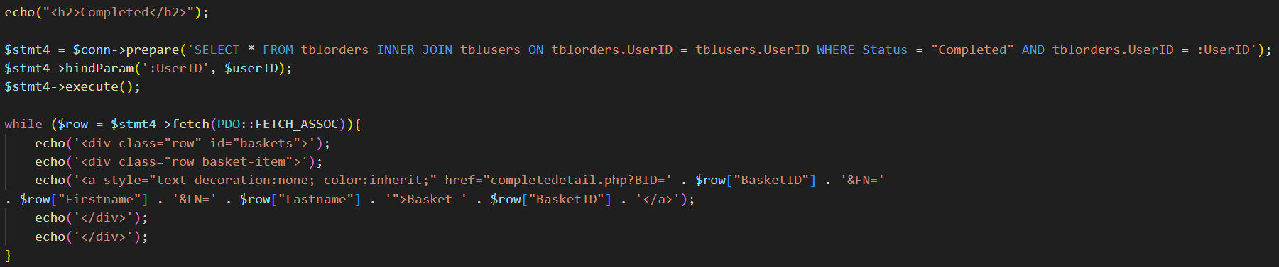This shows the display added onto the page

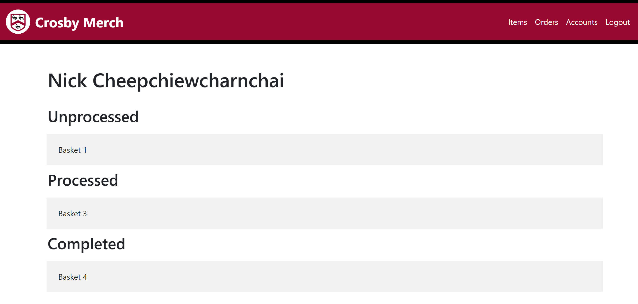This is the same code modified to display completed orders. Since completed orders can no longer by processed and wont have any redirects, I will link this to the already existing completedetail.php.

Final Annotated Code:

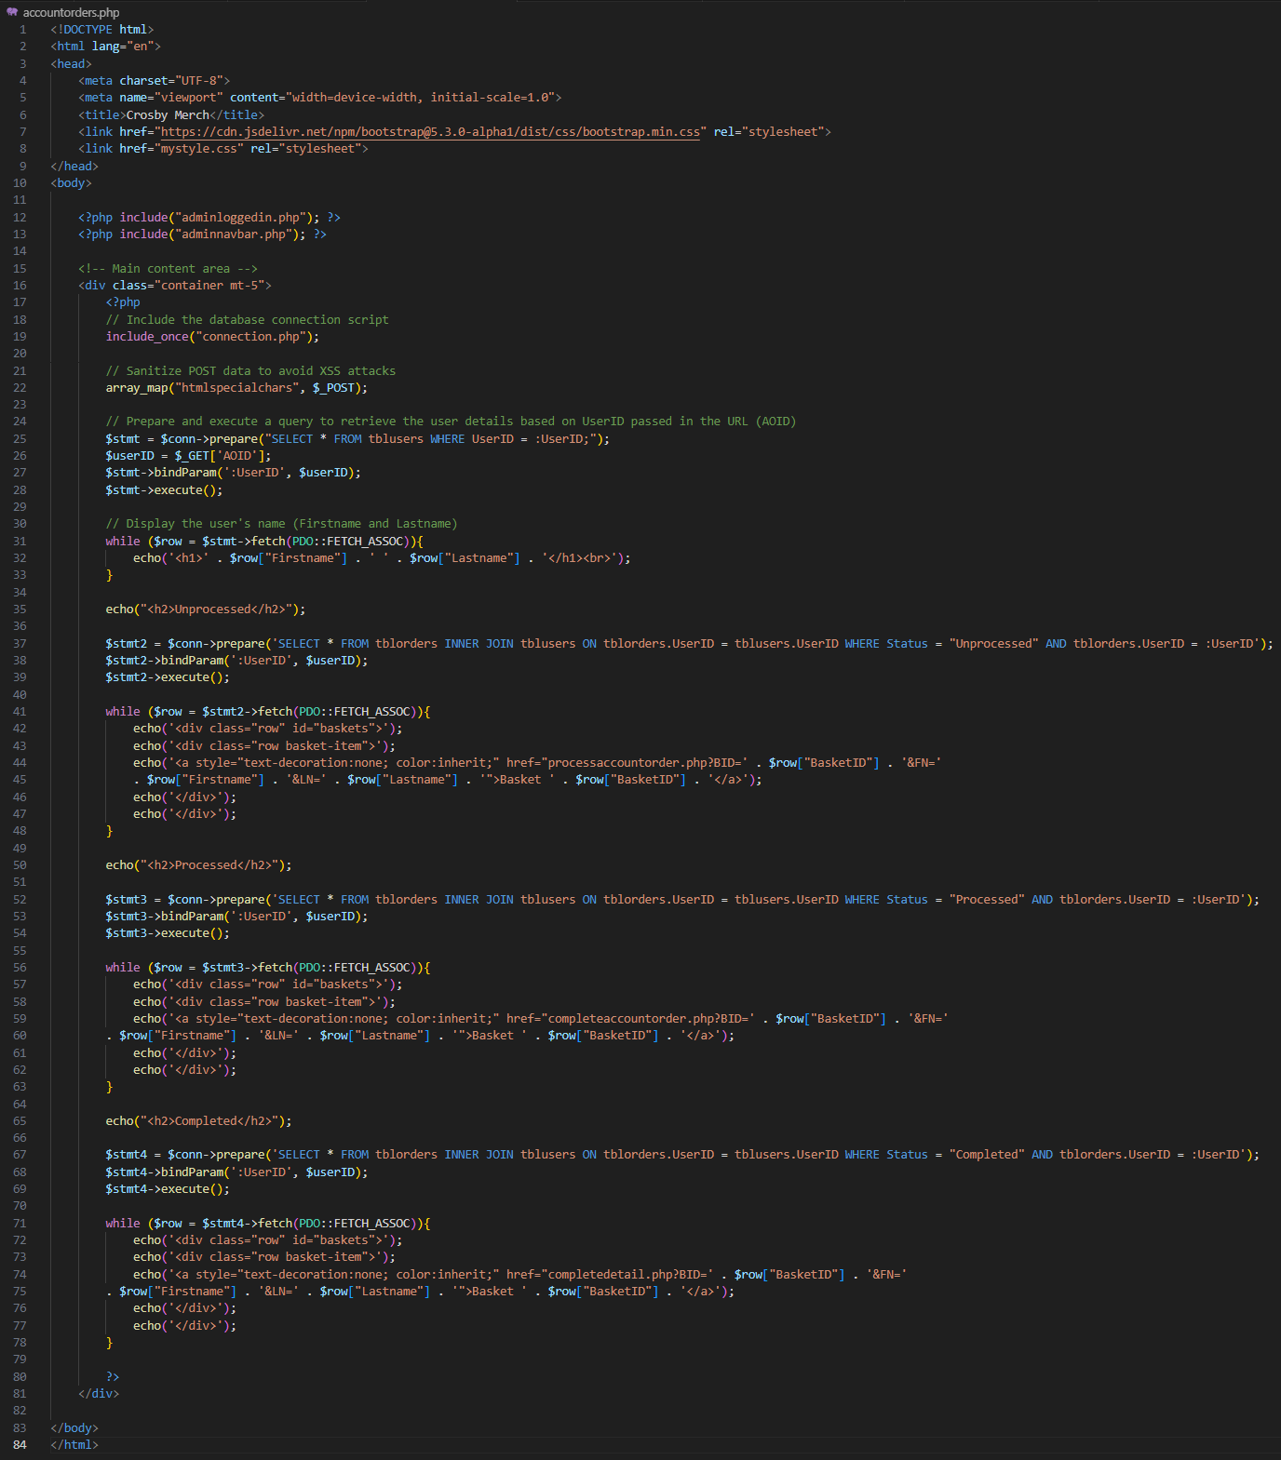

### Processaccountorder.php

This page is the exact the same as processorder.php therefore I will copy the code from that page.

The only change I made to this page is to redirect the form to a new page to process the order.

Final Annotated Code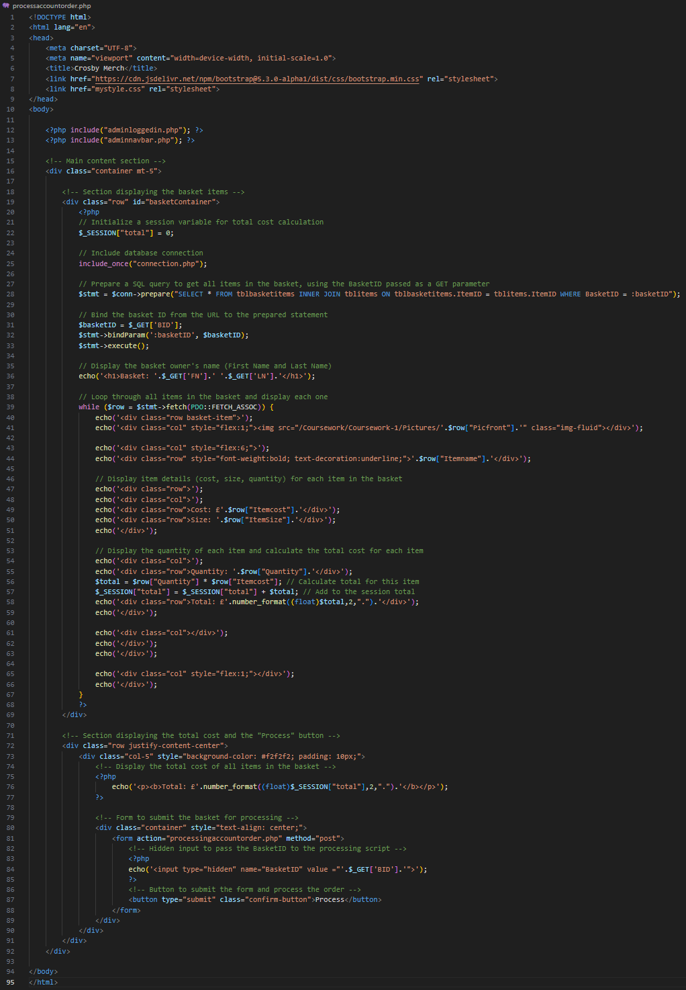:

### Processingaccountorder.php

This page has the exact same function as processingorder.php however it will direct the admin to the same customer’s orders page to show them the updated orders.

This is the header to the correct page, passing the correct parameters through the query string.

Final Annotated Code:

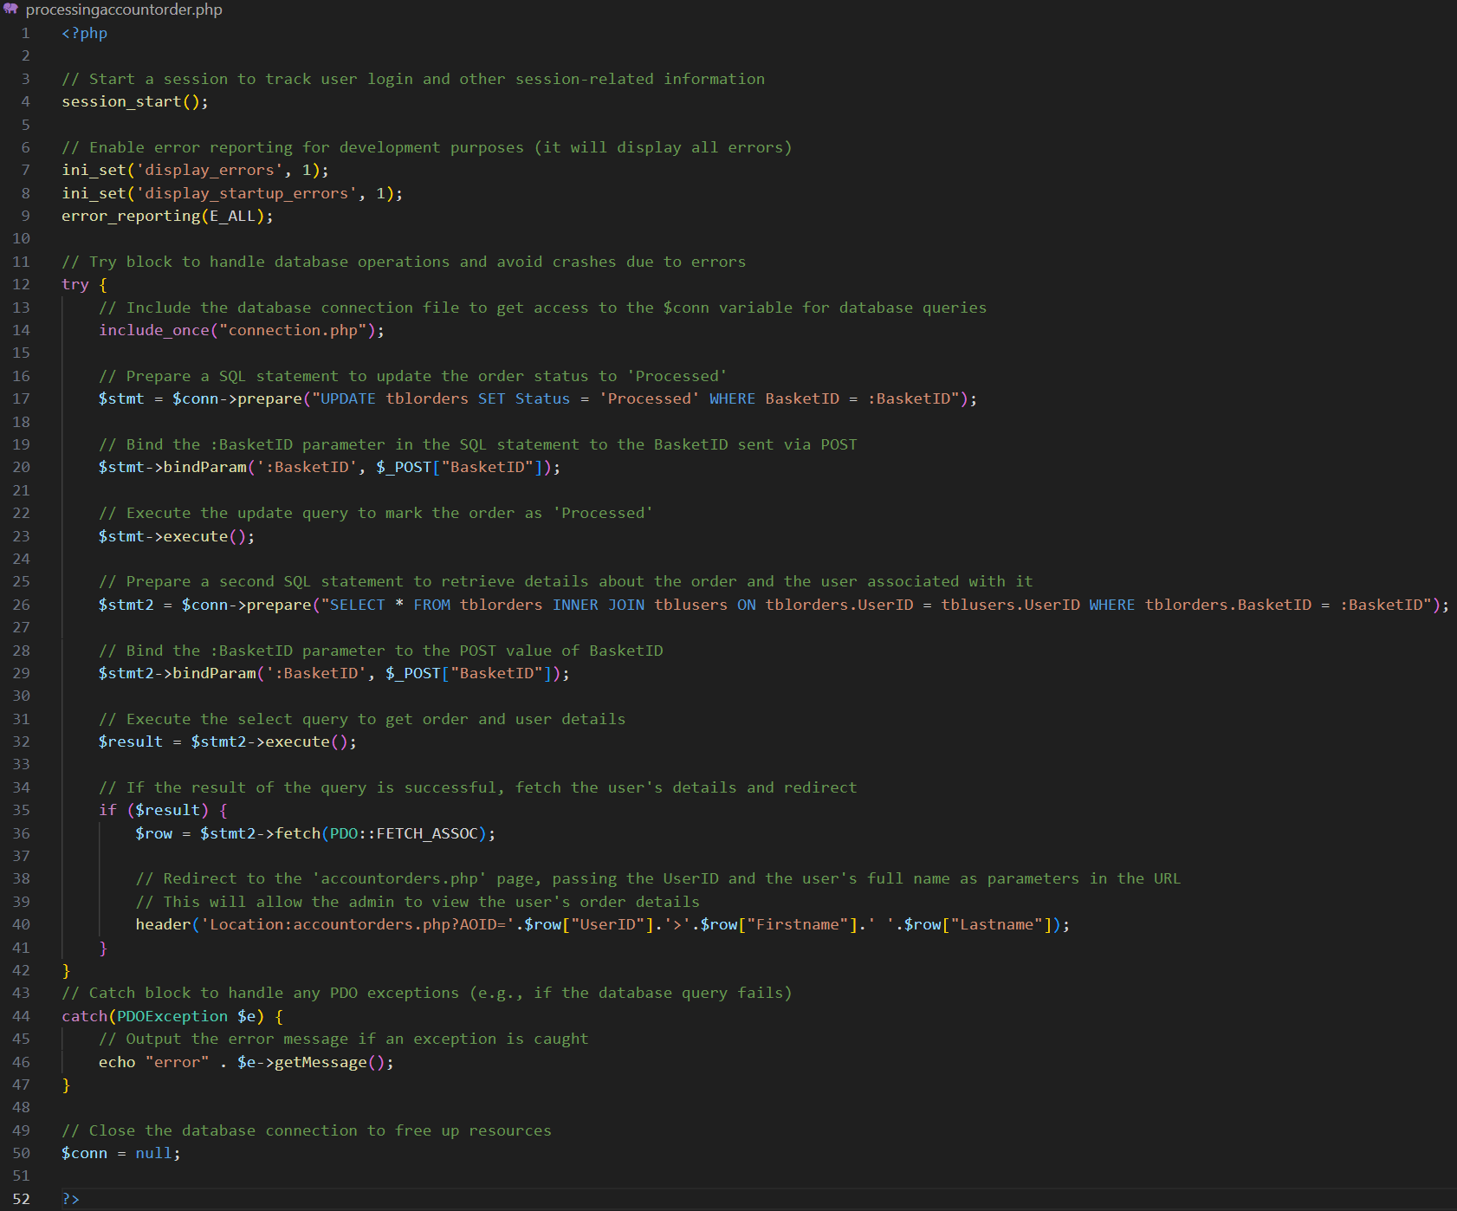

### Completeaccountorder.php

This page is the exact the same as completeorder.php therefore I will copy the code from that page.

The only change I made to this page is to redirect the form to a new page to complete the order.

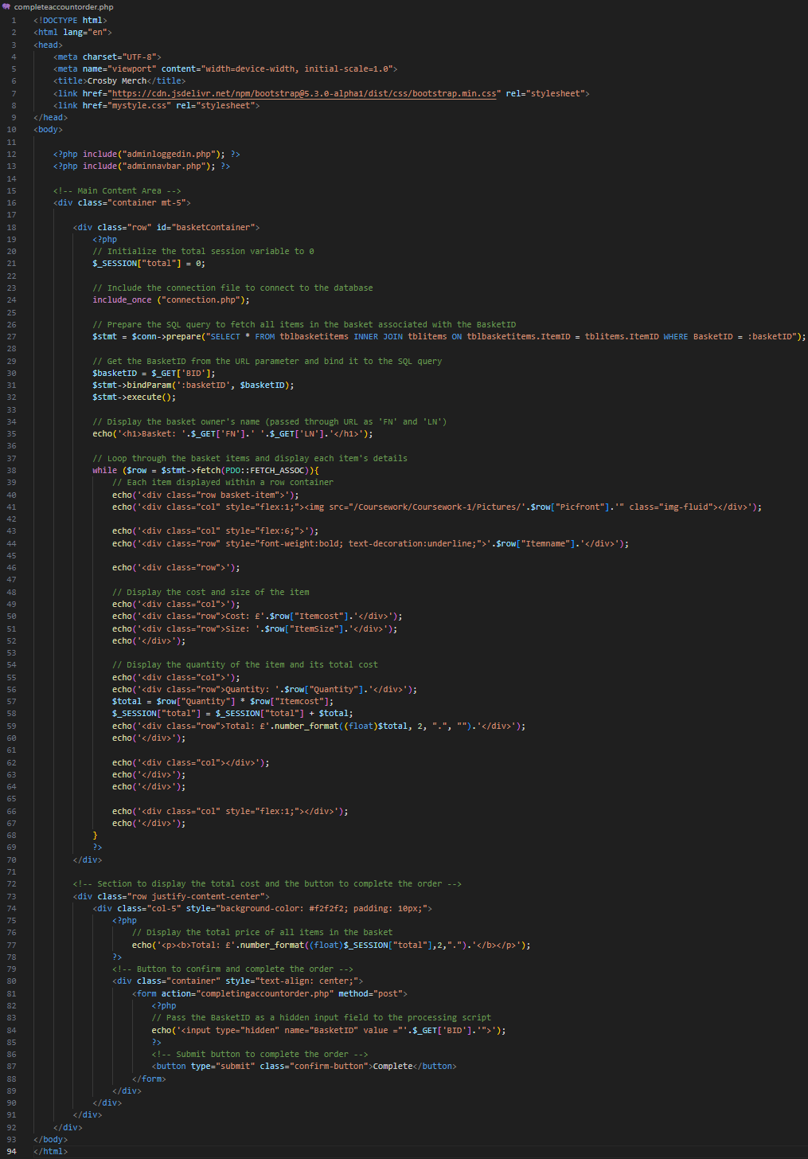Final Annotated Code:

### Completingaccountorder.php

This page has the exact same function as completingorder.php however it will direct the admin to the same customer’s orders page to show them the updated orders.

This is the header to the correct page, passing the correct parameters through the query string.

Final Annotated Code:

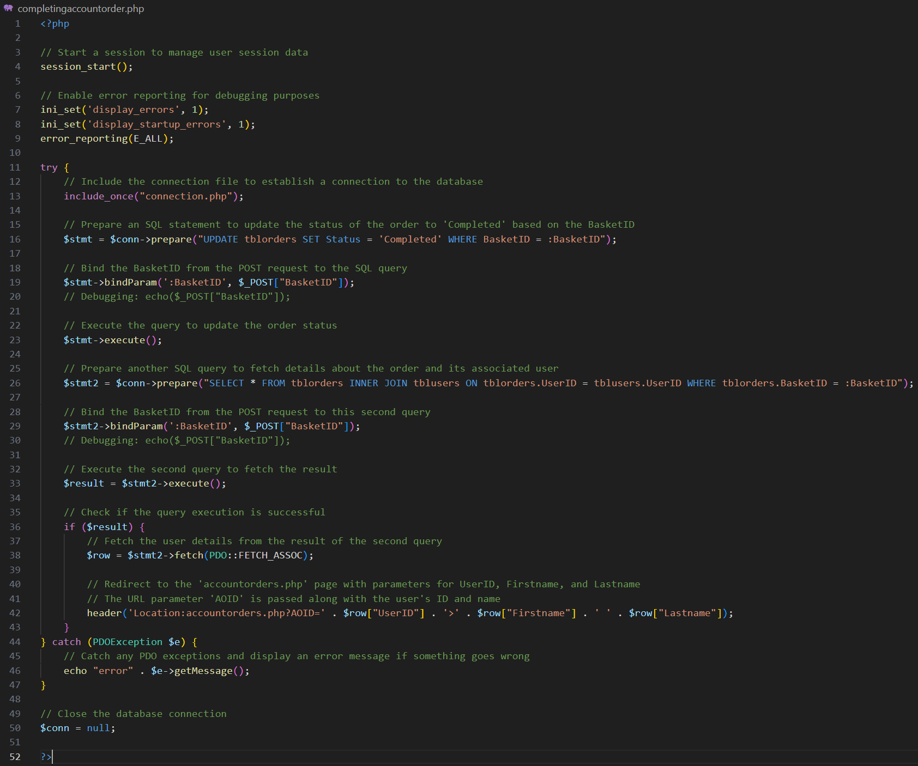

### Addaccounts.php

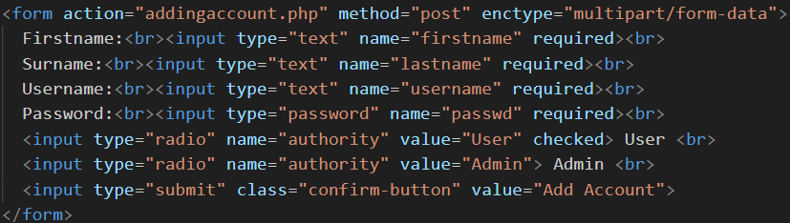 This page will feature a form that will take information from the users to be added into the database as a new account.

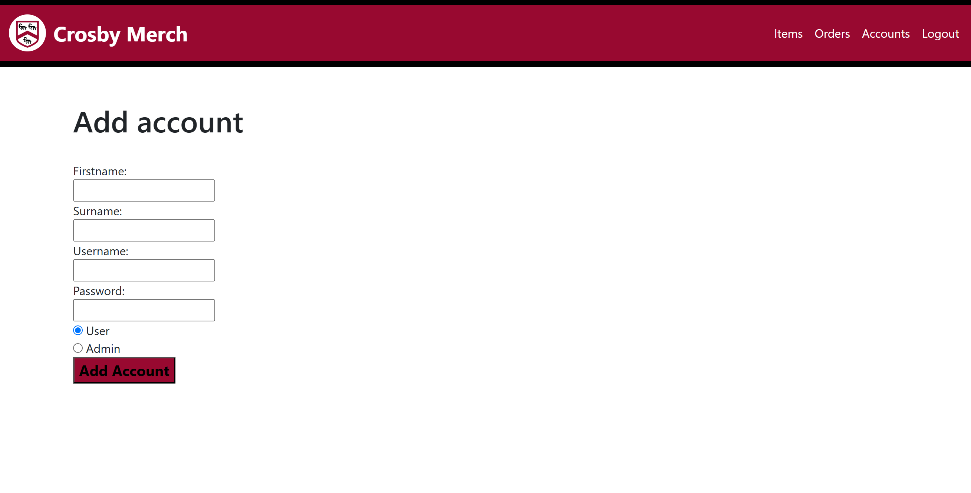 I started by creating the form itself, making sure that all fields are required (as per tables of database).

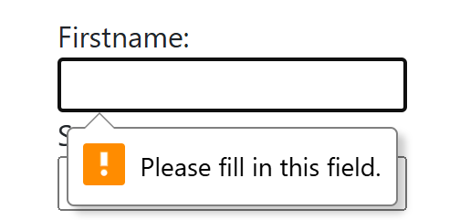 This shows that the forms is correct

This shows that the fields are required to be filled in.

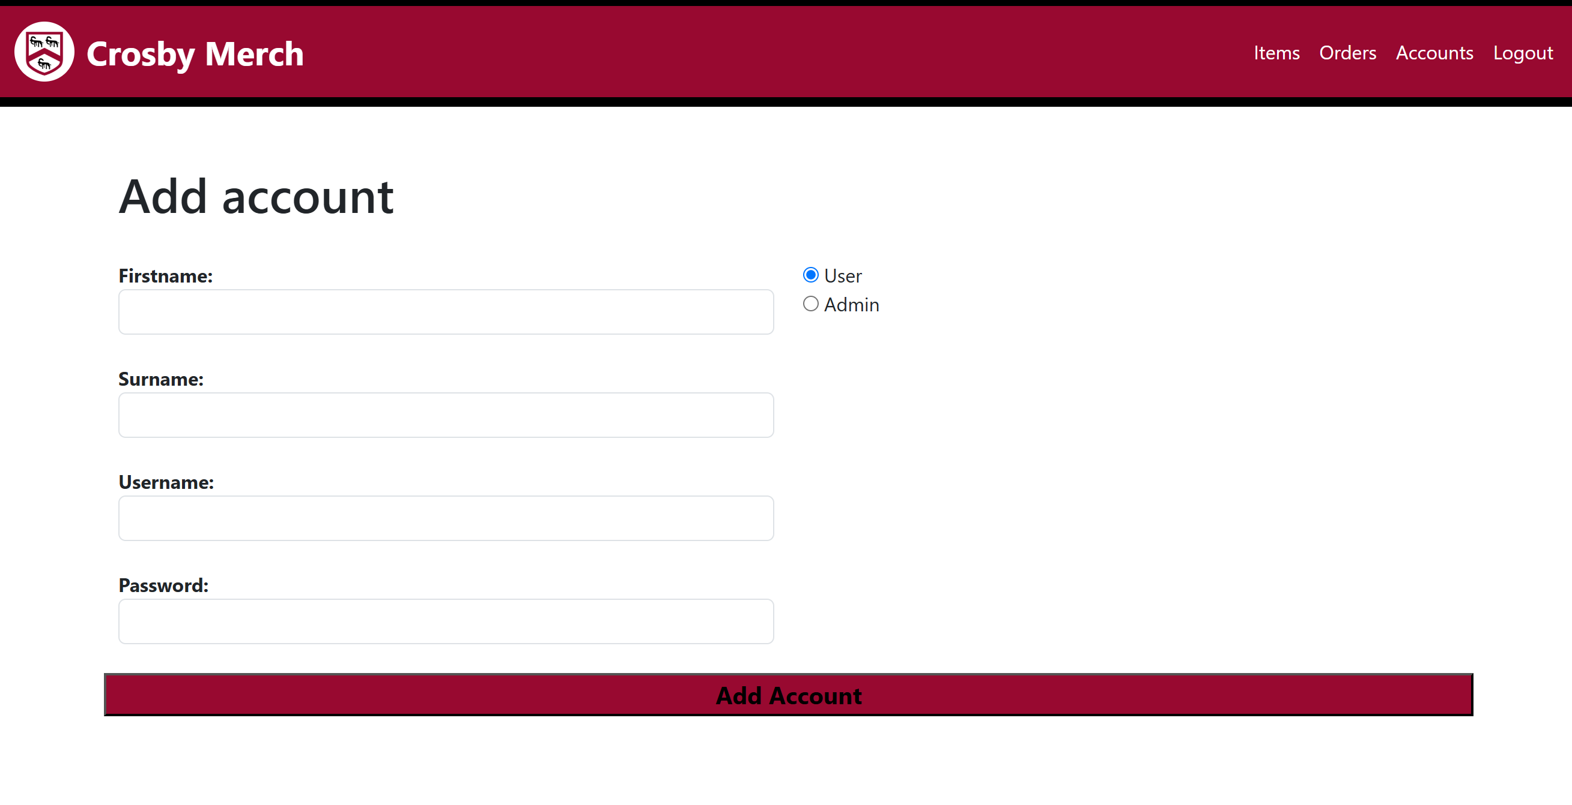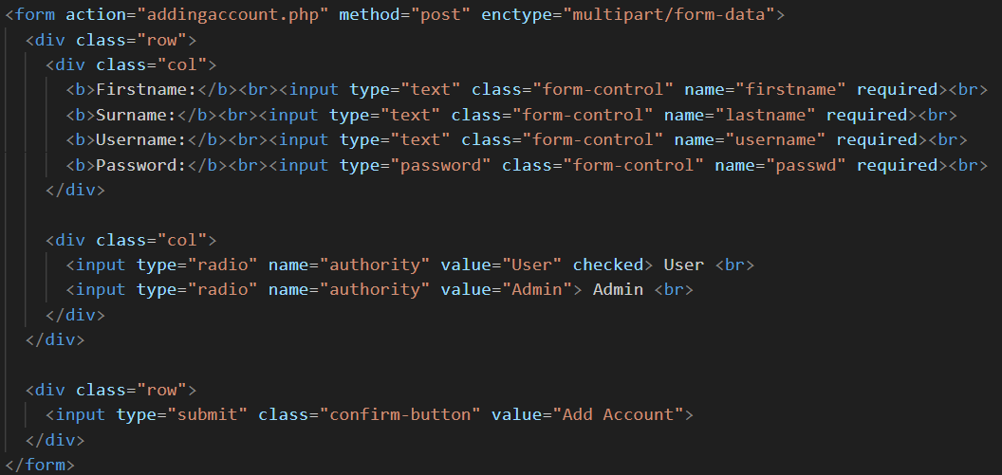I added bootstrap to display the form onto the page into how I want it to look like.

Final Annotated Code:

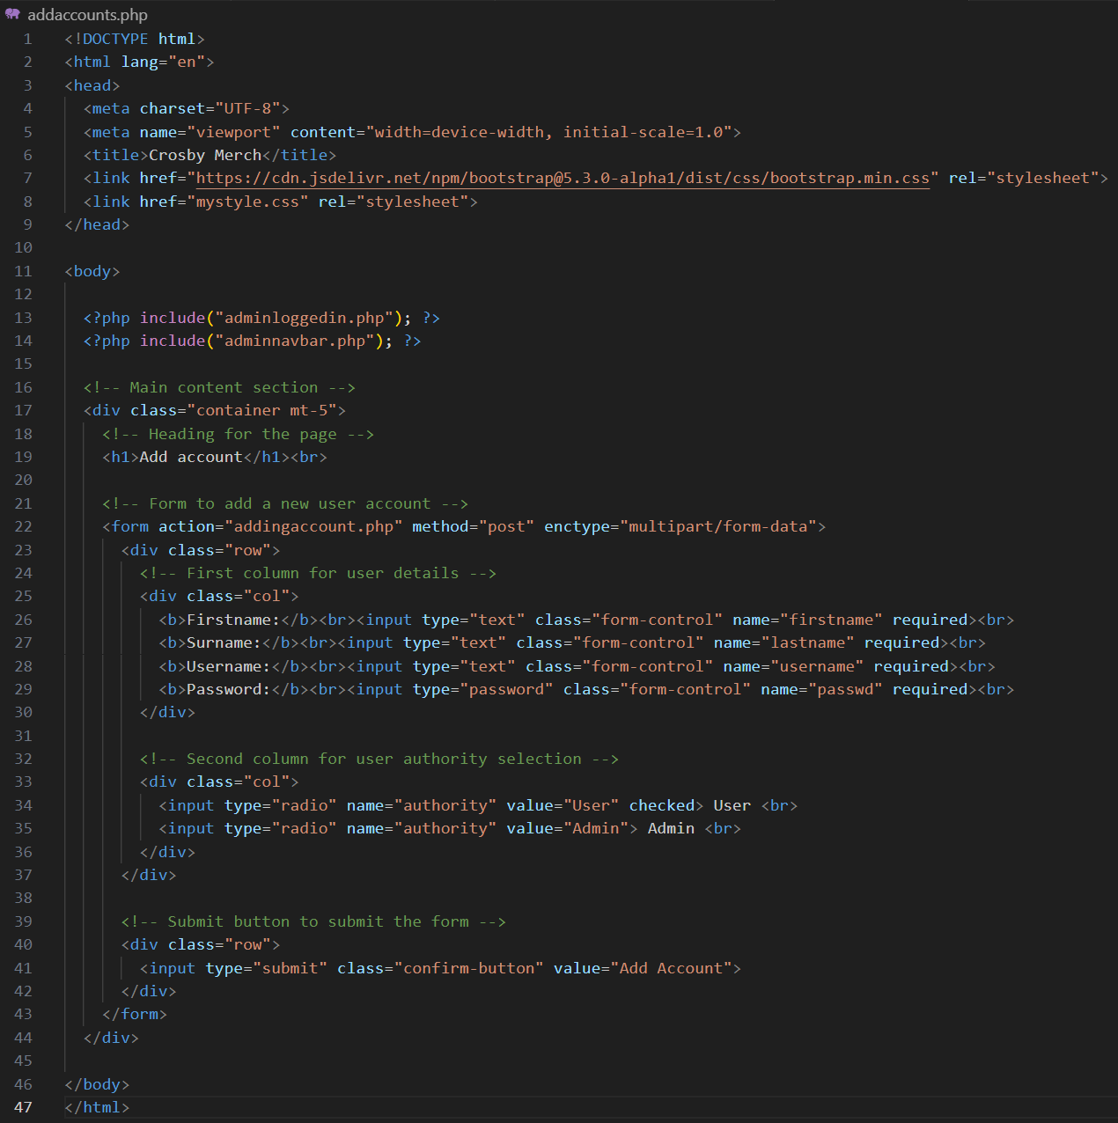

### Addingaccount.php

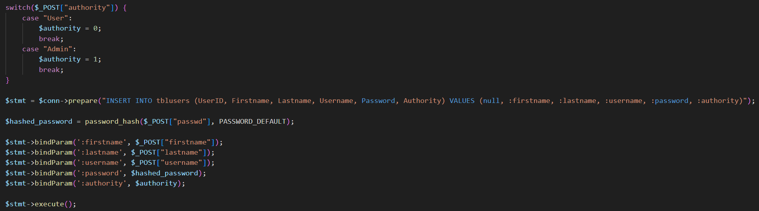This page will handle the form that has been sent from addaccounts.php, using SQL to add the inputted item details (Firstname, Lastname, etc.) into the database. There are two main parts to this page, inserting the new item data into the database, creating a basket for the account.

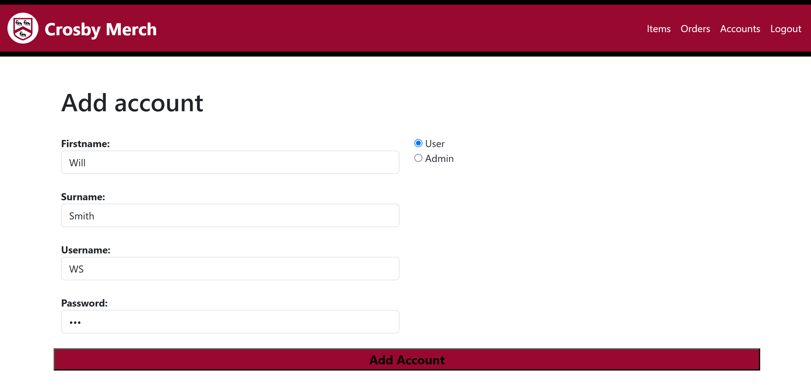This is the SQL that will take data summitted by the form in additems.php and insert it into TblUsers in the database. I used a switch case to convert the authority from words (User or Admin) into a number (0 or 1). I also hashed the inputted password for security purposes.

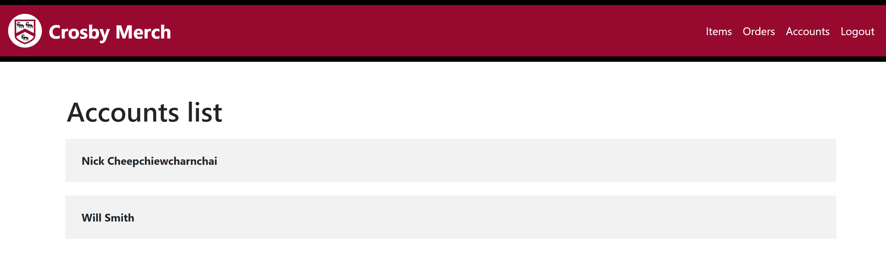This is what I entered into the form the test if my SQL works. (password: asd)

Checking the accounts list, the display of the account signifies that the account has been added successfully.

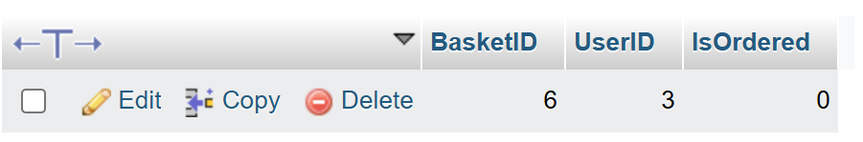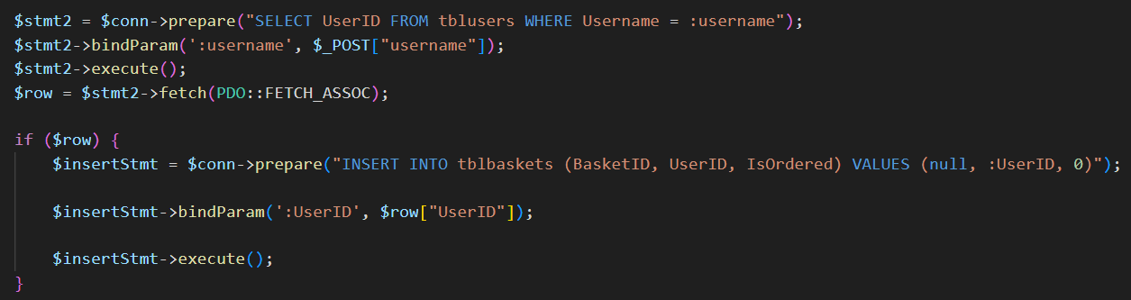This is the SQL that will select the UserID of the newly created account then create a new basket for that account.

After running the code, I checked the TblBaskets on phpMyAdmin and the data has been entered into the database correctly, indicating that my code works properly.

Now that I know both these codes work I can put it together onto one page.

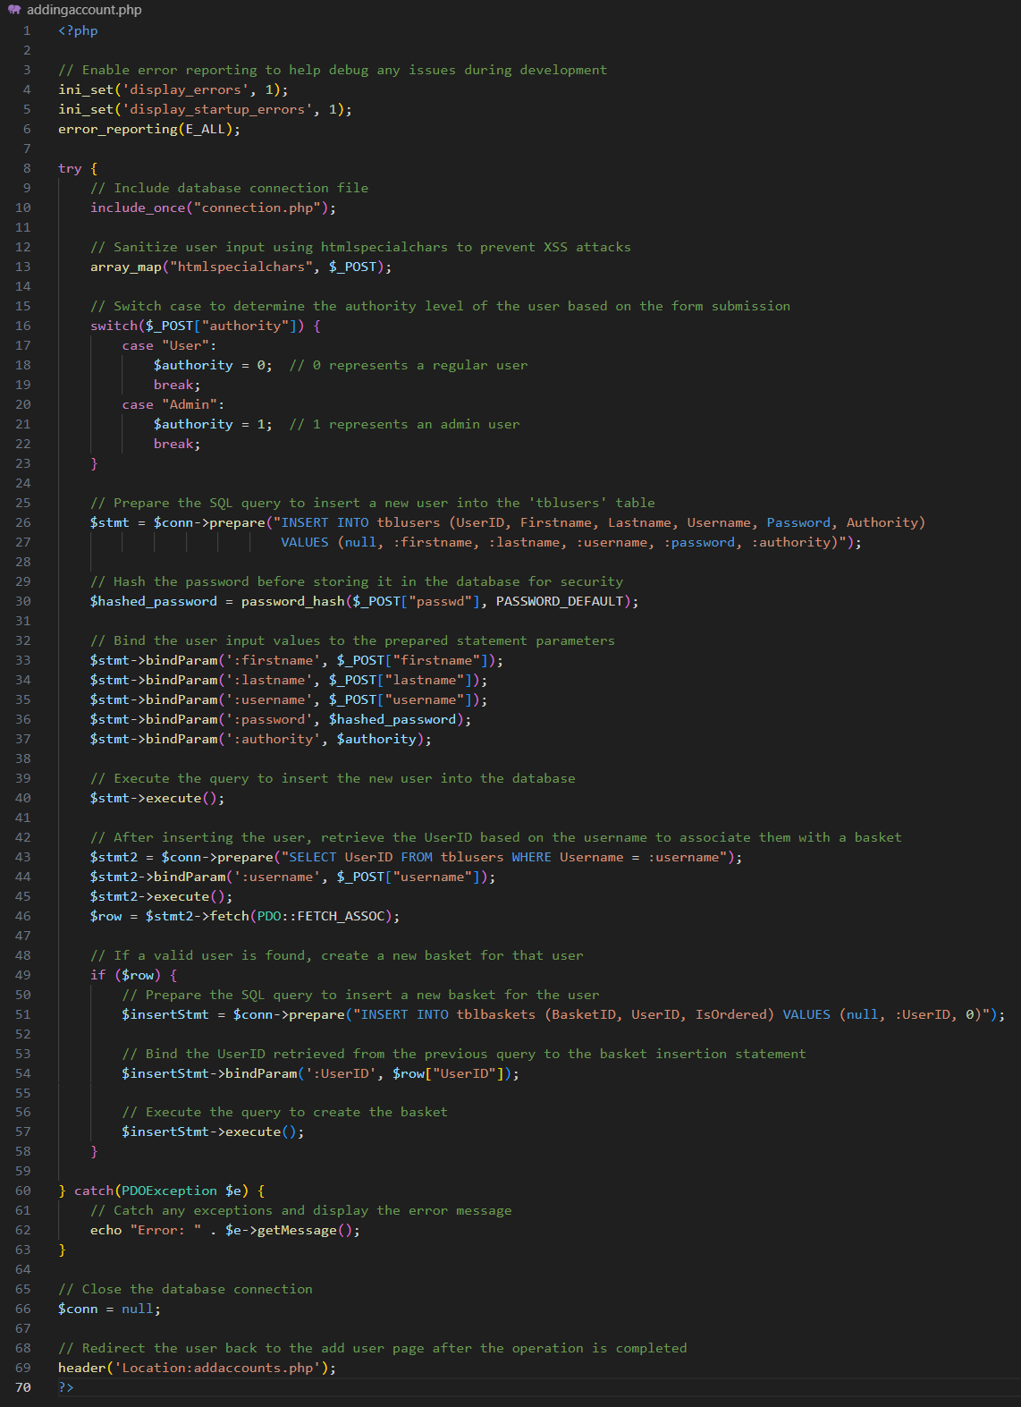Final Annotated Code:

### Removeaccounts.php

Unlike the items, I can fully remove accounts from the database without causing inconsistencies as long as I delete everything that is connected to that account (baskets, and orders)

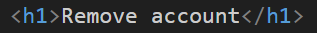Due to this page having the exact same display as accountslist.php I will copy most of the code over from that page and make some tweaks to it.

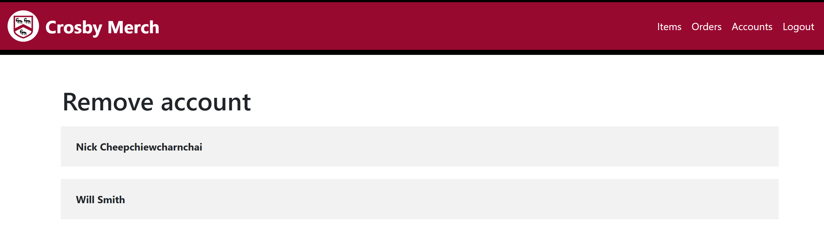I changed the Heading of the page to match it’s function. I also changed the link to direct to removeaccountdisplay.php, passing the UserID as a query parameter to use to display the details of the user in the next page.

This is what the page looks link and the links leads to the correct page.

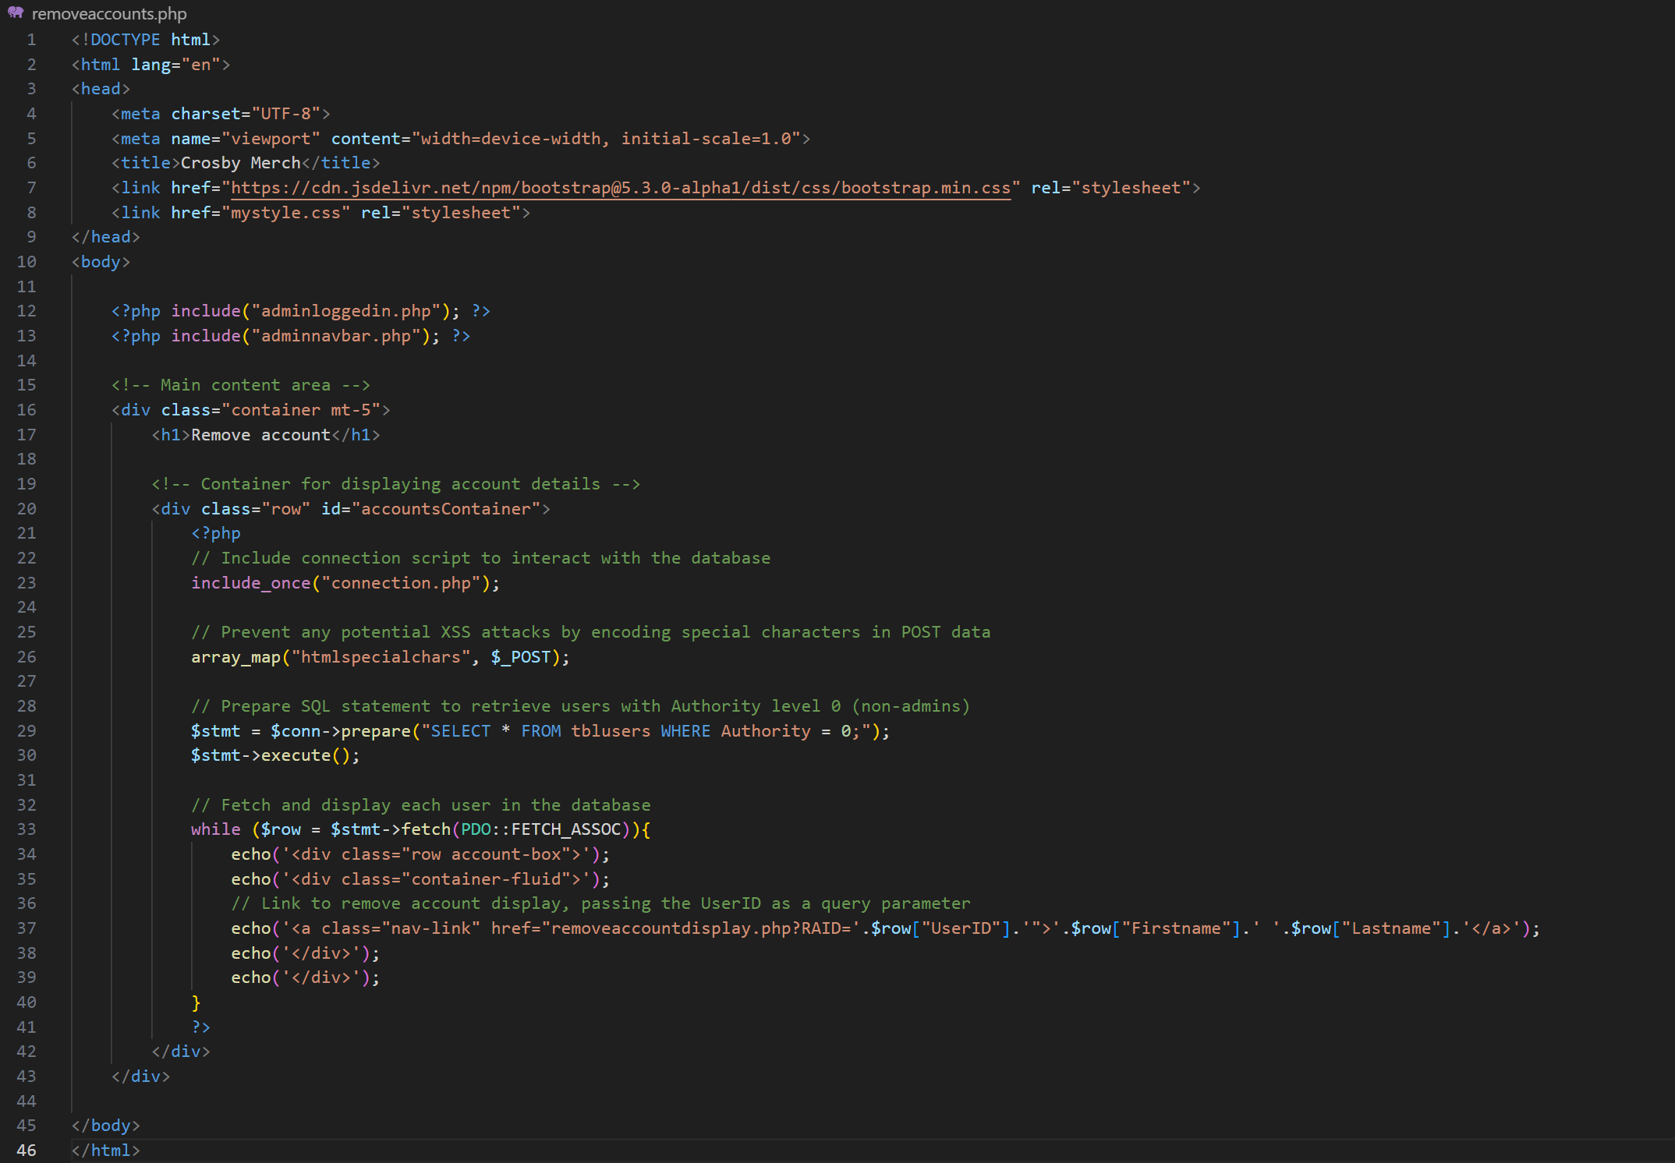Final Annotated Code:

### Removeaccountdisplay.php

Due to this page having the exact same display as accountinfo.php I will copy most of the code over from that page and make some tweaks to it.

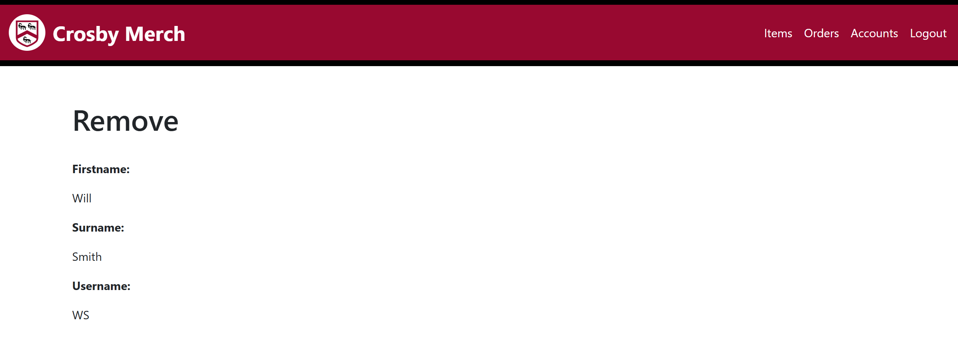From the copied code, I changed the heading to fit the feature pf the page. Then I changed the GET method to retrieve the correct parameter.

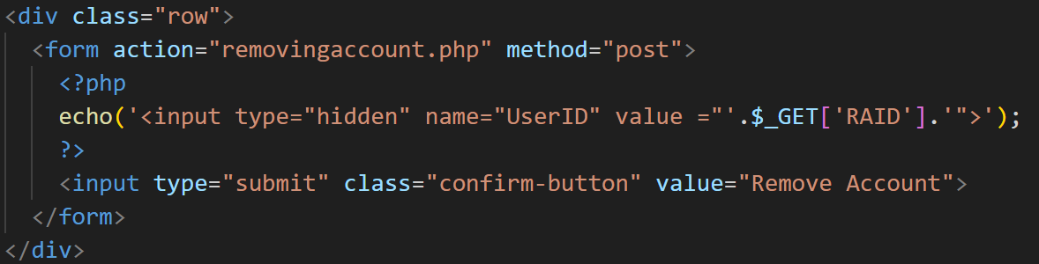This is what we have on the page so far, now I need to make a button to remove the user.

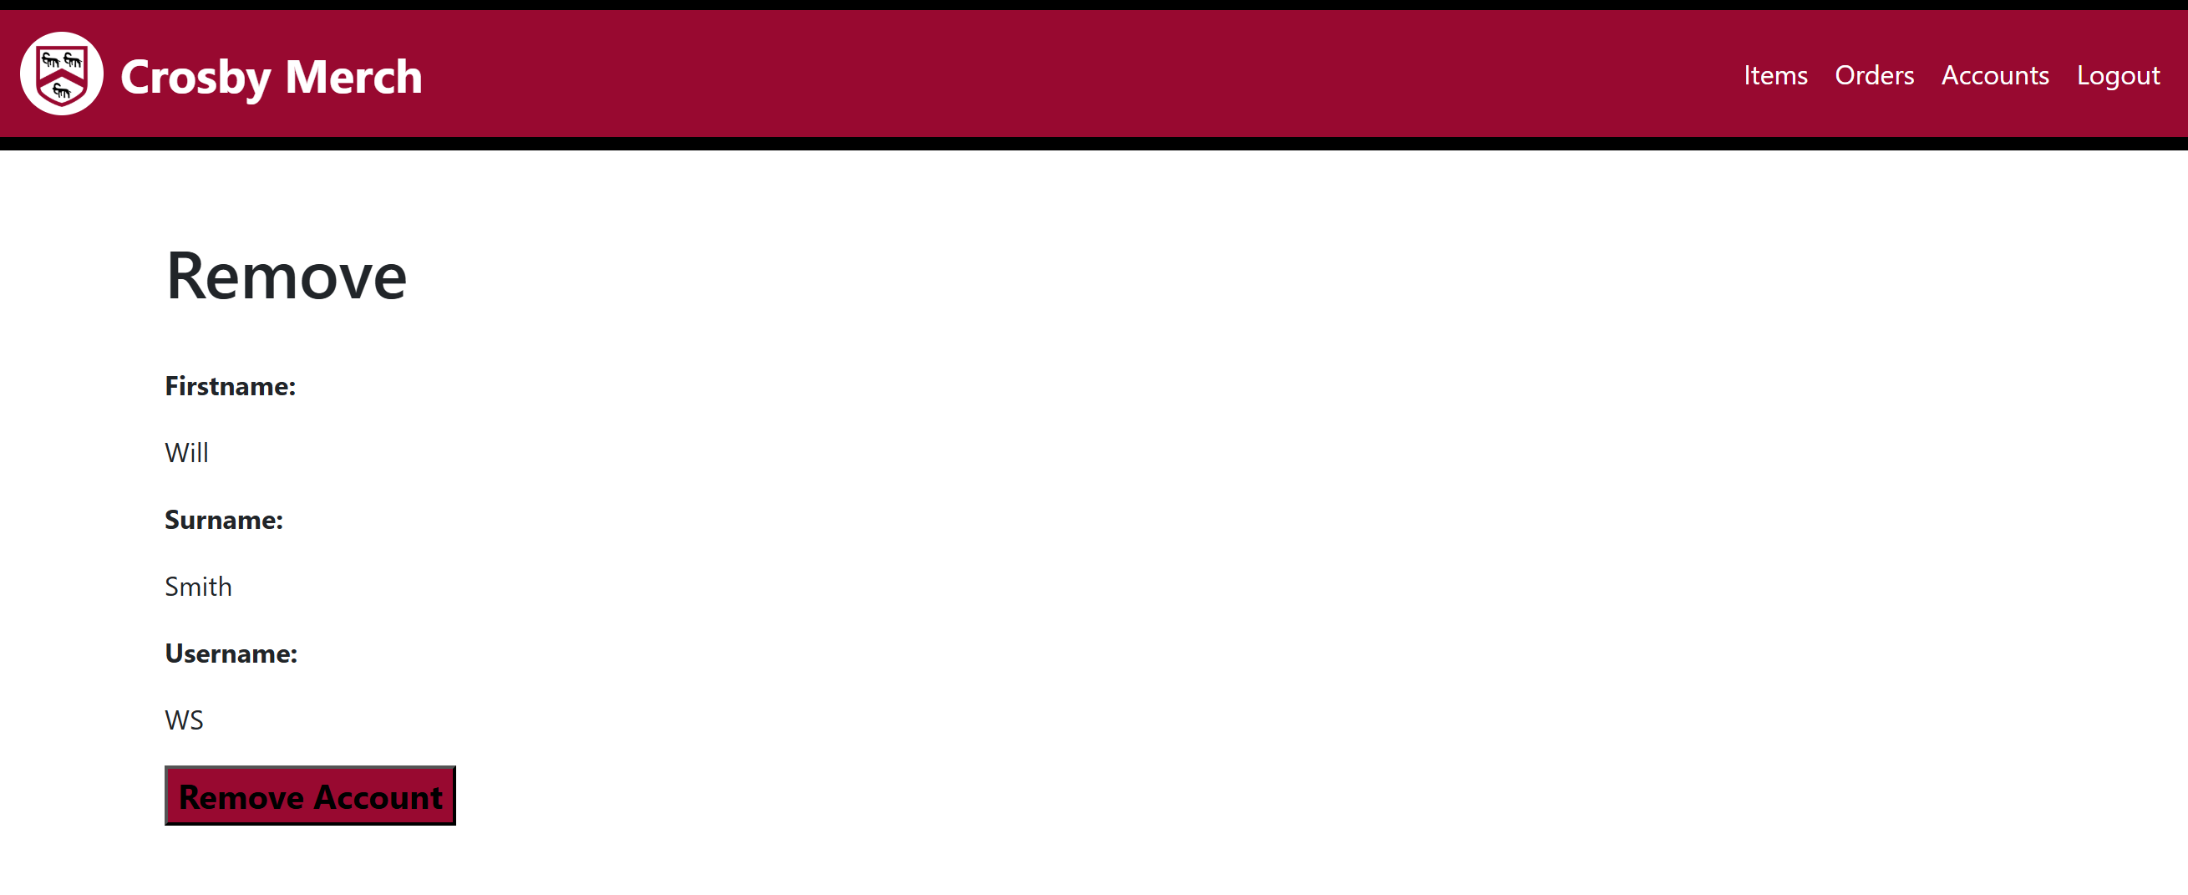This is the button that acts as a form to send the UserID of the account to be deleted as a hidden input to the removing account page which will handle all the SQL.

This shows that the code displayed correctly onto the page.

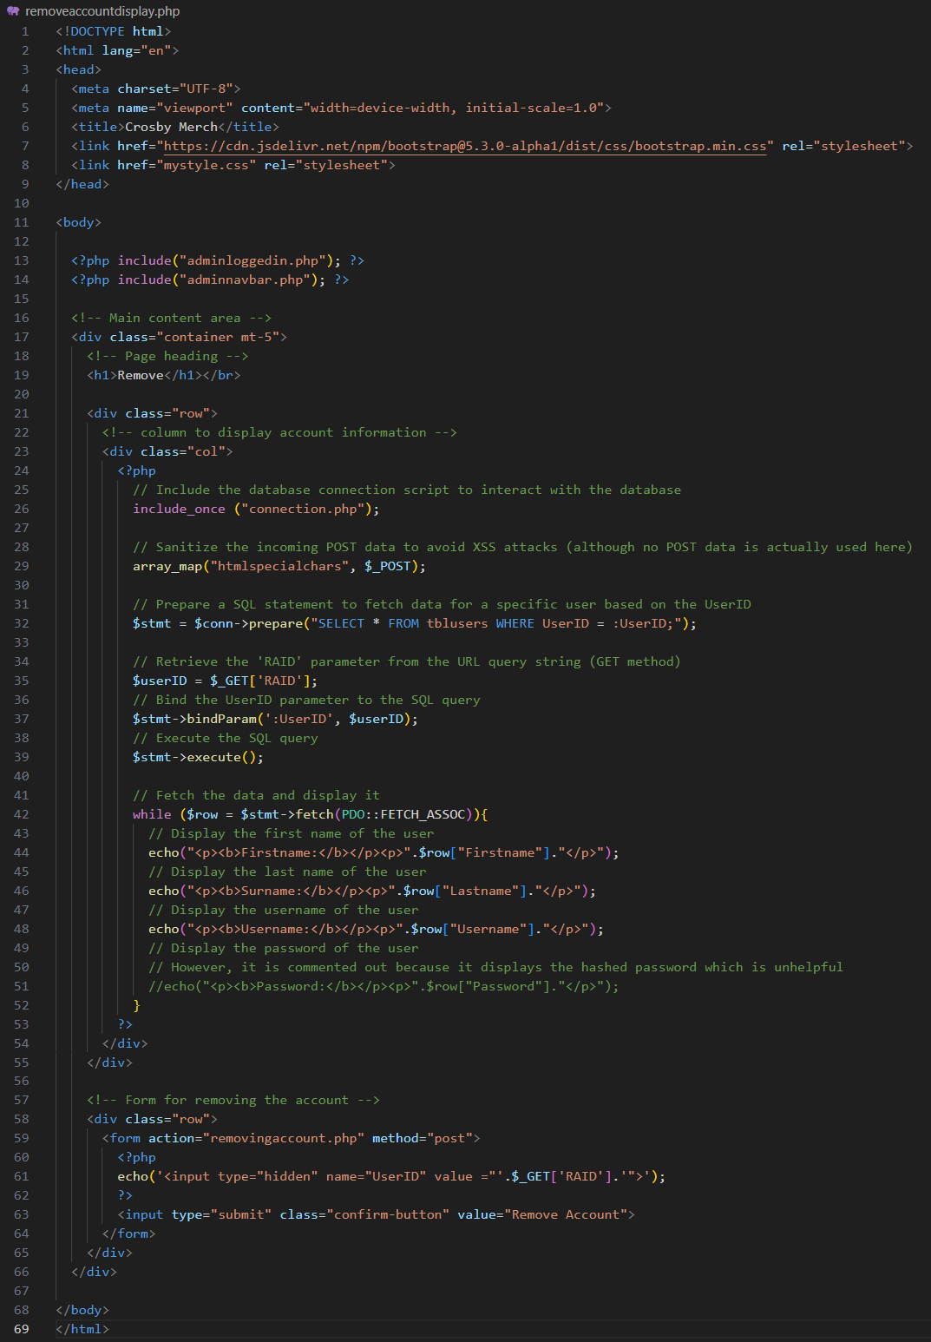Final Annotated Code:

### Removingaccount.php

This page will handle the form that has been sent from removeaccountdisplay.php, using SQL to delete everything that is connected to the UserID from the database. To make sure that no inconsistencies show in the database, I will need to delete everything that connects to the user in all the tables. To ensure that I don’t mess up the logic I decided to do this in four sections, deleting from TblBasketItems, deleting from TblOrders, deleting from TblBaskets, deleting from TblUsers.

For testing purposes, I will take screenshots of the contents in TblBasketItems, TblOrders, TblBaskets and TblUsers.

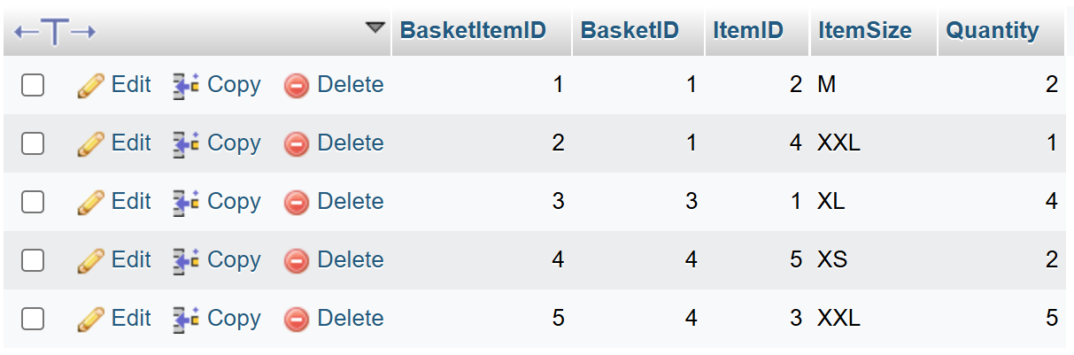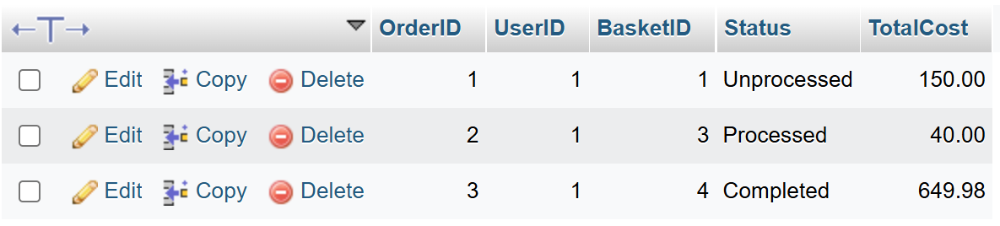TblBasketItems:

TblOrders:

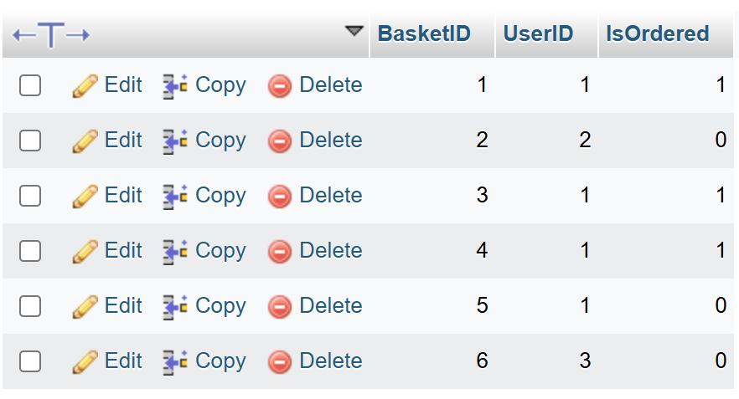TblBaskets:

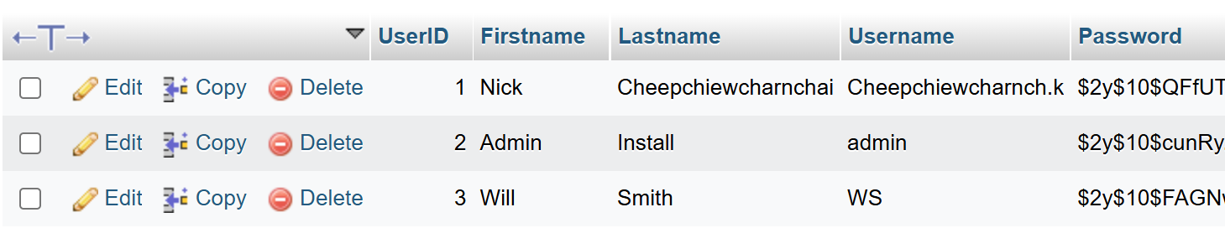TblUsers:

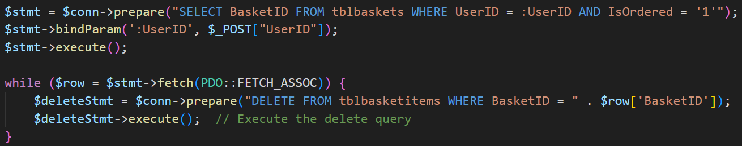Firstly, since TblBasketItems does not have UserID as a field, I will use this SQL that will select the BasketID from all ordered baskets placed by the UserID.

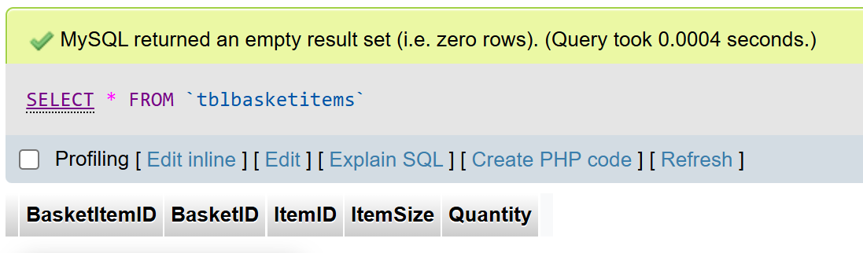Then I added to the code so that every time a BasketID is fetched, all data from TblBasketItems with a matching BasketID will be deleted from the database. These two code essentially works together to delete all items from the user’s orders.

After running the code, I checked the phpMyAdmin TblBasketItems, which showed that the code had worked as intended. Now that the hard part was finished, I will move on to the other tables.

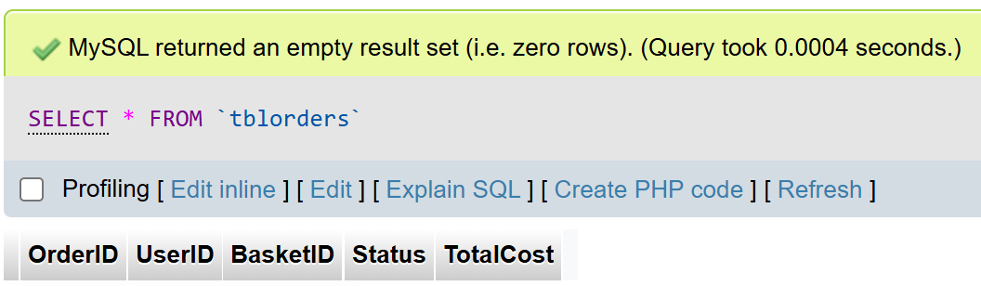This is the code that will delete all data from TblOrders where the UserID matches. This code essentially deletes all existing orders placed by the user.

After running the code, I checked the phpMyAdmin TblBasketItems, which showed that the code had worked as intended.

This is the code that will delete all data from TblBaskets where the UserID matches. This code essentially deletes all baskets that belongs to the user, both unordered and ordered.

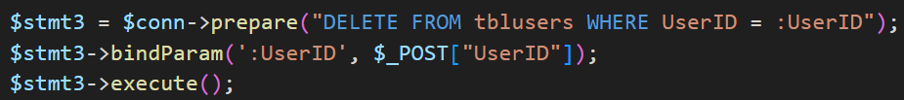After running the code, I checked the phpMyAdmin TblBaskets, which showed that the code had worked as intended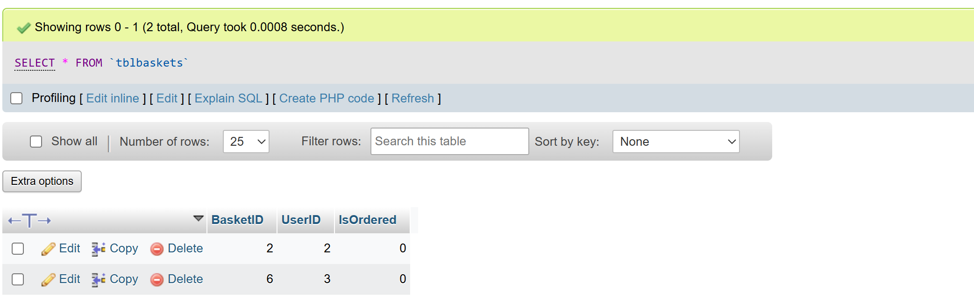.

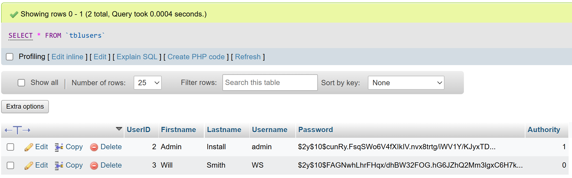Finally, now that I have deleted all related data to do with the user, I will delete the account and its details. This code deletes the account and its information from TblUsers where the UserID matches.

After running the code, I checked the phpMyAdmin TblBaskets, which showed that the code had worked as intended.

Now that I know all that all the code works, I can put it all together into one page.

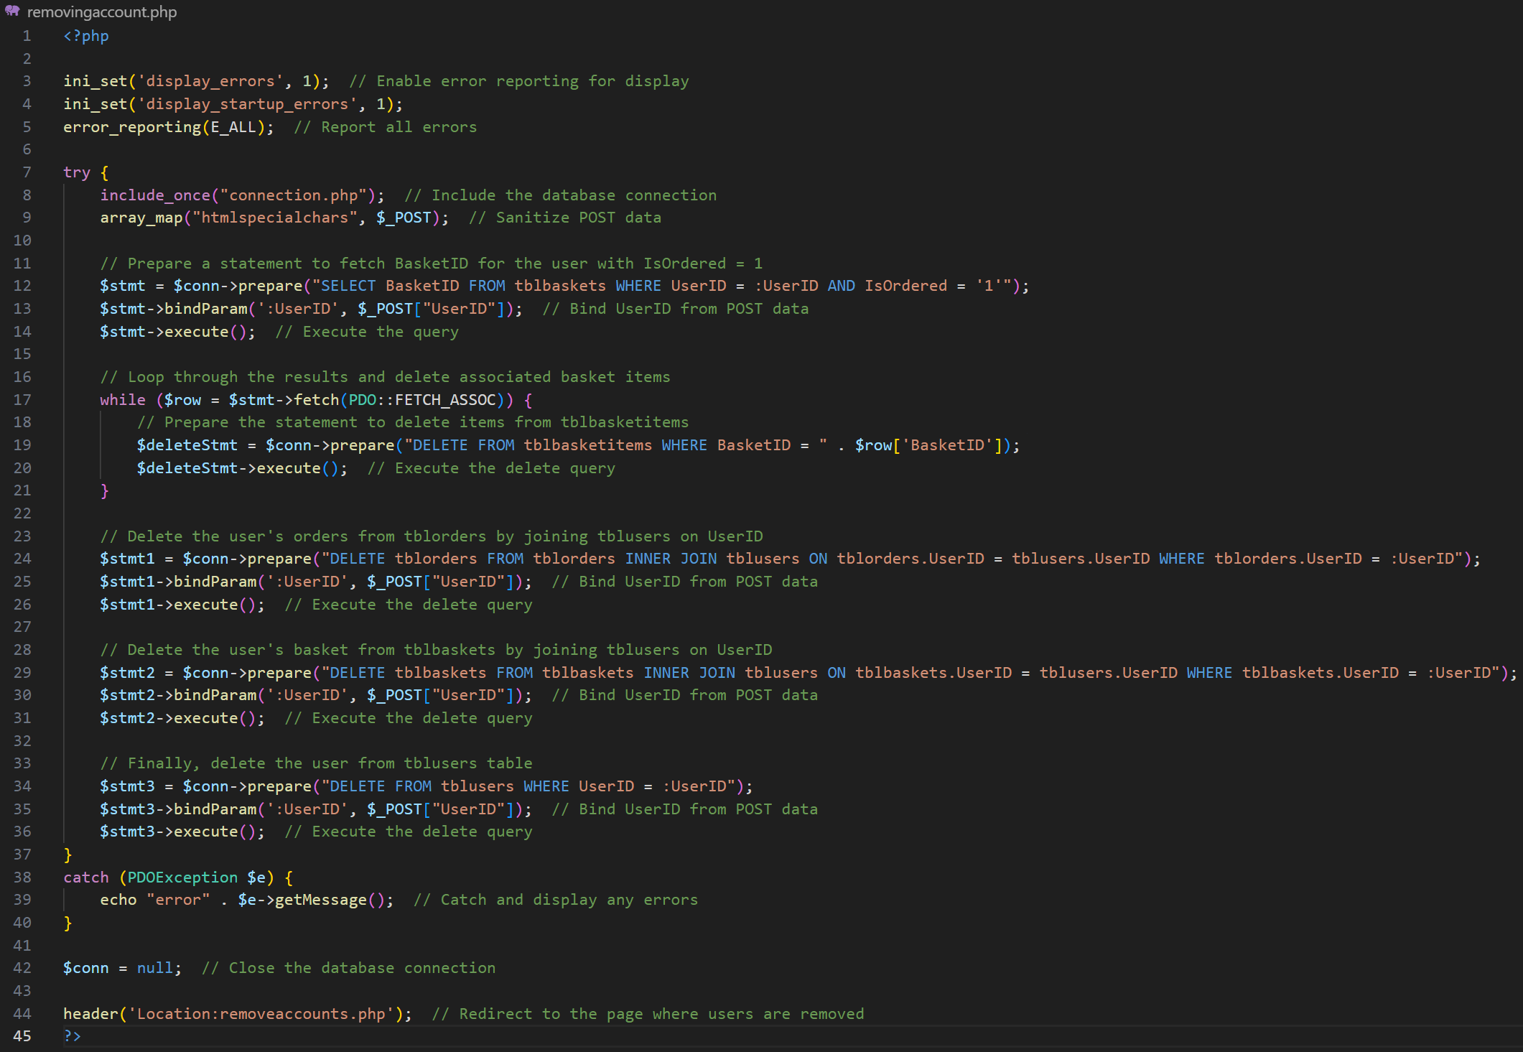Final Annotated Code:

# Evaluation

## Functional and Robustness testing

### Shared

Login page

|  |  |  |  |  |
| --- | --- | --- | --- | --- |
| Test No. | Test Purpose | Test Data | Expected Outcome | Actual Outcome |
| 1 | Function To test if the user can successfully login using correct details | Correct username:  Username  Correct password: 1234 | User logs in and is redirected to the correct home page | User logs in and is redirected to the correct home page |
| 2 | Robustness To test if the system will stop incorrect username from logging in | Incorrect username:  Usrname  Correct password: 1234 | Username error message is displayed | Username error message is displayed |
| 3 | Robustness To test if the system stop will incorrect password from logging in | Correct username:  Username  Incorrect password: 1243 | Password error message is displayed | Password message is displayed |

Logout button

|  |  |  |  |  |
| --- | --- | --- | --- | --- |
| Test No. | Test Purpose | Test Data | Expected Outcome | Actual Outcome |
| 4 | Function To test if the user can successfully logout | N/A | User is logged out and is redirected to the login page | User is logged out and is redirected to the login page |

Responsive design

|  |  |  |  |  |
| --- | --- | --- | --- | --- |
| Test No. | Test Purpose | Test Data | Expected Outcome | Actual Outcome |
| 5 | Function To test that the page design will work on different screen proportions | N/A | The design of the pages chases with the size of the screen | The design of the pages chases with the size of the screen |

### Customers

Navbar

|  |  |  |  |  |
| --- | --- | --- | --- | --- |
| Test No. | Test Purpose | Test Data | Expected Outcome | Actual Outcome |
| 6 | Function To test if the customer navigation bar allows users to navigate to different areas of the website | N/A | User is correctly directed to the page they clicked on | User is correctly directed to the page they clicked on |

Homepage

|  |  |  |  |  |
| --- | --- | --- | --- | --- |
| Test No. | Test Purpose | Test Data | Expected Outcome | Actual Outcome |
| 7 | Function To test if item names, prices and images are displayed correctly in a format that is easy for customers to view | All from TblItems | Item names, prices and images are displayed in rows | Item names, prices and images are displayed in rows |
| 8 | Function To test if users can search for, sort and filter items | Data from TblItems | Users can search for items using the search bar, and filter and sort items using the buttons. | Users can search for items using the search bar, and filter and sort items using the buttons. |
| 9 | Function To test if filter and searches affect homepage display (title and no. of items display) | N/A | Title and no. of items display changes correctly and | Title and no. of items display changes correctly and |
| 10 | Function To test that users can navigate to item details page when item is clicked | ItemID: 1 (hidden input) | User is directed to the page for a specific item, with details about the item displayed | User is directed to the page for a specific item, with details about the item displayed |

Item display page

|  |  |  |  |  |
| --- | --- | --- | --- | --- |
| Test No. | Test Purpose | Test Data | Expected Outcome | Actual Outcome |
| 11 | Function To test if item details are displayed correctly | All from TblItems | Item name, price images and description are displayed | Item name, price images and description are displayed |
| 12 | Function To test if correct size and quantity that user chosen is added to basket when | ItemID: 1 (hidden input)  SelectedSize: M  SelectedQuantity: 1 | Correct size and quantity added to basket | Correct size and quantity added to basket |
| 13 | Robustness To test if item can be added into basket if size is not chosen | Null | Error display telling user to choose size | Error display telling user to choose size |

Basket page

|  |  |  |  |  |
| --- | --- | --- | --- | --- |
| Test No. | Test Purpose | Test Data | Expected Outcome | Actual Outcome |
| 14 | Function To test that the items added to the basket by the customer appear on the basket page | ItemID: 1 (hidden input) 2 (hidden input)  SelectedSize: M XXL  SelectedQuantity: 1 4 | Item details and the selected size and quantity of each item are displayed | Item details and the selected quantity of each item are displayed |
| 15 | Function To test if a total amount to pay can be calculated | Prices and quantities of the items in the basket | Total is calculated and displayed | Total is calculated and displayed |
| 16 | Function  To test if an item that is no longer needed can be removed via the basket page | - | Clicking the ‘remove’ button next to an item removes that specific item from the basket | - |
| 17 | Function  To test if the user can order basket by clicking purchase button | ItemIDs, sizes and quantities of items in the basket | Basket is ordered and the users gets a new empty basket | Basket is ordered and the users gets a new empty basket |

Purchases page

|  |  |  |  |  |
| --- | --- | --- | --- | --- |
| Test No. | Test Purpose | Test Data | Expected Outcome | Actual Outcome |
| 18 | Function To test that all baskets ordered are displayed in the correct status section | N/A | Each basket ordered is displayed in the correct status section | Each basket ordered is displayed in the correct status section |
| 19 | Function To test that details of an ordered basket can be checked by clicking onto it | BasketID: 1 (hidden input) | Basket order clicked on redirects customer to a details page | Basket order clicked on redirects customer to a details page |
| 20 | Function To test that only unprocessed baskets may be cancelled and correctly | - | Only unprocessed orders may may be cancelled which will get rid of it | - |

Order details page

|  |  |  |  |  |
| --- | --- | --- | --- | --- |
| Test No. | Test Purpose | Test Data | Expected Outcome | Actual Outcome |
| 21 | Function To test that basket order displays correct details | BasketID: 1 (hidden input) | Each basket ordered displays correct details | Each basket ordered displays correct details |

### Admins

Navbar

|  |  |  |  |  |
| --- | --- | --- | --- | --- |
| Test No. | Test Purpose | Test Data | Expected Outcome | Actual Outcome |
| 22 | Function To test if the admin navigation bar allows users to navigate to different areas of the website | N/A | User is correctly directed to the page they clicked on | User is correctly directed to the page they clicked on |

Homepage

|  |  |  |  |  |
| --- | --- | --- | --- | --- |
| Test No. | Test Purpose | Test Data | Expected Outcome | Actual Outcome |
| 23 | Function To test if each link navigates the user to the correct destination | N/A | User is correctly directed to the page they clicked on | User is correctly directed to the page they clicked on |

Items pages

|  |  |  |  |  |
| --- | --- | --- | --- | --- |
| Test No. | Test Purpose | Test Data | Expected Outcome | Actual Outcome |
| 24 | Function Mirrors the exact customer homepage looks and functions | N/A | Page mirrors the customer homepage correctly | Page mirrors the customer homepage correctly |
| 25 | Function To test that admins can add new items | Item name: T-shirt  Item price: 49.99  Item description: An average t-shirt  Item type: Tops  Front picture: t-shirt-front.jpg  Back picture: t-shirt-back.jpg | The item details are successfully sent to the database and the item is displayed on the browse page | The item details are successfully sent to the database and the item is displayed on the browse page |
| 26 | Function To test if items can be removed | - | Page mirrors the customer homepage correctly | - |

Orders pages

|  |  |  |  |  |
| --- | --- | --- | --- | --- |
| Test No. | Test Purpose | Test Data | Expected Outcome | Actual Outcome |
| 27 | Function To test if each Status shows the correct orders | All BasketIDs | Orders are correctly shown in the correct status | Orders are correctly shown in the correct status |
| 28 | Function To test that details of an ordered basket can be checked by clicking onto it | BasketID: 1 (hidden input) | Basket order clicked on redirects customer to a details page | Basket order clicked on redirects customer to a details page |
| 29 | Function To test an ordered basket’s status can be shifted to the next | BasketID: 1 (hidden input) | Status of order is shifted  Unprocessed 🡪 Processed 🡪 Finished | Status of order is shifted  Unprocessed 🡪 Processed 🡪 Finished |

Accounts pages

|  |  |  |  |  |
| --- | --- | --- | --- | --- |
| Test No. | Test Purpose | Test Data | Expected Outcome | Actual Outcome |
| 30 | Function To test if list of accounts displays all customers correctly | All UserIDs | Displays all customers correctly | Displays all customers correctly |
| 31 | Function To test if customer details can be displayed correctly | UserID: 1 (hidden input) | Customer details are displayed correctly | Customer details are displayed correctly |
| 32 | Function To test if customer orders can be checked and processed | UserID: 1 (hidden input) | Customer orders are correctly displayed in the correct status, details can be checked and order can be processed | Customer orders are correctly displayed in the correct status, details can be checked and order can be processed |
| 33 | Function To test that admins can add new accounts | Firstname: Fname  Lastname:  Lname  Username:  Uname  Password:  Pword  Authority:  User | New account is correctly created and can be used | New account is correctly created and can be used |
| 34 | Function To test that admins can remove accounts | UserID: 1 (hidden input) | Account is deleted from the database, including all baskets and orders linked to the account | Account is deleted from the database, including all baskets and orders linked to the account |

## Usability Testing

I provided my stakeholders with the opportunity to use the system to carry out tasks relevant to their roles—for example, customers placing orders and administrators managing stock. Additionally, I allowed them an extra 10 minutes to explore their respective areas of the system freely. I then asked them all to fill in the questionnaire that I created in the design section.

### Customer

Five customer users, including my primary stakeholder (Customer 1), were invited to test the customer-facing side of the system. Each participant was asked to interact with the system by browsing the website and attempting to place at least one order. After completing these tasks, they were given an additional 10 minutes to explore the system freely. Their responses to the general usability questionnaire are documented below.

#### General Questionnaire

|  |  |  |  |  |  |  |  |
| --- | --- | --- | --- | --- | --- | --- | --- |
| No. | Statement | Score (1-10)  1: Strongly Disagree 10: Strongly Agree | | | | | |
| - | Customer No. | 1 | 2 | 3 | 4 | 5 | Avg. |
| 1 | I am satisfied with how easy it is to use this system | 9 | 9 | 9 | 10 | 9 | **9.2** |
| 2 | I was able to complete my tasks quickly using the system | 9 | 9 | 10 | 10 | 10 | **9.6** |
| 3 | I felt comfortable using the system | 9 | 9 | 9 | 9 | 9 | **9.0** |
| 4 | It was easy to learn to use this system | 10 | 10 | 10 | 10 | 10 | **10** |
| 5 | The interface of the system was visually attractive | 9 | 8 | 8 | 9 | 9 | **8.6** |
| 6 | The system has all the functions and capabilities I expected | 7 | 7 | 8 | 9 | 7 | **7.6** |
| 7 | I am satisfied with this system overall | 9 | 9 | 9 | 10 | 9 | **9.8** |

#### Customer Questionnaire

|  |  |  |  |  |  |  |  |
| --- | --- | --- | --- | --- | --- | --- | --- |
| No. | Statement | Score (1-10)  1: Strongly Disagree 10: Strongly Agree | | | | | |
| - | Customer No. | 1 | 2 | 3 | 4 | 5 | Avg. |
| 1 | It was easy to log into my account | 9 | 9 | 10 | 10 | 10 | **9.6** |
| 2 | The top navigation bar helped me navigate the website | 10 | 10 | 10 | 10 | 10 | **10** |
| 3 | I could quickly find and choose the items I needed | 9 | 10 | 10 | 10 | 9 | **9.6** |
| 4 | The basket page was easy to locate and order | 10 | 10 | 10 | 10 | 10 | **10** |
| 5 | I could see all the necessary details about my order | 9 | 9 | 10 | 9 | 9 | **9.2** |

#### Additional Comments

Additional comments that justifies some of their recorded rating:

Customer No.1:  
“The login process was smooth, but I would’ve liked it to have a toggle for viewing the password that I entered since I like to check if I entered it correctly or not. I also found it frustrating that I couldn’t remove items from my basket once I added them, and that there’s no option to cancel a basket. This made it hard to fix mistakes without starting over, which can be confusing if you change your mind or click something by accident.”

Customer No.2:  
“Although I could find items that I like in very few seconds, I wished that there would have been some kind of reviews section for each item, or some sort of indication as to how many each item has been bought to give an indication of which item is the most popular.”   
“It does the basics well, but small features like editing or cancelling an order would really improve the experience.”

Customer No.3:  
“The layout is clean and easy to follow, but some parts of the design feel a bit awkward in the slim webpage format. For example, the pictures in the items display page are stacked on top of each other. Also the confirm purchase button for the basket is quite hard to read since the black text had such low contrast with the dark Crosby red.”

Customer No. 4:  
“Most of the order information was clear, but it would be helpful to have an estimated processing time.”

Customer No.5:  
“Since there wasn’t a way to remove items once you added them to your basket, I think that it would be great if there is a confirming message pop-up for you to click before it gets added to your basket permanently.”  
“I did like that I am able to onto any page literally within 2 clicks, which shows how helpful the navigation bar is.”

### Admin

2 Admin users, including my primary stakeholder (Admin 1), were invited to test the customer-facing side of the system. Each participant was asked to interact with the system by browsing the website and attempting to place at least one order. After completing these tasks, they were given an additional 10 minutes to explore the system freely. Their responses to the general usability questionnaire are documented below.

#### General Questionnaire

|  |  |  |  |  |  |
| --- | --- | --- | --- | --- | --- |
| No. | Statement | Score (1-10)  1: Strongly Disagree  10: Strongly Agree | | | |
| - | Admin No. | 1 | 2 | 3 | Avg. |
| 1 | I am satisfied with how easy it is to use this system | 7 | 6 | 7 | **6.7** |
| 2 | I was able to complete my tasks quickly using the system | 4 | 3 | 3 | **3.3** |
| 3 | I felt comfortable using the system | 6 | 5 | 6 | **5.7** |
| 4 | It was easy to learn to use this system | 7 | 5 | 6 | **6.0** |
| 5 | The interface of the system was visually attractive | 8 | 9 | 9 | **8.7** |
| 6 | The system has all the functions and capabilities I expected | 7 | 7 | 6 | **6.7** |
| 7 | I am satisfied with this system overall | 6 | 5 | 5 | **5.3** |

#### Admin Questionnaire

|  |  |  |  |  |  |
| --- | --- | --- | --- | --- | --- |
| No. | Statement | Score (1-10)  1: Strongly Disagree  10: Strongly Agree | | | |
| - | Admin No. | 1 | 2 | 3 | Avg. |
| 1 | It was easy to log into my account | 10 | 9 | 9 | **9.3** |
| 2 | The top navigation bar helped me navigate the website | 9 | 8 | 8 | **8.3** |
| 3 | It was easy to manage items (view, add, remove) | 7 | 7 | 6 | **6.7** |
| 4 | It was easy to manage orders through each status (view, process) | 7 | 7 | 6 | **6.7** |
| 5 | It was easy to manage accounts (view, add, remove) | 9 | 9 | 9 | **9.0** |
| 6 | It was easy to manage orders through specific accounts (view, process) | 7 | 6 | 6 | **6.3** |

#### Additional Comments

Additional comments that justifies some of their recorded rating:

Admin No.1:  
“I found traversing and learning to use the system quite easy, although it was a little confusing at first since there was no written explanation for the system, but once I understood how it all worked, the simplicity of the design helps me to focus on only necessary details. Traversing through the pages was so easy because the navbar allowed me to access any page within 5 clicks”

Admin No.2:  
“Even though to process a basket on the system technically takes less than a minute and immediately changes the status for the order, I felt that performing the actual tasks processing the orders in real life takes forever, since I have to manually go through each order and process them the items details, not to mention the fact that I will have to handle all the payment myself through house bank afterwards, the same problem applies to processing orders through accounts. Perhaps it would have been nice if there was a bulk management of all items I need to order, which might help make simple tasks finish quicker.”

Admin No.3:  
“I think that not having an option to edit or even remove an item from the item list is something that will be very bothersome. I feel like if the items cannot be edited or removed then there should at least be a page that forces us to confirm all the details again before adding the item officially. On the topic of adding items, although it was a very quick process, it would be nice if the pictures that are inserted were shown alongside displaying their name, just to make sure that the correct images was selected. On the other hand, I found that the account management was very easy to use. It took less than a minute to add a user and probably only a few seconds to remove one.”

## Final Testing

### Shared

#### Login page

Test 1  
The login function correctly when valid login details are entered

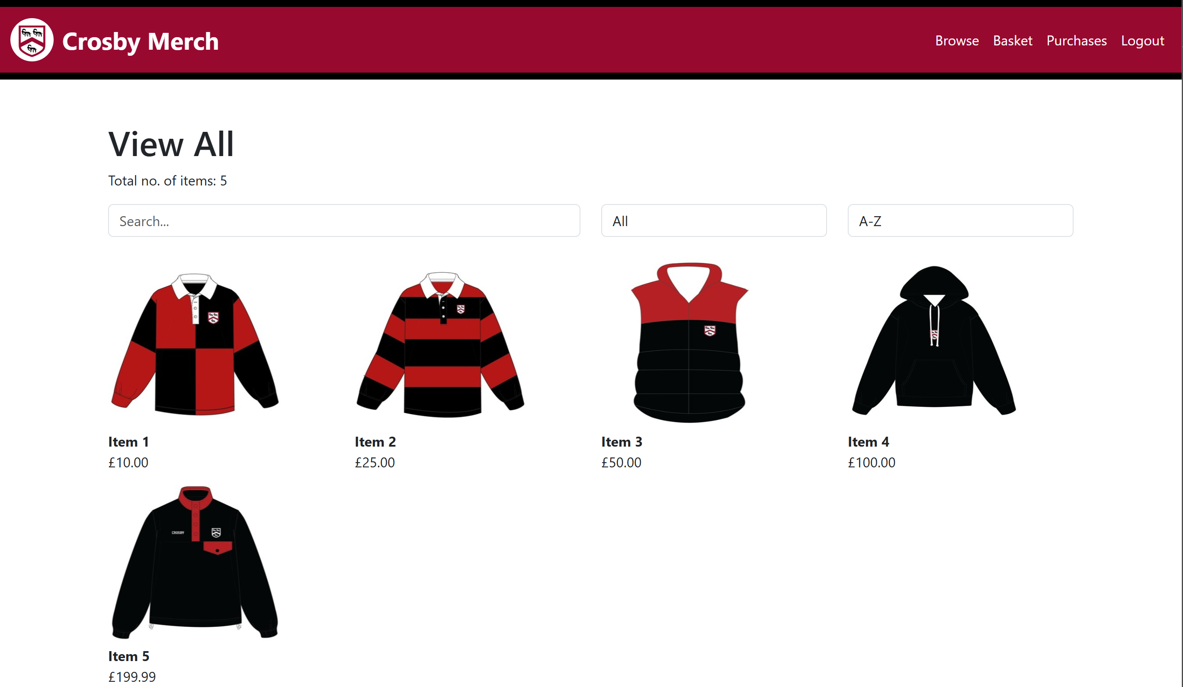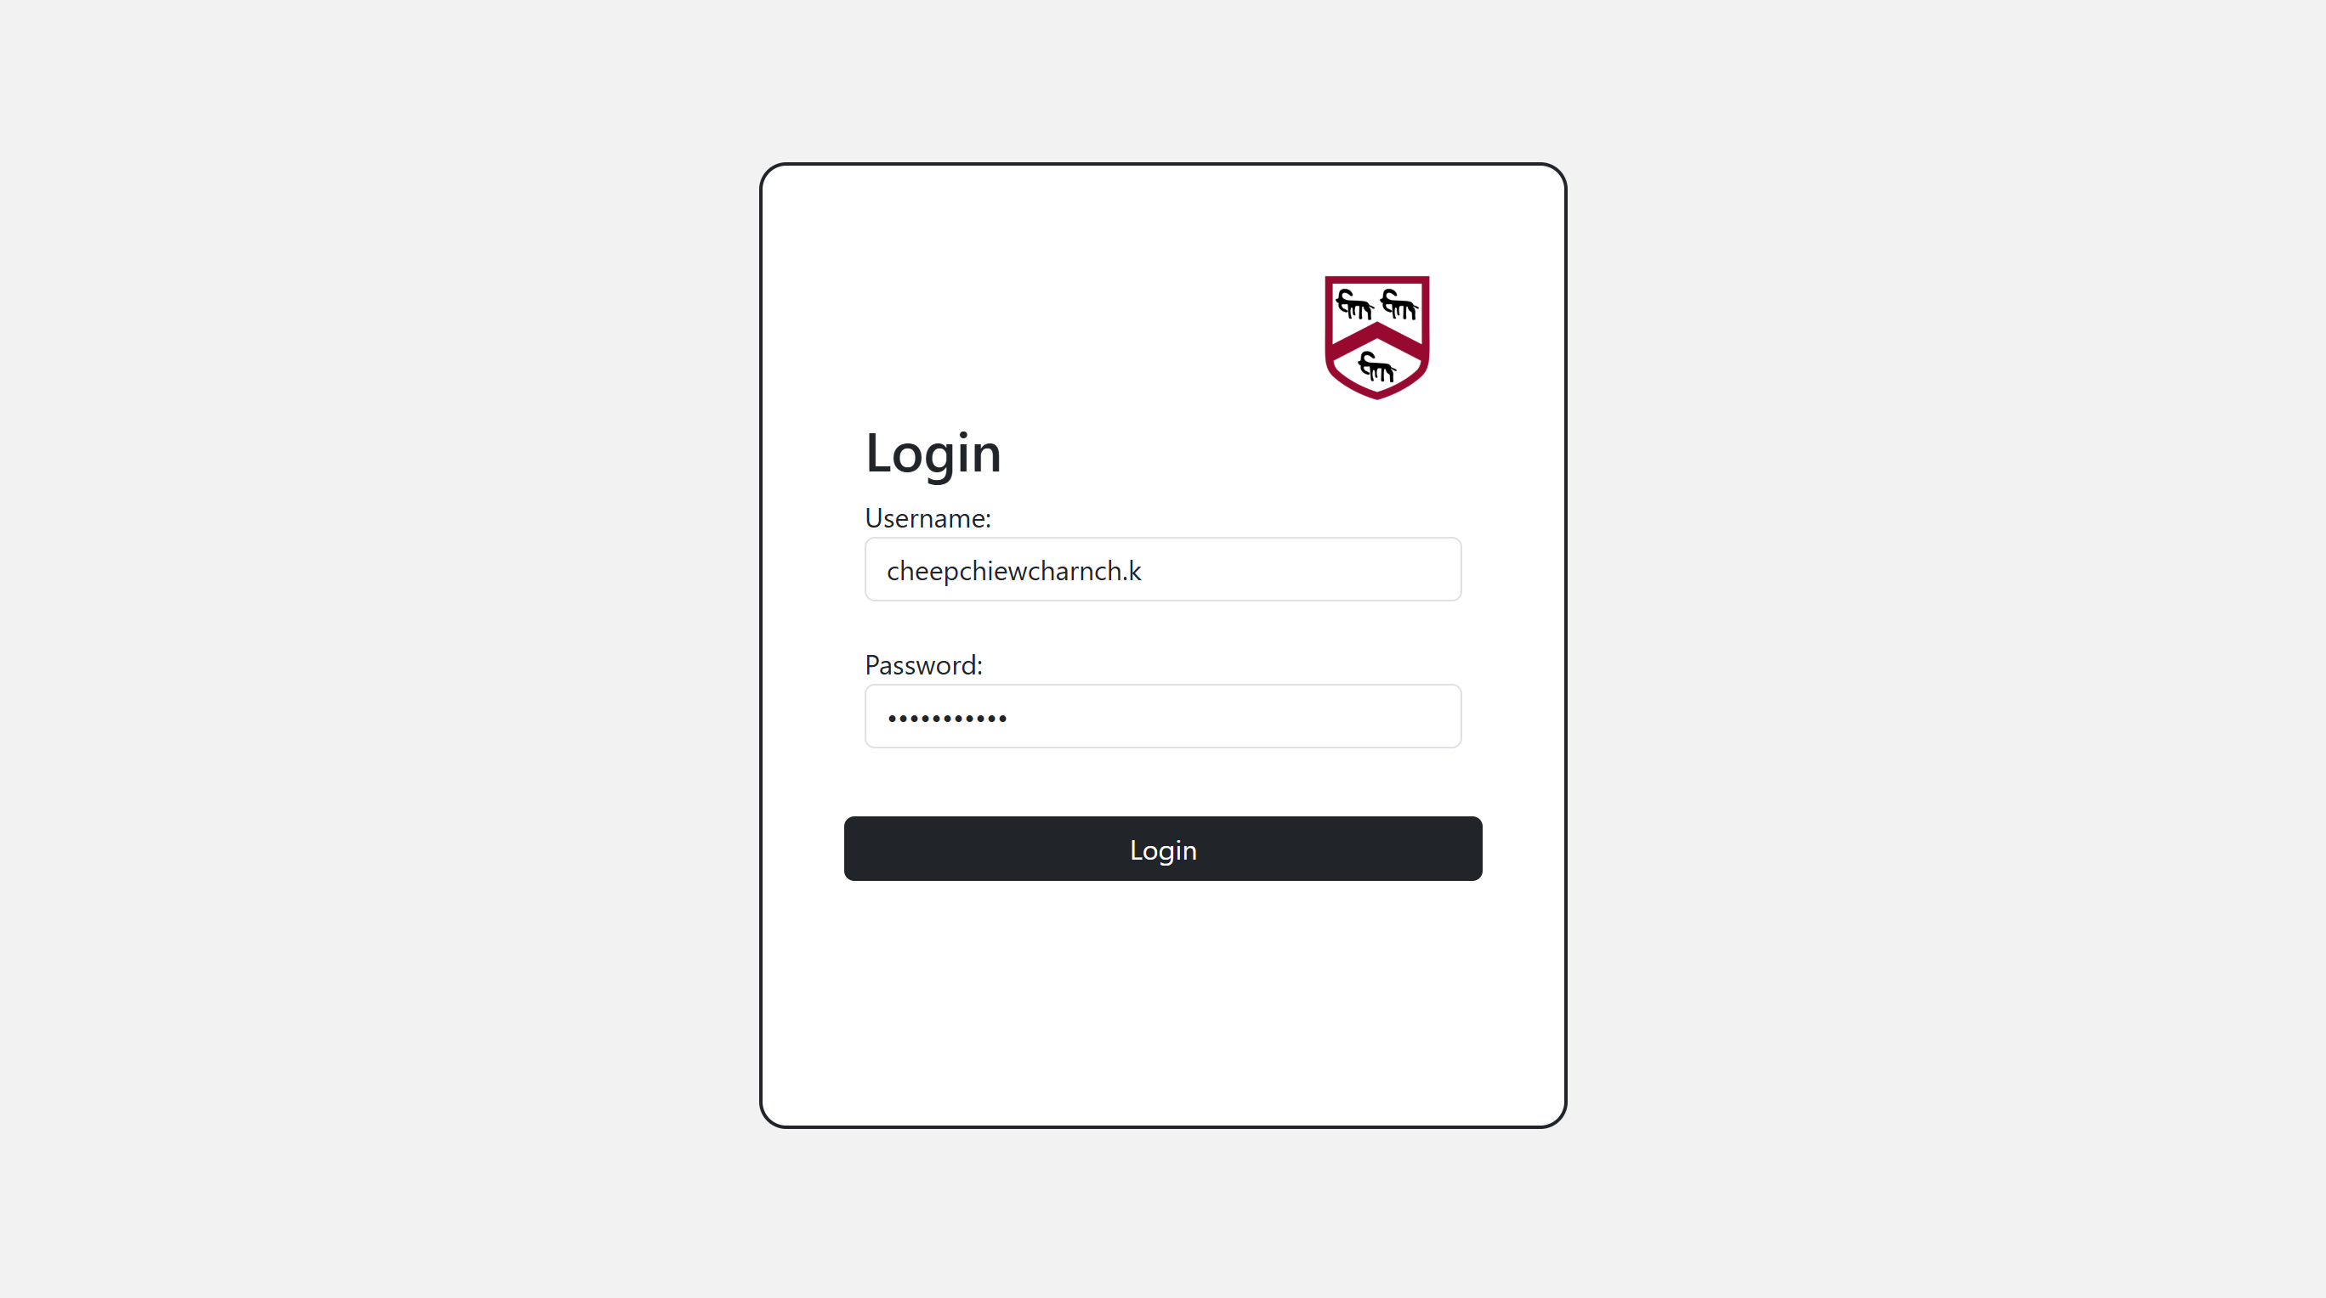When the correct customer login details are entered:  
The user is directed to the customer browse page

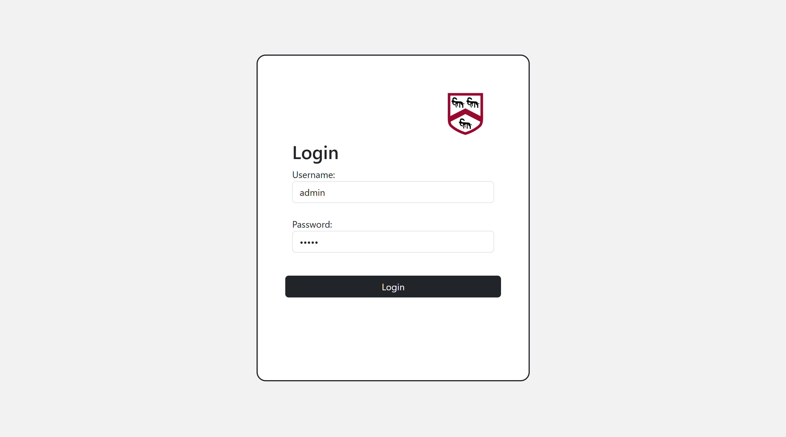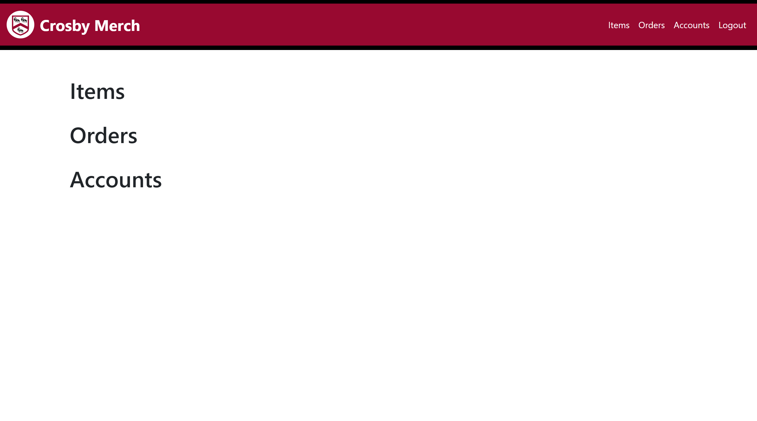When the correct admin login details are entered:  
The user is directed to the customer browse page

Test 2  
The login function correctly stops users from entering the website and displays incorrect username error message when invalid username is entered

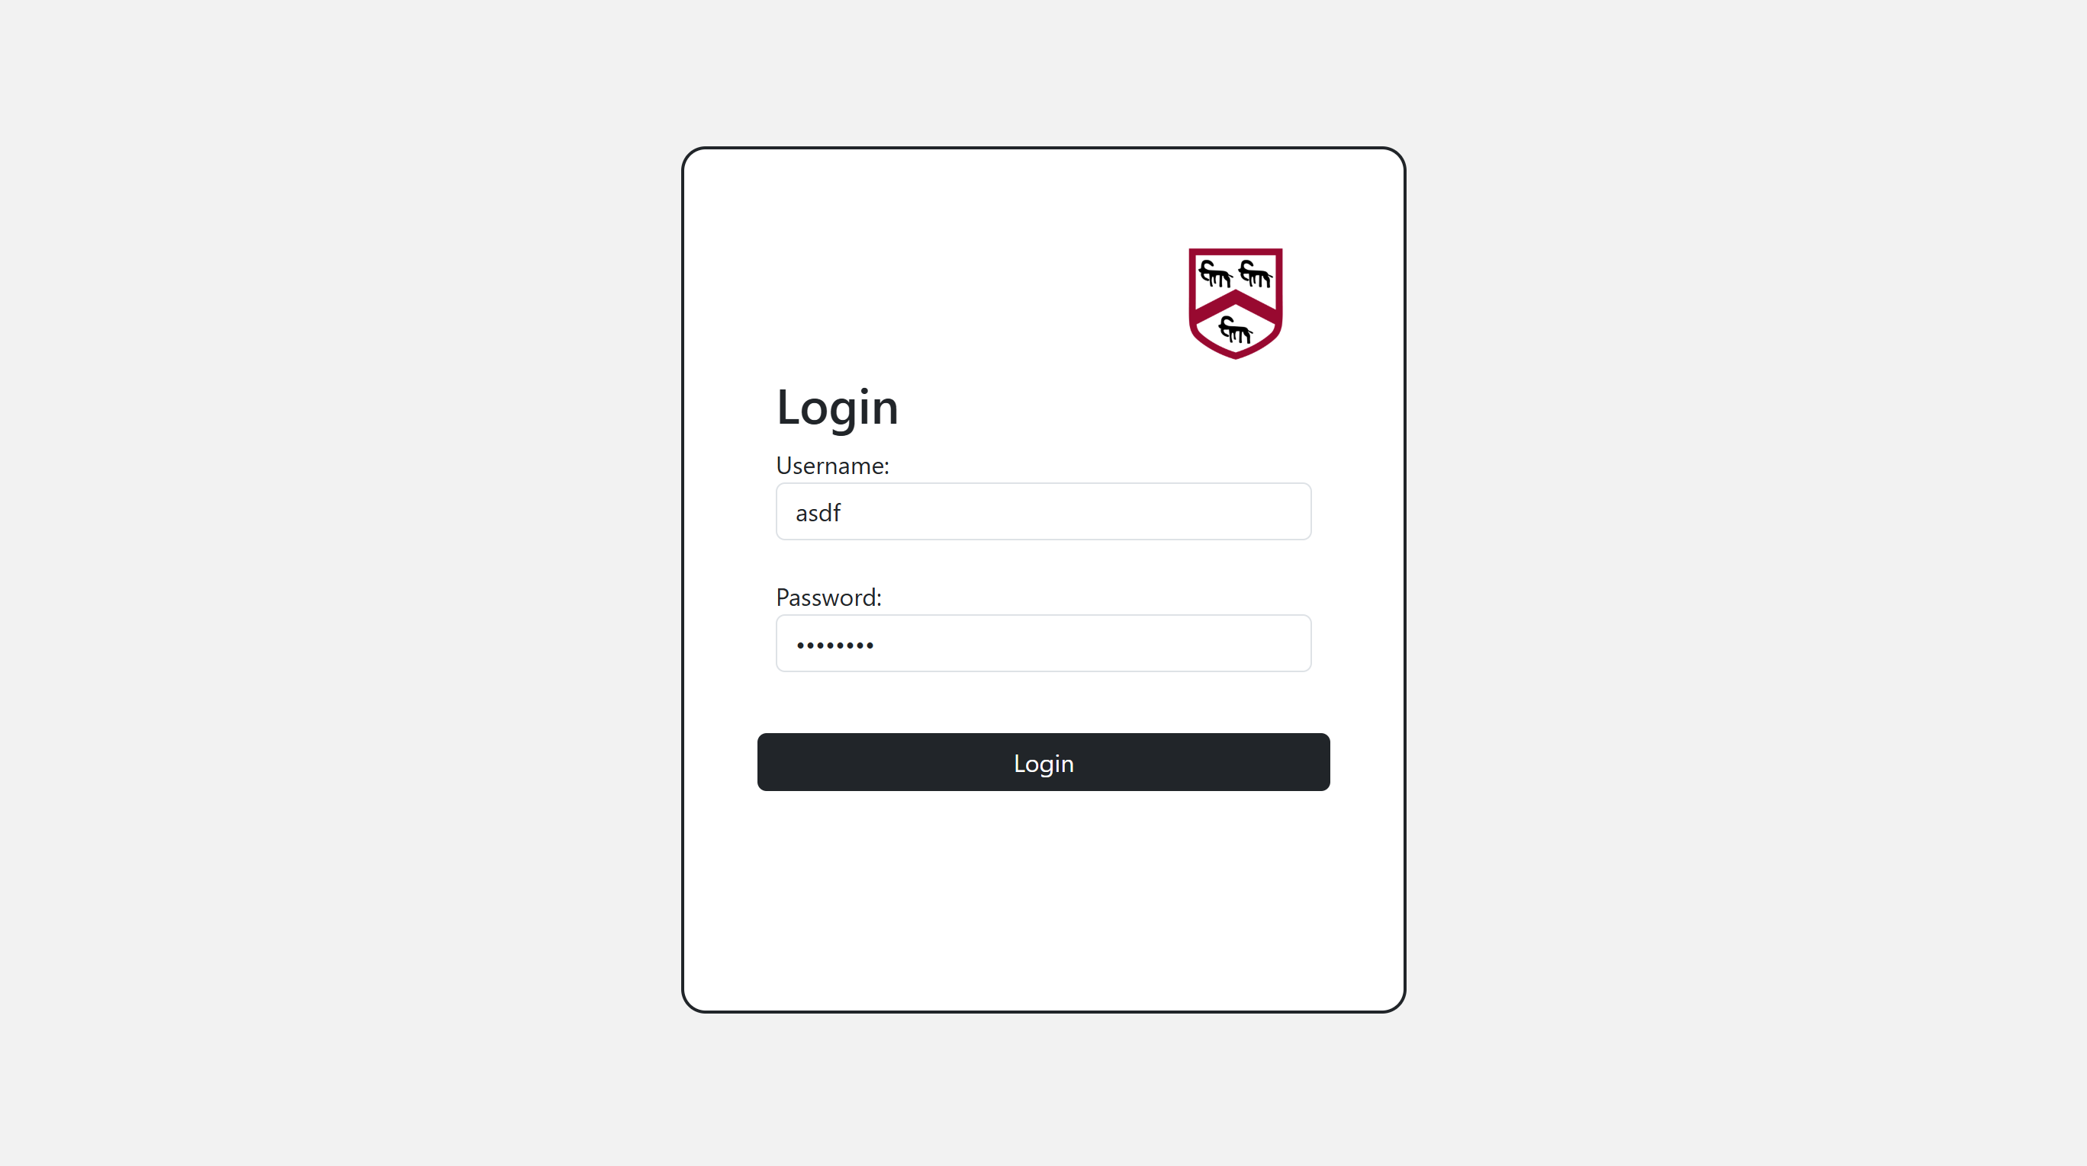When the correct incorrect username is entered

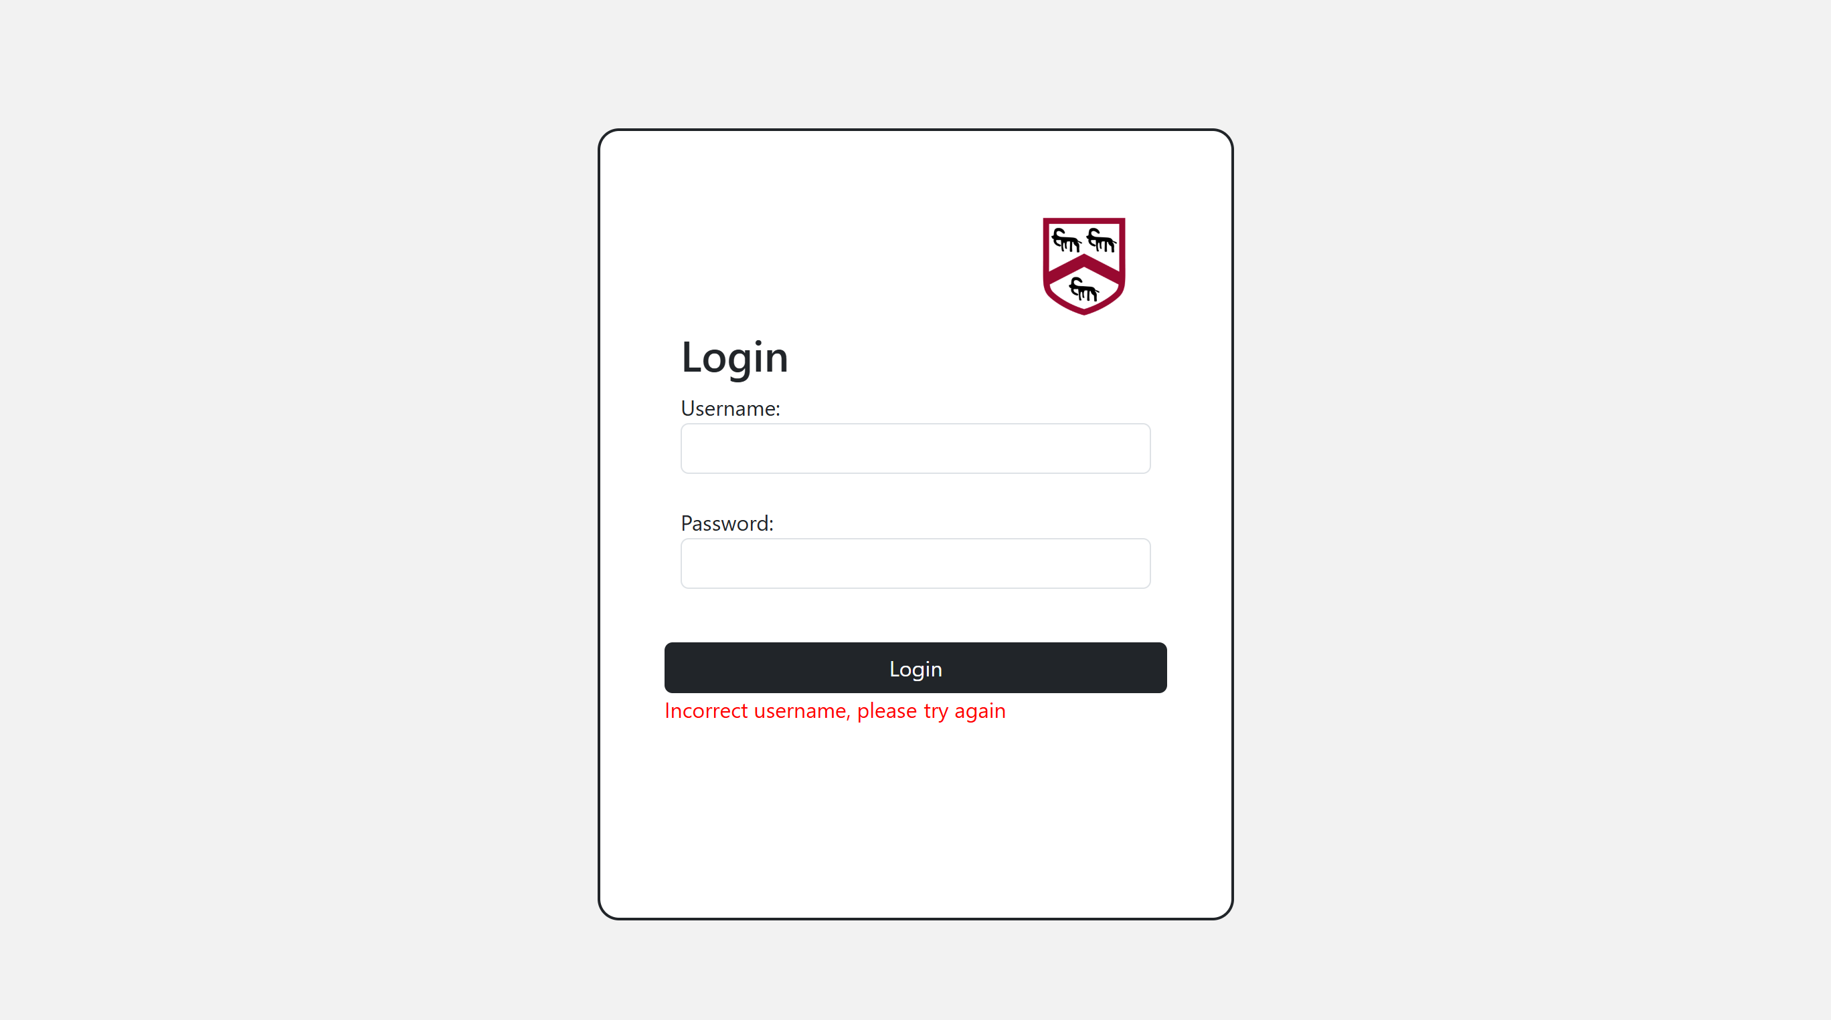Incorrect username error message appears

Test 3  
The login function correctly stops users from entering the website and displays incorrect password error message when invalid password is entered

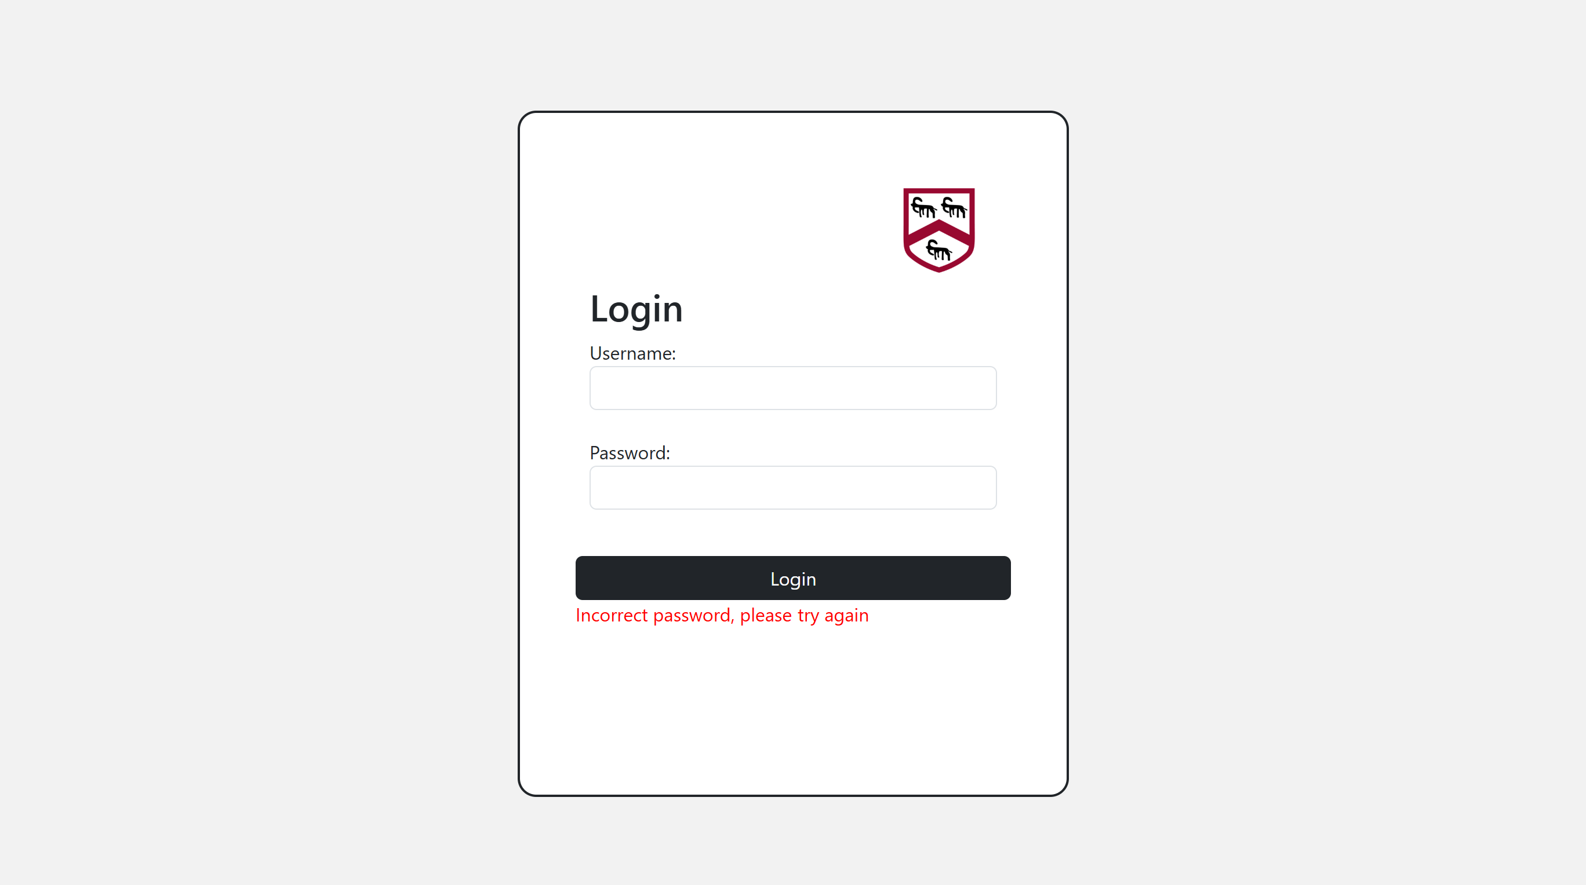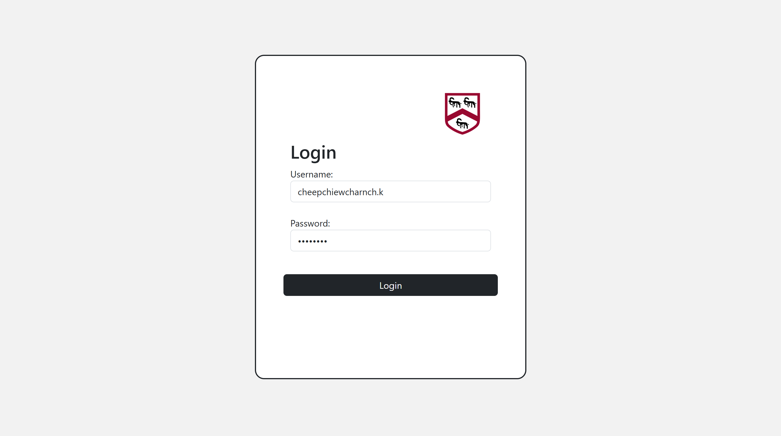When the correct incorrect username is entered  
Incorrect password error message appears

#### Logout button

Test 4  
The logout button functions correctly

When logout button on the navbar of both the customer and admin is pressed

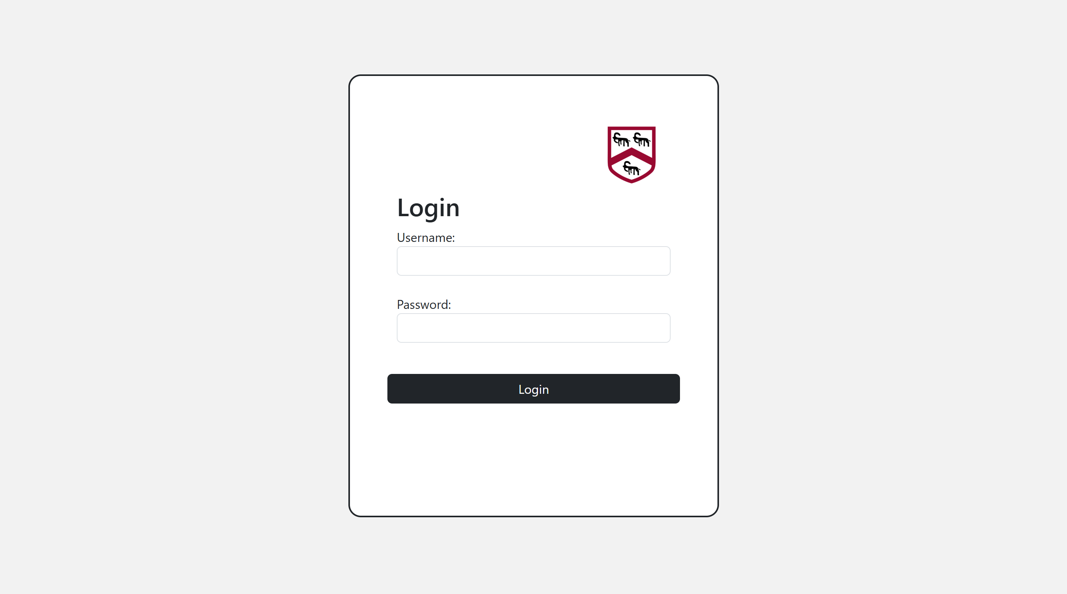User is logged out and redirected to the login page

#### Responsive design

Test 5  
The layout on pages on the website changes with the proportions of the screen size

Original:

Other sizes:

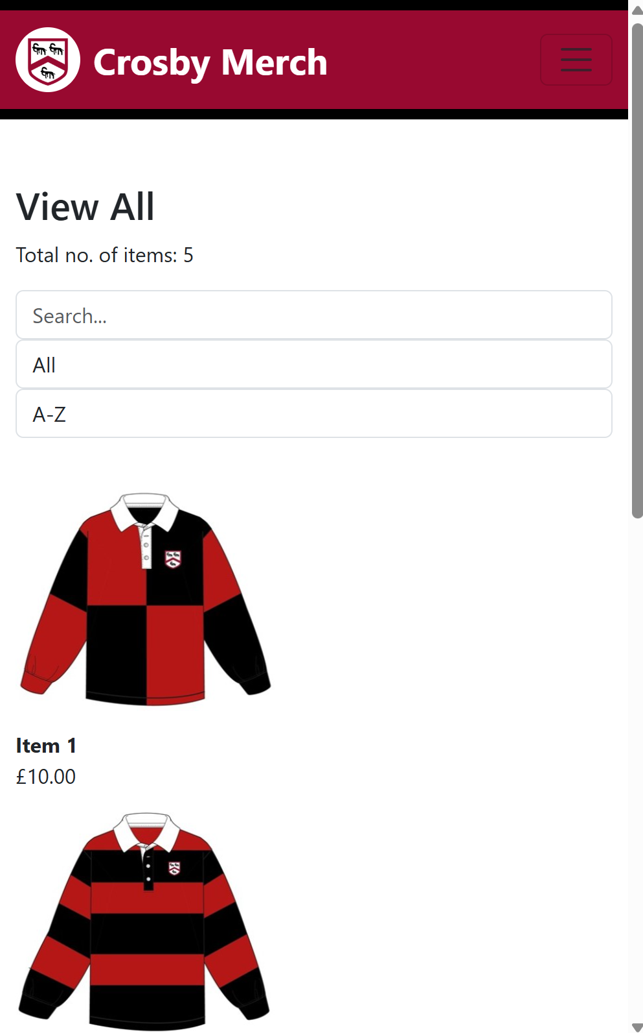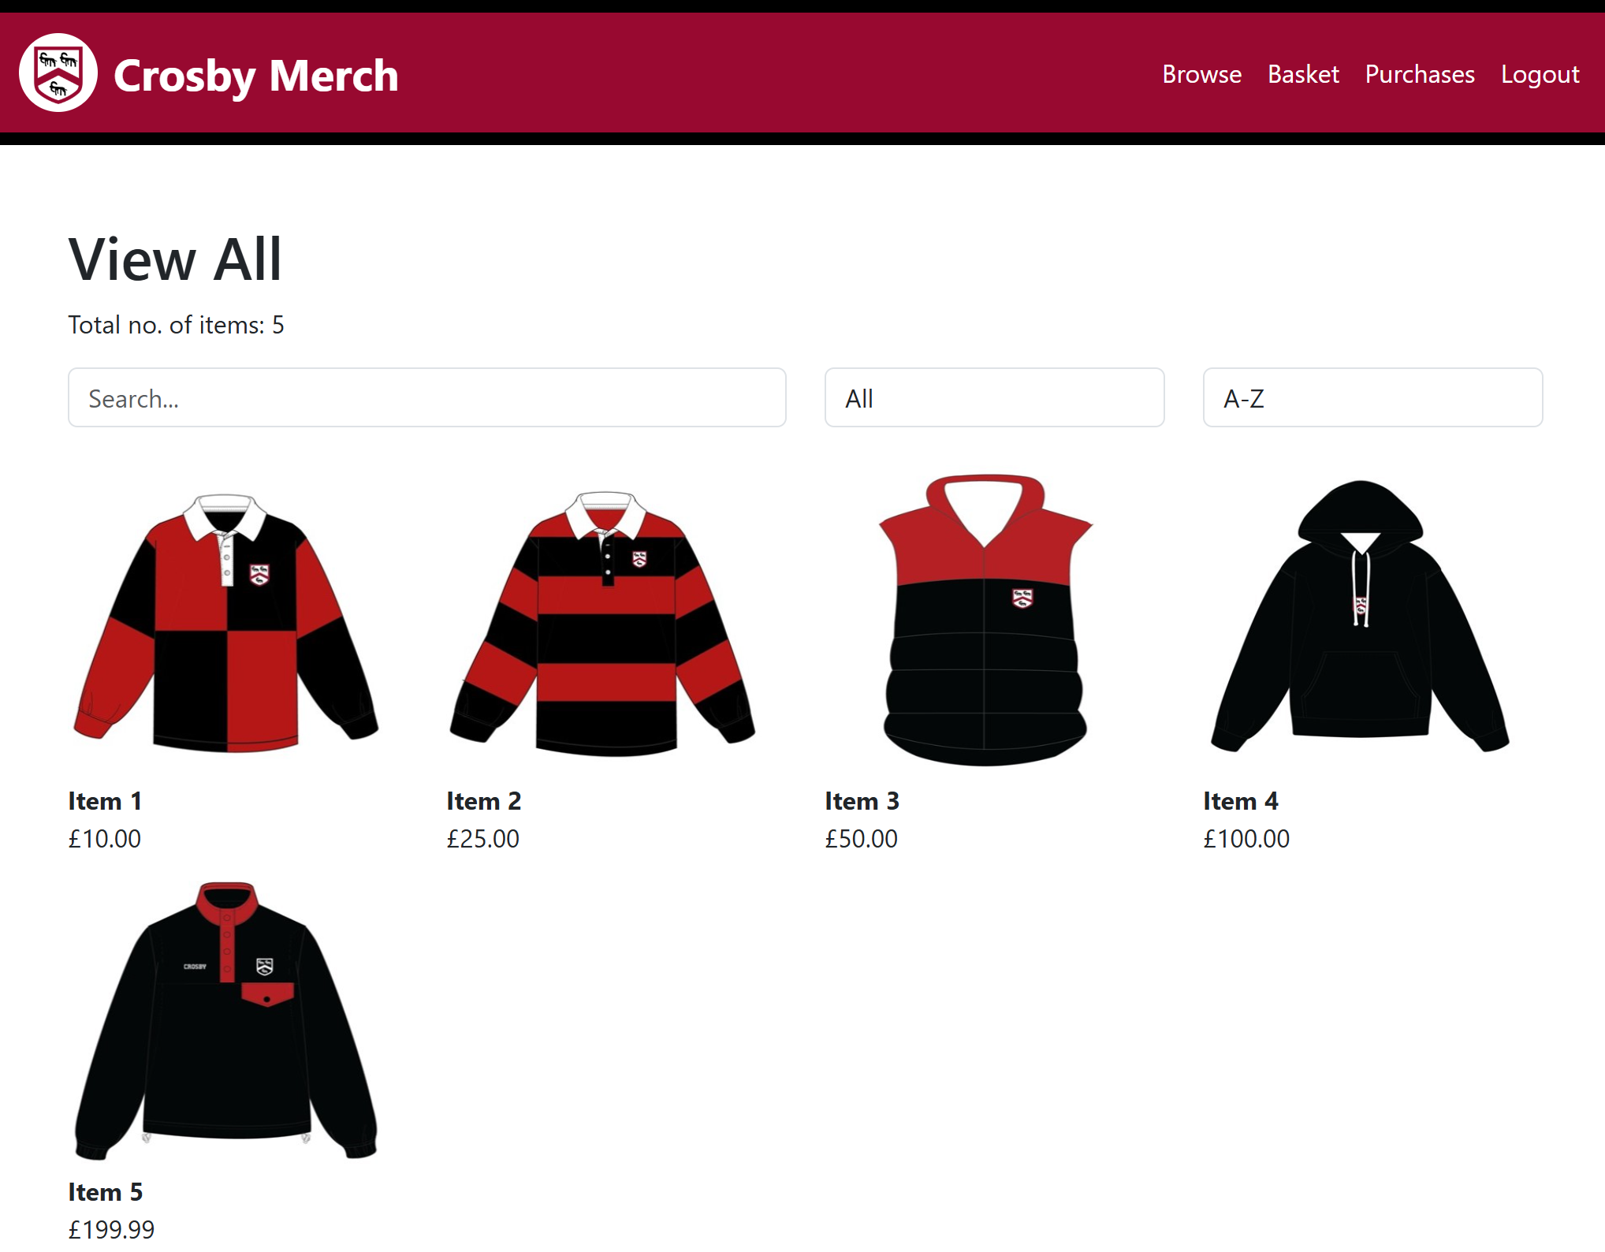

### Customers

#### Navbar

Test 6  
The navbar functions correctly

When any button on the navbar is clicked

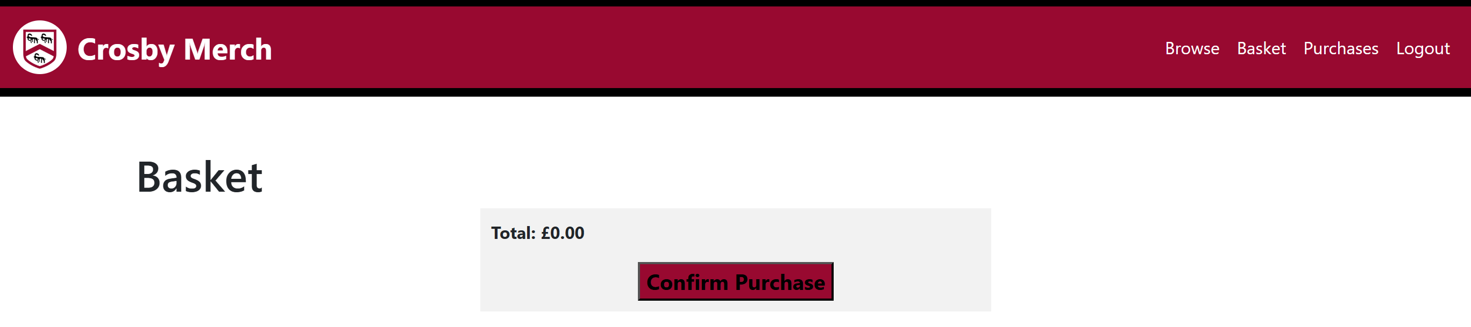 User is redirected to the correct page

#### Homepage

Test 7  
The items is displayed on the homepage in the correct format

Homepage defaults to displaying all items, showing pictures, name and prices

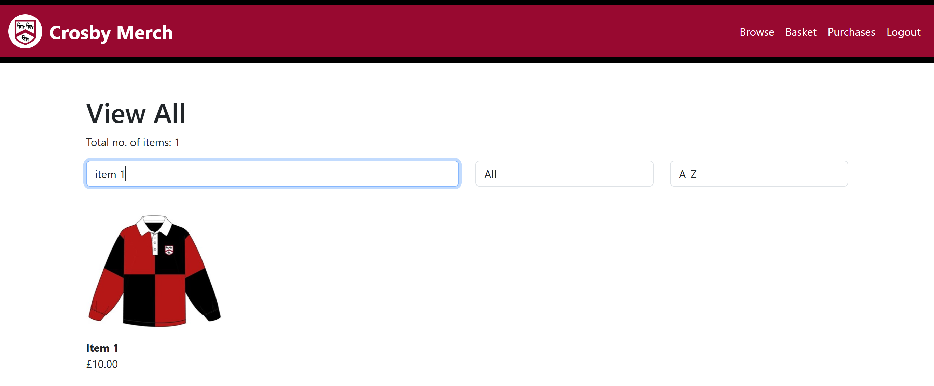Test 8 & 9  
Users can search for, sort and filter items, affect the displays on the page for the each

Correct item shows up through using the search bar and total no. of items changed

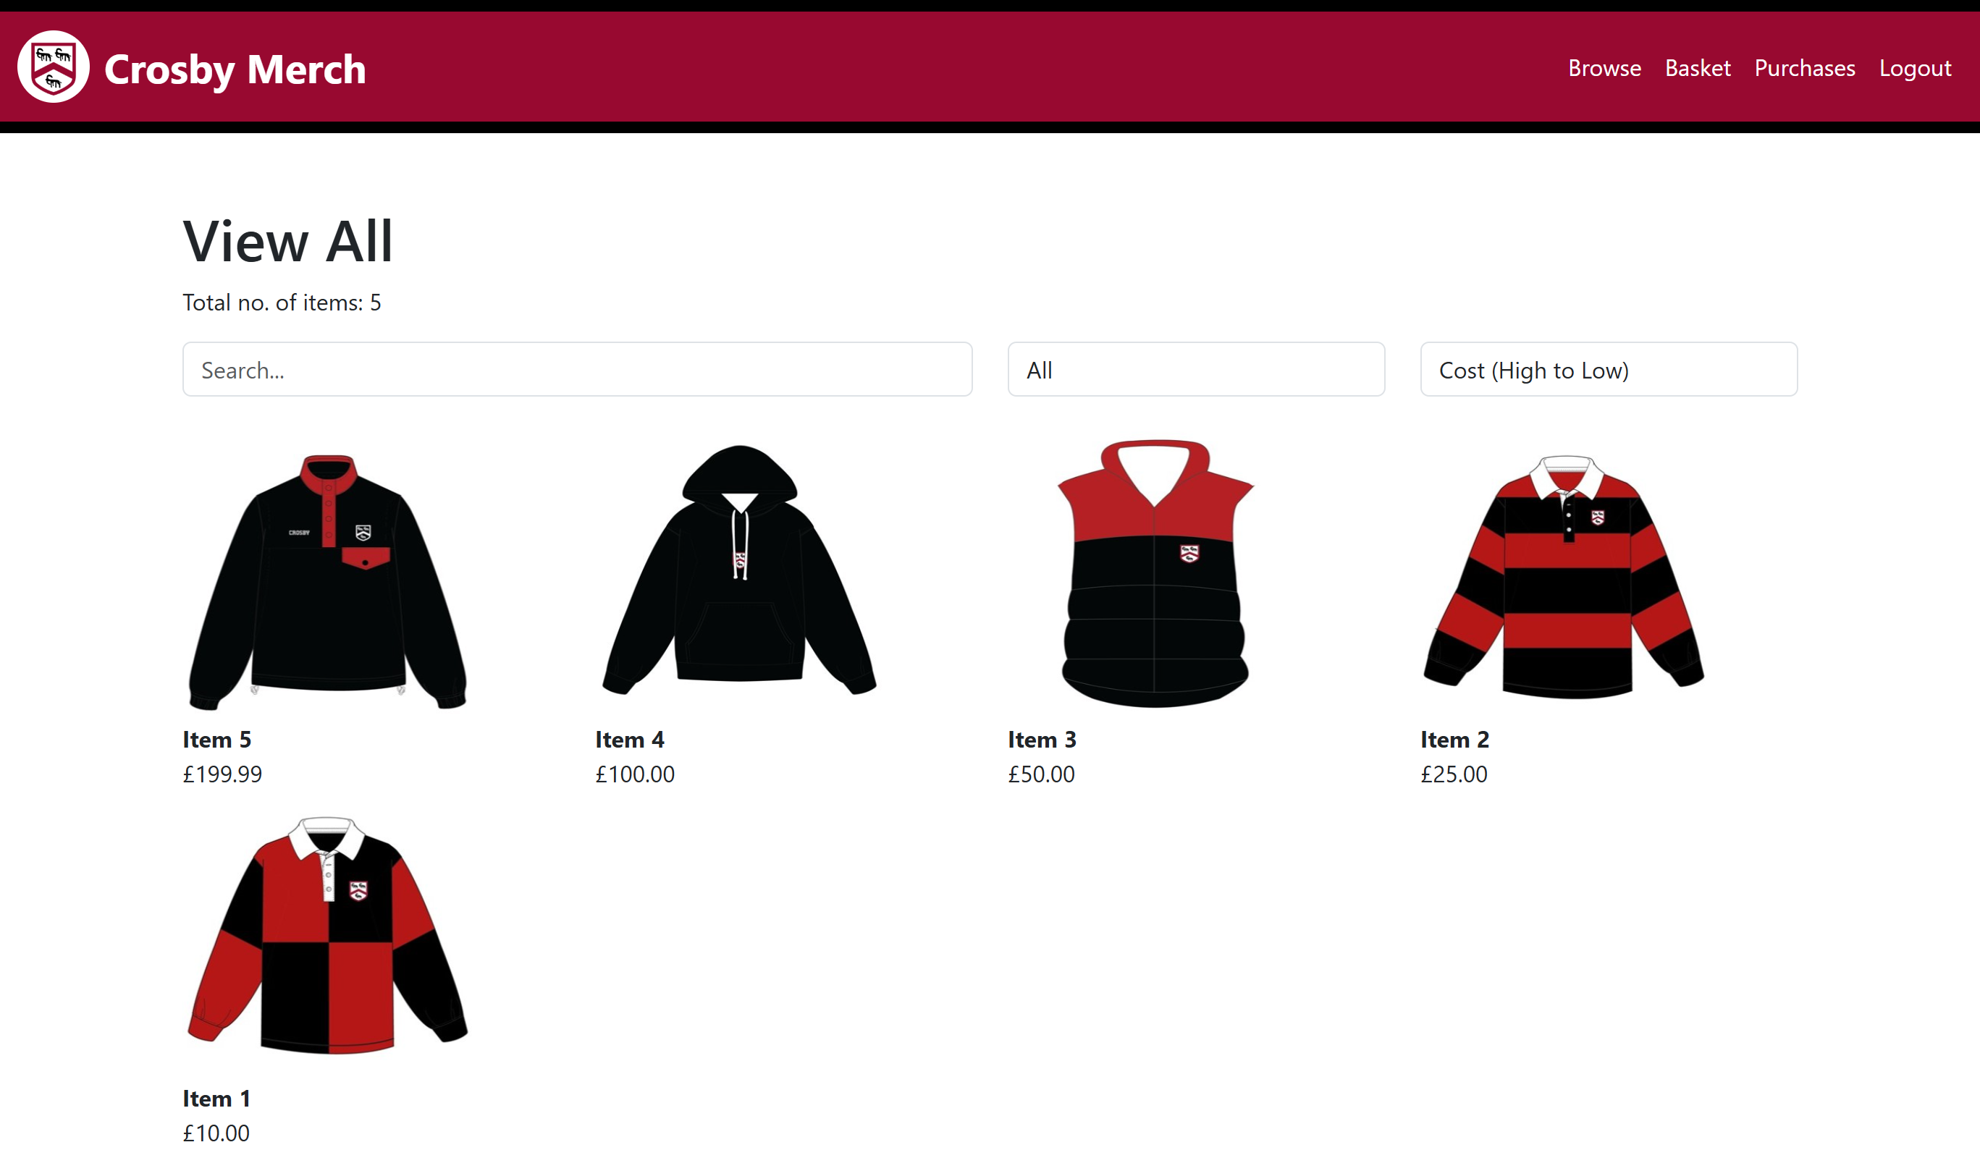Correct item orders through using the sort

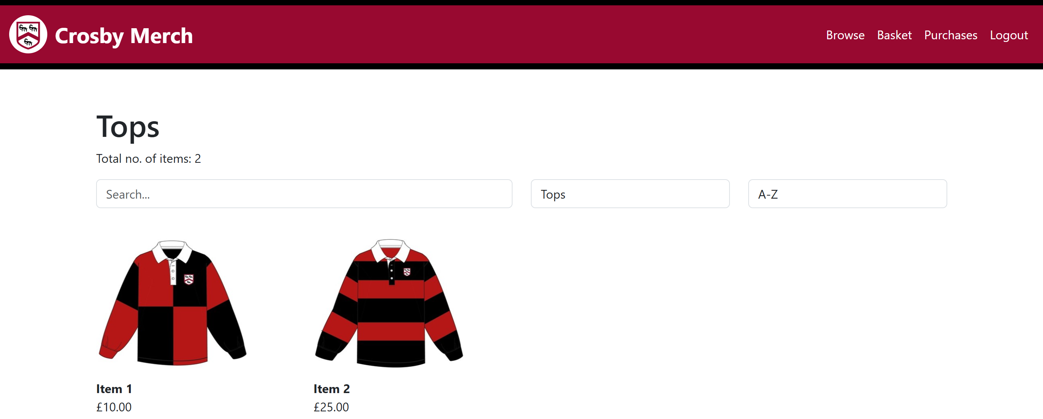Correct item shows up through using the filter and total no. of items changed

Test 10  
Users can navigate to item details page when item is clicked

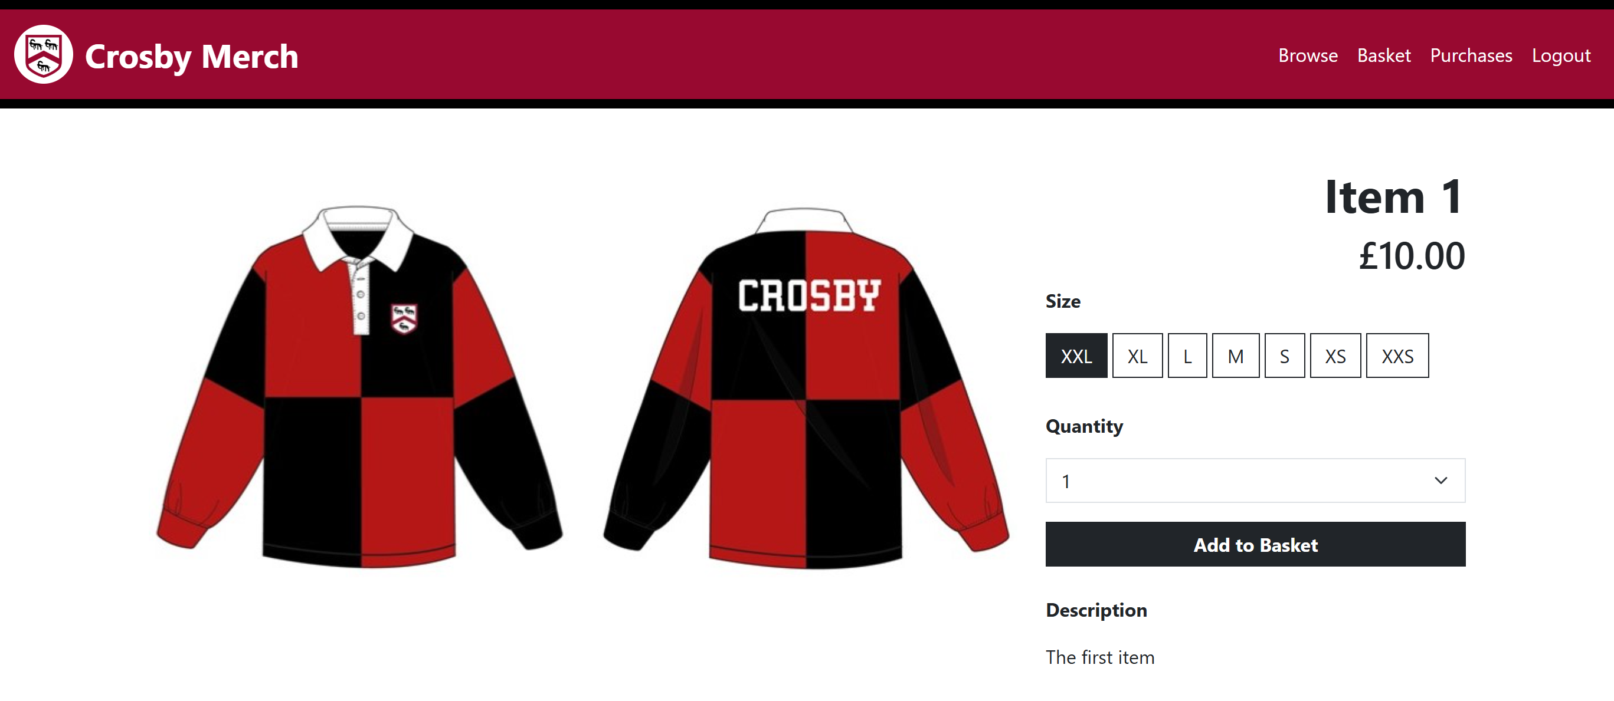When item 1 is clicked, user is redirected to the display page featuring item 1

#### Item display page

Test 11  
Images and name, cost and description of item are displayed correctly

display page featuring item 1:

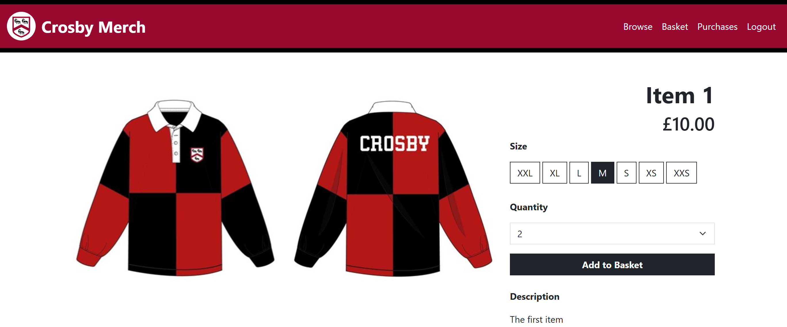Test 12  
Correct size and quantity that user chosen is added to basket

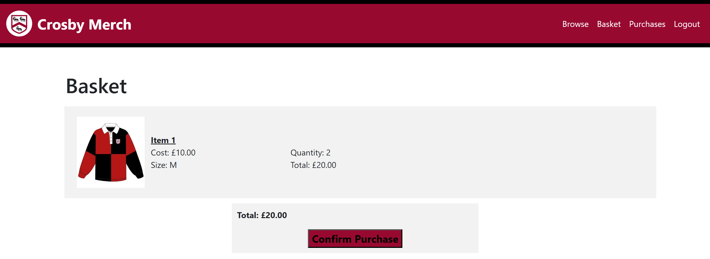

Test 13  
Size and quantity default selects to prevent customers from being able to add to basket without those data

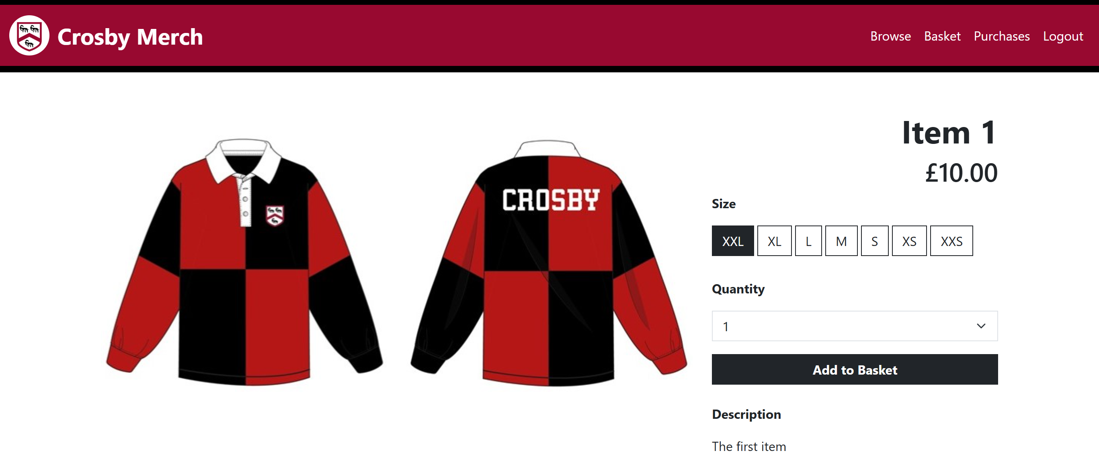

#### Basket page

Test 14  
Items added to the basket by the customer correctly appears on the basket page

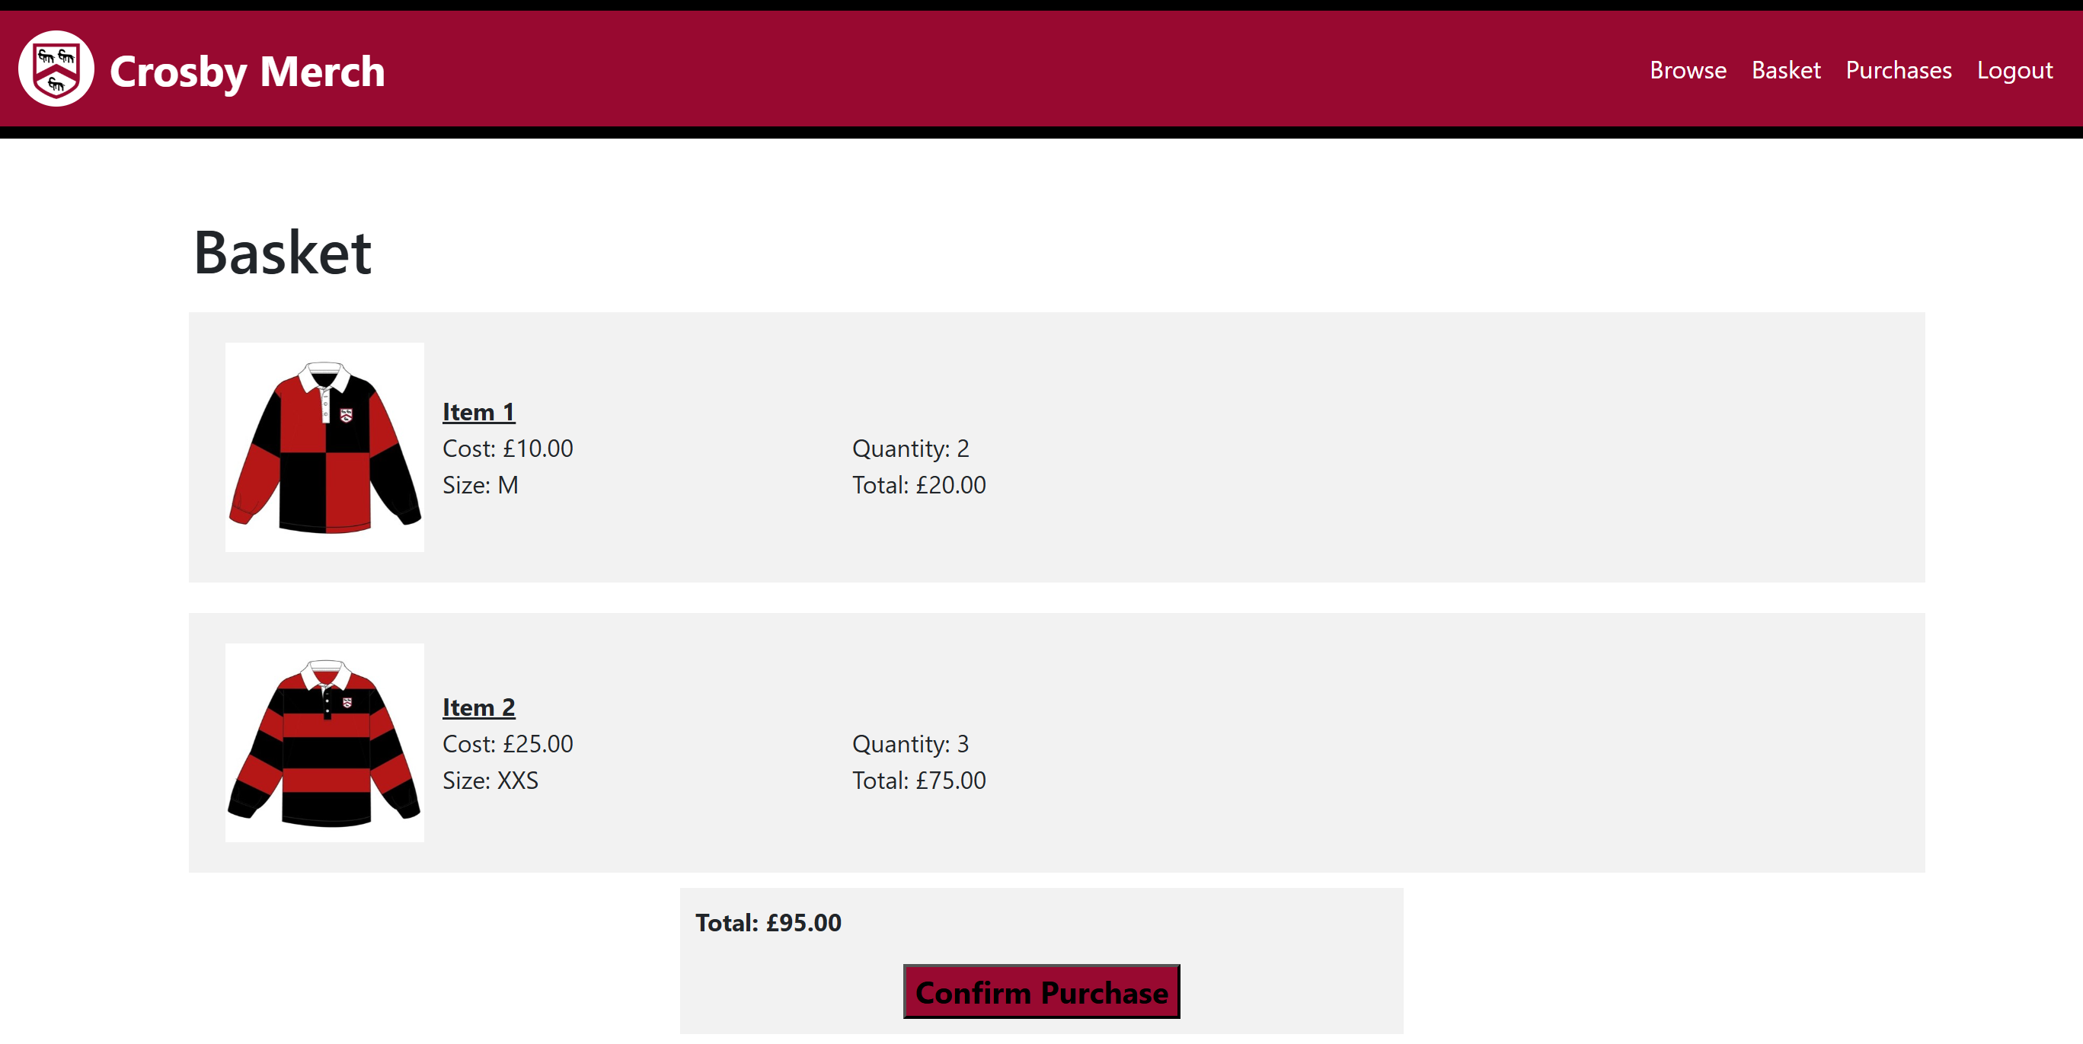Test 15

Total amount to pay is calculated correctly

Test 17

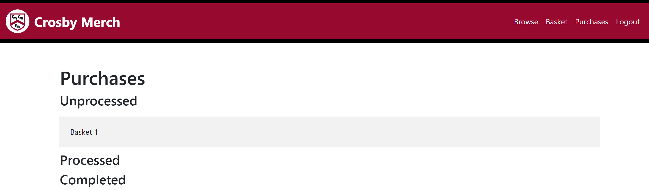User can order basket by clicking purchase button

Purchases page

Test 18  
All baskets ordered are displayed in the correct status section  
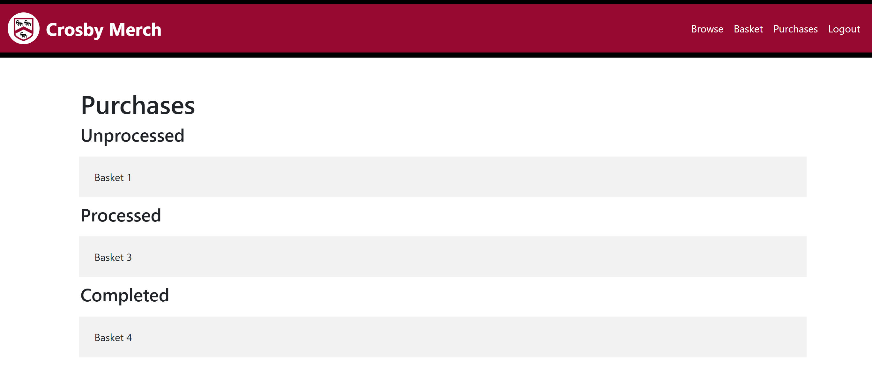

Test 19  
Details of an ordered basket can be checked by clicking onto it

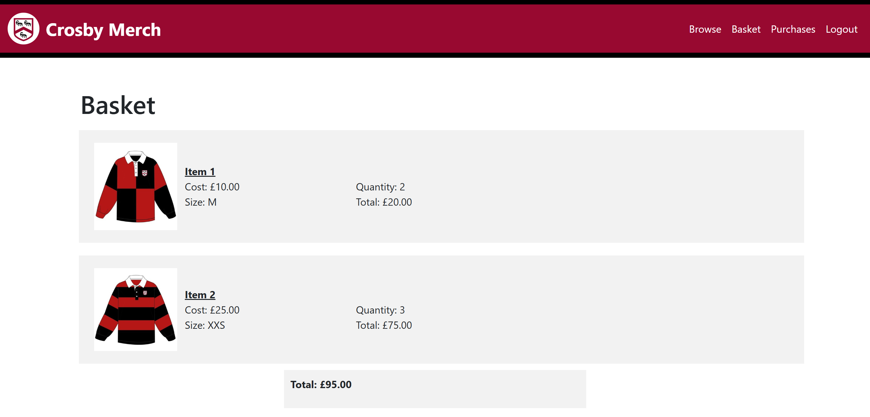

#### Order details page

Test 21  
Details of basket ordered are displayed correctly

### Admins

#### Navbar

Test 22  
The navbar functions correctly

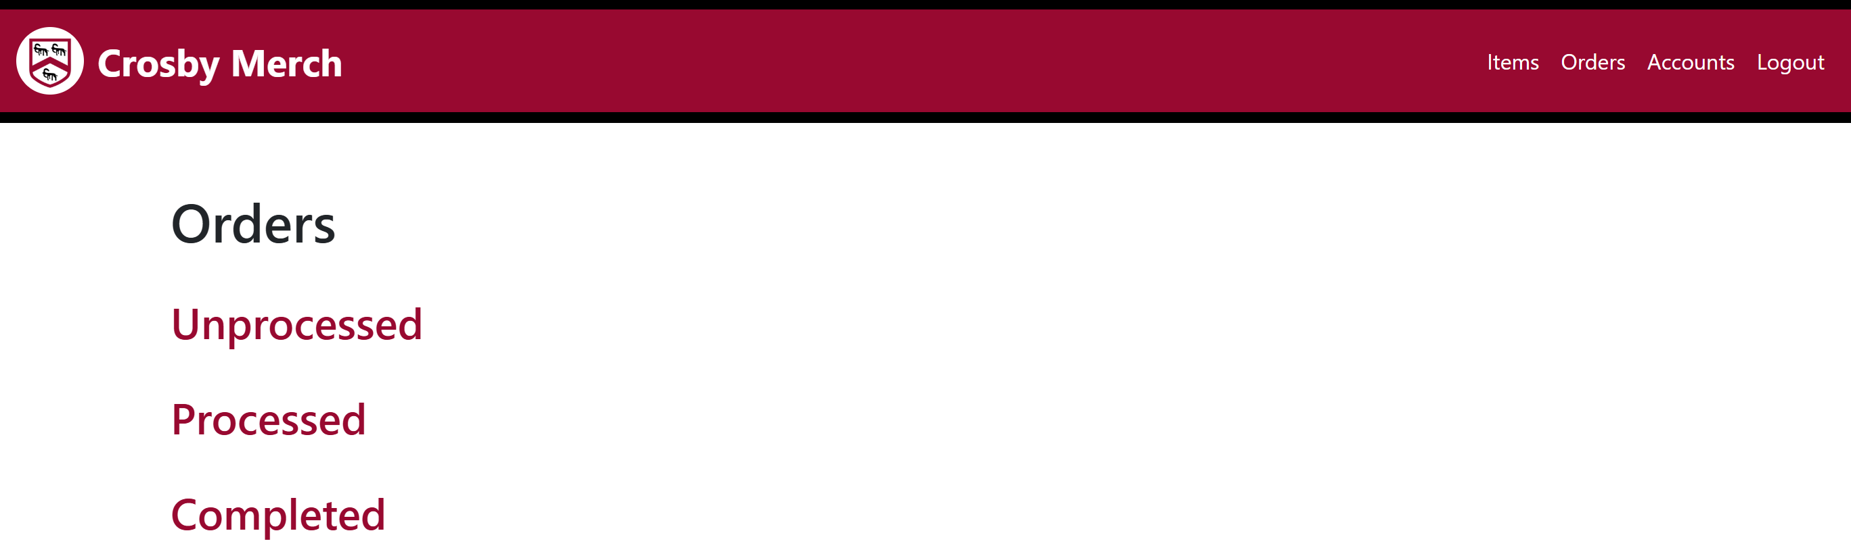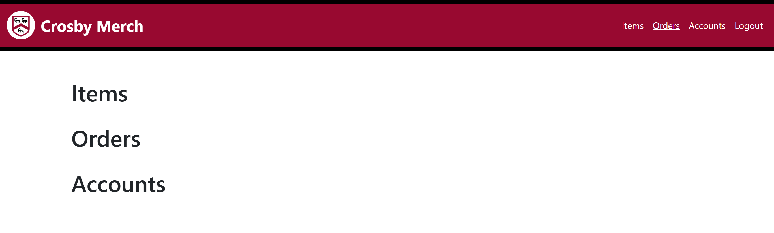 When any button on the navbar is clicked

User is redirected to the correct page

#### Homepage

Test 23  
All links link navigates the user to the correct destination

#### A red and white rectangle with black lines AI-generated content may be incorrect.Items pages

Test 24  
The admin item list page mirrors the exact customer homepage looks and functions (apart from not being able to add item to basket)

 Admin browse page:

Admin item display page:Test 25  
The admin add item page will successfully send input to the database and the item is displayed on 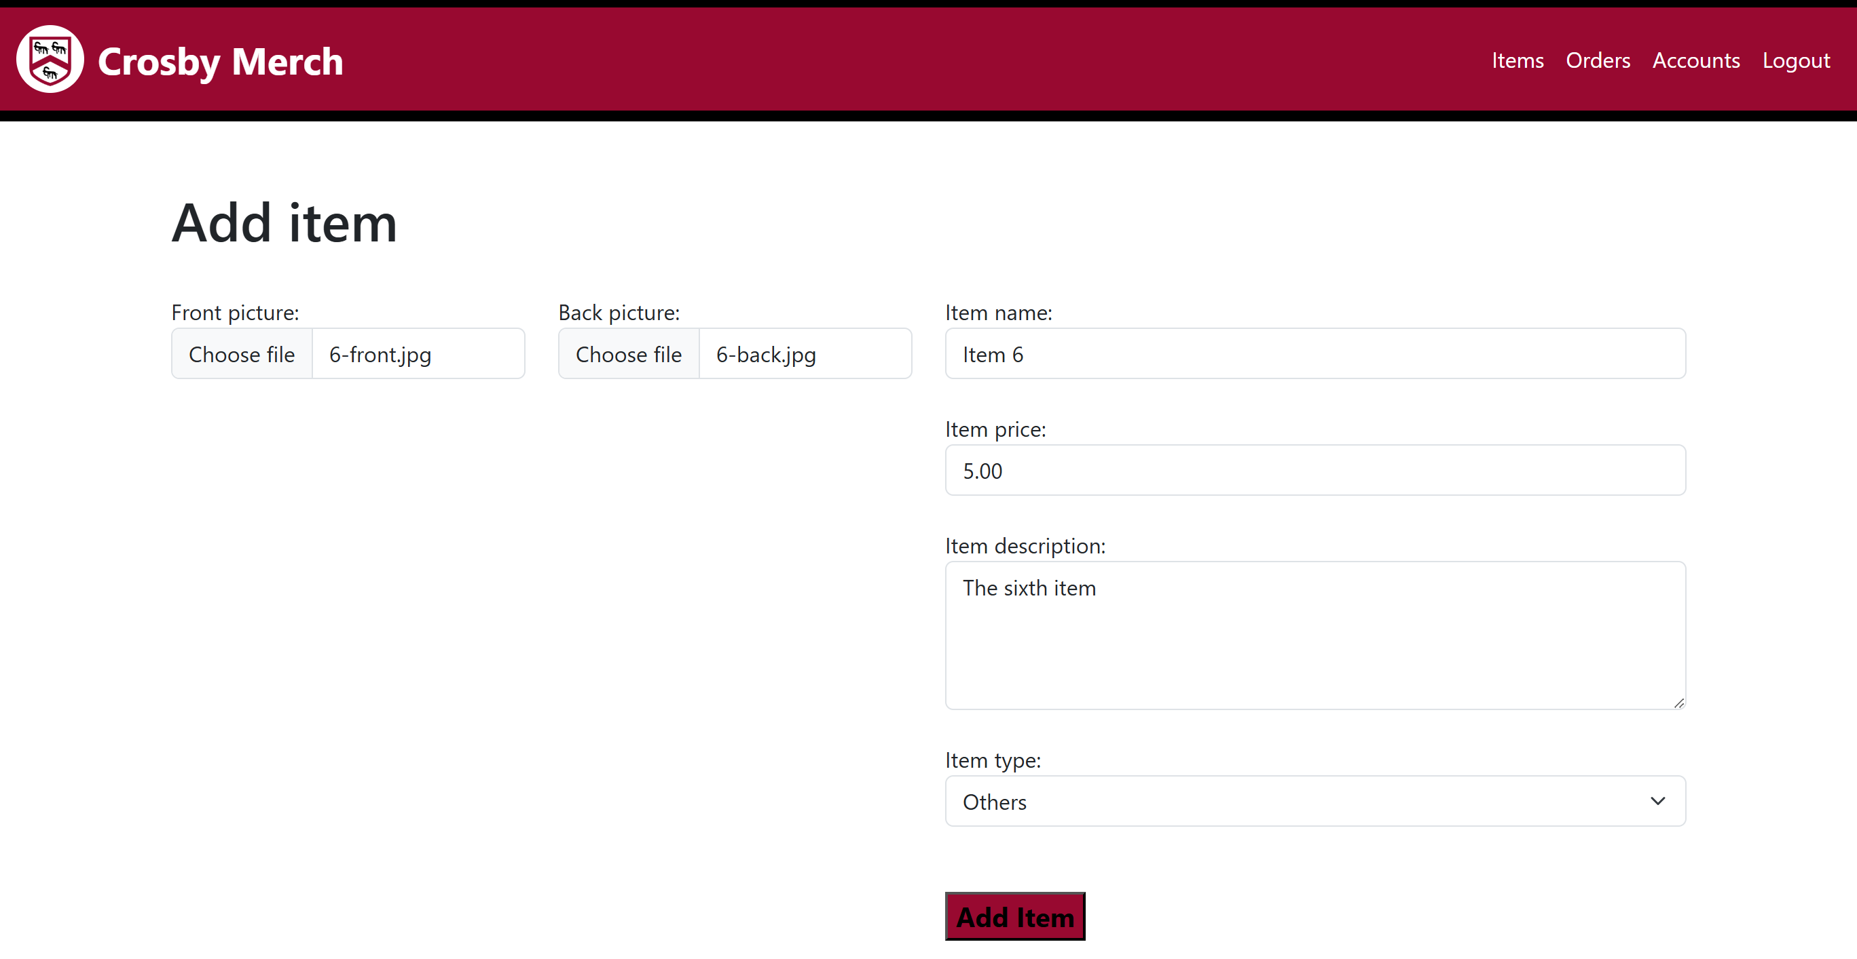the browse page.

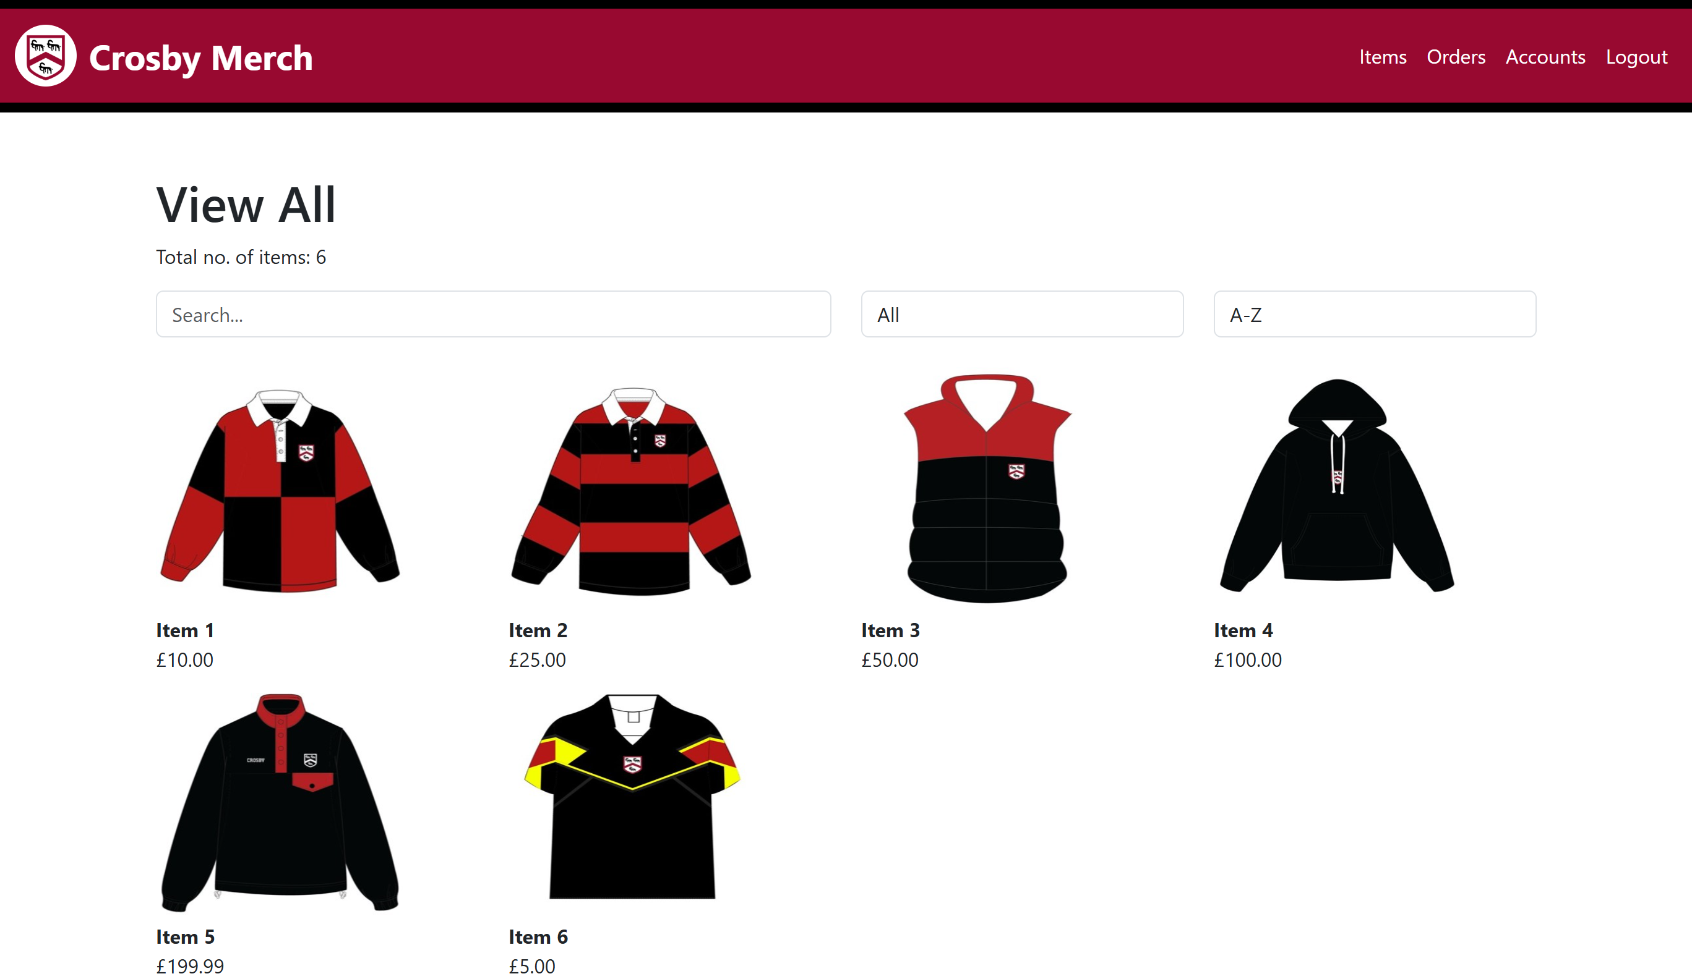

#### Orders pages

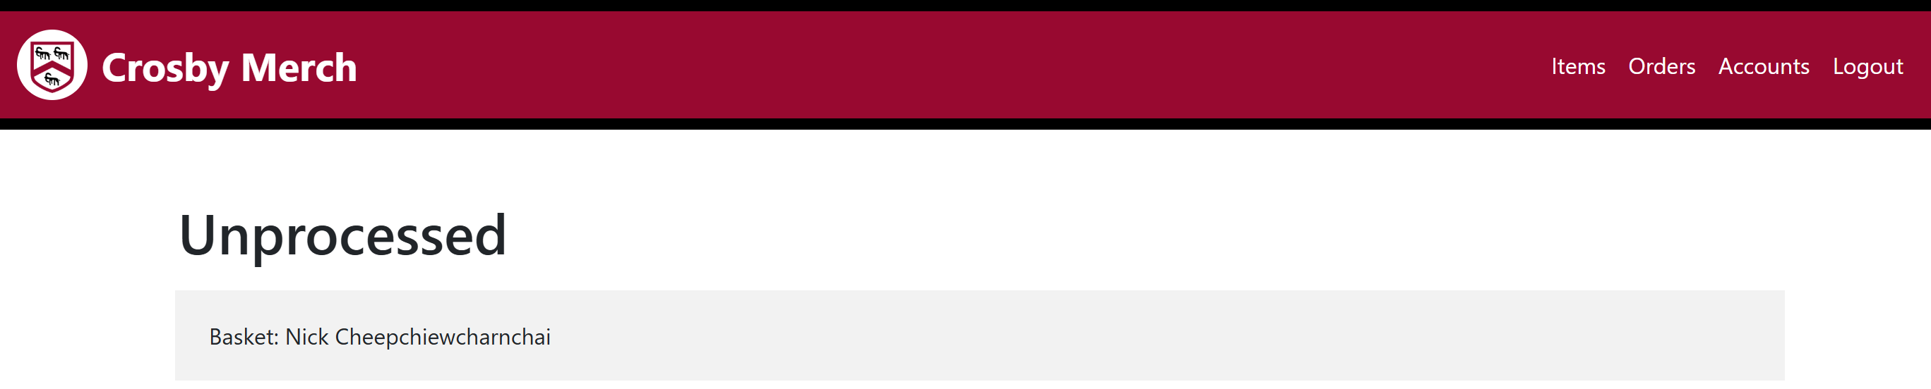Test 27  
Orders are correctly shown in the correct status

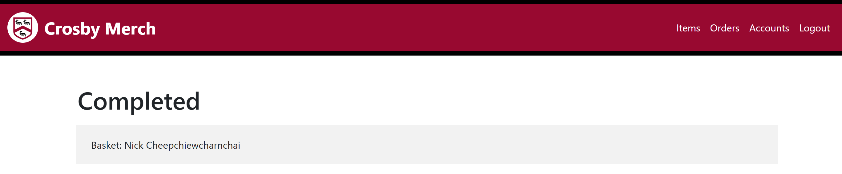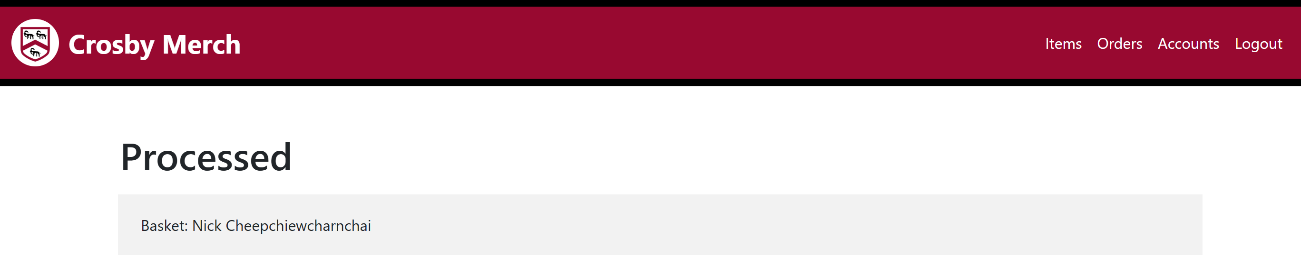

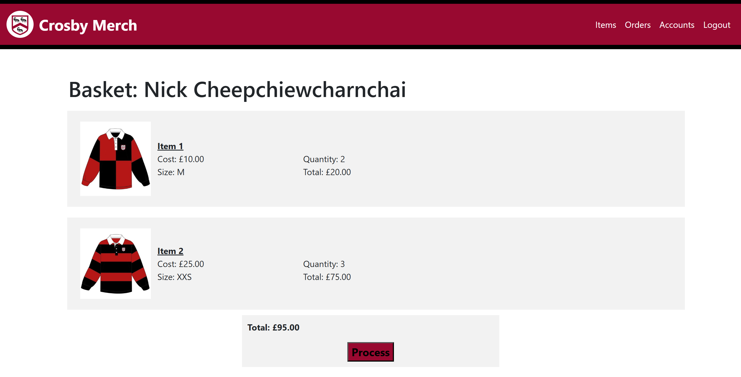Test 28  
Basket order clicked on redirects customer to a details page

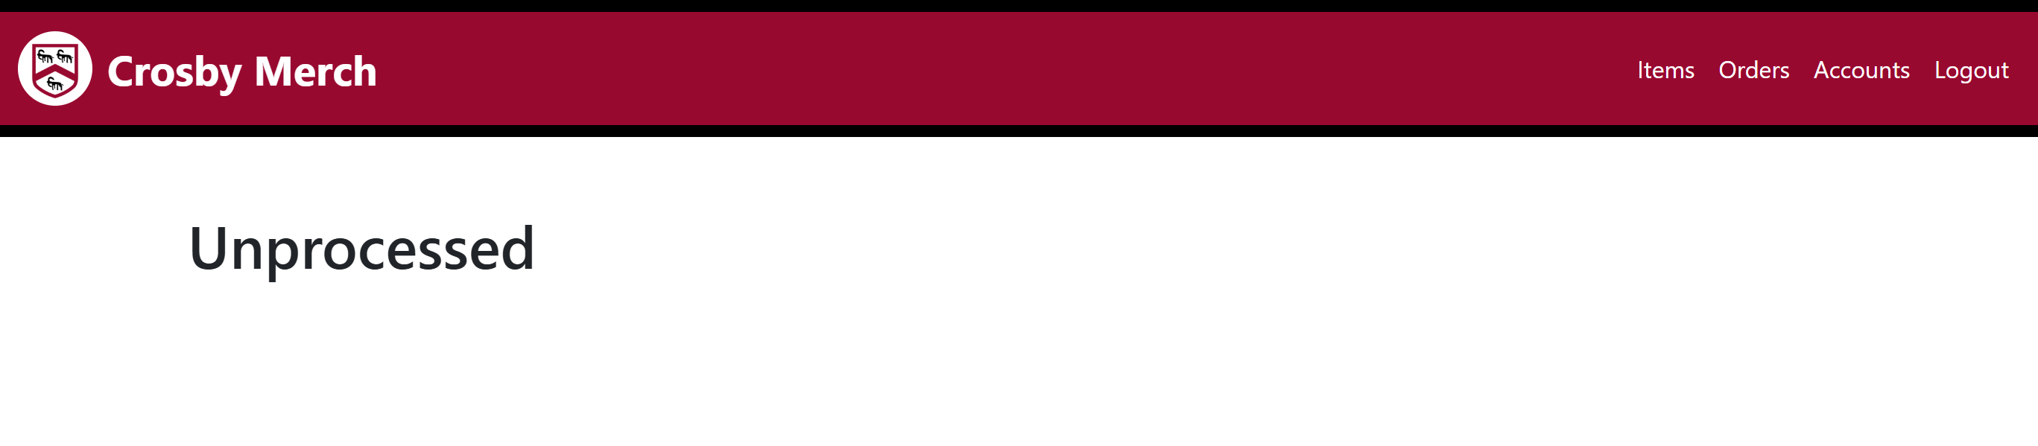Test 29  
Status of an order can be shifted to the next correctly

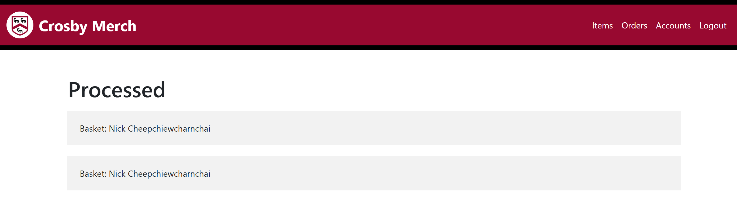Unprocessed and unprocessed orders after processing:

Processed and completed orders after processing:

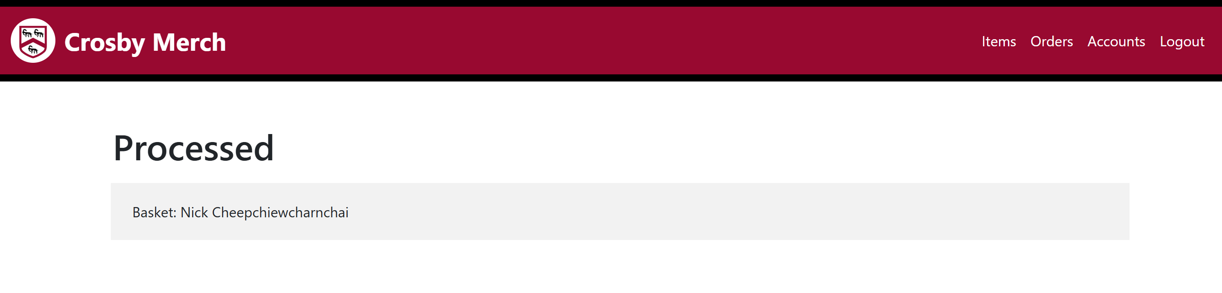

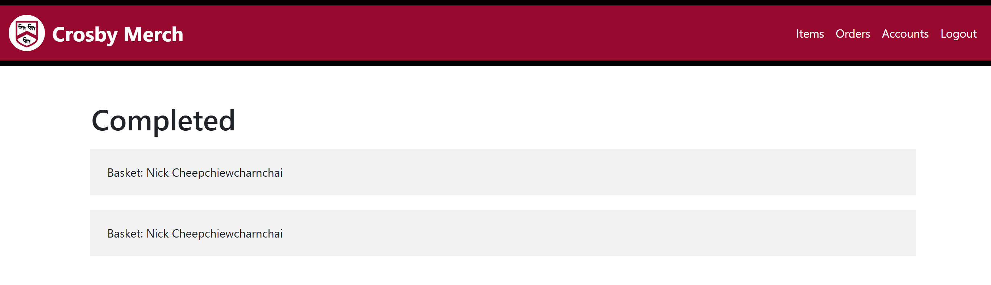

#### Accounts pages

Test 30  
List of accounts displays all customers correctly

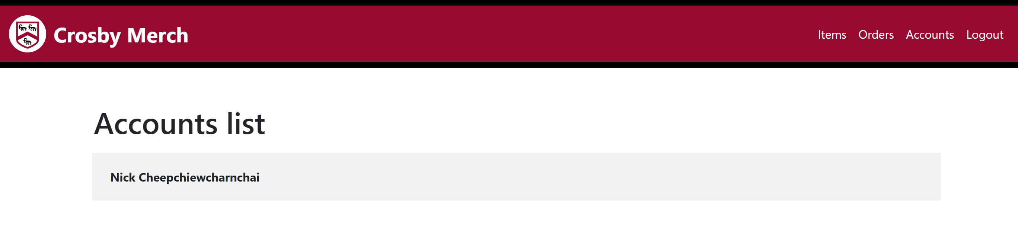

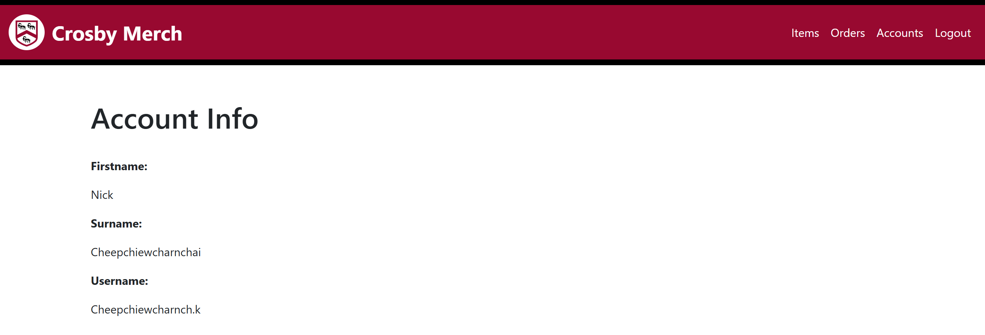Test 31  
Customer details are displayed correctly

Test 32  
Customer’s orders can be checked and processed correctly

Before and after processing one of the baskets through accounts processing pages:

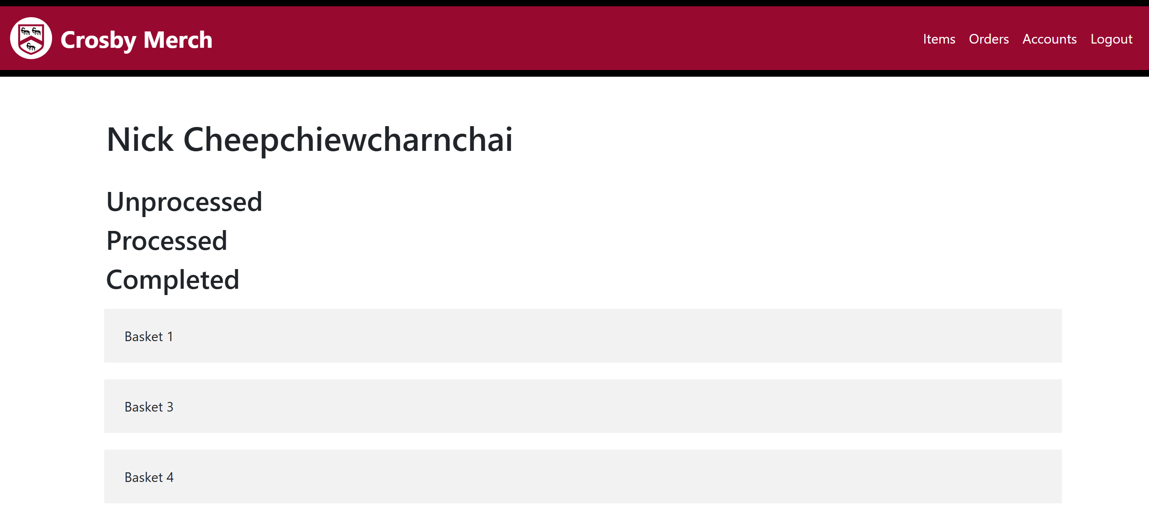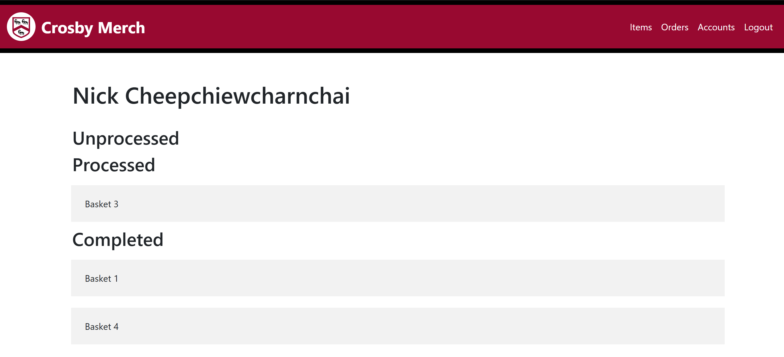

Test 33  
New account is correctly created and can be seen and used

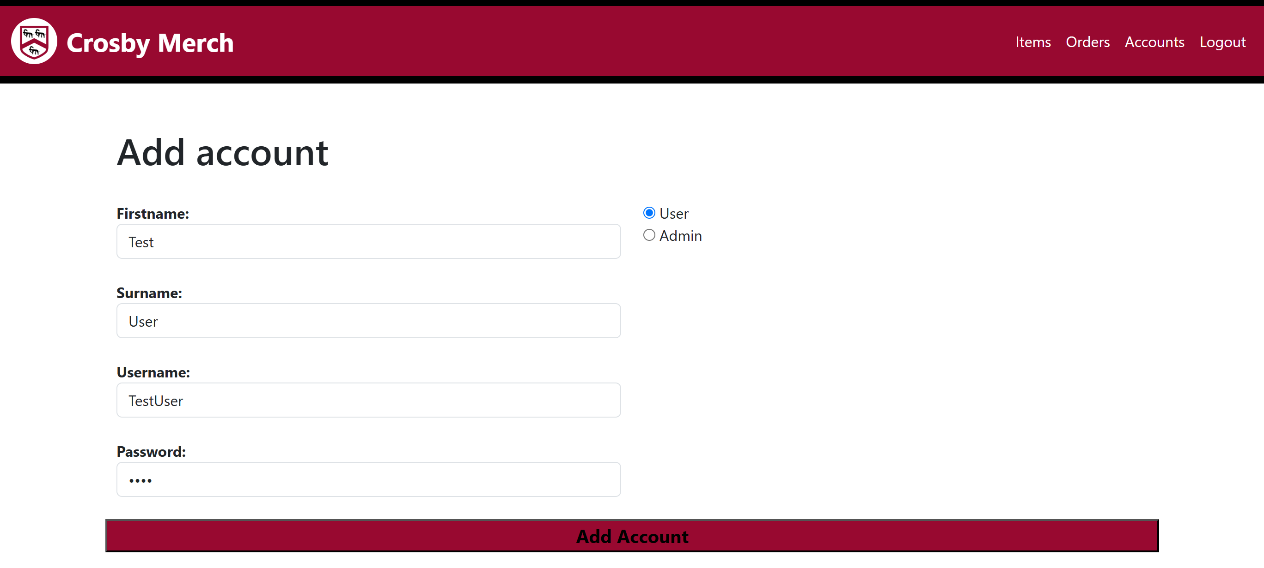Adding a new user:

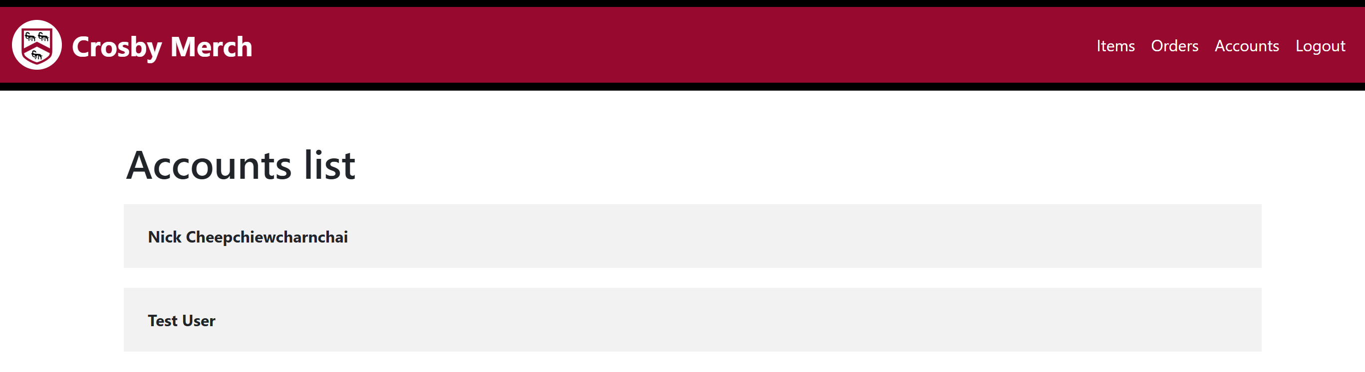After user is added:

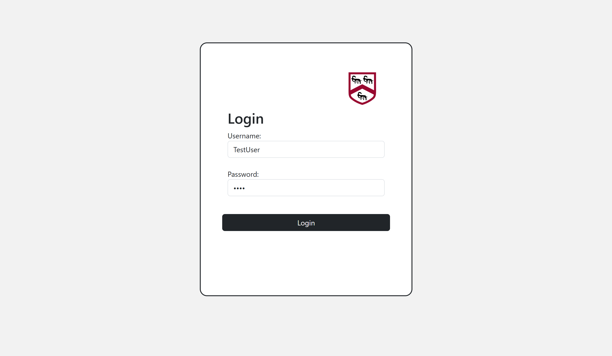 Login is also successful: Test 34  
Account is deleted from the database, including all baskets and orders linked to the account

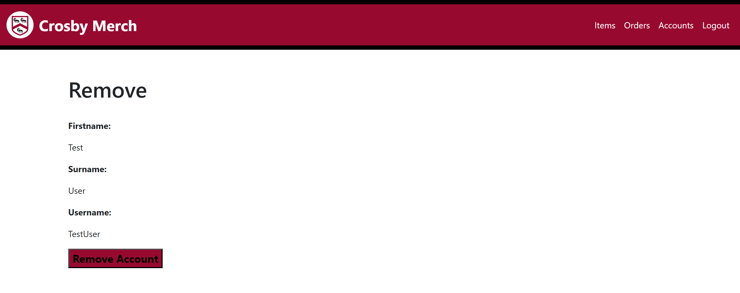Removing user:

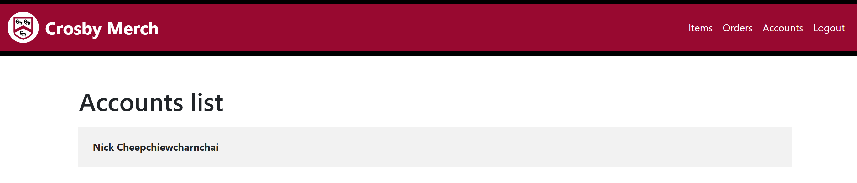After user removed:

Login is also unsuccessful:



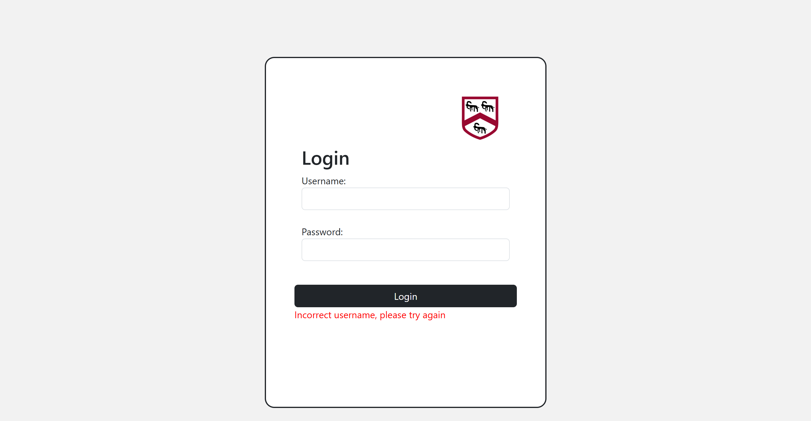

## Success of Solution

### Shared Criterions

|  |  |  |  |
| --- | --- | --- | --- |
| No. | Success criteria | Outcome | Description |
| 1 | Users and admins must be able to log in with valid credentials, and the system must prevent unauthorized access. Upon entering the correct credentials, users and admins must be sent to their respective pages. | Successful  See Functional and Robustness Test 1, 2 & 3  See Usability Testing customer questionnaire 1  See Usability Testing admin questionnaire 1  The login **always** works functionally and is also very well done in terms of utility, considering its high score of 9.6 and 9.3 from the utility testing | User can proceed from login when they enter correct login details, and not when incorrect details are entered |
| 2 | The website should be fully functional across different devices (laptops, PCs, tablets, smartphones). | Successful  See Functional and Robustness Test 5  When the page is scaled, it changes how the pages look generally due to dynamic sizing. **No features are broken** when the page is resized | Website can be used on multiple different screen proportions allowing access for different devices ( mobile, tablet, desktop devices) |
| 3 | The navbar should be consistent across all pages, allowing easy navigation between the various pages. | Successful  See Functional and Robustness Test 6 & 22  See Final Testing: Navbar looks constant throughout all pages  See Usability Testing customer questionnaire 2  See Usability Testing admin questionnaire 2  The navbar **look the same throughout all pages** and **correctly** redirects you to each page | The navbar is consistent across all the pages, allowing users to navigate easily through various pages correctly |

### Customer Criterions

|  |  |  |  |
| --- | --- | --- | --- |
| No. | Success criteria | Outcome | Description |
| 1 | Customers can easily navigate between pages (Browse, Basket, Purchases, Logout) without confusion or excessive clicks. | Successful  See Usability Testing customer no.5 comment: “within **2 clicks**”  Through the navbar, customers can navigate between all their pages within 2 clicks, making traversing through the website very easy and quick | Customers can navigate through the website very smoothly, and without confusion |
| 2 | Customers should be able to find products efficiently using search, filters, and sorting options. | Successful  See Functional and Robustness Test 7 & 8  See Usability Testing customer questionnaire 3  See Usability Testing customer no.2 comment: “**very few seconds**”  Customers can very quickly go to sections of items that they are interested in, looking at the high score of 9.6 from the utility testing | Customer is able to use the search, filters, and sorting options, very efficiently to find an item that they want |
| 3 | Customers can successfully select size, quantity, and add an item to the basket without errors. | Successful  See Functional and Robustness Test 12 & 13  Items are **always** added to basket successfully, quantity defaults at 1 and cannot proceed without selecting size, to **prevent an error from occurring** | Customer is able to select size, quantity of an item and add it to the basket without any errors |
| 4 | Customers can view and manage the contents of their basket, including removing items and seeing the total cost. | Partially successful  See Functional and Robustness Test 14, 15 & 16  The basket displays **correct items and total cost**. However, due to running out of time and **not** creating a way to **remove items from basket**, this criteria has not been met fully | Customers can view the contents of their basket and see the total cost |
| 5 | Customers can place an order successfully by clicking the "Purchase" button and clearing the basket afterward. | Successful  See Functional and Robustness Test 17  After pressing the purchase button, an order **can be seen in the purchases page**, and the user is given a new **empty basket** | Customers can p click the "Purchase" button successfully place an order, then they get a new basket |
| 6 | Customers should be able to view the status of their orders (unprocessed, processed, finished) and check the contents of past orders. | Successful  See Functional and Robustness Test 18 & 19  Each basket ordered is displayed in the **correct status section** and each basket can be clicked on the check its contents | Customers can see which of their baskets are unprocessed, processed, and finished, and click on the basket to view its details |
| 7 | Users can cancel unprocessed orders from their purchases page. | Unsuccessful  See Functional and Robustness Test 17  Due to running out of time I **did not create a way to cancel unprocessed orders** | Customers cannot cancel orders once they have been purchased |

### Admin Criterions

|  |  |  |  |
| --- | --- | --- | --- |
| No. | Success criteria | Outcome | Description |
| 1 | Admins must be able to navigate between Items Management, Orders Management, and Accounts Management pages without delays. | Successful  See Usability Testing admin no.1 comment: “within **5 clicks**”  Through the navbar, admins can navigate between all their pages within 5 clicks, making traversing through the website very easy and quick | Admin can navigate through the website very smoothly, and without confusion |
| 2 | Admins must be able to add new items and remove existing ones easily and seamlessly. | Partially successful  See Functional and Robustness Test 25 & 26  See Usability Testing admin questionnaire 3  See Usability Testing admin no.3 comment: “**not having** an option to edit or even **remove an item**”, “adding items, although it was a **very quick process**, it **would be nice** if the **pictures** that are inserted were **shown** alongside displaying their name”  I was not able to get the inserted picture to show during adding an item.  When item is deleted from the database directly, it will cause errors to occur in the system elsewhere, instead, I would have had to make an archiving system. However, since I ran out of time I was not able to create a feature to remove an item from the item list | Admins can add new items but cannot remove existing ones |
| 3 | Admins must be able to view order details and change the status of orders (Unprocessed, Processed, Finished). | Partially successful  See Functional and Robustness Test 27, 28 & 29  See Usability Testing admin questionnaire 4  See Usability Testing admin no.2 comment: “Even though to process a basket on the system technically takes **less than a minute** and **immediately changes the status** for the order, I felt that performing the actual tasks processing the orders in real life **takes forever**”  Although looking at this from a computational system wise it can be worked very quickly, but since the act of actually processing orders is done in real life, it technically still takes a lot longer than one minute | Admins can view order details and change the status of orders (Unprocessed, Processed, Finished) |
| 4 | Admins must be able to add new user accounts and view and remove existing ones when necessary. | Successful  See Functional and Robustness Test 30, 31,33 & 34  See Usability Testing admin questionnaire 5  See Usability Testing admin no.3 comment: “It took **less than a minute** to add a user and probably only a **few seconds** to remove one.”  Although I did not create an archiving system for managing accounts, I found that deleting users from the database directly does not cause any errors in other parts off the system. Apart from that adding viewing and removing accounts all works correctly and efficiently as proven by the high utility score of 9.0 | Admins can add new users, view and remove existing easily and quickly |
| 5 | Admins must be able to view customer baskets and change the order status from Unprocessed to Processed or Finished through their account page. | Partially successful  See Functional and Robustness Test 32  See Usability Testing admin questionnaire 6  See Usability Testing admin no.2 comment: “same problem applies to processing orders through accounts”  The same problem occurs from order processing through accounts as it does through the normal status way. | Admins can view order details and change the status of orders (Unprocessed, Processed, Finished) though specific user’s accounts |

## Improvements to Unmet Criteria

### Customer Criterions

#### Criterion 4

To fully meet the criterion I would need to implement a function for removing items directly from the basket, most likely by adding a "Remove" button next to each item in the basket display. When clicked, this button would trigger a PHP script to delete the corresponding item from the TblBasketItems table using its unique identifier (BasketItemID). Additionally, the total cost should be dynamically recalculated after an item is removed to reflect the updated basket contents. Implementing this feature would give customers full control over their basket, significantly improving the user experience and fulfilling the criterion in its entirety.

#### Criterion 7

To meet the criterion, I would implement a cancellation feature for unprocessed orders on the user's purchases page. This could involve adding a "Cancel Order" button next to each unprocessed order, which would trigger a PHP script to update the order’s status to "Cancelled" or remove it entirely from the database. Additionally, a confirmation prompt could be included to prevent accidental cancellations. Implementing this feature would provide users with greater control over their orders and ensure that the system meets the intended functionality of managing unprocessed purchases.

### Admin Criterions

#### Criterion 2

To meet the criterion, I would need to add a feature to delete items from item list. However, instead of deleting items directly from the database, which can cause system errors due to relational dependencies, I would create an archiving or soft-delete system. This would involve adding a status field (e.g., "active" or "archived") to the TblItems and filtering out archived items from being displayed on the browsing page. This approach would allow items to be safely hidden without breaking existing order or basket records, making item management smoother and more reliable for administrators.

#### Criterion 3 & 5

To meet the criterion I think that I would learn to integrate a basic transaction logging system or linking with external payment records would streamline financial tracking, reducing reliance on separate systems. I also think that perhaps a redesign of the orders page might help, where basket details are displayed on the page without having to click onto individual one, allowing the time to process order to reduce by not having to flip through many different pages.

## Maintenance and Limitations

In its current state, the system will face growing challenges in maintainability over time. Although it includes basic functionality for managing products and orders, there are significant limitations that would impact its long-term sustainability. For example, the item management section allows for adding new products but lacks any way of editing or archiving existing ones. This means that outdated or incorrect entries cannot be easily fixed or removed, leading to cluttered product listings and potential customer confusion. Deleting items directly from the database is possible, but doing so without cascading deletions or safeguards causes system-wide errors, especially in places where deleted items are referenced, such as baskets or order history.

Another maintenance concern is the absence of customer management tools for admins. Admins currently cannot modify existing user details such as names, usernames, or passwords. In a real-world setting, customers may request corrections to personal information, and the lack of this feature would require direct manipulation of the database by technical staff. Not only does this introduce a risk of accidental data corruption, but it also adds unnecessary workload and makes the system less user-friendly for administrative personnel.

The order processing system also presents long-term limitations. While order statuses can be updated through the admin interface, there is no logging system to track changes or indicate which admin made specific updates. This lack of traceability could lead to confusion or accountability issues, especially in larger systems with multiple staff members managing orders. Furthermore, there is no way to cancel an order once it's been marked as processed or completed, limiting flexibility and creating problems in scenarios where customers change their minds or errors are made in processing.

Additionally, the system heavily relies on session-based user verification without any timeout mechanisms or activity monitoring. Over time, as more users access the system, this could lead to security and performance concerns. There's also no role-based access control beyond the simple 'User' and 'Admin' distinction, which makes it difficult to implement more nuanced permission levels (e.g. customer support) in the future.

## Potential Improvements

One major improvement that could greatly increase the functionality of the system would be the integration of a payment gateway. Currently, the ordering process does not involve any real payment handling, meaning that all transactions must be completed in person or through a separate system. By adding a payment gateway such as PayPal, users could pay for their items securely and directly through the website. This would make the ordering experience far more streamlined and realistic, and would remove the need for manual money handling though house bank by staff members. In addition, payment confirmation could be linked to the order status, allowing orders to be automatically marked as “Processed” or “Completed” once payment has been successfully made.

Another improvement would be hosting the website online rather than running it locally. At the moment, the system can only be accessed from a single machine, which makes it impractical for actual use. By hosting the site on a web server and purchasing a domain, the website could be accessed by real users from anywhere with an internet connection. This would make the system far more useful for both customers and admins, as users could place orders at any time, and admins could manage the system remotely. Hosting would also allow for scalability, meaning the system could support many more users at once.

# Appendix

## Mystyle.php

